|  |  |
| --- | --- |
|  | Office 365: Everything You Wanted to Know |
|  |  |
|  |  |



How to Use this Document?

The **intended audience** of this document are the **IT Pros** (Primary) and **Developers** (Secondary) in **Organizations** using or planning to deploy Office 365. They can use this document as a reference to learn all-up Office 365 capabilities and plan the adoption journey and application development.

This document is meant to **complement existing Office 365 resources**, available on TechNet, MSDN, Office Blogs and Support websites, and draws heavily from them for content. A high-level information on Office 365 and its service is aggregated and made available in one place. Readers are encouraged to refer to the online resources shared, in each section, for more information.

Information and online resources on new Office 365 services and updates are given at multiple places in this document. Please refer to the online Office 365 Roadmap and your tenant’s Office 365 Message Center for current status of the updates.

A successful Office 365 rollout focuses on driving adoption and helping everyone understand the benefits of working in a new way. The sections – Four steps towards successful adoption and Getting Started Scenarios give walkthrough of the guidance and resources available from Microsoft for successful adoption.

|  |
| --- |
| Microsoft is using Microsoft Azure, Office 365 and Microsoft Dynamics to deliver the industry's most complete cloud — for every business, every industry, and every geography. Microsoft's Enterprise Cloud Roadmap section summarizes and compares Microsoft’s offerings across SaaS, PaaS, IaaS, and private cloud offerings. |

|  |  |
| --- | --- |
|  | **Important Note** |
| Keeping pace with the Office 365 innovation, this document would get updated at least once in a month. Please don’t refer to this document if the last modified date shown below is more than **3 months** old. [Request](mailto:vedantk@microsoft.com?subject=Office%20365%20-%20Everything%20You%20Wanted%20to%20Know) for the latest copy. | |
| Last modified: **Saturday, February 11, 2017.** | |

Table of Contents

Welcome to Office 365 1

Office 365 Services 4

Moving to Office 365 9

Driving Office 365 adoption 11

Four Steps Towards Successful Adoption 11

Getting Started Scenarios 12

Productivity Library 13

Typical Solutioning Process 14

Online Resources 15

Services Overview 17

Exchange Online (EXO) 17

Exchange Online Archiving (EOA) 18

Skype for Business Online (Skype) 19

Skype Meeting Broadcast 21

Cloud PBX 23

SharePoint Online (SPO) 25

OneDrive for Business (OneDrive) 36

Office 365 Videos 42

Yammer 44

Office 365 Groups 48

Microsoft Teams (Preview) 52

Delve 56

Power BI Pro 59

MyAnalytics 62

Office 365 ProPlus (Office) 65

Office 2016 for Mac 66

Office on iOS, Android, Windows 67

Sway 68

Exchange Online Protection (EOP) 68

Advanced Threat Protection (ATP) 69

RMS for Office 365 (RMS) 70

O365 Message Encryption (OME) 72

Office 365 Security & Compliance Center 73

Data Loss Prevention (DLP) 76

eDiscovery and Content Search 77

Advanced eDiscovery 77

MFA for Office 365 (MFA) 78

MDM for Office 365 (MDM) 80

Customer Lockbox 82

Office 365 Advanced Security Management 82

Office 365 Secure Score 84

Threat Intelligence (Preview) 86

Advanced Data Governance (Preview) 86

Plan Office 365 security & information protection 88

Migrate your Org’s data to Office 365 Enterprise 90

Migrate email to Office 365 90

Migrate files and folders 90

Migrate Skype for Business users 91

Archiving third-party data 91

Office 365 Application Development 93

Office 365 APIs 93

Microsoft Graph 94

SharePoint Online Development 95

Office UI Fabric 99

OneDrive API 99

Office 365 Connectors 100

Business Application Platform 100

Microsoft PowerApps 101

Microsoft Flow 102

Office Add-ins 103

Skype Developer Platform 104

Azure WebJobs 105

Office 365 Developer Patterns and Practices 106

Enterprise Mobility + Security (EMS) 107

Solutions 107

Business Benefits 109

Products 110

Microsoft's Enterprise Cloud Roadmap 111

Cloud Services and Platform Options 111

Microsoft IT moves its workloads to the cloud 113

Microsoft cloud storage options 113

# Welcome to Office 365

Office 365 is the most complete, secure cloud productivity service to help companies empower employees on the digital transformation journey.

To help companies maximize opportunities while going through digital transformation, we are delivering innovation in Office 365 against these key technology investment areas:

* **Collaboration**: Only Office 365 delivers a robust collaboration solution that meets the needs of diverse groups (whether that’s generational, geographical, functional or workstyle) and provides the option to collaborate as a team across applications through Office 365 Groups.
* **Mobility**: Office 365 enables mobile productivity across many scenarios for any corporate or personal device (Windows, iOS or Android) and protects both users and company data with built-in security.
* **Intelligence**: In addition to delivering powerful visualizations and insights for everyone with Power BI and Excel, Office 365 is built on the Microsoft Graph which uses machine learning to infuse intelligence into each application to connect people and information faster.
* **Trust**: Office 365 is secure & compliant, manageable, extensible, and always up to date with ongoing cloud updates. We provide a 99.9% uptime financially-backed SLA, Fast Track benefits and the transparency and enterprise commitment of a public-facing roadmap**.**

Office 365 is designed meet the unique collaboration needs of every group. For every collaboration category, Office 365 includes a purpose-built application. Together, these create a holistic solution that embrace diverse needs and workstyles and makes us different than any other vendor on the market.

|  |  |  |
| --- | --- | --- |
|  |  |  |
| **Mail & Calendar** | **Co-Authoring Content** | **Sites & Content Management** |
| *Outlook* | *Office365 Pro Plus* | *SharePoint* |

|  |  |  |
| --- | --- | --- |
|  |  |  |
| **Voice, Video & Meetings** | **Chat-based Workspace** | **Enterprise Social** |
| *Skype* | *Microsoft Teams* | *Yammer* |

### Choice and Flexibility

Large enterprises are not usually ready to move all of their workloads to the cloud at once. With Office 365, customers can choose between a cloud deployment, an on-premises solution, or a hybrid environment that integrates cloud services into an on-premises IT infrastructure.

Customers can move some users to the cloud and keep others on-premises for compliance or operational reasons. This enables customers to move to the cloud at a pace that makes sense for their unique business needs. If they choose a hybrid infrastructure, users will probably never know the difference, and customers can use the same management tools across online and on-premises servers.

Office 365 offers organizations the choice of various SKU plans to meet the needs a diverse workforce while continuing to keep their IT costs low.

Large enterprise organizations have a diverse end-user base with different job profiles. Some users are involved in corporate job functions that require access to dedicated devices and rich robust applications. Alongside those are users who constitute a mobile workforce and either share devices or have lightweight technology usage scenarios.

### Change Management Discipline

When implementing new solutions, enterprises rely on change-management processes and workflow to minimize the impact on their organizations. Enterprises cannot be hampered by unpredictable changes, inconsistent delivery, or the sudden disappearance of features. The power of cloud-based services is that they are always up-to-date and offer an experience that gradually improves over time. We realize that change can be daunting, and IT administrators need tools and information to manage ongoing change.

Microsoft customers will receive advance notice of significant changes to Office 365 so they can plan effectively.

We provide visibility for planned updates that are in development and in the process of being rolled out to the service, as well as items that have been launched and are now generally available for all eligible customers.

#### Office 365 Roadmap

[The Office 365 Roadmap](http://fasttrack.microsoft.com/roadmap) lists updates that are currently planned for applicable subscribers. Updates are at various stages from being in development to rolling-out to customers to being generally available for applicable customers world-wide

The roadmap provides customers a centralized place to learn more about pending updates before those changes come to the service. It provides a forward-looking view of new features, enhancements, and major updates, which in some cases may extend farther than just a few months, as evidenced by our long-term communications around Delve and Office Graph.

### Privacy, Security and Compliance

While end-user expectations and demand for the latest tools is high, IT has to balance this pressure to meet users’ needs with the requirement to adhere to corporate policies, industry regulations, and applicable laws.

Historically, security and compliance technologies and mandates were perceived as disruptive to productivity, driving down employee satisfaction while driving up IT costs. If users feel impeded by the technology they’re given, they often look for ways around it, which in turn can create new corporate non-compliance issues and bring the problem full circle.

It’s difficult to run a competitive business with information and access totally locked down--the trade-offs on agility and decision making are too great.

This is why we believe that the most well-run organizations are those in which people are empowered to do their best work, on any device, while IT is able to responsibly manage security and compliance requirements.

Office 365 includes two equally important capabilities:

1. **Service-level capabilities** that include technical features, operational procedures, and policies that are enabled by default for customers using the service
2. **Customer controls** that include features that enable businesses to customize the Office 365 environment based on the specific needs of their organization

#### Office 365 Trust Center

[Office 365 Trust Center](https://products.office.com/en-us/business/office-365-trust-center-welcome) is the place where we share our commitments and information on trust-related topics. The core tenets of our approach to earning and maintaining your trust are:

* Built-in security
  + Service-level security through defense-in-depth
  + Customer controls within the service
  + Security hardening and operational best practices
* Privacy by design
  + Your data is not used for advertising
  + You have extensive privacy controls
  + You can take your data with you when you want
* Continuous compliance
  + Proactive processes to meet evolving compliance needs
  + Customer controls for organizational compliance
  + Independently verified to meet evolving standards
* Transparent operations
  + You know where your data resides and who has access
  + Visibility into availability and changes to the service
  + Financially backed guarantee of 99.9% uptime

**Resources**

* The video series - [Conversations from Inside the Cloud](https://products.office.com/en-us/business/office-365-trust-center-engage-videos)
* [Office 365 Compliance Framework for Industry Standards and Regulations](https://go.microsoft.com/fwlink/p/?LinkId=615657)
* [Office 365 security white paper](https://go.microsoft.com/fwlink/p/?LinkId=401240)
* [Office 365 privacy white paper](https://go.microsoft.com/fwlink/p/?LinkId=517025)
* [Protecting data and privacy in the cloud](https://go.microsoft.com/fwlink/p/?LinkId=401092)
* [Tenant Isolation in Microsoft Office 365](https://www.microsoft.com/en-us/download/details.aspx?id=54249)
* [Customer controls for information protection white paper](https://go.microsoft.com/fwlink/p/?LinkID=404234)
* [Security Incident Management in Microsoft Office 365](https://www.microsoft.com/en-us/download/details.aspx?id=54302)
* [File Security in Microsoft SharePoint and OneDrive for Business](https://www.microsoft.com/en-us/download/details.aspx?id=53884)

#### Service Assurance

Use **Service assurance** in the **Office 365 Security & Compliance Center** to access documents that describe a variety of topics, including:

* Microsoft security practices for customer data that is stored in Office 365.
* Independent third-party audit reports of Office 365.
* Implementation and testing details for security, privacy, and compliance controls that Office 365 uses to protect your data.

You can also find out how Office 365 can help comply with standards, laws, and regulations across industries, such as the:

* International Organization for Standardization (ISO) 27001 and 27018
* Health Insurance Portability and Accountability Act of 1996 (HIPAA)
* Federal Risk and Authorization Management Program (FedRAMP)

| Content available | Description |
| --- | --- |
| **Compliance reports** |  |
| * FedRamp * GRC Assessment * ISO * SOC/SSAE | Use service compliance reports to review audit assessments performed by third-party independent auditors of Office 365 Service Delivery Operations. |
| **Trust documents** |  |
| * FAQ and White Papers * Risk Management Reports | Use white papers, FAQs, end-of-year reports and other Microsoft Confidential resources that are made available to you under non-disclosure agreement for your review / risk assessments. |
| **Audited controls** |  |
| Global standards and regulations that Office 365 has implemented. | Help with risk-assessment when you're evaluating, onboarding, or using Office 365 services. Find out:   * How Office 365 controls meet security, compliance, and privacy requirements. * About tests that have been applied to controls in Office 365, results of these tests, and when they were completed. |

For more details, refer to the [Service assurance in the Office 365 Security & Compliance Center](https://support.office.com/en-us/article/Service-assurance-in-the-Office-365-Security-Compliance-Center-47e8b964-4b09-44f7-a2d7-b8a06e8e389c?ui=en-US&rs=en-US&ad=US) article.

### Security in a Cloud-Enabled World

#### Security in the cloud is a partnership

The security of your Microsoft cloud services is a partnership between you and Microsoft.

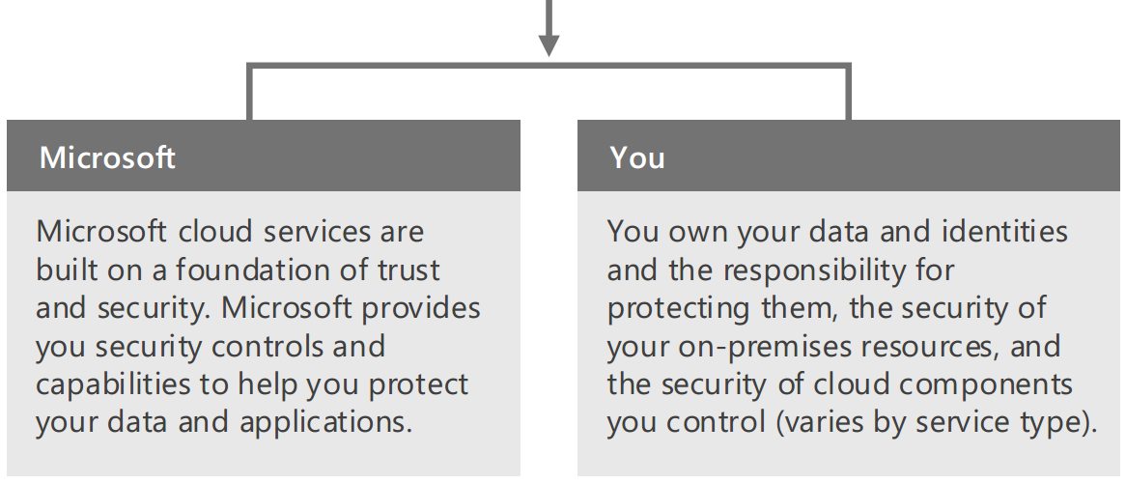

#### Keys to success

Enterprise organizations benefit from taking a methodical approach to cloud security. This involves investing in core capabilities within the organization that lead to secure environments.

**Governance & Security Policy**

Microsoft recommends developing policies for how to evaluate, adopt, and use cloud services to minimize creation of inconsistencies and vulnerabilities that attackers can exploit.

Ensure governance and security policies are updated for cloud services and implemented across the organization:

* Identity policies
* Data policies
* Compliance policies and documentation

**Administrative Privilege Management**

Your IT administrators have control over the cloud services and identity management services. Consistent access control policies are a dependency for cloud security.

Privileged accounts, credentials, and workstations where the accounts are used must be protected and monitored.

**Identity Systems and Identity Management**

Identity services provide the foundation of security systems. Most enterprise organizations use existing identities for cloud services, and these identity systems need to be secured at or above the level of cloud services.

**Threat Awareness**

Organizations face a variety of security threats with varying motivations. Evaluate the threats that apply to your organization and put them into context by leveraging resources like threat intelligence and Information Sharing and Analysis Centers (ISACs).

**Data Protection**

You own your data and control how it should be used, shared, updated, and published.

You should classify your sensitive data and ensure it is protected and monitored with appropriate access control policies wherever it is stored and while it is in transit.

|  |
| --- |
| Please refer to the Office 365 Security & Compliance Center and Enterprise Mobility + Security sections later in this document. |

**MSIT Showcase**: [Changing our approach to information security at Microsoft](https://www.microsoft.com/en-us/download/details.aspx?id=54436).

With collaboration on the rise, Microsoft IT is rethinking information security. Social collaboration, ubiquitous connectivity, and new ways of collecting data and storing content encourage innovation and content sharing—but they also pose potential security risks for organizations. We help protect content through technologies like Microsoft Office Delve, Azure Information Protection, and Microsoft Teams—securing content wherever it exists, and in ways that go beyond traditional IT security.

### Industry Leadership

Leading technology research companies Gartner Inc. and Forrester evaluate technology vendors and their solutions on a regular basis, and then publish research reports for customers. Both research companies have recognized Microsoft Office 365 as a “leader” and rated it “positive” in their research reports.

|  |  |  |
| --- | --- | --- |
| The Forrester Wave™: Enterprise Collaboration, Q4 2016 | Dec 2016 | Leader |
| Cloud Access Security Broker Leadership Compass, 2016 | Aug 2016 | Leader |
| Magic Quadrant for Unified Communications as a Service, Worldwide | Aug 2016 | Challenger |
| Magic Quadrant for Sales Force Automation | Aug 2016 | Leader |
| Magic Quadrant for Unified Communications | Jul 2016 | Leader |
| Magic Quadrant for Mobile App Development Platforms | Jun 2016 | Leader |
| Magic Quadrant for Enterprise Mobility Management Suites | Jun 2016 | Visionary |
| The Forrester Wave: Enterprise File Sync And Share Platforms, Cloud Solutions, Q1 2016 | Mar 2016 | Leader |
| Gartner Magic Quadrant for Web Conferencing | Dec 2015 | Leader |
| Gartner Magic Quadrant for Social Software in the Workplace | Oct 2015 | Leader |
| The Forrester Wave: Agile Business Intelligence Platforms, Q3 2015 | Sep 2015 | Leader |
| Gartner Magic Quadrant for Unified Communications as a Service | Sep 2015 | Challenger |
| Gartner Magic Quadrant for Unified Communications | Aug 2015 | Leader |
| Gartner Magic Quadrant for Secure Email Gateways | Jun 2015 | Leader |
| Gartner Magic Quadrant for Business Intelligence and Analytics Platforms | Feb 2015 | Leader |

Refer to [Analyst Relations – Reports](http://news.microsoft.com/analyst-reports/) page for a collection of reports published by leading independent analyst firms.

## Office 365 Services

Office 365 Enterprise E5 includes:

|  |  |
| --- | --- |
| Office suite | Always have latest versions of Office apps:   * Capture your ideas however you work best—using a keyboard, pen, or a touchscreen. * Easily format information in Excel with tools that recognize your pattern and autocomplete data. * Easily incorporate content from PDFs to create your own great-looking Word documents |
| Office on PCs, tablets, and phones | Enjoy a fully installed Office experience across PCs, Macs, Windows tablets, iPad® and Android™ tablets, and most mobile devices. Each user can install Office on 5 PCs or Macs, 5 tablets (Windows, iPad, and Android), and 5 phones |

Plus, these online services:

|  |  |
| --- | --- |
| Online Meetings | Host online meetings with audio, HD video, and web conferencing over the Internet. Join meetings with a single touch or click from the smartphone, tablet, or PC of your choice |
| Meeting Broadcast | Broadcast Skype for Business meetings on the Internet for to up to 10,000 people, who can attend in a browser on nearly any device. Meetings include real-time polling and sentiment tracking, plus Yammer, to enable dialogue during the broadcast |
| PSTN conferencing | Enable attendees to join Skype for Business from any telephone by dialing a local access number, and dial out from a meeting to add others when needed. The dial-in capability is in addition to single-touch join options on PC, smartphone, and browser, and allows people to join an online meeting even in places with no Internet access. Consumption rates are available. |
| Modern voice with Cloud PBX | Make, receive, and transfer business calls in the office, at home, or on the road, using phone, PC, and mobile without the need for a traditional phone system. Choose PSTN calling plans delivered by Microsoft where available, or use existing phone lines at your locations. |
| Instant messaging and Skype connectivity | Connect with other Skype for Business users via instant message, voice calls, and video calls, and let people know your availability with your online status. Share presence, IM, and audio calling with Skype users |
| Chat-based workspace | Connect your team with Microsoft Teams in Office 365, where chat, content, people, and tools live together, so your teams have instant access to everything they need. |
| Email and calendars | Use business-class email through a rich and familiar Outlook experience you can access from your desktop or from a web browser using Outlook on the web. Get 50GB of storage and unlimited archive storage per user. Also, send attachments up to 150 MB |
| Advanced email | Use archiving and legal hold capabilities, plus unlimited storage, for compliance needs. Use data loss prevention (DLP) policies and policy tips that educate your users for additional compliance enforcement in email. |
| Document and email access control | Rights Management Services enables you to restrict access to documents and email to specific people and to prevent anyone else from viewing or editing them, even if they are sent outside the organization. |
| Advanced information protection | Data loss prevention and encryption across Exchange Online, Skype for Business, and SharePoint Online help keep your content safe in email, IM and meetings, and team sites. |
| Advanced security | Advanced Threat Protection helps defend users against sophisticated threats hidden in emails, attachments, and links. Customer Lockbox lets you limit data access to only pre-assigned, two-factor-authenticated administrator approvals for greater control and transparency. And the built-in features of Office 365 Advanced Security Management give you enhanced visibility and control of your Office 365 environment. |
| Analytics tools | With the live dashboards and interactive reports of Power BI non-technical users can visualize and analyze data with greater speed, efficiency, and understanding. With its interactive dashboards, Microsoft MyAnalytics enables you to surface personal and organizational insights based on information across Office 365. |
| File storage and sharing | OneDrive for Business gives each user 1 TB of personal cloud storage that can be accessed from anywhere and syncs with their PC/Mac for offline access. Easily share documents with others inside and outside your organization and control who can see and edit each file. |
| Team Sites | Enable easy access and sharing of documents with 1 TB of baseline storage plus 500 MB of storage per user. Share insights through interactive reports with Excel Services and Visio Services, and view them on mobile device browsers that support HTML5. |
| Corporate social network | Yammer collaboration software and business applications allow your employees to connect with the right people, share information across teams, and organize around projects so they can communicate further, faster. |
| Office Online | Create and edit Word, OneNote, PowerPoint, and Excel documents from any modern browser. |
| Work management | Planner makes it easy for your team to create new plans, organize and assign tasks, share files, chat about what you’re working on, and get updates on progress. |
| Professional digital storytelling | With Sway, a new Office 365 app, you can easily create engaging, interactive web-based reports, presentations, newsletters, trainings and more—right from your phone, tablet, or browser. Sways are easy to share and look great on any screen. |
| Mobility | Sync email, calendar, and contacts; access SharePoint sites; view and edit Office documents with Office Online using a browser on Windows Phone, iOS, and Android devices. |
| Enterprise management of apps | Simplify management of apps in your organization with Group Policy, Telemetry, and Shared Computer Activation. |
| Search and discovery | Stay in the know. Search and discover content across Office 365 based on personalized insights. Office Delve is the first experience to be powered by Office Graph, a collection of analyzed signals or insights derived from each user’s behavior and relationships to content, topics, and contacts. |
| Corporate video portal | Easily manage videos within your organization. Office 365 Video is a company-wide destination for video upload, sharing and discovery, and smooth playback across devices. |
| Voicemail integration (Unified Messaging) | Hosted voicemail support integrated with Cloud PBX. Voicemails are recorded to Exchange Online and users can access them from Outlook, Outlook Web App, or compatible mobile and IP phones. |
| Compliance solutions | With the Compliance Center, you can search in-place across Exchange, Skype for Business, OneDrive for Business, and SharePoint. Advanced eDiscovery fully integrates the Equivio machine learning, predictive coding, and text analytics platform to reduce the costs and challenges that come with sorting through large quantities of data for eDiscovery purposes by quickly zeroing in on what is relevant. |
| Apps for Office and SharePoint | New third-party and customer-developed apps work with Office and SharePoint to bring web services right into your documents and sites. |

All Office 365 Enterprise Plans include:

|  |  |
| --- | --- |
| Reliability | Get peace of mind knowing your services are available with a guaranteed 99.9% uptime, financially backed service level agreement (SLA) |
| Security | Cutting-edge security practices with five layers of security and proactive monitoring help keep customer data safe |
| Privacy | Your data is yours. We safeguard it and protect your privacy |
| Administration | The admin portal provides IT detailed configuration options for your services, either from an online portal or through automated management with PowerShell commands. You can use the Admin app to manage your services on the go |
| Up to date | No need to pay for version upgrades; updates are included in your subscription. New features are rolled out to Office 365 customers in an IT-configurable experience |
| Active Directory Integration | Manage user credentials and permissions. Single sign-on and synchronization with Active Directory |
| Support | 24/7 phone support for all IT issues. For less urgent issues, you can make service requests directly through the admin portal |

For more information, refer to [Office 365 for Enterprises](https://products.office.com/en-us/business/enterprise-productivity-tools) and [Office 365 Service Descriptions](https://technet.microsoft.com/en-us/library/jj819284.aspx).

**Microsoft Teams joins the Office 365 universal toolkit**

**Microsoft Teams** joins the broadest and deepest portfolio of collaboration applications and services to help solve the diverse needs of people and organizations globally. As we’ve learned from our **85 million active monthly users**, all groups have a diverse set of needs when it comes to working together. Office 365 is designed for the unique workstyle of every group and includes purpose-built applications, all deeply integrated together.

* **Exchange** is the undisputed leader in corporate email and [according to Gartner](http://www.gartner.com/newsroom/id/3196317) has “80 percent share of companies using cloud email with revenue above $10 billion.”
* **SharePoint** provides intranets and content management solutions to more than 200,000 organizations and 190 million people.
* **Yammer** is the social network for work, enabling cross-company discussions for 85 percent of the Fortune 500.
* **Skype for Business** provides real-time voice, video and conferencing and hosts more than 100 million meetings a month.
* **Office 365 Groups** is our cross-application membership service that makes it easy for people to move naturally from one collaboration tool to another.

|  |
| --- |
| **Note**: Microsoft Teams is available in preview to eligible Office 365 commercial customers. **We expect the service to become generally available in the first quarter of calendar year 2017**. |

### Plans & Services Mapping

Office 365 is available in a variety of plans in order to best meet the needs of your organization. The TABLE below shows the availability of services across K1, E1, E3 and E5 suite plans.

| Office 365 Plans | K1 | E1 | E3 | E5 |
| --- | --- | --- | --- | --- |
| **Communicate** |  |  |  |  |
| Exchange Online (EXO) | ⚫ | ⚫ | ⚫ | ⚫ |
| Exchange Online Archiving (EOA) |  |  | ⚫ | ⚫ |
| Skype for Business Online (Skype) |  | ⚫ | ⚫ | ⚫ |
| Skype Meeting Broadcast |  | ⚫ | ⚫ | ⚫ |
| Cloud PBX |  |  |  | ⚫ |
| PSTN Conferencing |  |  |  | ⚫ |
| **Collaborate & Discover** |  |  |  |  |
| SharePoint Online (SPO) | ⚫ | ⚫ | ⚫ | ⚫ |
| OneDrive for Business (OneDrive) |  | ⚫ | ⚫ | ⚫ |
| Outlook Groups |  | ⚫ | ⚫ | ⚫ |
| *Microsoft Teams\** |  | ⚫ | ⚫ | ⚫ |
| Yammer | ⚫ | ⚫ | ⚫ | ⚫ |
| Office 365 Videos |  | ⚫ | ⚫ | ⚫ |
| Microsoft Planner |  | ⚫ | ⚫ | ⚫ |
| Delve |  | ⚫ | ⚫ | ⚫ |
| StaffHub | ⚫ | ⚫ | ⚫ | ⚫ |
| **Insights** |  |  |  |  |
| Power BI Pro |  |  |  | ⚫ |
| MyAnalytics |  |  |  | ⚫ |
| **Office** |  |  |  |  |
| Office 365 ProPlus (Office) |  |  | ⚫ | ⚫ |
| Office 2016 for Mac |  |  | ⚫ | ⚫ |
| Office on iOS, Android, Windows |  |  | ⚫ | ⚫ |
| Office Online | ⚫ | ⚫ | ⚫ | ⚫ |
| Sway | ⚫ | ⚫ | ⚫ | ⚫ |
| **Security & Compliance** |  |  |  |  |
| Office 365 Secure Score | ⚫ | ⚫ | ⚫ | ⚫ |
| Audit Log Search, Activity APIs | ⚫ | ⚫ | ⚫ | ⚫ |
| Exchange Online Protection (EOP) | ⚫ | ⚫ | ⚫ | ⚫ |
| MDM for Office 365 (MDM) | ⚫ | ⚫ | ⚫ | ⚫ |
| MFA for Office 365 (MFA) | ⚫ | ⚫ | ⚫ | ⚫ |
| RMS for Office 365 (RMS) |  |  | ⚫ | ⚫ |
| O365 Message Encryption (OME) |  |  | ⚫ | ⚫ |
| Data Loss Prevention (DLP) |  |  | ⚫ | ⚫ |
| eDiscovery, Content Search |  |  | ⚫ | ⚫ |
| Customer Lockbox |  |  |  | ⚫ |
| Advanced Threat Protection (ATP) |  |  |  | ⚫ |
| Advanced Security Management |  |  |  | ⚫ |
| Advanced eDiscovery |  |  |  | ⚫ |
| *Threat Intelligence\** |  |  |  | ⚫ |
| *Advanced Data Governance\** |  |  |  | ⚫ |
| **Application Development** |  |  |  |  |
| Microsoft Graph API | ⚫ | ⚫ | ⚫ | ⚫ |
| Office 365 REST APIs | ⚫ | ⚫ | ⚫ | ⚫ |
| Microsoft Flow |  | ⚫ | ⚫ | ⚫ |
| Microsoft PowerApps |  | ⚫ | ⚫ | ⚫ |
| **Infrastructure Services** |  |  |  |  |
| Azure AD Basic | ⚫ | ⚫ | ⚫ | ⚫ |
| Cloud Identity | ⚫ | ⚫ | ⚫ | ⚫ |
| Federated Identity | ⚫ | ⚫ | ⚫ | ⚫ |
| Office 365 Groups | ⚫ | ⚫ | ⚫ | ⚫ |

**\*** will be available in the first quarter of 2017.

### Mobile Apps

| Application |  |  |  |
| --- | --- | --- | --- |
| Word, Excel, PowerPoint, OneNote | ⚫ | ⚫ | ⚫ |
| Microsoft Outlook, OWA | ⚫ | ⚫ | ⚫ |
| Skype for Business | ⚫ | ⚫ | ⚫ |
| *Microsoft Teams\** | ⚫ | ⚫ | ⚫ |
| Yammer | ⚫ | ⚫ | ⚫ |
| OneDrive | ⚫ | ⚫ | ⚫ |
| Outlook Groups | ⚫ | ⚫ | ⚫ |
| SharePoint | ⚫ | ⚫ | ⚫ |
| Office 365 Videos |  | ⚫ |  |
| Delve | ⚫ | ⚫ | ⚫ |
| StaffHub |  | ⚫ | ⚫ |
| Microsoft Flow |  | ⚫ | ⚫ |
| PowerApps |  | ⚫ | ⚫ |
| Power BI | ⚫ | ⚫ | ⚫ |
| RMS Sharing | ⚫ | ⚫ | ⚫ |
| O365 Message Encryption Viewer |  | ⚫ | ⚫ |
| Office 365 Admin | ⚫ | ⚫ | ⚫ |

### Bundled Storage

Office 365 Enterprise Plans come with base storage as part of subscription.

| Service | Storage per user |
| --- | --- |
| Exchange Online (K1) | 2GB |
| Exchange Online (E1) | 50GB |
| Exchange Online (E3) | 50GB + Unlimited Archive |
| SharePoint Online | 1TB + (0.5GB * E users) |
| OneDrive for Business (E1) | 1TB |
| OneDrive for Business (E3) | 5TB* |
| Yammer | No Limits |

**Note**: Office 365 Videos leverages SharePoint Online storage and, when needed, additional storage can be purchased for SharePoint Online.

### Office 365 identity and Azure Active Directory

Office 365 uses the **cloud-based user authentication service Azure Active Directory** to manage users. You can choose from three main identity models in Office 365 when you set up and manage user accounts:

* **Cloud identity**. Manage your user accounts in Office 365 only. No on-premises servers are required to manage users; it's all done in the cloud.

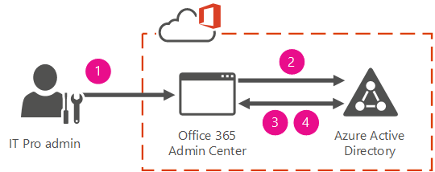

In this model, you create and manage users in the Office 365 admin center and store the accounts in Azure AD. Azure AD verifies the passwords. Azure AD is the cloud directory that is used by Office 365. No on-premises servers are required — Microsoft manages all that for you.

* **Synchronized identity**. Synchronize on-premises directory objects with Office 365 and manage your users on-premises. You can also synchronize passwords so that the users have the same password on-premises and in the cloud, but they will have to sign in again to use Office 365.

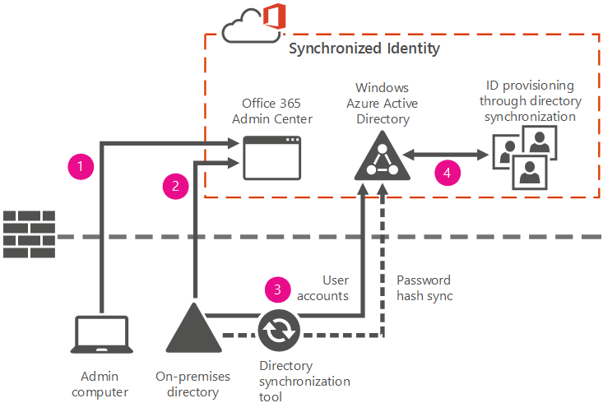

In this model, you manage the user identity in an on-premises server and synchronize the accounts and, optionally, passwords to the cloud. The user enters the same password on-premises as he or she does in the cloud, and at sign-in, the password is verified by Azure AD. This model uses a directory synchronization tool to synchronize the on-premises identity to Office 365.

* **Federated identity**. Synchronize on-premises directory objects with Office 365 and manage your users on-premises. The users have the same password on-premises and in the cloud, and they do not have to sign in again to use Office 365. This is often referred to as single sign-on.

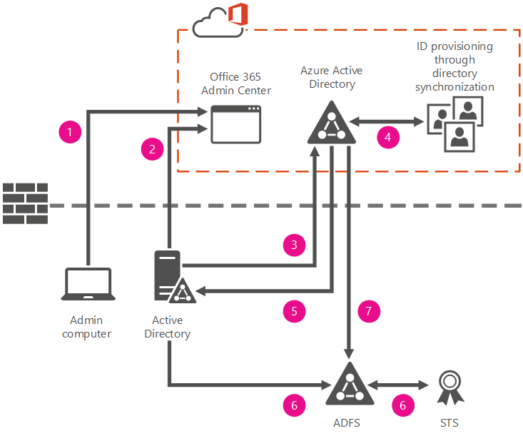

This model requires a synchronized identity but with one change to that model: the user password is verified by the on-premises identity provider. This means that the password hash does not need to be synchronized to Azure AD. This model uses Active Directory Federation Services (AD FS) or a third-party identity provider.

It’s important to carefully consider which identity model to use to get up and running. Think about time, existing complexity, and cost. These factors are different for every organization; [Understanding Office 365 identity and Azure Active Directory](https://support.office.com/en-us/article/Understanding-Office-365-identity-and-Azure-Active-Directory-06a189e7-5ec6-4af2-94bf-a22ea225a7a9?ui=en-US&rs=en-US&ad=US) topic reviews these key concepts for every identity model to help you choose the identity you want to use for your deployment.

**Related resources**:

* [Azure AD Connect FAQ](https://azure.microsoft.com/en-us/documentation/articles/active-directory-aadconnect-faq/)
* [Prepare to provision users through directory synchronization to Office 365](https://support.office.com/en-us/article/Prepare-to-provision-users-through-directory-synchronization-to-Office-365-01920974-9e6f-4331-a370-13aea4e82b3e)
* [Fixing problems with directory synchronization for Office 365](https://support.office.com/en-us/article/Fixing-problems-with-directory-synchronization-for-Office-365-79c43023-5a47-45ae-8068-d8a26eee6bc2)

### Azure ExpressRoute for Office 365

|  |
| --- |
| **Read this first**: The [Microsoft Cloud Networking for Enterprise Architects](https://technet.microsoft.com/en-us/library/mt733214.aspx) article describes what IT architects need to know about designing networking for organizations using Microsoft cloud services and platforms. |

**Microsoft Azure ExpressRoute** lets you extend on-premises networks into the Microsoft cloud over a dedicated private connection facilitated by a connectivity provider. With ExpressRoute, you can establish connections to Microsoft cloud services, such as Microsoft Azure, Office 365, and CRM Online.

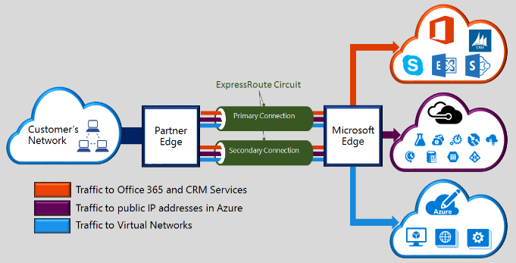

Connectivity can be from an any-to-any (IP VPN) network, a point-to-point Ethernet network, or a virtual cross-connection through a connectivity provider at a co-location facility. ExpressRoute connections do not go over the public Internet. This allows ExpressRoute connections to offer more reliability, faster speeds, lower latencies, and higher security than typical connections over the Internet.

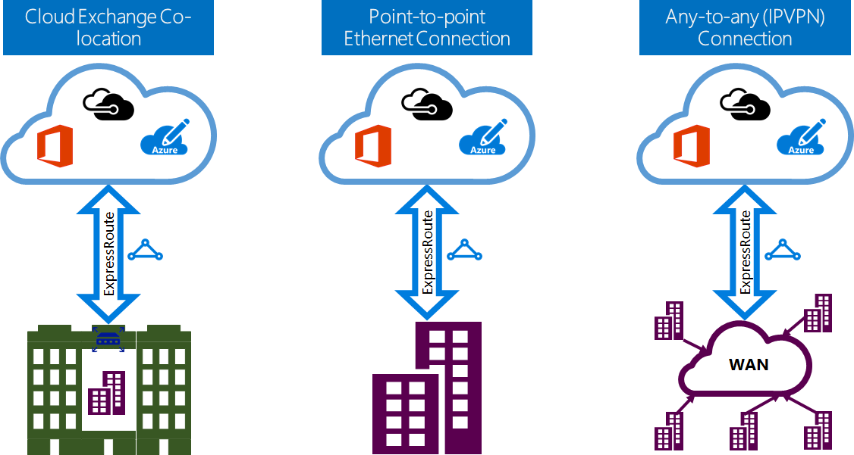

**Connectivity to Microsoft cloud services**

ExpressRoute provides private network connectivity to Microsoft cloud services. Infrastructure and platform services running in Azure often benefit by addressing network architecture and performance considerations. Therefore, we recommend enterprises use ExpressRoute for Azure.

Software as a Service offerings, like Office 365 and Dynamics 365, were created to be accessed securely and reliably via the Internet. Therefore, **we only recommend ExpressRoute for these applications in specific scenarios**.

**Azure ExpressRoute for Office 365** is a premium network connection for connecting to Office 365 without using the public Internet. ExpressRoute offers Customers the ability to have control over the path their Office 365 network traffic takes.

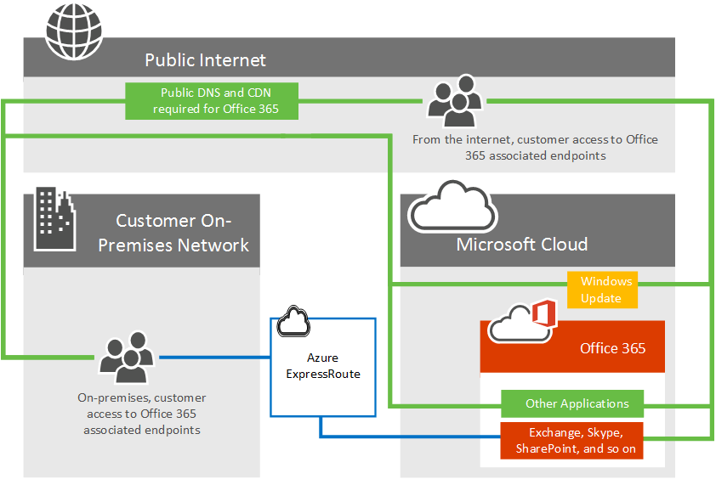

Users no longer have to be concerned with the unpredictable routing that happens on the internet where data is carried by third party network. Traffic sent through ExpressRoute is sent directly across the network provider's network into Microsoft's network.

To properly understand routing traffic to Office 365 using Azure ExpressRoute, you’ll need a firm grasp of the core [ExpressRoute routing requirements](https://azure.microsoft.com/documentation/articles/expressroute-routing/) and the [ExpressRoute circuits and routing domains](https://azure.microsoft.com/documentation/articles/expressroute-circuit-peerings/).

#### Resources

* [ExpressRoute FAQ](https://azure.microsoft.com/en-us/documentation/articles/expressroute-faqs/)
* [Network connectivity to Office 365](https://support.office.com/en-us/article/Network-connectivity-to-Office-365-64b420ef-0218-48f6-8a34-74bb27633b10)
* [Azure ExpressRoute for Office 365](https://support.office.com/en-us/article/Azure-ExpressRoute-for-Office-365-6d2534a2-c19c-4a99-be5e-33a0cee5d3bd)
* [Network planning with ExpressRoute for Office 365](https://support.office.com/en-us/article/Network-planning-with-ExpressRoute-for-Office-365-103208f1-e788-4601-aa45-504f896511cd)
* [Routing with ExpressRoute for Office 365](https://support.office.com/en-us/article/Routing-with-ExpressRoute-for-Office-365-e1da26c6-2d39-4379-af6f-4da213218408)
* [Implementing ExpressRoute for Office 365](https://support.office.com/en-us/article/Implementing-ExpressRoute-for-Office-365-77735c9d-8b80-4d2f-890e-a8598547dea6)
* [Media Quality and Network Connectivity Performance in Skype for Business Online](https://support.office.com/en-us/article/Media-Quality-and-Network-Connectivity-Performance-in-Skype-for-Business-Online-5fe3e01b-34cf-44e0-b897-b0b2a83f0917)
* [Optimizing your network for Skype for Business Online](https://support.office.com/en-us/article/Optimizing-your-network-for-Skype-for-Business-Online-b363bdca-b00d-4150-96c3-ec7eab5a8a43)
* [ExpressRoute and QoS in Skype for Business Online](https://support.office.com/en-us/article/ExpressRoute-and-QoS-in-Skype-for-Business-Online-20c654da-30ee-4e4f-a764-8b7d8844431d)
* [Call flow using ExpressRoute](https://support.office.com/en-us/article/Call-flow-using-ExpressRoute-413acb29-ad83-4393-9402-51d88e7561ab)

## Moving to Office 365

### FastTrack Center Benefit for Office 365

With FastTrack Center Benefit for Office 365, you work remotely with Microsoft specialists to get your Office 365 environment ready for use. FastTrack Center provides assistance for the following Office 365 services:

* Exchange Online
* SharePoint Online
* OneDrive for Business
* Skype for Business Online
* Project Online
* Project Pro for Office 365
* Yammer Enterprise
* Office 365 ProPlus

Your services are eligible if you purchase at least 50 licenses for an Office 365 tenant using the Enterprise E or K Plans or one of the plans listed here: [Eligible Services and Plans](https://technet.microsoft.com/en-us/library/mt651701.aspx). Onboarding has two major components:

* **Core onboarding** — These are tasks required for tenant configuration and integration with Azure Active Directory if needed. Core onboarding also provides the baseline for onboarding other eligible services.
* **Service onboarding** — These are the eligible services that licensed users can access.

The [FastTrack Center Benefit Overview](https://technet.microsoft.com/en-us/library/office-365-onboarding-benefit-process.aspx) article provides an overview of the benefit process, lists the expectations for your source environment, describes the onboarding phases, and defines who’s responsible for what in each phase.

Another important resource is the Microsoft Virtual Academy Course: [Microsoft FastTrack: The Customer Success Service](https://mva.microsoft.com/en-us/training-courses/microsoft-fasttrack-the-customer-success-service-13909?l=pILKh5nmB_5800115881).

### Planning the Transition

“The secret of change is to focus all your energy not on fighting the old, but on building the new”

**Reimagine Productivity.** *New way to work*

Enterprises today are focusing more than ever on how to give employees access to information, provide collaboration tools for internal and external use, and do it all across a multitude of devices.

The first step is all about understanding Office 365 Services and their capabilities and how these can help you transition to the new way to work. People are empowered to do their best work, on any device, while IT is able to responsibly manage security and compliance requirements.

Some examples of the technology transition can be …

* from Exchange DLs and simple Team Sites to Office 365 Groups
* from File Servers to Office 365 Groups or SharePoint Online or OneDrive for Business based on usage scenario or,
* from Exchange Public Folders to Yammer

**Drive Office 365 Adoption.** *More Services, More Usage*

A successful Office 365 rollout focuses on driving adoption and helping everyone understand the benefits of working in a new way.

The Four Steps Towards Successful Adoption section in this document gives a walkthrough of a four-step approach to help you successfully drive Office 365 adoption.

Defining a clear, concise, and comprehensive vision as a first step and outlining your desired business scenarios is always good for adoption in long term.

You can also start building scenarios using the [Productivity Library](https://fasttrack.microsoft.com/office/envision/productivitylibrary) available in FastTrack site as a reference.

[Office Blogs](https://blogs.office.com/) also provides useful tips related to collaboration and productivity in the [Business Academy](https://blogs.office.com/?filter=true&filter-type=business-academy#038;filter-type=business-academy) section.

**Migrate from On-Premises.** *Less Servers, Less Usage*

Reducing the on-premises IT infrastructure footprint is an important pillar for the Return on Investment (RoI) on investment in Office 365.

As users and applications are enabled on Office 365, IT needs to work with business to plan and migrate all relevant applications and content from on-premises to Office 365.

Gradual and sustained reduction also leads to simpler IT landscape and a better Office 365 adoption in long term.

### Measuring the Progress

Best way to capture your transition to Office 365 and illustrate ROI to business is to spend time with their teams using the services and create **Success Stories** which can be shared with everyone in the Organization.

Given below are some ways to capture the progress …

* **Increase** in Office 365 Consumption. *Frequency*: Monthly
* **Decrease** in on-premises Server Farms, Storage and related Licenses. *Frequency*: Quarterly
* **Decrease** in Vendors. *Frequency*: Quarterly

### Customer Stories

Industry leaders and business executives from around the globe share their cloud productivity success stories on the [Office Blogs](https://blogs.office.com/). Some of the recent posts are:

* [Mediterranean Shipping Company builds a global productivity network with Office 365](https://blogs.office.com/2017/02/06/mediterranean-shipping-company-builds-a-global-productivity-network-with-office-365/)
* [Liberty Mutual launches an IT transformation](https://blogs.office.com/2017/01/31/liberty-mutual-launches-an-it-transformation/)
* [Sanofi Pasteur unlocks quality excellence and unleashes innovation with Yammer](https://blogs.office.com/2017/01/25/sanofi-pasteur-unlocks-quality-excellence-and-unleashes-innovation-with-yammer/)
* [Flex—delivering supply chain innovation on a global scale with Office 365](https://blogs.office.com/2016/12/09/flex-delivering-supply-chain-innovation-global-scale-office-365/)
* [Georgia State University tackles malware with Office 365 Advanced Threat Protection](https://blogs.office.com/2016/11/30/georgia-state-university-tackles-malware-with-office-365-advanced-threat-protection/)
* [NGA Human Resources builds a more engaging employee experience with move to Office 365](https://blogs.office.com/2016/11/21/with-move-to-office-365-nga-human-resources-builds-a-more-engaging-employee-experience/)
* [Renault Sport: Racing ahead with collaboration, analytics and data security using Office 365](https://blogs.office.com/2016/11/15/racing-ahead-with-collaboration-analytics-and-data-security-using-office-365/)
* [easyJet soars into a collaborative digital future with Office 365](https://blogs.office.com/2016/11/03/easyjet-soars-into-a-collaborative-digital-future-with-office-365/)
* [Macy’s sets the standard for empowering employees using Office 365](https://blogs.office.com/2016/11/01/macys-sets-the-standard-for-empowering-employees-using-office-365/)
* [Land O’Lakes: advancing agriculture for a new generation](https://blogs.office.com/2016/10/18/land-olakes-agriculture-for-a-new-generation/)
* [The Hershey Company: where collaboration and productivity are a recipe for goodness](https://blogs.office.com/2016/09/29/the-hershey-company-where-collaboration-and-productivity-are-a-recipe-for-goodness/)
* [Carhartt—building a durable, agile workplace with Office 365](https://blogs.office.com/2016/09/06/carhartt-building-a-durable-agile-workplace-with-office-365/)
* [Grundfos makes global business happen with Office 365](https://blogs.office.com/2016/08/26/grundfos-makes-global-business-happen-with-office-365/)
* [Carvajal switches to Office 365 for faster business, reduced costs](https://blogs.office.com/2016/08/09/carvajal-switches-to-office-365-for-faster-business-reduced-costs/)
* [Assurant: transforming a risk management solutions business with Office 365](https://blogs.office.com/2016/08/23/assurant-transforming-a-risk-management-solutions-business-with-office-365/)
* [Democratizing data - Atkins goes digital by default with Office 365 E5](https://blogs.office.com/2016/08/03/democratizing-data-atkins-goes-digital-by-default-with-office-365-e5/)
* [Kelly Services - putting nearly one million people to work every year, one great hire at a time](https://blogs.office.com/2016/07/27/kelly-services-putting-nearly-one-million-people-to-work-every-year-one-great-hire-at-a-time/)
* [Discovery Communications embraces Office 365 to foster creative culture of innovation](https://blogs.office.com/2016/07/18/discovery-communications-embraces-office-365-to-foster-creative-culture-of-innovation/)
* [Kennametal saves more than $750,000 annually with move to Skype for Business Online](https://blogs.office.com/2016/07/15/kennametal-saves-more-than-750000-annually-with-move-to-skype-for-business-online/)
* [Guardian Industries - connect, collaborate and innovate from anywhere](https://blogs.office.com/2016/07/15/guardian-industries-connect-collaborate-and-innovate-from-anywhere/)
* [Why Facebook is betting on Office 365 and the Microsoft Cloud](https://blogs.office.com/2016/07/12/why-facebook-is-betting-on-office-365-and-the-microsoft-cloud/)
* [CSC elevates workplace agility, cultivates new market opportunities with Office 365](https://blogs.office.com/2016/07/07/csc-elevates-workplace-agility-cultivates-new-market-opportunities-with-office-365/)
* [Polycom dials up business value using Office 365](https://blogs.office.com/2016/06/28/polycom-dials-up-business-value-using-office-365/)
* [Mindtree uses Office 365 to create digital experiences, deliver innovative solutions](https://blogs.office.com/2016/06/08/mindtree-uses-office-365-to-create-digital-experiences-deliver-innovative-solutions/)
* [Telefónica uses Yammer to stay engaged, aligned and more competitive](https://blogs.office.com/2016/06/14/telefonica-uses-yammer-to-stay-engaged-aligned-and-more-competitive/)
* [Câmara Municipal de Cascais embarks on digital culture change with Office 365](https://blogs.office.com/2016/06/06/camara-municipal-de-cascais-embarks-on-digital-culture-change-with-office-365/)
* [Smithfield Foods: many brands, a single mission](https://blogs.office.com/2016/05/11/smithfield-foods-many-brands-a-single-mission/)
* [Marks & Spencer uses Office 365 to boost competitive edge in global business](https://blogs.office.com/2016/05/04/marks-spencer-uses-office-365-to-boost-competitive-edge-in-global-business/)
* [Jabil - Global manufacturer moves to Office 365 to capture promise of digital manufacturing](https://blogs.office.com/2016/04/20/jabil-global-manufacturer-switches-to-office-365-to-capture-promise-of-digital-manufacturing/)
* [Atkins to become “digital by default” with move to Office 365](https://blogs.office.com/2016/04/22/atkins-chooses-office-365-in-quest-to-become-digital-by-default/)
* [Carlsberg continues to brew local favorites with global efficiency using Office 365](https://blogs.office.com/2016/04/08/carlsberg-continues-to-brew-local-favorites-with-global-efficiency-using-office-365/)
* [Cushman & Wakefield - New opportunities for real estate on a global scale, supported by Office 365](https://blogs.office.com/2016/04/14/new-opportunities-for-real-estate-on-a-global-scale-supported-by-office-365/)
* [Quintiles quickly transforms into global modern workplace with Office 365](https://blogs.office.com/2016/03/23/quintiles-quickly-transforms-into-global-modern-workplace-with-office-365/)
* [Wolters Kluwer promotes global collaboration using Office 365](https://blogs.office.com/2016/03/08/wolters-kluwer-promotes-global-collaboration-and-innovation-using-office-365/)
* [Goodyear brings spirit of innovation to every facet of product development and delivery](https://blogs.office.com/2016/02/11/goodyear-brings-spirit-of-innovation-to-every-facet-of-product-development-and-delivery/)
* [Employee engagement at KLM reaches new heights as crew share expertise on enterprise social platform](https://blogs.office.com/2016/01/13/employee-engagement-at-klm-reaches-new-heights-as-crew-share-expertise-on-enterprise-social-platform/)
* [Connected on day one - The Kraft Heinz Company creates united workforce quickly and smoothly](https://blogs.office.com/2016/01/14/connected-on-day-one-the-kraft-heinz-company-creates-united-workforce-quickly-and-smoothly/)
* [Yammer posts top one million—British Airways inspires innovative teamwork](https://blogs.office.com/2015/09/08/yammer-posts-top-one-million-british-airways-inspires-innovative-teamwork/)
* [AIA Group - Digitalizing teamwork to transform customer care in the insurance industry](https://blogs.office.com/2016/01/05/digitalizing-teamwork-to-transform-customer-care-in-the-insurance-industry/)
* [ABB - sparking innovation through the collective power of knowledge](https://blogs.office.com/2015/12/02/abb-sparking-innovation-through-the-collective-power-of-knowledge/)
* [Booz Allen Hamilton increases staff engagement and collaboration with Office 365 and SharePoint Online](https://blogs.office.com/2015/12/10/booz-allen-hamilton-increases-staff-engagement-and-collaboration-with-office-365-and-sharepoint-online/)
* [Louis Vuitton - Building on a global culture of tradition and innovation to boost customer service and artistic excellence](https://blogs.office.com/2015/07/21/building-on-a-global-culture-of-tradition-and-innovation-to-boost-customer-service-and-artistic-excellence/)
* [UL—product safety leader maintaining security and moving at the speed of innovation with Office 365](https://blogs.office.com/2015/08/04/ul-product-safety-leader-maintaining-security-and-moving-at-the-speed-of-innovation-with-office-365/)
* [At Aon, collaboration is key](https://blogs.office.com/2015/09/21/at-aon-collaboration-is-key/)
* [BASF - IT leader of world’s no. 1 chemical company talks ‘business-centered technology’](https://blogs.office.com/2015/06/12/cio-of-worlds-leading-chemical-company-talks-business-centered-technology/)
* [TESCO - Democratizing a global business while building brand and customer loyalty](https://blogs.office.com/2015/05/12/democratizing-a-global-business-while-building-brand-and-customer-loyalty/)
* [3M races forward to enable enterprise-wide collaboration](https://blogs.office.com/2015/02/25/3m-races-forward-enable-enterprise-wide-collaboration/)
* [Merck - A new foundation for connected business processes at a German pharmaceutical and chemical company](https://blogs.office.com/2015/03/04/new-foundation-connected-business-processes-german-pharmaceutical-chemical-company-2/)
* [Air Canada employees use the cloud to learn, share, develop ideas and collaborate](https://blogs.office.com/2015/04/01/air-canada-employees-use-the-cloud-to-learn-share-develop-ideas-and-collaborate/)

# Driving Office 365 adoption



There are multiple strategies and possible paths to achieve a wide and impactful adoption of Office 365. Every Organization is unique in its own way so plan, try out, learn and innovate as you go along.

1. **Structured adoption process**. Go to Four steps towards successful adoption section
2. **Get quick wins**. Go to Getting Started Scenarios section
3. **Discover possibilities and get inspired**. Go to Productivity library section
4. **Think end-to-end transformation**.

## Four Steps Towards Successful Adoption

A successful Office 365 rollout focuses **on driving adoption and helping everyone understand the benefits of working in a new way**.

Driving adoption is about understanding the business challenges that you will address with solutions based out of Office 365. It is about ensuring that people across your organization understand the benefits and embrace the solutions you provide.

That's why we've created a four-step approach to help you successfully drive Office 365 adoption.

1. **Define a vision and identify business scenarios**

One of the most important factors in driving Office 365 adoption is to define a clear, concise, and comprehensive vision and outline your desired business scenarios. A well-defined business vision and list of targeted business objectives will serve as your guiding light throughout your launch and rollout planning, and also help secure buy-in across your organization.

1. **Prioritize solutions and create an adoption plan**

Once you've established your vision and have assessed your business challenges and opportunities, the next step is all about mapping the Office 365 capabilities to your targeted business goals and prioritizing the workloads that will help you get there.

1. **Commit resources and execute an adoption plan**

Raising awareness is an essential step to driving Office 365 adoption as it informs, involves, and inspires your users about the business value that Office 365 can bring to their day-to-day. As you go about launching your messaging and events, remember to highlight the vision and business scenarios that you identified in the previous adoption stages so you can easily convey the "What's in it for me?"

1. **Measure, share success, and iterate**

As you move through your adoption journey, it's important to continuously consolidate feedback, assess levels of success, and iterate on your approach through identifying new business scenarios, use cases, and audiences. After your organization-wide launch, measure how well Office 365 has been received and how usage relates back to the success criteria you established early on.

### Complete visioning exercise

**Host** a meeting with executives, key department stakeholders, project managers, and champions who understand overarching company goals.

**Discuss** the challenges and barriers that may be affecting workflows, and start to identify how new ways of working could make an impact.

**Consider these questions to drive the conversation:**

* What are the current collaboration and communications challenges within the organization?
* Why is the organization changing the way   
  we work at this time?
* How does working in a new way support the organization’s overarching mission, vision, and strategy?
* How will a more social and open way of working benefit the overall organization and employees personally?
* What does success look like following the adoption of this new way of working?

### Define your scenarios

**Host** a meeting to delve deeper into current challenges, strategies, and goals.

**Identify** the important business objectives and challenges, and start to recognize areas of opportunity to improve work processes.

**Consider these questions to drive the conversation:**

* What are some of the organization’s challenges or pain points related to communication and collaboration?
* What are the main areas in which your organization would like to see improvement?
* What methods of communication and collaboration are typically better received by your organization than others?
* What is the process for drafting, distributing and sharing information?
* What are some of the factors that would help drive the business scenario forward?

**Top tasks and needs differ by Functions**

|  |  |
| --- | --- |
| Engineering, Research & Development | Share best practices across geographies |
| Operations, Logistics & Manufacturing | Improve and monitor business processes |
| Sales, Marketing, PR & Communications | Align Sales and Marketing teams |
| HR & Legal Services | Gather and process forms from employees |
| Accounting, Finance & Procurement | Pull data and build financial reports |
| Administration | Organize teams and manage calendars |

### Prioritize solutions

It’s important to start small and demonstrate quick value, so that you don’t overwhelm your teams. We encourage you to take the following four parameters into consideration as you work to prioritize the solutions and define your step-by-step approach.

* **Complexity**: How complex or difficult is it to put the solution into place? Complexity could be due to technical, organizational, or cultural challenges.
* **Added Value**: How much value will this usage scenario deliver to employees?
* **Impact**: Will the usage scenario impact employees across the whole company or is it specific to a team or department?
* **Leadership Involvement**: For each usage scenario, estimate the amount of leadership support you are likely to receive.

### Drive awareness & excitement

“If people understand how it’s going to help them they will be more motivated to learn it.”

To maximize results, use a variety of tactics:

* **Communications**: including internal announcements or newsletters, is critical to driving adoption, as it informs and inspires users about the new technology and helps create a natural “buzz” or excitement.
* **Engagement events**: such as parties, town hall meetings, contests, and giveaways, can help further momentum and encourage employees to start interacting with the new tools. Events should require users to interact with Office 365, so that they can experience the value first hand.
* **Training**: which can vary from classroom-style sessions to self-help getting started guides, is essential to ensure that employees understand how to actually use the new technologies to get their work done.

Keep in mind that the more communications, events and training sessions that you organize, the more likely your colleagues will engage with Office 365.

### Resources

**Read** …

* [Driving Adoption](http://fasttrack.microsoft.com/office/envision/definevision)
* [Get the adoption guide](http://successcenter.blob.core.windows.net/media/Default/Resources/Adoption/Office_365_Adoption_Guide.pdf) and the [Adoption Plan Guide](https://view.officeapps.live.com/op/view.aspx?src=https://fto365dev.blob.core.windows.net/media/Default/Resources/LocalizedResources/en-us/Adoption/Adoption_Plan_Guide.pptx)
* [Getting to Know Office 365](https://fto365dev.blob.core.windows.net/media/Default/Resources/Adoption/Getting_to_know_Office%20365.pdf)
* [IT Showcase Productivity Guidance Zip Download](http://www.microsoft.com/en-us/download/details.aspx?id=1229)
* [Switching from IBM Lotus Notes 8.5](https://support.office.com/en-in/article/Switching-from-IBM-Lotus-Notes-85-2e89ac3b-d6ef-4a22-a6b9-edec921be600)
* [Switching from Google Apps](https://support.office.com/en-in/article/Switching-from-Google-Apps-6c4b9ed0-e59a-4a9c-b0fd-049c1cf9f2eb)

## Getting Started Scenarios

Once you've established your vision and have assessed your business challenges and opportunities, the next step is all about mapping the Office 365 capabilities to your targeted business goals and prioritizing the workloads that will help you get there. Refer to: [Identify Scenarios](http://fasttrack.microsoft.com/office/envision/identify-scenarios), [Office 365 Catalog](https://fto365dev.blob.core.windows.net/media/Default/DocResources/en-us/Getting_to_know_Office_365.pdf), [Identify scenario templates](https://view.officeapps.live.com/op/view.aspx?src=https://fto365dev.blob.core.windows.net:443/media/Default/DocResources/en-us/Adoption/Identify_Scenarios_Template.pptx) and [Office 365 productivity training](https://support.office.com/en-us/article/Office-365-productivity-training-af07cb6b-980d-4f33-8599-322582767408?ui=en-US&rs=en-US&ad=US).

Select from the following key scenarios or build your own using the [Productivity Library](http://fasttrack.microsoft.com/office/envision/productivitylibrary).

|  |  |
| --- | --- |
| Get it done from anywhere | |
|  | People need consistent, fast experiences, regardless of their device. Find out how Office 365 enables you to get the job done from anywhere. |

**Me and my documents.** With familiar Office experiences on the devices you use most, you can create with confidence, stay productive, and act on inspiration anywhere, anytime. [Video tutorial](https://support.office.com/en-us/article/Me-and-my-docs-f4038601-67d7-465c-82be-11e15eac1bf8?ui=en-US&rs=en-US&ad=US)

**Work together seamlessly.** Do your best work together with Office 365—wherever you like to work. [Video tutorial](https://support.office.com/en-us/article/Work-together-seamlessly-27136232-e097-48da-9002-41812629d3d8?ui=en-US&rs=en-US&ad=US)

|  |  |
| --- | --- |
| Email and calendar on the go | |
|  | Office 365 makes it easier than ever to manage your inbox. Coordinate meetings. Access synchronized contacts. Check your task list. And tackle your busy calendar. All so you can quickly deal with important matters on the go. |

**Unite your group.** With Outlook Groups, groups can work together using the rich capabilities of email without the fear of overloading their inboxes. Each Outlook Group is a dedicated workspace that contains the full history of conversations, files, and meetings accessible to all members. [Video tutorial](https://support.office.com/en-us/article/Unite-your-team-with-Groups-in-Outlook-aef27003-2ce6-4c62-ad6c-d5fc472507cf?ui=en-US&rs=en-US&ad=US)

|  |  |
| --- | --- |
| Collaborate on Content | |
|  | Access the documents and information you need, when you need them. SharePoint Online and OneDrive for Business empower teams to collaborate on documents, share reports with partners, and connect with colleagues and customers—from virtually any device. |

**Anywhere access and sharing for your files.** OneDrive for Business makes it easy to access your files—and share them with colleagues—online and offline, at your desk or on the go. [Video tutorial](https://support.office.com/en-us/article/Anywhere-access-and-file-sharing-with-OneDrive-for-Business-376db1bc-1721-447b-be5d-ebd74238a87c?ui=en-US&rs=en-US&ad=US)

**Collaborate and publish team and project information.** Create SharePoint team sites to help people work together better, keep them connected to the information they need, and provide rich destinations that promote their work across the organization. [Video tutorial](https://support.office.com/en-us/article/Collaborate-with-team-content-using-SharePoint-Online-2dd9aeff-7749-4b78-9696-eb0f6267f1f5?ui=en-US&rs=en-US&ad=US)

|  |  |
| --- | --- |
| Make meetings matter | |
|  | Getting the right people working together can be a challenge in our on-the-go-world. Skype for Business makes it easier for people to meet and connect online, across locations and devices. |

**Communicate your way.** Get input without leaving your Office app. With Skype for Business integration, you can IM, screen-share, talk, or video-chat right from your document. Easily bring others into a conversation and share your desktop so you can make decisions in real time. [Video tutorial](https://support.office.com/en-us/article/Communicate-your-way-c50059a4-9114-4c81-8581-bd4fd6e97fc6?ui=en-US&rs=en-US&ad=US)

**Complete meeting solution.** Skype for Business helps your team work together from any location, on virtually any devices—as if you were all in one room. Share your desktop, annotate your presentations with feedback, record a meeting for future reference, and capture it all with OneNote for reference after the meeting. [Video tutorial](https://support.office.com/en-us/article/Complete-meeting-solution-518a36ec-8b7d-4c12-a77a-f4a2c9f47e45?ui=en-US&rs=en-US&ad=US)

|  |  |
| --- | --- |
| Bring your organization together | |
|  | Yammer helps your organization listen, adapt, and grow in new ways by working like a network. Its open community feed helps employees get answers to their questions faster. Perhaps most important, Yammer can inspire unity and innovation by enabling people to learn from each other, share ideas and feedback, and be heard across your organization |

**Launch your Yammer network.** Using Yammer enables people to easily share ideas and work together across geographies, cultures, and functional groups. Yammer brings groups across a company together, making it possible to tap into the knowledge that exists within their organization and build on the work of others. [Video tutorial](https://support.office.com/en-us/article/Roll-out-a-successful-Yammer-network-a19aedab-6dc8-44b1-a8c3-72c38abf18b4?ui=en-US&rs=en-US&ad=US)

|  |  |
| --- | --- |
| Provide a chat-centered workspace | |
|  | Workplace dynamics are changing and team collaboration has become a key part of getting work done. Today, employees work on two times more teams than they did just five years ago. Microsoft Teams is integrated with Office 365, so it gives the team a hub that brings together all of their chats, content, people, and tools. |

**Achieve more together.** Teams can be more effective when all the conversations, content, people, and tools live in just one hub. Plus, team chats, files, and notes are available to the entire team and can be referenced at any time, so everyone’s up to speed. [Video tutorial [en-US]](https://go.microsoft.com/fwlink/?linkid=831850)

**Connect your team.** Teams can communicate in whatever way works best in the moment: private chat with one or a group of people, chat with the entire team to tap into the group knowledge, or a call or video call for real-time collaboration. [Video tutorial [en-US]](https://go.microsoft.com/fwlink/?linkid=831848)

|  |
| --- |
| **Drive Value**. Make sure everyone gets the most out of your investment in Office 365. FastTrack resources can help you increase adoption by raising awareness about the value Office 365 can bring to people’s day-to-day activities.  Talk to your FastTrack Engineer and refer to online resources here: FastTrack > [Drive Value](http://fasttrack.microsoft.com/office/drive-value/engage). |

## Productivity Library

You can build your own scenarios using the [Productivity Library](https://fasttrack.microsoft.com/office/envision/productivitylibrary) available in FastTrack site. You can filter the scenarios by Roles, Industry and/or Products. To view a scenario, click on it.

**Sample scenario …**

[Educate distributed sales representatives from anywhere](https://fasttrack.microsoft.com/office/envision/productivitylibrary/Educate-distributed-sales-representatives-from-anywhere). Provide a way for distributed sales staff to attend training workshops and access product documentation from anywhere and on any device.

**Get started**

1. Easily schedule meetings accommodating multiple calendars
2. Make large group training virtual
3. Share training resources from a central location
4. Build a digital employee handbook
5. Engage in conversation with colleagues

**Case studies**

[Telefonica calls on Office 365 and Yammer to power global workforce collaboration](https://blogs.office.com/2013/05/16/telefonica-calls-on-office-365-and-yammer-to-power-global-workforce-collaboration/).

## Typical Solutioning Process

Most organizations have a well-established process to convert business need into an application and iterate on it. You can extend the same for Office 365; the only major difference being that the target service should not be restricted to SharePoint Online. Put simply *Office 365 != SharePoint Online*.

A typical process is described below ...

**Business problem**: Digital Transformation is leading to higher Customer expectations of knowledge from Salespersons.

**Stage 1**: Understand the problem. Lead: Business Analyst.

Today’s Customer:

* Have access to detailed product information and expects specific solutions from sellers
* More likely to trust a seller who shows expertise about their company
* More likely to trust a seller that shares insights about the industry

Sales Challenge:

* Provide sellers with critical info and insights be more productive
* Accelerate skill development and reduce readiness time to deliver deeper knowledge faster product change
* Traveling sellers need social connections for peer engagement, collaboration, and feedback

Seller Readiness demands:

* Product capabilities/technology (changing ever faster)
* Value prop, positioning, and customer targeting
* Offers, promotions and pricing (more & complex)
* Industry/solution expertise (and partners/suppliers)
* Competitor offerings, positioning, and differentiation

**Stage 2**: How Office 365 will be leveraged. Lead: Enterprise Architect.

| Service | Capabilities and Usage |
| --- | --- |
| OneDrive for Business | * Personal storage (5TB per user) for work documents. 2-way offline sync * Content related to customer engagements, events, analyst reports, projects worked on … * Sharing (edit/view) content, folder with other Org users and Office 365 Groups * Learning content related to work, interests, courses, conferences, seminars etc.. |
| Office 365 Groups | * Eases Team collaboration. Share emails, calendar, notebook, files, tasks, BI * Use for Presales engagements, Bid Teams, Customer events, Focus Groups * Share (edit/view) content with other Org users and Office 365 Groups * Self-service. Provision / de-provision groups and add/remove members as per business need |
| SharePoint Online | * Curated content - managed by Sales Excellence team. High value & High confidence. * Information on all Industries, Services and Products served/sold by the Org * Capabilities, technology, value prop, positioning, case studies and customer targeting info * Offers and, promotions. Competitor offerings, positioning, and differentiation * Document Templates. Presentations, RFP Responses, Case study and related content * Guided learning, recommended content and search-driven community content * Proposals, RFP Responses, Reference architectures. Metadata driven navigation and, search. |
| Skype Meeting Broadcast | * Live Video streaming sessions for Sales, Marketing and Leadership teams * Monthly/Quarterly updates, major announcements, sessions by internal SMEs and external experts * All broadcasts recorded and made available on Office 365 Videos |
| Office 365 Videos | * On-Demand Video streaming to drive readiness and improve customer conversation quality * Complement the curated content – case studies, compete, leadership updates * Ease transition to Sales roles * Created using Skype Meeting Broadcast, Skype meetings or mobiles or, procured |
| Yammer | * Enables work like a network. Follow more people, groups and topics. Know more, know early. * Connects Sales, Marketing and Leadership teams with other teams in the Org * Engage users around ideas, feedback, updates, queries. Accelerate new hire on-boarding |
| Azure RMS | * Enables protection of financially or strategically sensitive content – emails, documents |
| Office | * Enables work from anywhere and using any device. Great presentations using mobile devices * PCs: Office 365 ProPlus. Macs: Office 2016 for Mac. Mobile apps for iOS, Android |

All services except SharePoint Online can go-live at this stage.

**Stage 3**: Start planning for SharePoint Online. Lead: SharePoint Online Architect.

Multiple Site Collections

* 3 Site collections. One each for curated content, community content and, Records.
* Each can independently scale up to 1TB in size
* Allows more flexibility in features, branding and, roles & permissions.

Main Site Collection

* Core experience: Homepage and Landing pages with its static and dynamic content
* All curated content managed by Sales Excellence. No workflows or ratings. Content managers publishing content
* Open to all employees with read-only permission

Secondary Site Collection

* Community driven content with workflows, ratings and retention policies
* Open to all employees for contribution

Record Center

* Long term archival of all content. Hierarchical file plan as per the Records manager
* Access only to ~0.1 % employees

Related content in other services

* Office 365 Videos: hosts all Video content needed across multiple Channels
* Yammer: Groups to engage Sales excellence with Sales, Marketing, Practice, Leadership and others

**Stage 4**: Start SharePoint Online development. Lead: Developer

| Component | Purpose |
| --- | --- |
| Homepage | * Highlighted Content – new product, offering, promotion, case study or, leadership video * Latest news, announcements, upcoming events, learning sessions … |
| Landing pages | * Individual homepage for each Industry, Service and Product. * Standardised Page layout to ensure consistent look & feel across. * Top: Title, description, introductory video, top 5 content, Yammer groups to join. * Middle: Role based recommended content for each Sales stage. * Bottom: Community content. Search-driven content based on metadata values |
| Repositories | * Page libraries to store / manage the web page content – homepage, landing pages * Document libraries to store and manage documents * IRM Integrated Document libraries to store and manage sensitive content |
| Content Types | * Manage multiple artefacts required – sales presentation, case study etc. * Multiple columns attached to each type to capture relevant metadata. Mandatory or Optional * Rating column to capture user feedback in form of ratings * Information Policies attached to manage document lifecycle – deletion, archival … |
| Taxonomy Term Store | * Enables uniformity in the way users tag content, search for it and also refine the search results * Manage taxonomies by managing term sets and the terms * Managed metadata column in Content Types to enable users to select terms from a specific term set * Global term sets: Verticals, Services, Products, Countries, Confidentiality, … |
| Content Organizer | * Upload all docs to a Drop-Off Library. * Route documents to different libraries or folders which can be in a different sites * Rules can be based on a combination of content types and metadata |
| Retention Policies | * Schedule how content is disposed by specifying a sequence of retention stages. * Actions: Move to Recycle Bin, Permanently Delete, Transfer to another location, Start a Workflow * Helps in clean-up too: Delete previous drafts, Delete all previous versions * Ensures freshness of Sales repository. Moves old content to Records Center |
| Records Center | * Site to submit and find important documents that needs long term archival * Submitted records are automatically placed in the correct library and folder based upon properties * Curated and Community content would end up here using retention policies |
| Content Search Web Part (CSWP) | * Content Search web part issues a query and displays the search results * To control how content is displayed in a CSWP, customize display templates. * Use: Search-driven content on the landing pages, popular items or, recently changed items |

## Online Resources

**Watch Videos** …

* [Office 365 delivers social networking](https://www.youtube.com/watch?v=MdBqXZah0o4)
* [Office 365 delivers web conferencing](https://www.youtube.com/watch?v=ADQzOqHfsjQ)

For Manufacturing

* [Office 365 helps manufacturing organizations streamline supply chain](https://www.youtube.com/watch?v=P-IG3dwl37s)
* [Office 365 helps manufacturing organizations sell effectively as a team](https://www.youtube.com/watch?v=i-LvCKNPOOg)
* [Office 365 helps manufacturing organizations speed M&A and onboarding](https://www.youtube.com/watch?v=6uqQTpDnnB0)
* [Office 365 helps manufacturing organizations improve field service](https://www.youtube.com/watch?v=6xWe1b1IgFE)
* [Office 365 helps manufacturing organizations ensure operational excellence](https://www.youtube.com/watch?v=YMCiJ8HHojo)
* [Office 365 helps manufacturing organizations accelerate product innovation](https://www.youtube.com/watch?v=aOKvUuX4-wI)

For Hospitality

* [Office 365 helps hospitality organizations open a new location](https://www.youtube.com/watch?v=JsbpZt1kL2k)
* [Office 365 helps hospitality organizations deliver effective training](https://www.youtube.com/watch?v=z8cHZy_ikPU)

For Retail

* [Office 365 helps retail organizations deliver training effectively](https://www.youtube.com/watch?v=EKcbUmyvvsI)
* [Office 365 helps retail organizations improve supplier relations](https://www.youtube.com/watch?v=248zlaaBKMM)
* [Modern Workplace: The Evolution of Store Communications](https://www.youtube.com/watch?v=VbhaZ4twCrQ)

For Financial Services

* [Office 365 helps financial services organizations meet regulatory demands](https://www.youtube.com/watch?v=0ARdEYlYwIw)
* [Office 365 helps financial services organizations improve sales](https://www.youtube.com/watch?v=xgGX7aqjAXg)

For Professional Services

* [Office 365 helps professional services organizations streamline firm administration](https://www.youtube.com/watch?v=AdRf7PqdSiw)
* [Office 365 helps professional services companies deliver excellent service](https://www.youtube.com/watch?v=B4PFjc70ofI)
* [Office 365 helps professional services organizations elevate employee talent](https://www.youtube.com/watch?v=G8oIU_EwxrM)

**Microsoft Virtual Academy Courses** …

* [Reimagine Finance: Finance BI for Sales Organizations](https://mva.microsoft.com/en-us/training-courses/reimagine-finance-finance-bi-for-sales-organizations-8485?l=unryv2Xz_904984382)
* [Reimagine Finance: Global Trade Compliance and Efficiency](https://mva.microsoft.com/en-us/training-courses/reimagine-finance-global-trade-compliance-and-efficiency-9089)

# Services Overview

## Exchange Online (EXO)

Use business-class email through a rich and familiar **Outlook** experience you can access from your desktop or from a web browser using Outlook Web App.

### Features

* **Large mailboxe**s: Each user gets 50 GB of mailbox storage and can send messages up to 150 MB in size. (Kiosk users get 2GB mailbox)
* **Unlimited storage**: Take advantage of unlimited storage -50 GB of storage in the user's primary mailbox, plus unlimited storage in the user's In-Place Archive. (Not available for Kiosk users)
* **Outlook support**: Users can connect supported versions of Outlook to Exchange Online, so they can use the rich client application they already know.
* **Web-based access**: For web-client access, Outlook on the web provides a premium browser-based experience that matches the look and feel of the full Outlook client.
* **Outlook app**: Get more done on your phone and tablet with the Outlook app for iOS and Android.
* **Document collaboration**: Save attachments directly to OneDrive for Business with just one click and share the link to the file—right from Outlook on the web.
* **Groups**: Simplify collaboration with Office 365 Groups, which lets teams self-organize, work together across tools and devices, and build upon the expertise of others.
* **Shared calendar and contacts**: Compare calendars to schedule meetings and access collaboration features, including shared calendars, groups, the global address list, external contacts, tasks, conference rooms, and delegation capabilities.
* **In-Place Archive**: Keep your inbox clean by automatically moving old messages to an In-Place Archive.
* **In-Place Hold**: Use In-Place Hold to preserve deleted and edited mailbox items from users' primary mailboxes and In-Place Archives.
* **Data loss prevention (DLP)**: Control sensitive business data with built-in DLP policies based on regulatory standards such as PII and PCI, which help to identify, monitor, and protect sensitive data through deep content analysis.

For more comprehensive information, refer to [Exchange Online Service Description](https://technet.microsoft.com/en-us/library/exchange-online-service-description.aspx).

### Change how much mail to keep offline

You can decide how much mail is available in Outlook 2013/2016 when working offline with a slow or no network connection. Click **File** > **Account Settings** > **Account Settings**

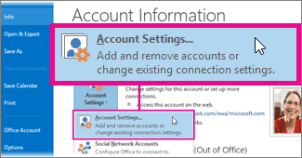

Select an Exchange account, and then click **Change**. Under **Offline Settings**, move the slider to the desired amount of time. You can change this setting at any time.

Outlook 2016 and Outlook 2013 both provide the options of 1, 3, 6, 12, or 24 months, or All. Outlook 2016 provides the additional options of 3 days, 1 week, and 2 weeks. The following table shows the default Sync Slider setting for different disk sizes.

|  |  |
| --- | --- |
| Disk size | Default |
| Smaller than or equal to 32 GB | 1 month |
| Greater than 32 GB, but smaller than 64 GB | 3 months |
| Equal to or greater than 64 GB | 1 year |

### Focus on what matters to you

We are being inundated with more information, more communication and more email vying for our attention. It is more critical than ever to have tools that help us cut through the noise and focus on what matters most. Today, Outlook is expanding the availability of two new experiences to do just that—**Focused Inbox** and **@mentions**.

#### Focused Inbox

For many, the inbox is the command center for their day. It’s the way to keep track of what is going on and what needs to get done. Outlook’s Focused Inbox makes this process easier by helping you focus on the emails that matter most to you. It separates your inbox into two tabs—Focused and Other.

Emails that matter most to you are in the Focused tab, while the rest remain easily accessible—but out of the way in the Other tab. You’ll be informed about email flowing to Other, and you can switch between tabs at any time to take a quick look.

Focused Inbox is a refinement and improvement of a previous feature called Clutter. Clutter’s purpose was also to help you focus on the most important items in your inbox, but it did so by moving “Other” email to a separate folder. Focused Inbox makes it easier for you to stay on top of incoming email without having to visit another folder. As Focused Inbox rolls out, we’ll stop moving messages to the Clutter folder.

Office 365 admins will have mailbox and tenant level control of the feature to stage the rollout in a manner that works best for their organization.

For more information, refer to: [Focused Inbox for Outlook](https://support.office.com/en-us/article/Focused-Inbox-for-Outlook-f445ad7f-02f4-4294-a82e-71d8964e3978).

#### @mentions

@mentions make collaborating on email fast and easy. Simply type the @ symbol anywhere in the body of your email and start typing to pick the person you want to address. Once you pick the person you want to address their name is highlighted in the message in blue, helping them know they are being asked to take an action in your message.

If the person isn’t part of the email conversation already, they will be automatically added to the To… line so they receive a copy of your email.

### Resources

**Microsoft Virtual Academy Courses** …

* [What’s New in Exchange Online](https://mva.microsoft.com/en-us/training-courses/whats-new-in-exchange-online-14086?l=BPLqQAunB_1500115881)
* [Manage Exchange Online Services](https://mva.microsoft.com/en-us/training-courses/manage-exchange-online-services-10596)
* [Exchange Hybrid Deployment](https://mva.microsoft.com/en-us/training-courses/exchange-hybrid-deployment-14057?l=3lGj5wnmB_3000115881)

**Read** …

For Admins

* [Security and compliance for Exchange Online](https://technet.microsoft.com/en-us/library/jj200706(v=exchg.150))
* [Exchange admin center in Exchange Online](https://technet.microsoft.com/en-us/library/jj200743(v=exchg.150))
* [Exchange Online migration performance and best practices](https://technet.microsoft.com/library/dn592150%28v=exchg.15%29.aspx)
* [Monitoring, reporting, and message tracing in Exchange Online](https://technet.microsoft.com/en-us/library/jj200725(v=exchg.150))
* [Use Office 365 tools for security investigations in Exchange Online and SharePoint Online](https://technet.microsoft.com/EN-US/library/mt219044.aspx)
* [Restrict access to email and O365 services with Microsoft Intune](https://docs.microsoft.com/en-us/intune/deploy-use/restrict-access-to-email-and-o365-services-with-microsoft-intune)
* [Restrict email access to Exchange Online and new Exchange Online Dedicated with Intune](https://docs.microsoft.com/en-us/intune/deploy-use/restrict-access-to-exchange-online-with-microsoft-intune)
* [Intune service-to-service connector](https://docs.microsoft.com/en-us/intune/deploy-use/intune-service-to-service-exchange-connector)

For Users

* [What's new in Exchange Online](https://technet.microsoft.com/en-us/library/jj200719(v=exchg.150))
* [Change how much mail to keep offline](https://support.office.com/en-us/article/Change-how-much-mail-to-keep-offline-F3A1251C-6DD5-4208-AEF9-7C8C9522D633?ui=en-US&rs=en-US&ad=US)
* [Only a subset of your Exchange mailbox items are synchronized in Outlook 2016 or 2013](https://support.microsoft.com/EN-US/kb/2733062)
* [Ways to migrate multiple email accounts to Office 365](http://go.microsoft.com/fwlink/p/?LinkID=524030)
* [Clients and mobile in Exchange Online](https://technet.microsoft.com/en-us/library/jj945871(v=exchg.150))
* [Email collaboration in Office 365](https://support.office.com/en-US/Article/Email-collaboration-in-Office-365-eb3e840f-ed60-4461-81f5-12381c132b89)
* [Focused Inbox for Outlook](https://support.office.com/en-us/article/Focused-Inbox-for-Outlook-f445ad7f-02f4-4294-a82e-71d8964e3978)

## Exchange Online Archiving (EOA)

Microsoft Exchange Online Archiving is a Microsoft Office 365 cloud-based, enterprise-class archiving solution for organizations that have deployed Microsoft Exchange Server 2013, Microsoft Exchange Server 2010 (SP2 and later), or subscribe to certain Exchange Online or Office 365 plans.

**Note: For Exchange Online customers, Exchange Online Archiving is what is referred to as “In-Place Archive” as feature in Exchange Online.**

### Features

**Archive mailbox**

* An archive mailbox is a specialized mailbox that appears alongside the users’ primary mailbox folders in Outlook or Outlook Web App.
* Users can access the archive in the same way that they access their primary mailboxes. In addition, they can search both their archives and primary mailboxes.

**Move messages to Exchange Online Archiving**

* Users can drag and drop messages from .pst files into the archive, for easy online access.
* Users can also move email items from the primary mailbox to the archive mailbox automatically, using Archive Polices, to reduce the size and improve the performance of the primary mailbox.

**Deleted item recovery**

* Users can restore items they have deleted from any email folder in their archive.
* When an item is deleted, it is kept in the archive’s Deleted Items folder. It remains there until it is manually removed by the user, or automatically removed by retention policies.
* After an item has been removed from the archive’s Deleted Items folder, the item is kept in the archive’s Recoverable Items folder for an additional 14 days before being permanently removed.
* Users can recover these items using the Recover Deleted Items feature in Microsoft Outlook or Outlook Web App.
* If a user has manually purged an item from the Recoverable Items folder, an administrator can recover the item within the same 14-day window, through a feature called Single Item Recovery.

**Retention policies**

* Helps organizations reduce the liabilities associated with email and other communications.
* Administrators can apply retention settings to specific folders in users’ inboxes.
* Administrators can also give users a menu of retention policies and let them apply the policies to specific items, conversations, or folders.
* Offers two types of policies: **archive** and **delete**. Both types can be applied to the same item or folder. For example, a user can tag an email message so that it is automatically moved to the personal archive in a specified number of days and deleted after another span of days.

**In-Place eDiscovery**

* Supports In-Place eDiscovery for searching the contents of mailboxes, primary mailboxes and archives.
* Administrators or authorized Discovery managers can search a variety of mailbox items – including email messages, attachments, calendar appointments, tasks, and contacts.

For more comprehensive information, refer to [Exchange Online Archiving Service Description](https://technet.microsoft.com/en-us/library/exchange-online-archiving-service-description.aspx).

### Scenarios

Exchange Online Archiving assists these organizations with their archiving, compliance, regulatory, and eDiscovery challenges while simplifying on-premises infrastructure, and thereby reducing costs and easing IT burdens.

* **Reduce potential liabilities**. Archive and delete emails as per business needs. Employees don’t have to create and manage multiple PST files on their devices any more
* **Reduce Risk**. Compliance search and eDiscovery gives your Legal/Compliance teams ability to search all emails
* **Drive Mobile Productivity**. Employees can search and view all their emails from Outlook, Outlook on the Web and mobile devices.

### Resources

* [Exchange Online Archiving Service Description](https://technet.microsoft.com/en-us/library/exchange-online-archiving-service-description.aspx)
* [Enable or disable archive mailboxes in Exchange Online](http://go.microsoft.com/fwlink/p/?LinkId=404425)
* [Archive mailboxes in Exchange Online](http://go.microsoft.com/fwlink/p/?LinkId=404421)
* [Retention Tags and Retention Policies](http://go.microsoft.com/fwlink/p/?LinkId=314153)
* [Enable or disable single item recovery for a mailbox](http://go.microsoft.com/fwlink/p/?LinkId=314155)
* [In-Place Hold and Litigation Hold](http://go.microsoft.com/fwlink/p/?LinkId=271746)

## Skype for Business Online (Skype)

Microsoft Skype for Business Online is a hosted communications service that **connects people anytime and from virtually anywhere**. It gives users access to presence, instant messaging, audio and video calling, rich online meetings, and extensive web conferencing capabilities.

|  |  |  |
| --- | --- | --- |
| **Skype for Business** | | |
|  |  |  |
| Enables you to | From your | With |
| * Text, call, communicate * Meet, discuss, collaborate * Connect, present, demonstrate | * Laptop * Desktop * Tablet * Phone * Skype Room System | * Colleagues * Customers * Skype contacts * Remote users |

### Features

Features given below are based on the Skype for Business Online service working together with Skype for Business client app on the user’s PC.

**Presence**

* Display presence status—for example, Available, Away, Do Not Disturb, or Offline—to let others know of your availability.
* Presence information is presented throughout the Office 365 suite.
* When Outlook calendar integration is enabled, check another user’s schedule and get up-to-date availability information directly from that person’s calendar

**Instant Messaging**

* Available for both Skype-to-Skype and multiparty communication. IM text is encrypted for enhanced security
* Within the IM window, photos of the sender/receiver appear inline with the conversation.

**Contacts List Configuration**

* Create a persistent list of contacts for all Skype for Business users
* Organize, and group these contacts in different ways (by department, for example).
* Search address books to find other users.

**Skype-to-Skype Audio and Video Calls**

* Make one-to-one computer-based audio and video calls to other Skype for Business users using a PC and a web camera.
* High-definition video (1920 x 1080) is supported for peer-to-peer calls between users running Skype for Business on high-end computers

**File Transfer**

* Provides PC-to-PC file transfer that lets users transfer files as part of a Skype for Business session

**Desktop and Application Sharing**

* Desktop sharing enables presenters to broadcast any visuals, applications, webpages, documents, software, or part of their desktops to remote participants in real time
* Audience members can follow along with mouse movements and keyboard input. Presenters can choose to share the entire screen or only a portion.
* Enables presenters to share control of software on their desktops without losing sight of participant feedback or text questions.
* Presenters can also delegate control of the application to meeting participants

**Ad-Hoc Skype for Business Meetings**

* Start or join an ad-hoc Skype for Business Meeting with just a few clicks in the Skype for Business client or in Office.
* Escalate simple instant messaging conversations or email conversations to PC-based, multiparty audio and video meetings with shared desktops, applications, and documents

**Skype for Business Multiparty Audio and Video**

* Provides for Skype for Business-based, multiparty (three or more users) audio conferencing capabilities.
* Provides users with an adaptive audio codec for optimal performance under varying bandwidth conditions, visual call and roster controls, network quality indicator, and powerful user management features
* Gallery View shows videos of participants in the conference

**Presenter Controls**

* Mute or unmute all attendees, or mute individual attendees.
* Block attendees from starting video.
* Hide names on the pictures.
* Change permissions so that all participants are attendees instead of presenters.
* Send email invitations to additional people.
* Backstage content preview if the user is a presenter

**Participant Views**

* **Gallery View** shows all the participants’ pictures, or videos, plus meeting content.
* **Speaker View** shows the presenter’s picture or video at the lower-right corner of the meeting window, plus meeting content.
* **Presentation View** shows only the meeting content.
* **Compact View** shows the tiles of the participants’ pictures in a compact window

**PowerPoint**

* Provides multiparty PowerPoint presentation, with higher-resolution displays and support for PowerPoint capabilities, such as animations, slide transitions, and embedded video.

**Web Conferencing Tools**

* Provides multiparty web conferencing capabilities including virtual whiteboard and annotations.
* Annotations made on whiteboards can be seen by all meeting participants
* Enhances collaboration by enabling meeting participants to discuss ideas, brainstorm, take notes, and so on

**Polling**

* Enhances collaboration by enabling presenters to quickly determine participants’ preferences.
* During online meetings and conversations, presenters can use polling to gather anonymous responses from participants.
* All presenters can see the results and can either hide the results or show them to all attendees

**Recording and Playback**

* Allows organizers and presenters to record all aspects of a Skype for Business session, including who entered the meeting, audio and video, and content from IM conversations, program sharing sessions, PowerPoint presentations, handouts, whiteboards, and so on.
* Organizers and presenters can choose 480p, 720p HD, or 1080p Full HD as their preferred resolution for client-side recordings.
* Recordings are saved to the presenter’s computer
* Recordings can also be uploaded to the **Office 365 Videos** service for sharing with larger audience

**Meeting Lobby**

* Decide who gets into the meeting directly, and who waits until the presenter lets them in
* Different Lobby options can be set for users who are connecting through a Skype for Business client and users who are dialing in

**Scheduled Meetings from Outlook**

* Skype for Business desktop client includes an Outlook plug-in that provides users with single-click scheduling of online meetings in Outlook.
* Participants can join with a single click from the Outlook reminder, or through the Outlook meeting itself

**Federation and Public IM Connectivity**

* External connectivity (federation) enables a Skype for Business user to connect with users in other organizations that use Skype for Business as well as those that host their own Skype for Business Server on-premises.
* Federated contacts can see presence, communicate by using IM, and make Skype-to-Skype audio and video calls

**Interoperability with Third-Party Dial-in Audio Conferencing Services**

* Dial-in audio conferencing, which is the ability to dial into a scheduled Skype for Business meeting/conference from fixed-line or mobile phones, can be achieved through interoperability with leading third-party audio conferencing services.

For more comprehensive information, refer to [Skype for Business Online Service Description](https://technet.microsoft.com/en-us/library/skype-for-business-online-service-description.aspx).

### Device Apps

You can connect with your team anywhere using clients across Windows, Mac, iOS, and Android, or bring remote participants into meeting spaces of all sizes with Skype for Business. Refer to: [Download Skype for Business across all your devices](https://products.office.com/en-IN/skype-for-business/download-app?tab=tabs-1).

Skype for Business Mac is now publicly available for [download](https://go.microsoft.com/fwlink/?linkid=829752). The Mac client offers edge-to-edge video and full immersive content sharing and viewing. The result is a great first class experience for Mac users.

#### Enhancements to Skype for Business mobile apps on Android and iOS

**Present in a meeting from your mobile app**—Now you can present content right from Android or iOS device. No more emailing files and links back and forth when you present from your phone or tablet. Now, sharing a PowerPoint deck in a meeting is as easy as selecting the file from your favorite cloud drive and presenting right from your phone. On Android, you can also share a file stored on the device itself. With swipe gestures, you can easily transition between different slides. Once shared, the PowerPoint file also becomes available in the meeting’s content bin for other participants to download or present.

**Video-based Screen Sharing for mobile devices**—We’re also continuing to enhance the content viewing experience with Skype for Business on mobile devices by using Video-based Screen Sharing (VbSS) for content viewing on iOS and Android apps. The initial setup is much faster, the experience more reliable, while also consuming network bandwidth efficiently. It provides a seamless viewing experience, especially if you are sharing animated content such as CAD models. [Learn more about VbSS and how it can enhance your meeting experience](https://technet.microsoft.com/library/mt756736.aspx).

### Scenarios

* **Meetings and calls with anyone**. Meet with up to 250 people, even if they're not on Skype for Business. All they need is a phone or internet connection.
  + Financial Sector – Bringing Relationship based and Anonymous customer contact to their web and mobile properties
  + Healthcare – Bringing remote advisory services to patients and connecting doctors around the world
  + Retail – Bringing customer advice to their web properties to upsell and increase sell through
  + Insurance and Travel – To Support brokers and customers with real time communications in the field and in branch locations
  + Recruitment Teams – Connecting Interviewers and candidates to conduct interviews
  + Employee Onboarding – Shorten the time for on-boarding by conducting online sessions for new hires even before their joining date.
* **Enable Work from home**. Home office or field-based employee can rely on the real-time collaboration technologies in Skype for Business to develop and maintain relationships as well as do their job.
* **Drive Knowledge sharing**. Empowers employees to share ideas, best practices and knowledge on processes, products, services, customers and competitors with colleagues across regions, departments and teams. These sessions can be recorded and uploaded to Office 365 Videos for those who couldn’t attend the live session.
* **Light up Mobile apps**. Enable custom Mobile apps with real time collaboration. Skype for Business can provide IM and Presence in mobile applications through APIs. Skype URI integration into mobile apps can launch first party clients for audio/video connectivity.
* **Reduce cost and complexity with one solution**. Skype for Business will work with most communications technology, so you can still make and receive calls on PBX phones and join meetings with video teleconferencing systems. You’ll also reduce the cost of supporting multiple services by upgrading to one solution that includes everything—voice, video, and online meetings.

### Resources

**Microsoft Virtual Academy Courses** …

* [Bring Your Communications to the Cloud with Skype for Business](https://mva.microsoft.com/en-us/training-courses/bring-your-communications-to-the-cloud-with-skype-for-business-13987?l=BXwAIqnmB_000115881)
* [Manage Skype for Business](https://mva.microsoft.com/en-us/training-courses/manage-skype-for-business-11046)
* [Optimize Your Network for Skype for Business](https://mva.microsoft.com/en-US/training-courses/optimize-your-network-for-skype-for-business-14082?l=13jdLComB_4300115881)
* [The Voice of Skype for Business: Cloud and Hybrid](https://mva.microsoft.com/en-US/training-courses/the-voice-of-skype-for-business-cloud-and-hybrid-14081?l=ytnkc8umB_7500115881)

**Read** …

* [What's Skype for Business?](https://support.office.com/en-US/article/What-s-Skype-for-Business-3a21eca4-434d-41f1-ab06-3d4a268573b7)
* [Add a contact in Skype for Business](https://support.office.com/en-US/article/Add-a-contact-in-Skype-for-Business-89338023-2adf-4f5c-90b6-f8b6f72fadd1)
* [Send an IM in Skype for Business](https://support.office.com/en-US/article/Send-an-IM-in-Skype-for-Business-48c07e01-c833-4c63-8505-0fda906ef33b)
* [Make and receive calls using Skype for Business](https://support.office.com/en-US/article/Make-and-receive-calls-using-Skype-for-Business-228e03aa-7361-4997-8dfa-1dd9bdc717f6)
* [Set up a Skype for Business meeting in Outlook](https://support.office.com/en-US/article/Set-up-a-Skype-for-Business-meeting-in-Outlook-b8305620-d16e-4667-989d-4a977aad6556)
* [Start using Skype for Business for IM and online meetings](https://support.office.com/en-US/article/Start-using-Skype-for-Business-for-IM-and-online-meetings-cc05afa6-1894-4a82-9dd9-6222061f50fd)
* [Share your desktop or a program in Skype for Business](https://support.office.com/en-US/article/Share-your-desktop-or-a-program-in-Skype-for-Business-2d436dc9-d092-4ef1-83f1-dd9f7a7cd3fc)
* [Skype for Business Quick Start Guides](https://docs.com/OfficeTraining/9869/skype-for-business-quick-start-guides)
* [Restrict access to Skype for Business Online with Microsoft Intune](https://docs.microsoft.com/en-us/intune/deploy-use/restrict-access-to-skype-for-business-online-with-microsoft-intune)

**Skype on iOS and Android** …

* [Skype for Business is now on iOS](https://support.office.com/en-us/article/Skype-for-Business-is-now-on-iOS-1a2cf653-955b-4329-b289-db7a67d32bfd?ui=en-US&rs=en-US&ad=US)
* [Skype for Business for iOS productivity guide](http://download.microsoft.com/download/4/6/2/46248F20-E5BE-4DA1-871F-300D01DC8331/Skype%20for%20Business%20for%20iOS%20Productivity%20Guide.docx)
* [Skype for Business for Android now available](https://blogs.office.com/2015/12/16/skype-for-business-for-android-now-available/)
* [Skype for Business for Android productivity guide](https://www.microsoft.com/download/details.aspx?id=49958)

## Skype Meeting Broadcast

Skype Meeting Broadcast enables organizations to broadcast a Skype for Business meeting on the Internet to up to 10,000 people, who can attend from a browser on nearly any device. Meeting broadcast makes it easy to host large virtual meetings like internal “Town Hall” style meetings and public webinars.

The service includes integration with [Bing Pulse](http://pulse.bing.com/), for real-time polling and sentiment tracking, and Yammer, to enable attendee dialogue during the broadcast.

### Communicate to the size of your audience

#### When to use varying types of communication?

Broadcast meetings are the perfect solution for reaching large audiences. See which modes of communication will best help you achieve your goals.

|  |  |  |
| --- | --- | --- |
| Communication type | # of people* | Use cases + benefits |
| Instant message | 2+ | Quick, informal communication and collaboration |
| Email | 2+ | Written communication that is typically longer that instant messages and is best memorialized in an email thread. |
| Phone Call | 2 | Real-time collaboration. An efficient way to get people up to speed; helps eliminate miscommunications. |
| Conference call | 3+ | Collaborative phone conversation with multiple parties in various locations. |
| Video call | 2-10 | When face-to-face communication is best for a meeting’s success, but people are in different locations. |
| Webinar | 10–250 | Presenting information to a medium-sized or largescale audience. May or may not require or allow audience participation |
| Broadcast | 250–10,000 | One-way presentation or town-hall style meeting, catered to reach a large audience in many locations |

*Based on general numbers and software; actual numbers may vary with different platforms.

#### When to meet and when to broadcast?

A typical video call or meeting can pose problems when accommodating more than a few attendees—while they’re great for one-on-one collaboration sessions, background noise, a lack of control, and scaling capabilities limit their effectiveness. A larger audience requires a more robust alternative. Consider a broadcast solution for meetings you’d hold in an auditorium, if everyone were in the same location. Online meetings are comparable to the type of meeting you’d hold in a conference room. Take a look at when a broadcast or meeting solution is best for your needs.

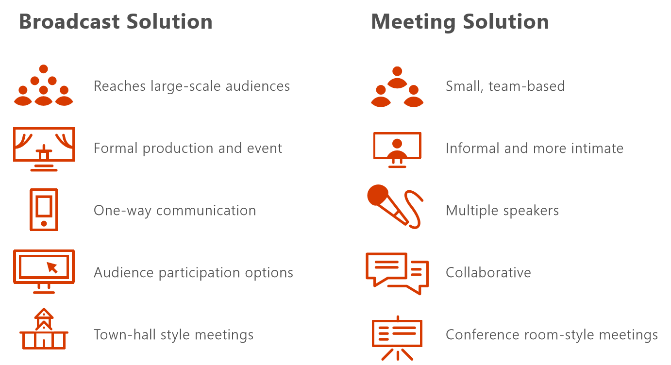

### Skype Meeting Broadcast roles

* **Organizer**. Creates the meeting request and invites attendees. Reviews meeting reports.
* **Producer**. Manages the meeting sources (live presentations, dial-in presentations, audio, video, and PowerPoint decks), records the event, and posts the recording to Office 365 Video.
* **Event team member**. Participates in the meeting by presenting live or dialing in from a remote location.
* **Attendee**. Watches the event online.

**Attendee options**

* **Anonymous**: anyone with the meeting link can join the meeting
* **Secure**: only attendees listed below can join the meeting
* **All Company**: anyone from my company can join the meeting

### Features

* **Schedule your meeting**: use the Skype Meeting Broadcast scheduling and management portal to schedule a meeting
* **Manage an Event**: Upload PowerPoint decks, cue live feeds from Camera sources, activate feeds and, switch sources during event. You can have one feed providing audio and another providing video.
* **Customize your meeting**: add a Yammer feed or Bing Pulse to your meeting so your audience can participate during the event and you can gauge their involvement and satisfaction

### Large Meeting Capabilities

|  | Skype Meeting | Skype Meeting Broadcast |
| --- | --- | --- |
| Maximum audience size | 250 | 10,000 |
| Presenter Camera A/V | **●** | **●** |
| Present a PowerPoint | **●** | **●** |
| Desktop & App Sharing | **●** | **●** |
| Attendee Camera A/V | **●** |  |
| Collaborative Apps (Whiteboard, Poll, Q&A) | **●** |  |
| Engagement Apps (Pulse, Yammer, Q&A) |  | **●** |
| PSTN Access | **●** | **●** |
| Cloud based meeting recording |  | **●** |
| Client DVR controls (ex: pause, rewind) |  | **●** |
| Branded meeting experience |  | **●** |
| Meeting Producer role |  | **●** |

### Set up Skype Meeting Broadcast

Distribution of the media content of a broadcast meeting utilizes Microsoft Azure's Content Delivery Network (CDN) to achieve very high scale, supporting thousands of people watching a broadcast. The chunked media content passing through the CDN is encrypted, and the CDN cache has a limited lifetime. Because Azure CDN is not included in the services that commit to meet the EU Standard Contractual Clauses, Skype Meeting Broadcast has been **disabled by default for all locations worldwide**.

Customers with EU Standard Contractual clauses must choose whether or not to opt into the service after reviewing the information in our communication to them. In the regions not affected by the EU Standard Contractual Clauses, the IT Admin can manually activate the Skype Meeting Broadcast feature.

To setup …

* **Enable Skype Meeting Broadcast for your organization**: You need to enable Skype Meeting Broadcast for your organization. See, [Enable your organization for Skype Meeting Broadcast](https://support.office.com/en-in/article/Enable-your-organization-for-Skype-Meeting-Broadcast-5299cce0-850e-42dc-b6ae-2d0ee775c4a9) to have us walk you through this.
* **Enable external access and setting up allowed domains**: You can use either Skype for Business admin center or the Office 365 admin center to enable external access and allow access. See, [Set up Skype Meeting Broadcast](https://support.office.com/en-in/article/Set-up-Skype-Meeting-Broadcast-dfa736b9-4920-4f48-b8c0-b5487ec6086f?ui=en-US&rs=en-IN&ad=IN) for the walkthrough

The Skype Meeting Broadcast portal can be found at **portal.broadcast.skype.com**. You can also go to **broadcast.skype.com** and go to the main Skype Meeting Broadcast page.

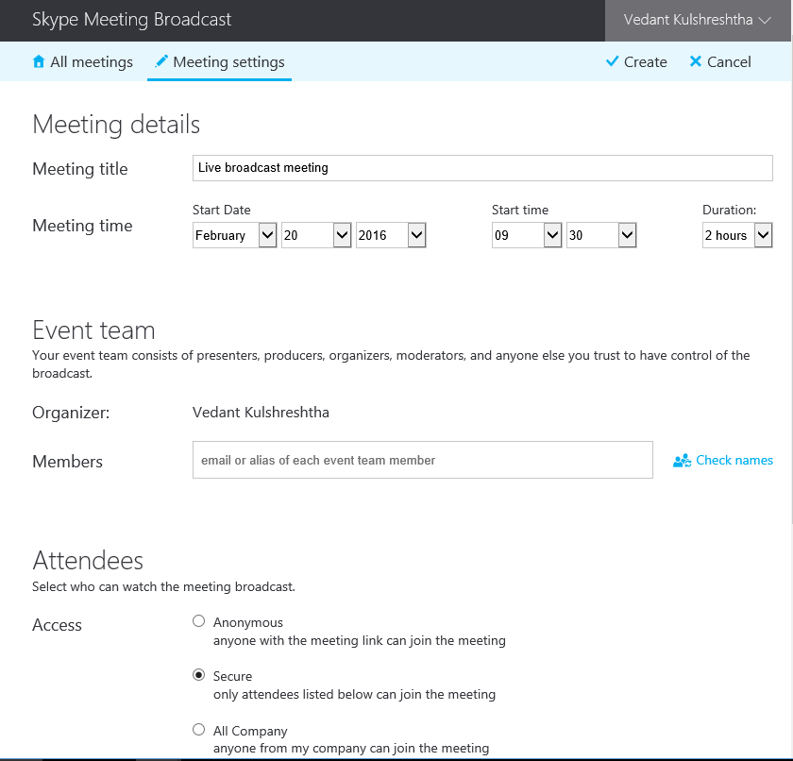

### Resources

**Watch Videos** …

* [First look at Skype Meeting Broadcast](https://www.youtube.com/watch?v=wLWpAEH2cyI) - Duration: 9 minutes, 6 seconds.

**Read** …

* [What is Skype Meeting Broadcast?](https://support.office.com/en-US/article/What-is-Skype-Meeting-Broadcast-c472c76b-21f1-4e4b-ab58-329a6c33757d)
* [Schedule a Skype Meeting Broadcast event](https://support.office.com/en-US/article/Schedule-a-Skype-Meeting-Broadcast-event-c3995bc9-4d32-4f75-a004-3bc5c477e553)
* [Manage a Skype Meeting Broadcast event](https://support.office.com/en-US/article/Manage-a-Skype-Meeting-Broadcast-event-c7b98cbe-d168-4cf4-b87f-867707b25811)
* [Join a Skype Meeting Broadcast](https://support.office.com/en-US/article/Join-a-Skype-Meeting-Broadcast-14689da0-821d-48d4-9035-ea762de80ebe)
* [Set up Skype Meeting Broadcast](https://support.office.com/en-in/article/Set-up-Skype-Meeting-Broadcast-dfa736b9-4920-4f48-b8c0-b5487ec6086f?ui=en-US&rs=en-IN&ad=IN)
* [Enable your organization for Skype Meeting Broadcast](https://support.office.com/en-in/article/Enable-your-organization-for-Skype-Meeting-Broadcast-5299cce0-850e-42dc-b6ae-2d0ee775c4a9?ui=en-US&rs=en-IN&ad=IN)

## Cloud PBX

Microsoft offers a variety of options for enabling your users to call landlines and mobile phones through the Public Switched Telephone Network (PSTN)--whether their accounts exist in Office 365 on Skype for Business Online or in your on-premises Skype for Business Server or Lync Server 2013 deployment.

**Enterprise Voice**

Enterprise Voice is Microsoft's world-class software-powered Voice over Internet Protocol (VoIP) solution, included in on-premises deployments of Skype for Business Server. Enterprise Voice offers a rich set of capabilities and features, including Response Groups, Call Park, Enhanced 9-1-1, and much more. Enterprise Voice is a full PBX system for your organization, including PSTN connectivity through your local operator

For more information about Microsoft's Enterprise Voice solutions, see: [Plan for Enterprise Voice in Skype for Business Server 2015](https://technet.microsoft.com/en-us/library/gg413081.aspx), [Deploy Enterprise Voice in Skype for Business Server 2015](https://technet.microsoft.com/en-us/library/gg412876.aspx).

**Cloud PBX**

Cloud PBX is Microsoft's technology for enabling call control and PBX capabilities in the Office 365 cloud with Skype for Business Online. Skype for Business Cloud PBX allows you to replace your existing PBX system with a set of features directly delivered from Office 365 and tightly integrated into the company’s cloud productivity experience.

With Cloud PBX, your users can use Skype for Business Online to take care of basic call control tasks, such as placing and receiving calls, transferring calls, and muting and unmuting calls. Cloud PBX users can click a name in their address book, and Skype for Business places a call to that person. To place and receive calls, Cloud PBX users can use their mobile devices, a headset with a laptop or PC, or one of many IP phones that work with Skype for Business.

To enable calls to landlines and mobile phones, Cloud PBX can be connected to the PSTN in one of two ways:

* By purchasing the **PSTN Calling service add-on** to Office 365.
* By using **on-premises PSTN connectivity**, where software on-premises connects with your existing telephony infrastructure.

**Skype for Business – Advanced Features**

|  |  |  |  |
| --- | --- | --- | --- |
| Feature | Cloud PBX | PSTN  Conf | PSTN  Calling |
| End-user call handling (answer, hold, transfer, ring) | ● |  |  |
| Setup and use call designation | ● |  |  |
| Team Calling | ● |  |  |
| Use IP Desk Phone | ● |  |  |
| Set and enforce calling policies | ● |  |  |
| Emergency calling | ● |  |  |
| Skype for Business Plus CAL | ● |  |  |
| Dial-in for Skype Meetings |  | ● |  |
| Meeting dial out to PBX/PSTN users |  | ● |  |
| Default join from PBX/PSTN phones |  | ● |  |
| Phone number assignment |  |  | ● |
| Inbound calling |  |  | ● |
| Outbound calling (domestic/int’l) |  |  | ● |

### Cloud PBX solutions

You can choose a completely-in-the-cloud offering, or you can choose a hybrid deployment that takes advantage of Cloud PBX, but keeps some functionality on premises. Depending on your needs, you can choose to have PSTN functionality provided by the Office 365 service or by your on-premises software--as shown in the following diagram

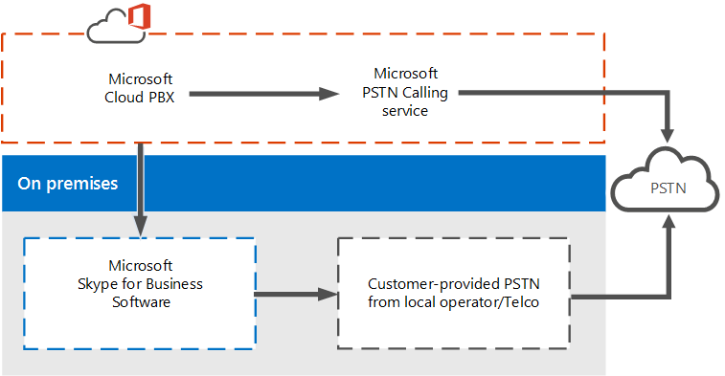

* **Cloud PBX with PSTN Calling service** – This is the service plan you can add to Cloud PBX to enable calling to landlines and mobile phones around the world (depending on the level of service being licensed). Your users are homed in the cloud and are enabled for Cloud PBX with PSTN Calling provided by Microsoft. The PSTN Calling offering is an add-on to Office 365 that does not require an on-premises server deployment.
* **Cloud PBX with on-premises PSTN connectivity** – This option uses software on premises to connect your existing PSTN carrier, circuit, and contract with Office 365. Your users are homed in the cloud and are enabled for Cloud PBX, but their calling is processed through software on premises.

#### PSTN Calling service

**PSTN Calling service** is the service that works with Cloud PBX allowing users to make calls to landlines and mobile phones. Because the PSTN Calling service operates out of Office 365, this is a completely-in-the-cloud offering that does not require an on-premises server deployment.

Users of this option are homed in Skype for Business Online in Office 365 and have access to Skype for Business Online voice services. Microsoft is the provider of both core calling and PSTN services, and can even provide or port your users' phone numbers.

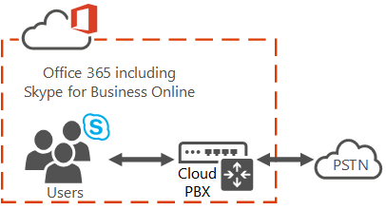

PSTN Calling service is available in specific but growing geographic locations. Please check with your Microsoft representative for availability in your area.

#### On-premises PSTN connectivity with Cloud Connector Edition

**Cloud Connector** is a set of packaged Virtual Machines (VMs) that implement on-premises PSTN connectivity with Cloud PBX. This hybrid offering is designed for organizations that want to enable their Skype for Business Online users to use their existing on-premises PSTN connection, with Skype for Business call control in the cloud.

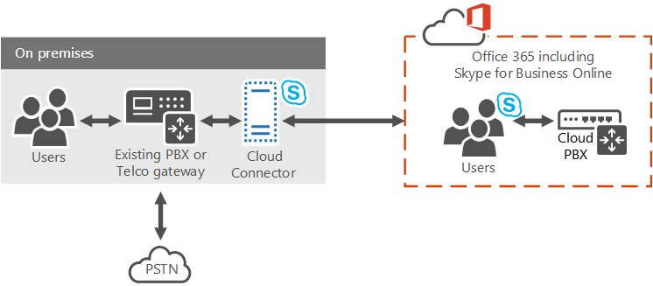

With this option, you deploy a set of packaged VMs that contain a minimal Skype for Business Server topology--consisting of an Edge component, Mediation component, and a Central Management Store (CMS) role. These services are configured for hybrid with your Office 365 tenant that includes Skype for Business Online services.

#### On-premises PSTN connectivity with an existing deployment

You can implement a hybrid solution using your existing Skype for Business Server deployment and PSTN connectivity. In this topology, users are homed in the cloud on Skype for Business Online instead of being homed on the on-premises deployment. You can choose this option if you currently have users homed in the cloud or if you want to start migrating users to the cloud.

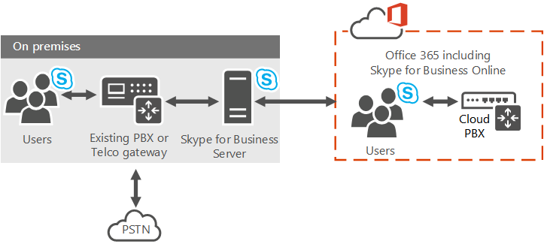

With this option, your Skype for Business Online users get their PSTN connectivity through Enterprise Voice on your on-premises Skype for Business Server deployment, with Skype for Business call control in the cloud.

### Resources

* [Plan your Cloud PBX solution in Skype for Business 2015 or Lync Server 2013](https://technet.microsoft.com/en-us/library/mt612869.aspx)
* [Plan Cloud PBX with on-premises PSTN connectivity in Skype for Business Server 2015 or Lync Server 2013](https://technet.microsoft.com/en-us/library/mt455212.aspx)
* [Deploy Cloud PBX with on-premises PSTN connectivity in Skype for Business Server 2015 or Lync Server 2013](https://technet.microsoft.com/en-us/library/mt634319.aspx)
* [Plan for Skype for Business Cloud Connector Edition](https://technet.microsoft.com/en-us/library/mt605227.aspx)
* [What is PSTN Calling?](https://support.office.com/en-us/article/What-is-PSTN-calling-3dc773b9-95e0-4448-b2f1-887c54022429?ui=en-US&rs=en-US&ad=US)
* [Plan for Skype for Business Cloud Connector Edition](https://technet.microsoft.com/en-us/library/mt605227.aspx)
* [Configure Skype for Business Cloud Connector edition](https://technet.microsoft.com/en-us/library/mt605228.aspx)

## SharePoint Online (SPO)

SharePoint is about giving you and the people you work with a **better way to get things done together**. That means your content is stored and organized in one place. You can access it from virtually anywhere and share it with anyone.

SharePoint Online delivers the powerful features of SharePoint without the associated overhead of managing the infrastructure on your own. Flexible management options ensure that you still retain the control you need to meet the compliance requirements of your organization.

### Features

**Content**

The following Content features makes Enterprise Content Management (ECM) easy for everyone. It’s the combination of traditional content management, social capabilities, and powerful search.

* **Accessibility Standards Support**: Most SharePoint user interface (UI) elements, such as links, form controls, and buttons are designed to use Microsoft Active Accessibility (MSAA).
* **Asset Library**: Library pre-configured to use special features that help users manage rich media assets, such as image, audio, and video files
* **Content Organizer**: Acts as a gatekeeper for documents. You can automatically manage some important library tasks, such as managing folder sizes and routing documents to different libraries or folders. This not only saves time, but can help make sure that a document library is managed consistently.
* **Document Sets**: Let users store, act on, export, and add a description to multiple files as a single entity. Policies, tagging, and templates can be applied to any document set that is created.
* **External Sharing: External Access**: You can use sites to share content with people outside your organization. When a site is shared in SharePoint Online, an email message is sent to the external user containing the invitation to join the site.
* **External Sharing: Guest Link**: Site users can generate a Guest Link (an anonymous link to a document) to share documents stored in SharePoint Online with external users without requiring the external user to sign in. Site users can create a Guest Link right from where the document is stored by using the “Get a link” button
* **Information Rights Management (IRM)**: IRM uses Azure Rights Management (RMS), an information protection technology in Office 365. IRM protection is applied to files at the SharePoint list and library levels.
* **Managed metadata service**: Provides multiple taxonomies and folksonomies from a tenant-level store service that can be consumed at the site collection level. Metadata fields can even be embedded in documents
* **Metadata-driven Navigation**: Makes it easier to discover content in large lists and libraries. User tagging incentives are introduced and offer anticipatory suggestions of appropriate metadata based on location and context
* **Multi-stage Disposition**: Retentions policies can have multiple stages, allowing you to specify the entire document lifecycle as one policy. For example, review contracts every year, and delete after seven years.
* **Preservation hold library**: Content that is placed on hold is preserved, but users can still change it. The state of the content at the time of preservation is recorded. If a user changes the content or even deletes it, the item is retained at the time of deletion and the original, preserved version is still available.
* **Records management**: In SharePoint, you can manage records in an archive or you can manage records in-place in the same document repository as active documents.
* **Recycle Bin (SharePoint admin center)**: SharePoint Online administrators can restore a deleted site collection by using SharePoint admin center
* **Recycle Bin (site collection)**: SharePoint users have a Recycle Bin where deleted content is stored. They can access the Recycle Bin to recover deleted documents and lists, if they need to. Items in the Recycle Bin are retained for 90 days.
* **Unique Document IDs**: Improves the managing and tracking of information by assigning a unique, human-readable identifier to every piece of content, making it easier to locate, even if the content was moved from its original location.
* **Managed navigation**: Navigation method that lets you define and maintain your site navigation by using term sets

**Insights**

The following Insights features allow organizations to use the information in databases, reports, and business applications to address their specific business needs.

* **Excel Services**: Enables you to share workbooks with others, interact with reports, view and explore information in a browser window, and refresh data.
* **Power View for Excel in SharePoint**: You can use Excel Online to view and interact with workbooks that contain Power View sheets in a browser window.
* **Power Pivot for Excel in SharePoint**: You can use Excel Online to view and interact with charts, tables, PivotChart reports and PivotTable reports in a browser window.
* **Visio Services**: Lets users share and view Microsoft Visio Drawing (*.vsdx) and Visio 2010 Web drawing (*.vdw) files using Web Browser

Also, refer to the Power BI section later in this document.

**Search**

The following Search features help people find the information that they need to do their jobs. Search is a combination of relevance, refinement, and people.

* **Advanced content processing**: To improve search relevance, the document parsing functionality in the content processing component analyzes both the structure and content of documents. Documents parsers extract useful metadata and remove redundant information.
* **Continuous crawls**: Help keep search results fresh by frequently crawling content in SharePoint sites. Continuous crawls are enabled in SharePoint Online, with crawl frequencies managed by Microsoft.
* **Deep links**: Search system automatically creates links directly to sub-sections of a main page that is frequently visited.
* **Event-based relevancy**: Determines the relevance of search results in part by how content is connected, how often an item appears in search results, and which search results people click.
* **Phonetic name matching**: Improved phonetic name matching finds search results for similar sounding names (is it John or Jon?).
* **Query rules—add promoted results**: In a query rule, specify conditions and correlated actions. When a query meets the conditions in a query rule, the search system performs the actions specified in the rule. The “Add promoted results” action lets you promote individual results so that they appear at the top of search results
* **Query rules—advanced actions**: The "Add result blocks" action lets you display a subset of the search results as a group. The "Change ranked results by changing the query" action lets you change the ranking of the returned search results
* **Query spelling correction**: Edit exclusions and inclusions lists to decide which queries the search results page should display alternative query spellings for. This feature is often called “Did you mean?”.
* **Query suggestions**: Suggested phrases that users have already searched for. The suggestions appear in a list below the Search Box as a user types a query. Query suggestions are generated automatically, and phrases can be added to the system as “always” or “never” suggest.
* **Quick preview**: Users can rest the pointer over a search result to preview and interact with the document or site content in the hover panel to the right of the result. The preview shows rich metadata and has deep links to the main sections of the document or site
* **Refiners**: Categorize the top documents in SharePoint Server search results into groups that let users filter the search results

**Sites**

* **Change the look**: Quickly customize your team site so that it’s easier to use and reflects your professional style and brand. You can change the background image, colors, site layout and fonts with just a few clicks.
* **Governance**: Important but often invisible part of any site is its governance model—the set of policies, roles, responsibilities, and processes that you establish to determine how the people in your group use SharePoint.
* **Mobile Connectivity**: You can access SharePoint sites on the go from an Internet-connected mobile phone or tablet. You can view and update documents, lists, and other site content and collaborate with colleagues, all from your mobile device.
* **Permissions Management**: Three key security elements work together to control user access to sites and site content: permissions inheritance, permission levels (sometimes known as SharePoint roles), and SharePoint groups (or SharePoint security groups).
* **SharePoint Lists**: List is a collection of data that you can share with team members and other site users. For example, you can create a sign-up sheet for an event or track team events on a calendar by using a list.
* **Drag & Drop**: Upload documents, pictures, and other types of files to your site by dragging them from your computer to a library on your site.
* **Editing text on sites**: Embed videos, cut and paste from Microsoft Word without losing your formatting, and drag and drop images into the rich text editor.
* **Notebook**: When you create a team site, a OneNote shared notebook is automatically created as part of the site. You can use this notebook to capture, compile, and share information.
* **Simplified Access**: When you share a site, you invite other people to have access to the site. You can share any site in which you have the required permissions.
* **Templates**: When you create a new site in SharePoint, you start by selecting a site template to base your site on. Site templates contain lists, libraries, pages, and other elements or features that support the needs of an organization.
* **Themes**: Quickly customize your team site so that it’s easier to use and reflects your professional style and brand. Themes are a quick and way to apply colors and fonts to sites.
* **Usage Analytics**: Web Analytics reports are pre-built reports in SharePoint that use usage data to analyze various aspects of sites and site collections.

**Social**

* **Blogs**: Enable an organization to quickly share information among employees, partners, or customers. People can add insight to a difficult subject area, provide inspiration and guidance, or explain a new guideline or procedure.
* **Document Conversations with Yammer**: Start a conversation about a document, image, or video that is stored in a SharePoint Online document library
* **One Click Sharing**: Share documents and sites with others in your organization helping promote team collaboration
* **Ratings**: Add ratings to document libraries that allow sites visitors to ‘Like’ a library document or to use a ‘star’ tool to rate it.
* **Wikis**: Site designed for groups of people to quickly capture and share ideas by creating simple pages and linking them together. Every team site is a wiki, but you can also add a separate wiki page library to a site, or create a large-scale Enterprise wiki as a separate site or site collection

**Developer**

The following features support developers who want to build apps and solutions to extend SharePoint functionality.

* **Access Services**: Build web databases and publish them to a SharePoint site. Users can use your database application in a web browser by using SharePoint permissions to determine who can see what.
* **App Catalog (SharePoint)**: Publish your apps to an internal corporate catalog to make them available to users
* **Provider-hosted Add-in**: Add-ins that include at least one remote component and may also include SharePoint-hosted components
* **SharePoint-Hosted Add-in**: Allows you to reuse common SharePoint artifacts, such as lists and Web Parts. When you take this approach, you can use only JavaScript and you cannot use any server-side code
* **Browser-based customizations**: Customize your site without any special tools or coding expertise just by using the site settings. For example, you can change the look, title, and logo, change the navigation links, change the contents of a page, or change the appearance of views for lists and libraries.
* **Developer Site**: Use an Office 365 Developer Site as a development and testing environment to shorten your setup time and start creating, testing, and deploying your apps for SharePoint.
* **JavaScript Object Model**: SharePoint provides a JavaScript object model for use in either inline script or separate .js files. It includes all the same functionality as the .NET Framework and Silverlight client object models.
* **Office 365 APIs**: Provide access to your SharePoint Online data using REST APIs. You can access the Office 365 APIs from solutions across all mobile, web, and desktop platforms
* **Remote Event Receiver**: To handle events in an app for SharePoint, developers can create remote event receivers and app event receivers. Remote event receivers handle events that occur to an item in the app, such as a list, a list item, or a web.

Also, refer to the Office 365 Application Development section later in this document.

**IT Professional**

* **Anti-malware protection**: Provides anti-malware protection for files uploaded and saved to document libraries, using the Microsoft anti-malware engine that is also integrated into Exchange.
* **Data loss prevention**: Identifies sensitive data stored in SharePoint Online. Identifying sensitive data can help you reduce risks to your organization. You can search for the sensitive information types in your organization using the eDiscovery Center.
* **Encryption at rest**: There are two levels of encryption at rest for SharePoint Online- BitLocker encryption and. Per-file encryption.
* **Minimal Download Strategy (MDS)**: Uses a single .aspx file (start.aspx) for your pages, with the actual URL encoded in the text following the hashmark (‘#’). When moving from page to page, only the changes between two compatible pages will be downloaded. Fewer bytes will be downloaded and the pages will appear more quickly.
* **SharePoint admin center**: Enables administrators to manage features such as: Site collections, User Profiles, Managed metadata and the Term Store, Records management, Search, Apps for SharePoint, External sharing, Information Rights Management and, Self-service site creation
* **Windows PowerShell Support**: Administrators can use SharePoint Online Windows PowerShell cmdlets to script and automate administrative tasks.

For more comprehensive feature list, refer to [SharePoint Online Service Description](https://technet.microsoft.com/en-us/library/sharepoint-online-service-description.aspx).

|  |
| --- |
| Keep track of monthly updates to SharePoint Online here: [What’s new in Microsoft SharePoint Online](https://support.office.com/en-us/article/What-s-new-in-Microsoft-SharePoint-Online-02449ef0-027e-4089-8717-f0ae7ea58029?ui=en-US&rs=en-US&ad=US). |

**Browser Support**

SharePoint Online supports the latest version of the Safari, Firefox, Chrome and Edge browsers, along with Internet Explorer 10 and 11. Older versions of Internet Explorer are already [out of support](https://support.microsoft.com/en-us/lifecycle#gp/Microsoft-Internet-Explorer) generally.

### Per-File Encryption

Encryption at rest includes two components: BitLocker disk-level encryption and per-file encryption of customer content.

File-level encryption at rest takes advantage of blob storage to provide for virtually unlimited storage growth and to enable unprecedented protection.

|  |
| --- |
| As part of public roadmap, **customer-controlled** SharePoint and OneDrive **encryption keys** will be available in Q1 CY2017 |

Refer to following online resources for more details:

* [File Security in Microsoft SharePoint and OneDrive for Business](https://www.microsoft.com/en-us/download/details.aspx?id=53884)
* [Enhanced conditional access controls, encryption controls and site classification in SharePoint and OneDrive](https://blogs.office.com/2016/09/26/enhanced-conditional-access-controls-encryption-controls-and-site-classification-in-sharepoint-and-onedrive/)
* Ignite video: [Learn how SharePoint safeguards your data in the cloud](https://myignite.microsoft.com/videos/1367)

### Where you can store documents in Office 365?

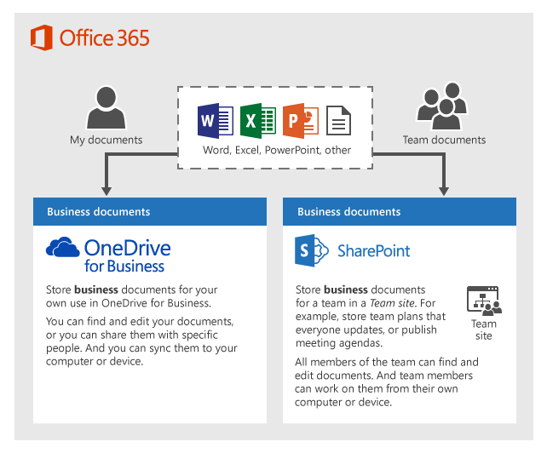

* **OneDrive for Business** is designed for individual use, with the occasional sharing of files. OneDrive for Business is ideal for storing files you own.
* **SharePoint Team site** is designed for sharing and collaborating on files regularly. A team site is ideal for storing files that have shared ownership, that is, where several people or the whole team owns the files and might collaborate on them.

Both OneDrive for Business and Team Sites provide anywhere access for you and your employees.

#### File Storage in Office 365 Groups

Office 365 Groups provide an integrated experience that link together email conversations, file storage, and calendar event management. File storage for Groups is accessed through OneDrive for Business, using a dedicated document library connected to the Group.

Use of Office 365 Groups is suggested when the team **needs File sharing in addition to shared Mailbox, Calendar and OneNote**. Simple collaboration scenarios, where a single library meets the needs, is best fit for Groups. Think of various teams working in Pre-Sales, Sales, Marketing, Accounts, Projects departments.

For content-centric enterprise applications like – Sales Portal, Knowledge Management Portal, Policy Portal etc. leverage SharePoint Online for content management.

### Governance Model

An important but often invisible part of any site is its *governance model*—the set of policies, roles, responsibilities, and processes that you establish to determine how the people in your group use SharePoint.

A governance model makes it easier to:

* Let site users know when they should create a new sub-site, as opposed to creating a list or other site content.
* Make sure sub-sites and content are retired when they’re obsolete, rather than using up your storage space and diluting your search results.
* Ensure that the right people have access to the right content.
* Let sub-site owners know what templates and themes they can use.
* Smoothly transition ownership of a site from one person to another.

#### Elements of a governance model

Your governance model needs to address the following issues:

* Site creation
* Permissions management
* Information architecture
* Site lifecycle and retirement
* Storage limits
* Classification of information
* Customization
* Data protection
* Navigation
* Search
* Roles and responsibilities for supporting the site

#### Information architecture

A site’s information architecture is like the table of contents for a book: It determines how the information in that site — its webpages, documents, lists, and data — is organized and presented to the site’s users. Information architecture is often recorded as a hierarchical list of site content, search keywords, data types, and other concepts.

To create an information architecture, you must analyze the information to be presented in the site. Here are some of the questions you can use to develop an information architecture:

* What kind of content will you have on the site? How will that translate into sub-sites, lists, libraries, and so on?
* How will information be presented in the site?
* How will site users navigate through the site?
* How will information be targeted at specific audiences?
* How will search will be configured and optimized?

Part of your information architecture might include classification of information.

If the information you’re dealing with has high value to the company, requires special security, or is covered by regulatory compliance rules, you might want to set up a classification scheme to identify specific types of content that need to be managed carefully. After you’ve organized information into specific lists and libraries, you can use governance features to manage how the content is managed.

Please refer to the article - [Best practices for creating and managing team sites](https://support.office.com/en-us/article/Best-practices-for-creating-and-managing-team-sites-95E83C3D-E1B0-4AAE-9D08-E94DCAA4942E?ui=en-US&rs=en-US&ad=US) for more information on Governance and Best Practices.

### Using SharePoint Online as a B2B Extranet solution

With SharePoint Online, partners connect directly to a members-only site in Office 365, without access to the corporate on-premises environment or any other Office 365 site. Office 365 Extranet sites can be accessed anywhere.

Industry verticals where business-to-business (B2B) collaboration is key to their business success include the automotive, manufacturing, retail and energy. The following example depicts Contoso Ltd, a company whose core of their business is collaboration with partners and vendors.

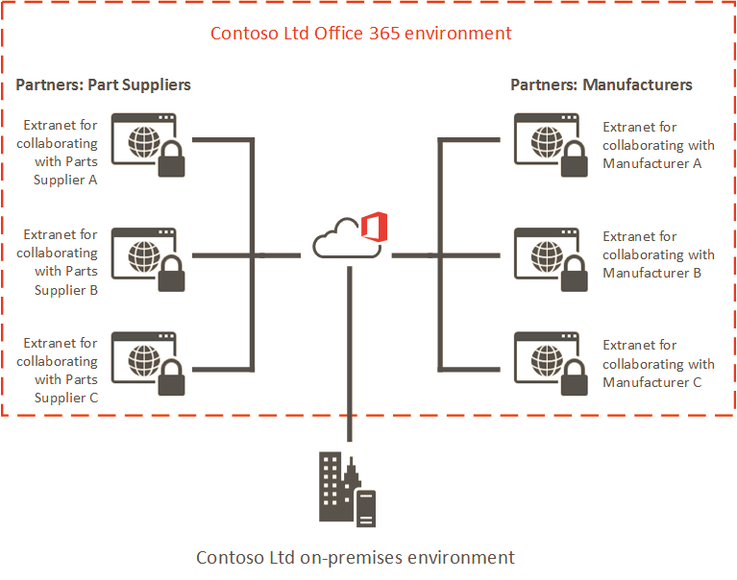

#### SharePoint Online B2B collaboration features

* **SPO Cloud B2B:** You can have both Intranet and Extranet (B2B) sites in the same SharePoint online tenant. You can allow sharing with user initiated invitations but with added IT control.
* **Site-owners only sharing:** Ability to have site collections where only Owners can bring in or share with new users. Site Members, which are typically external partner users, can see only the existing site members in the site. This helps in governing what partners can see and with whom they can share your corporate partnership documents. See [Create a partner-facing Extranet Site in Office 365](https://support.office.com/en-us/article/Create-a-partnerfacing-Extranet-Site-in-Office-365-c40d4670-7f6c-4719-9c6f-8dee36220a48) for more details.
* **Allow users to Invite new partner users:** In certain Site Collections, Admins can optionally allow users to invite new partner users. In this model, an email invite is sent to the partner user and the user must redeem that invite to access the resource. See [Manage external sharing for your SharePoint Online environment](https://support.office.com/en-us/article/Manage-external-sharing-for-your-SharePoint-Online-environment-c8a462eb-0723-4b0b-8d0a-70feafe4be85) for details.
* **Restricted Domains Sharing:** Admins can control the list of partner domains that their employees can share with outside the organization. Either an allow list of email domains or a deny list of email domains can be configured. See [Restricted Domains Sharing in O365 SharePoint Online and OneDrive for Business](https://support.office.com/en-us/article/Restricted-Domains-Sharing-in-O365-SharePoint-Online-and-OneDrive-for-Business-5d7589cd-0997-4a00-a2ba-2320ec49c4e9) more details.
* **Auditing & Reporting:** Activities of the business partner users are audited and reports can be viewed in Office 365 Activity Reports.

For more details, please refer to the support article - [SharePoint Business to Business Collaboration: Extranet for Partners with Office 365](https://support.office.com/en-us/article/SharePoint-Business-to-Business-Collaboration-Extranet-for-Partners-with-Office-365-7b087413-165a-4e94-8871-4393e0b9c037?ui=en-US&rs=en-US&ad=US).

### New and Upcoming Features

Microsoft’s vision for SharePoint Online focuses on four areas of innovation:

* [Simple and powerful file sharing](https://blogs.office.com/2016/05/04/announcing-simple-and-powerful-file-sharing-and-collaboration-for-office-365/) and collaboration on any device.
* The [mobile and intelligent intranet](https://blogs.office.com/2016/05/04/sharepoint-the-mobile-and-intelligent-intranet/), with modern team sites, publishing, and business applications on your desktop and in your pocket.
* An [open and connected platform](https://blogs.office.com/2016/05/04/the-sharepoint-framework-an-open-and-connected-platform/) that evolves SharePoint extensibility to embrace modern web development.
* Investments in [security, privacy and compliance](https://www.youtube.com/watch?v=0mvZr_Gc36U&list=PLXtHYVsvn_b-gqw2KcW0vzRyHRjnOtY-6&index=4) across Office 365.

Please refer the [blog post](https://blogs.office.com/2016/05/04/the-future-of-sharepoint/) and watch the [Microsoft Mechanics playlist](https://www.youtube.com/playlist?list=PLXtHYVsvn_b-gqw2KcW0vzRyHRjnOtY-6) to learn about great new features coming to SharePoint Online. .

#### SharePoint home page in Office 365

The SharePoint home page in Office 365 is where you can easily find and access SharePoint sites and portals within your organization. If enabled by your administrator, you can also quickly create new team sites from the SharePoint home page.

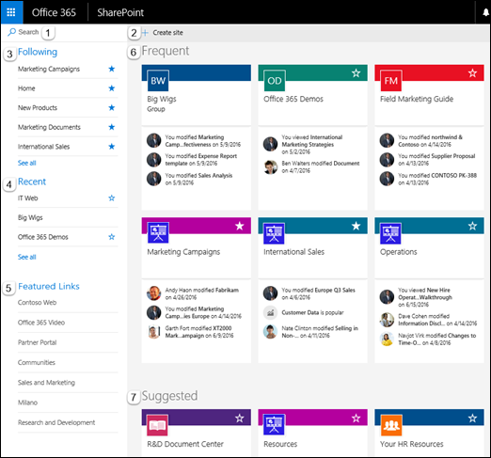

1. A search box where you can search for sites you've recently visited or files you've recently viewed or edited. You can also search for other sites, files, or people in your organization.
2. A link to start a new team site if enabled by your administrator. For help starting a new team site, see [Create a site](https://support.office.com/en-us/article/Create-a-site-ef10c1e7-15f3-42a3-98aa-b5972711777d).
3. SharePoint sites you're following.
4. Recent SharePoint sites you've visited. Clicking **See all** will take you to a page that lists all recent SharePoint sites you’ve visited.
5. Links to SharePoint sites and portals featured by your organization. If you're an Office 365 administrator, you can set which links appear in this section. For more information, see [Change the Links list on the SharePoint Home page](https://support.office.com/en-us/article/Change-the-Links-list-on-the-SharePoint-Home-page-aa93f89b-ffce-4edb-aa89-22b16d6915a7).
6. SharePoint sites you visit frequently or, if enabled by your administrator, a list of recommended SharePoint sites generated by Office Delve. In addition to the site name and link, you will also see recent activity information about the site, for example, if something on the site has been recently updated. If 12 or more sites are listed in this section, you'll see a **See all** link that, when clicked, will take you to a page that lists all of the SharePoint sites you visit frequently.
7. Suggested SharePoint sites based on recent searches or, if enabled by your administrator, a list of recommended SharePoint sites generated by Delve.

For more details, refer to the [Find sites and portals in Office 365](https://support.office.com/en-us/article/Find-sites-and-portals-in-Office-365-6b85097a-87e0-4611-a29a-dfd49b1a1220) article.

#### Modern Experiences in SharePoint Online

The modern experiences in SharePoint Online are:

* **Modern team sites**
* **Modern list and library experiences**
* **Modern site pages**

"Modern" experiences are gradually released in SharePoint Online and you can control how they are taken into use from tenant or site level. If you have a lot of existing important customizations, you can defer taking new experiences into use until needed customizations scenarios can be enabled with them as well.

#### Modern Team Site

The home page of a SharePoint Online modern team site gives you immediate visibility into site activity and important documents, with quick access to Office 365 Groups, its members and associated Office 365 apps.

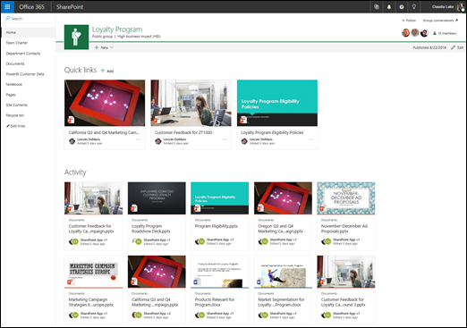

You can access your team site from the [SharePoint Home page](https://support.office.com/en-US/article/SharePoint-Home-page-6b85097a-87e0-4611-a29a-dfd49b1a1220), from the **Files** section of your Office 365 Group, or on the go with the [SharePoint mobile app](https://support.office.com/en-us/article/Getting-started-with-the-SharePoint-mobile-app-339402ce-16bb-4c97-9475-0c5375ccef7a).

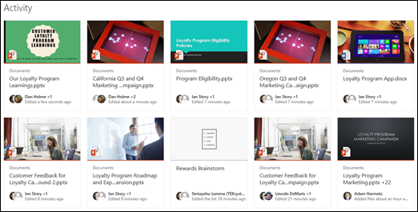

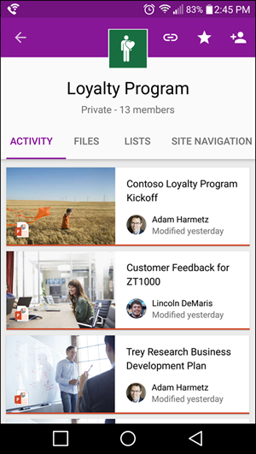

**Note:** Some functionality is introduced gradually to organizations that have opted in to the [First Release program](https://support.office.com/en-US/article/Office-365-release-options-3B3ADFA4-1777-4FF0-B606-FB8732101F47). This means that you may not yet see this feature or it may look different than what is described in the help articles.

For more details, refer to [What is a team site?](https://support.office.com/en-US/article/What-is-a-team-site-75545757-36c3-46a7-beed-0aaa74f0401e) article.

#### Team site publishing pages and new web parts

Modern team site pages are fast, easy to author and support rich multimedia content. And pages look great on any device, in a browser or from within the SharePoint app. Using pages is a great way to communicate and share your ideas—such as status and trip reports, how-to write-ups, know-before-you-go guides and frequently asked questions.

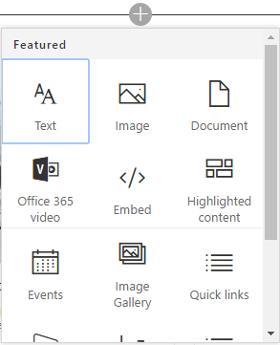

Just click the + sign and pick a web part from the toolbox to add content to your page. The new **“highlighted content” web part** lets you set criteria so that specific content will automatically and dynamically populate in that area of the page. And using the SharePoint Framework, developers can build custom web parts that will show up right in the toolbox.

#### Integration with Office 365 Groups

Office 365 Groups is a powerful and productive platform that brings together conversations and calendar from Outlook, information and files from SharePoint, tasks from Planner, and a shared OneNote notebook into a single collaboration space for your team. All new and existing Office 365 Groups get a team site.

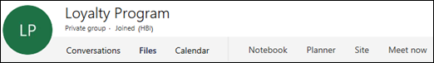

When you create an Office 365 Group in Office 365, a SharePoint team site is automatically created and any users you add to your Office 365 Group get added to the team site. All members of the Office 365 Group have access to the team site and can add additional document libraries, lists, and web apps as needed. There's no need to create a distribution list or a SharePoint group.

#### Modern document libraries

Helping people share files and collaborate on content has always been central to our mission. That’s why we’re creating a better experience for document libraries that’s faster, more intuitive and responsive.

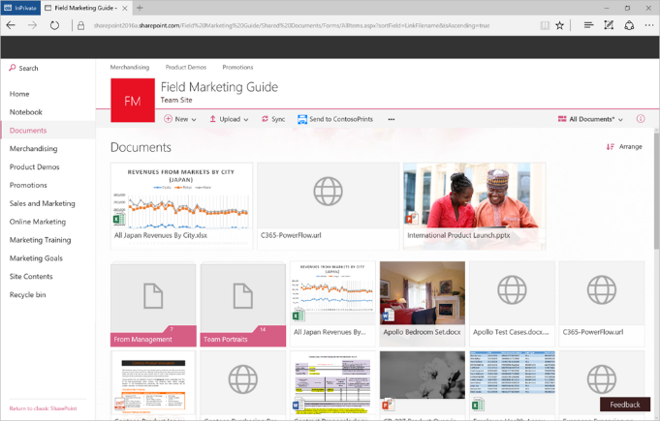

Modern document libraries have an updated user interface that offers an experience similar to OneDrive, so it’s more intuitive to create a new folder and upload files in the browser.

In a document library, you can:

* Add, [edit](https://support.office.com/en-US/article/edit-02d8497f-1c13-4114-949a-b8466f639b07), [delete](https://support.office.com/en-US/article/delete-f9f0ce3a-e0df-4d89-a99c-67f898bb320f), co-author, and download documents.
* [Control who has access](https://support.office.com/en-US/article/Control-who-has-access-02d770f3-59eb-4910-a608-5f84cc297782) to a library, a folder with in a library, or an individual file within a library.
* [Track the activity on a file](https://support.office.com/en-US/article/Track-the-activity-on-a-file-6105ecda-1dd0-4f6f-9542-102bf5c0ffe0), such as when it was last modified, and receive a notification when something has changed.
* [Create a custom view of a document library](https://support.office.com/en-US/article/Create-a-custom-view-of-a-document-library-8f6b08e0-a9a0-4232-9b9b-b374a2ad3da7)
* [Share files or folders with others](https://support.office.com/en-US/article/Share-files-or-folders-with-others-1fe37332-0f9a-4719-970e-d2578da4941c).
* [Add a link in a document library](https://support.office.com/en-US/article/Add-a-link-in-a-document-library-346b1eb9-1e71-4155-80ca-f868d058a56a) to something that is stored outside the library, for example, a link to a file located in a different library or even a link to an external web page.
* [Highlight a link, file or folder in a document library](https://support.office.com/en-US/article/Highlight-a-link-file-or-folder-in-a-document-library-9c5f46de-f0f4-4cf1-bd5e-b4ebc7a8b31c) so you and others can get to them quickly.

Mobile browsers have the same features as the desktop, making SharePoint productive for every user—whether they interact via mouse, keyboard, touch or screen reader.

Learn more about how to use modern libraries in this article: [What is a document library?](https://support.office.com/en-US/article/What-is-a-document-library-3b5976dd-65cf-4c9e-bf5a-713c10ca2872).

#### Modern Lists

We’re delivering a **modern list** experience that looks great and is responsive, accessible and easy to use on any device. The modern SharePoint list experience will be automatically available to all existing classic SharePoint Online lists.

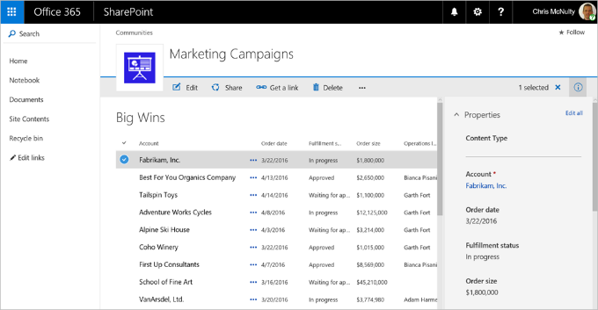

With modern SharePoint lists you can:

* Improve ease of use by empowering users to add columns to lists and sort, filter and group data in place.
* Elevate data quality by viewing and editing all item details in the information panel without leaving the list.
* Improve productivity by bulk editing list items with Quick Edit.
* Automate simple business processes with versions, approvals and alerts.
* Enrich static information with rich data types including people, images and managed metadata tags.

In addition, modern SharePoint lists look great on the **SharePoint mobile app** — making every location and every device a first-class component of business processes.

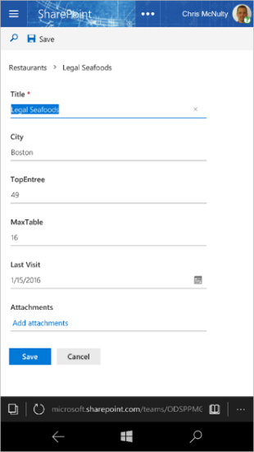

#### Integrating PowerApps and Microsoft Flow

Customers regularly exchange data between SharePoint lists and other systems to support business processes. Flow automates workflow and data exchange between SharePoint and a variety of Microsoft and third-party services. Now, you can create and launch Flows directly from a SharePoint list and store and modify that data within SharePoint.

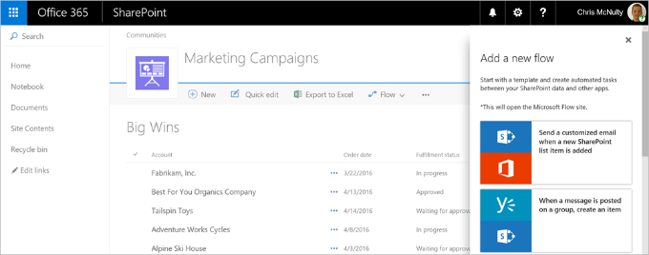

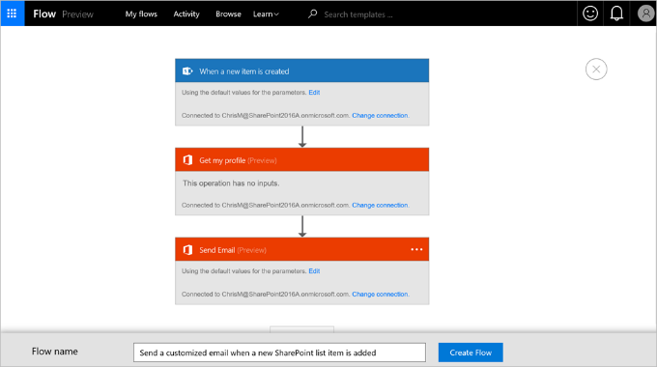

With PowerApps, you can connect, create and share business apps on any device in minutes. You can build efficient mobile forms and apps directly from a SharePoint list, without needing to write code. PowerApps and Flow share a common connector framework that allows you to weave in dozens of data sources on-premises and in the cloud, including Exchange, SQL, Dynamics, Salesforce, Google, Mail Chimp, Twitter, Wunderlist and more.

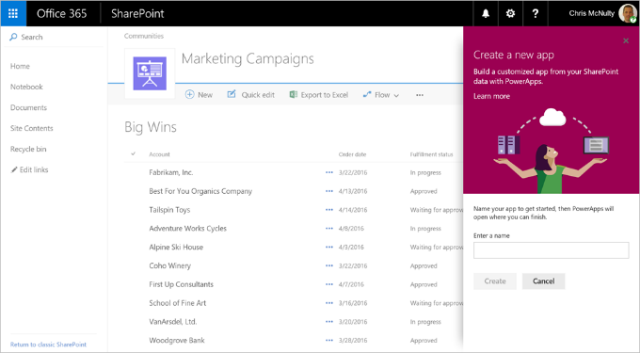

Flow and PowerApps are both currently in [public preview](https://powerapps.microsoft.com/en-us/blog/powerapps-public-preview/).

#### SharePoint Site Contents page

The new SharePoint Online Site contents page has been redesigned to help site owners, members and visitors get an immediate view into the activities within the site, like site visits and trending content. Plus, it provides clearer access to add lists, document libraries, subsites and apps.

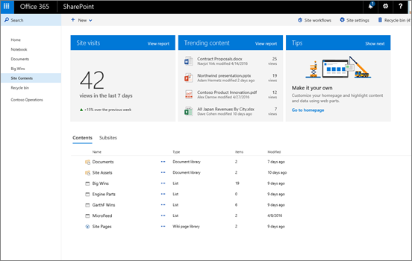

**Site visits and Trending content**

You can view the number of visits to your site within a rolling 7-day period. You can also view trending content - the most popular content on your site - over a rolling 2-week period.

**Tips**

Need help getting started creating and setting up content? Check the Tips box. You can go directly to the pages where you can set up and customize your site, lists, libraries, and more.

Refer to [The SharePoint Site Contents page](https://support.office.com/en-us/article/The-SharePoint-Site-Contents-page-ba495c1e-00f4-475d-97c7-b518d546566b) article for more information.

#### New site collection limit

As more and more teams embrace the breadth of capabilities offered in SharePoint Online across team sites, Office 365 Video and portal sites, their content storage requirements are growing. To address this, we will increase the SharePoint Online site collection storage limit in the coming weeks from 1 TB to **25 TB**. This increased limit will be immediately reflected in the official [SharePoint Online boundaries and limits](http://office.microsoft.com/en-us/office365-sharepoint-online-enterprise-help/sharepoint-online-software-boundaries-and-limits-HA102694293.aspx) article.

#### SharePoint Mobile App

The SharePoint mobile app helps keep your work moving forward by providing quick access to your team sites, organizational portals and the people you work with throughout Office 365 by letting you search for content and people across your organization. We leverage the Microsoft Graph to power several of the in-app experiences, providing you relevant information to get to the content and people you work with most frequently.

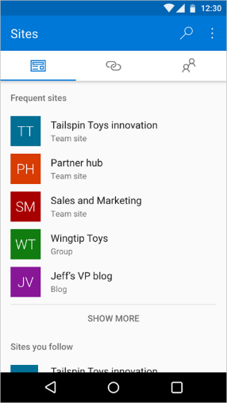 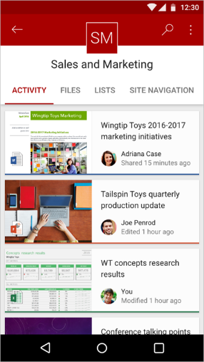

You can use the SharePoint mobile app to:

* Navigate from Sites to team sites you follow or frequently visit.
* Navigate from Links to important sites configured by your organization.
* Catch up on what’s happened with the Activity view, which shows recent file activity in your team site.
* Open your document libraries with the OneDrive app and then edit your files using Office mobile apps like Word, Excel, PowerPoint and OneNote.
* Learn more about people you work with and discover what they are working on.
* Perform an enterprise-wide search to find sites, files and people throughout your organization.
* Android first: you’ll be able to launch a PowerApp from a team site directly in the SharePoint mobile app.

Learn more about [SharePoint mobile app for iOS](https://support.office.com/en-us/article/SharePoint-mobile-app-for-iOS-339402ce-16bb-4c97-9475-0c5375ccef7a), [SharePoint mobile app for Android](https://go.microsoft.com/fwlink/p/?linkid=828159) and the [SharePoint mobile app for Windows 10 Mobile](https://go.microsoft.com/fwlink/p/?linkid=828162).

#### SharePoint Online sync preview

*Public preview* of a single sync experience for all your files in Office 365, across OneDrive and SharePoint has been announced. Please refer to the new sync options in OneDrive section later in this document.

#### Auto-acceleration for your SharePoint Online tenancy

SharePoint Online now supports home realm discovery when users log on by using third-party identity providers, such as Active Directory Federation Services (ADFS). This feature reduces logon prompts for users by "accelerating" the user through the Azure Active Directory home realm discovery logon page. This feature is called **auto-acceleration** and is applied by running a Windows PowerShell cmdlet in the SharePoint Online Management Shell.

Refer to [Enable auto-acceleration for your SharePoint Online tenancy](https://support.office.com/en-us/article/Enable-auto-acceleration-for-your-SharePoint-Online-tenancy-74985ebf-39e1-4c59-a74a-dcdfd678ef83) article for configuration details.

#### Office 365 Public CDN Developer Preview

Office 365 Public Content Delivery Network (CDN) capability in the Office 365 will enable you to automatically host static assets, like images and JavaScript files in CDN for providing better performance with SharePoint pages. CDN will work effectively as a geo-distributed caching proxy, by caching the static assets closer to the browsers requesting them.

Office 365 Public CDN is now released as a *Developer Preview* for all tenants in Office 365. You can start using it by explicitly enabling the capability on the tenant level using PowerShell cmdlets.

Refer to [Office 365 Public CDN Developer Preview Release](http://dev.office.com/blogs/office-365-public-cdn-developer-preview-release) blog post for more information.

### Scenarios

This section provides a walkthrough of some of the scenarios where SharePoint Online can be used in an Organization. In most of these scenarios, related services like OneDrive, Groups, RMS, Yammer, O365 Videos also play a role.

**Onboard new employees**

First days are stressful—for both new employees and the HR department. There’s a lot to learn and a lot to tell. SharePoint can be the single hub for everything that a new hire needs on its first day, and beyond.

You can make it easier for people to understand the business, and ramp up rapidly. You can take advantage of automatic task routing and use forms built right into your site, leading to less paperwork and faster completion.

* Onboarding Site with all the information new hires would need – Company information, Employee handbook, onboarding processes, Forms to fill and, documents to submit.
* New Hire Training material. Wikis, Videos, Documents and, links to LMS Courses/Modules
* Welcome Videos from the Leadership Team published in the New Hire Channel on O365 Videos
* Scan, OCR and Upload all the statutory documents submitted by Employees in to the Record Center. Search and retrieve as per need later
* Business Process Workflows to gather Employee information and complete joining formalities
* Yammer integration. Share content on Yammer and engage new hires in 2-way conversations

**Share your knowledge**

With SharePoint, your knowledge isn’t limited to the people in your immediate circle. SharePoint lets you share what you know with as many people as you want, whether they’re in your department or in another country.

* Knowledge Management Portal with one or more Site Collections having one or more document libraries each to store content as per the appropriate information architecture
* Assign Viewers, Members and Owners Permissions to users as per the business need
* Rights Management integration in document libraries containing sensitive documents
* Approval workflows to review the content being submitted
* Term Store hierarchies to create a Taxonomy to tag, navigate and search documents
* Retention Policies to expire/archive old content
* Show Videos published in Office 365 Videos
* Yammer integration to share the documents on Yammer for feedback, discussion and updates
* Delve powers the content discovery

**Digitize your records**

All Organizations handle a lot of paper documents – employee records, Know Your Customer (KYC) documents, legal agreements, land records, project files, purchase orders etc. Storing paper can be costly, particularly when offsite storage is required, and offers no return on investment. Retrieving paper documents is time consuming and the possibility exists that they can be misplaced.

Document digitization is the process of converting paper documents into digital format. SharePoint lets you manage these digital records securely and meet legal and compliance needs through its content encryption, retention policies, auditing and ediscovery capabilities.

Microsoft Partners provide scanning solutions integrated with SharePoint Online to support your document input lifecycle needs through scanning, OCR, barcode recognition, indexing and many more other features.

* Share and Track records. Scanning can help you share the information in those records instantly with users across multiple locations. They can eliminate the need for costly reproduction and mailing and are also easier to track electronically.
* Prepare for disasters. Scanned records can be an integral part of your disaster recovery plan. This provides extra assurance that you will be able to access the information in the records should disaster strike.
* Respond to audits and discoveries. Records are subject to audits, discovery demands, and related legal inquiries. These requests are often high-profile and extremely time sensitive. Digital records are easy to store & search and can help you quickly comply with these kinds of requests.
* Protect aging paper originals. In case of fragile paper records, scanning can offer significant benefits. Digitizing fragile records preserves the integrity of the originals by allowing them to be handled less. And often, the scanning process increases legibility of aging or hard-to-read records.
* Save money and free up office space. Storing paper records in your office is extremely costly. If you have paper records that are currently taking up space in your office, digitizing these records can save you both storage space and money.

**Boost business processes**

With SharePoint you could improve your business processes and help people save time. Automating recurring approval or review processes is easy and doesn’t take much time with built-in workflows. With Visio you can work with others to design and model processes that run in SharePoint.

* Employee Self Service Portal. Automate all employee processes like Leaves, Expense Reimbursement, Employee Benefits, Investment Declaration, Voluntary Provident Fund, LTA
* Automate IT Service requests like SmartCard, Hardware procurement, Software procurement, Software download, Installation and, Support
* Other requests like Travel, Cab, Visa, Company Letter, Employment Certificate, Salary Certificate

**Align your teams**

Deals are won and lost depending on how closely marketing and sales teams are aligned. That’s how important communication is and that’s why SharePoint gives people a better way to stay in sync.

* SharePoint site (Sales Portal) where sales representatives can access the most up-to-date marketing information, even when on the road, so that messaging is consistent.
* Sales and Marketing teams can work together, refine content and keep it up to date
* Sales Excellence team can publish Sales reports, campaigns, promotions, contests and other relevant updates
* Rights Management integration in document libraries containing sensitive documents
* O365 Video Channels to host videos on service offerings, product updates, selling it right, major announcements, how to compete and, win & loss analysis
* Yammer Groups where teams can have conversations, share ideas, share best practices, knowledge on customers, competitors, or sales processes, making it easier to act on new opportunities and close deals more quickly.

**Crunch the numbers together**

Crunching the numbers doesn’t have to be difficult. SharePoint lets you gather a lot of information from different people and different departments into a single spreadsheet or multiple. Best of all, you can work with more than one person—even your whole team if you want—on the same spreadsheet at the same time.

Crunching the numbers together doesn’t just make your life easier, but it also helps boost productivity and can lead to more insights that can be easily shared with anyone in your organization.

* Budgeting or Quota setting exercises where multiple teams need to come together and provide inputs which need analysis and discussion
* RFP Response Teams working on complex bids where multiple inputs are required from users across multiple locations – requirements, effort estimates, input costs, billing rates, quality parameters, timelines and, competitors.

**Help meet compliance needs**

Trying to make sense of all the rules, laws, and regulations you need to follow is hard enough without retrofitting your whole IT infrastructure to comply with them. You won’t run into this problem with SharePoint because it’s built to make compliance easy and straightforward.

* Digitize and preserve important Paper documents and files like land records, employee records, contracts and other legal agreements
* Automate many of the processes for managing, protecting, and preserving critical data
* Create retention schedules to manage the entire life cycle of your organization’s digital assets.
* Respond quickly to litigation or audits by using self-service eDiscovery to help get what you need immediately without involving IT.

**Provide the right support**

SharePoint and Yammer working together can help you take your IT support beyond the telephone - way beyond. Think of it as a virtual helpdesk.

* A one-stop shop where people can get in touch with IT, browse through a shared knowledge base, and submit ticket requests to get help.
* Enterprise Wiki to capture and share all the support and troubleshooting information. Quicker answers to common problems.
* Office 365 Videos channel to host videos on common tasks and self-service troubleshooting
* Yammer Groups for faster, more focused conversations between people and IT—all without ever being placed on hold.

**Other scenarios**

With its rich feature set SharePoint can help you solve lot more business problems. Some of these would require study of existing processes and applications and Organization’s vision and priorities.

* **Intranet Portal**. Corporate news, Industry News, company history, founders, leadership team, offices, CSR activities, award winners
* **Department Sites**. HR, Finance, Legal, Sales, Marketing, Travel, Quality etc. – structure, leaders, locations, useful documents, FAQs, Yammer presence, Video channels.
* **Country sites**. Travel information for employees visiting different countries. Cities, Culture, Stay, Food, Currency, Things to see, Local contacts, Helpline numbers, useful Yammer Groups and Video Channels
* **Careers website**. Career profiles, Roles in technical / non-technical streams, training opportunities, mentoring programs, soft skill programs, part-time education, work from home programs and, current openings.

### Resources

**General Information**

* [SharePoint Online Service Descriptions](http://technet.microsoft.com/en-us/library/jj819267.aspx)
* [Data Encryption in OneDrive for Business and SharePoint Online](https://technet.microsoft.com/en-us/library/dn905447.aspx)
* [Find content about SharePoint Online for Office 365 for business](https://support.office.com/en-in/article/Find-content-about-SharePoint-Online-for-Office-365-for-business-0ff4f5c6-b8b3-4d6a-be9a-99e6dcb9a3b7)
* [Should I save my documents to OneDrive for Business or a team site?](https://support.office.com/en-in/article/Should-I-save-my-documents-to-OneDrive-for-Business-or-a-team-site-d18d21a0-1f9f-4f6c-ac45-d52afa0a4a2e)
* [Set up Office 365 file storage and sharing](https://support.office.com/en-in/article/Set-up-Office-365-file-storage-and-sharing-7aa9cdc8-2245-4218-81ee-86fa7c35f1de)
* [Work with files in a document library](https://support.office.com/en-us/article/Work-with-files-in-a-document-library-a9d89171-1673-4892-9dd2-1ca52037dea2)

**Microsoft Virtual Academy (MVA) Courses**

* [The Modern Intranet Powered by SharePoint Services](https://mva.microsoft.com/en-US/training-courses/the-modern-intranet-powered-by-sharepoint-services-14059?l=NietbXLsB_9005368485)
* [Plan a Collaboration Solution Using Office 365](https://mva.microsoft.com/en-us/training-courses/plan-a-collaboration-solution-using-office-365-11048)
* [SharePoint and Office 365 Cloud-Connected Hybrid Scenarios](https://mva.microsoft.com/en-US/training-courses/sharepoint-and-office-365-cloudconnected-hybrid-scenarios-14078?l=YpspLDomB_9000115881)
* [Office Graph, Delve, and SharePoint: Better Together](https://mva.microsoft.com/en-US/training-courses/office-graph-delve-and-sharepoint-better-together-14067?l=ivGqKBomB_3400115881)
* [Transform SharePoint Customizations to SharePoint App Model](https://mva.microsoft.com/en-us/training-courses/transform-sharepoint-customizations-to-sharepoint-app-model-9087)
* [Create SharePoint Online Site Collections](https://mva.microsoft.com/en-us/training-courses/create-sharepoint-online-site-collections-11047)
* [SharePoint Online Migration Planning](https://mva.microsoft.com/en-us/training-courses/sharepoint-online-migration-planning-10526)

**Planning**

* [Plan sites and manage users](https://support.office.com/en-in/article/Plan-sites-and-manage-users-95f9eb7a-4ac8-4dd5-a883-17686cbf8fff)
* [Plan content on sites](https://support.office.com/en-in/article/Plan-content-on-sites-93f6be53-6906-4661-b952-8e36acdeb6ab)
* [Plan the content for your Team Site](https://support.office.com/en-in/article/Plan-the-content-for-your-Team-Site-6cfc059e-2c45-46d5-8d7d-507d3dace301)
* [Best practices for creating and managing team sites](https://support.office.com/en-us/article/Best-practices-for-creating-and-managing-team-sites-95E83C3D-E1B0-4AAE-9D08-E94DCAA4942E?ui=en-US&rs=en-US&ad=US)

**Performance**

* [Diagnosing performance issues with SharePoint Online](https://technet.microsoft.com/en-us/library/dn879455.aspx)
* [Navigation options for SharePoint Online](https://technet.microsoft.com/en-us/library/dn850367.aspx)
* [Using content delivery networks in SharePoint Online](https://technet.microsoft.com/en-us/library/dn850364.aspx)
* [Delay loading images and JavaScript in SharePoint Online](https://technet.microsoft.com/en-us/library/dn850359.aspx)

**Developers**

* [Customize your Office 365 team site for file storage and sharing](https://support.office.com/en-in/article/Customize-your-Office-365-team-site-for-file-storage-and-sharing-70a62f09-45ea-4968-8482-43cddfb8cc01)
* [SharePoint Add-ins](https://msdn.microsoft.com/en-us/library/fp179930.aspx)
* [Use the App Catalog to make custom business apps available for your SharePoint Online environment](https://support.office.com/en-in/article/Use-the-App-Catalog-to-make-custom-business-apps-available-for-your-SharePoint-Online-environment-0b6ab336-8b83-423f-a06b-bcc52861cba0)

Also, refer to the Office 365 Application Development section later in this document.

**Administrators**

* [Find content about the SharePoint Online admin center](https://support.office.com/en-in/article/Find-content-about-the-SharePoint-Online-admin-center-887d34fd-7c6b-4323-9e1a-4b479f2aa277)
* [Manage site collections and global settings in the SharePoint admin center](https://support.office.com/en-in/article/Manage-site-collections-and-global-settings-in-the-SharePoint-admin-center-abacd1bb-295d-4235-afdd-15f5e4cc2e6c)
* [SharePoint Online URLs or IP addresses](https://support.office.com/en-in/article/Office-365-URLs-and-IP-address-ranges-8548a211-3fe7-47cb-abb1-355ea5aa88a2?ui=en-US&rs=en-IN&ad=IN#BKMK_SPO)
* [SharePoint Online: software boundaries and limits](https://support.office.com/en-in/article/SharePoint-Online-software-boundaries-and-limits-8f34ff47-b749-408b-abc0-b605e1f6d498)
* [Introduction to the SharePoint Online Management Shell](https://support.office.com/en-in/article/Introduction-to-the-SharePoint-Online-Management-Shell-c16941c3-19b4-4710-8056-34c034493429)
* [Enable auto-acceleration for your SharePoint Online tenancy](https://support.office.com/en-us/article/Enable-auto-acceleration-for-your-SharePoint-Online-tenancy-74985ebf-39e1-4c59-a74a-dcdfd678ef83)
* [Introduction: Control user access with permissions](https://support.office.com/en-us/article/Introduction-Control-user-access-with-permissions-ab2d1ab1-07cf-4c69-bdd9-390bfd787b26)
* [Edit permissions for a list, library, or individual item](https://support.office.com/en-us/article/Edit-permissions-for-a-list-library-or-individual-item-02d770f3-59eb-4910-a608-5f84cc297782)
* [Types of files that cannot be added to a list or library](https://support.office.com/en-in/article/Types-of-files-that-cannot-be-added-to-a-list-or-library-30be234d-e551-4c2a-8de8-f8546ffbf5b3)
* [SharePoint Business to Business Collaboration: Extranet for Partners with Office 365](https://support.office.com/en-us/article/SharePoint-Business-to-Business-Collaboration-Extranet-for-Partners-with-Office-365-7b087413-165a-4e94-8871-4393e0b9c037?ui=en-US&rs=en-US&ad=US)
* [Create a partner-facing Extranet Site in Office 365](https://support.office.com/en-us/article/Create-a-partner-facing-Extranet-Site-in-Office-365-c40d4670-7f6c-4719-9c6f-8dee36220a48?ui=en-US&rs=en-US&ad=US)
* [Restricted Domains Sharing in O365 SharePoint Online and OneDrive for Business](https://support.office.com/en-us/article/Restricted-Domains-Sharing-in-O365-SharePoint-Online-and-OneDrive-for-Business-5d7589cd-0997-4a00-a2ba-2320ec49c4e9?ui=en-US&rs=en-US&ad=US)
* [Switch the default experience for lists or document libraries from new or classic](https://support.office.com/en-us/article/Switch-the-default-experience-for-lists-or-document-libraries-from-new-or-classic-66dac24b-4177-4775-bf50-3d267318caa9)
* [Restrict access to SharePoint Online with Microsoft Intune](https://docs.microsoft.com/en-us/intune/deploy-use/restrict-access-to-sharepoint-online-with-microsoft-intune)

## OneDrive for Business (OneDrive)

Store your files with the industry leader in enterprise-grade software, not a startup or consumer-focused company.

OneDrive for Business is a place where you can store, sync, and share your work files. OneDrive lets you update and share your files from anywhere and work on Office documents with others at the same time.

### Features

Save your work files to OneDrive for Business so they're always with you

* **Store**. Securely store all your files and share them with coworkers. Each user gets 1 TB of storage.
* **Sync**. Sync files across devices and access them anywhere, even when you’re offline.
* **Search**. Find the files you need in seconds with simple search. Or use Office Delve to discover new relevant content.

Get work done together with anyone at any time

* **Share**. Securely share your files with colleagues, business partners, or customers. You control who can see and edit each file.
* **Contribute**. OneDrive for Business lets you use familiar tools to create, edit, and review documents in real time and even discuss them on Yammer.
* **Manage**. Keep everyone working on the most recent version of a document, and view or restore previous versions if you need to.

### Storage plans

Office 365 customers on our premium Enterprise, Government and Education plans will receive OneDrive for Business unlimited storage. Specifically, this includes unlimited storage for individuals in organizations with more than five people subscribing to one of the following plans:

* Office 365 Enterprise E3, E4 and E5
* Office 365 Government E3, E4 and E5
* Office 365 Education
* OneDrive for Business Plan 2 and SharePoint Online Plan 2

**Note**: Customers on all other Office 365 Enterprise, Business and standalone plans that include OneDrive for Business will continue to receive 1 TB of storage per user.

### Modern Attachments

In Outlook 2016 you can easily attach documents you most recently worked on to your emails from the Insert tab. When you attach files from OneDrive for Business or SharePoint Online, you can share them as View only, or give the recipients Edit permissions, which helps them collaborate easily on one copy that everyone works on.

* **Recent items**. Outlook provides you with a list of the recent files you saved or worked with. These files could be saved locally, or they might exist on internal network locations, such as OneDrive, Group Files, and SharePoint.

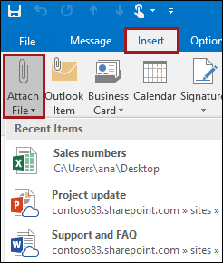

* **Browse Web Locations**. This option lets you select files from your OneDrive, SharePoint sites, or Group Files that you've accessed before.

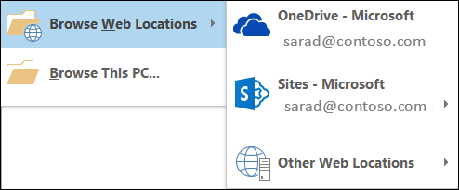

**Manage the items attached to an email**

After you've attached an item, select the drop-down menu next to the attachment to take other actions, such as Open, Remove, Print and so on.

If you've attached a file from a shared location, you can also choose:

* **Attach as copy**. If you want to send a local copy of a file, instead of the file on a shared location.

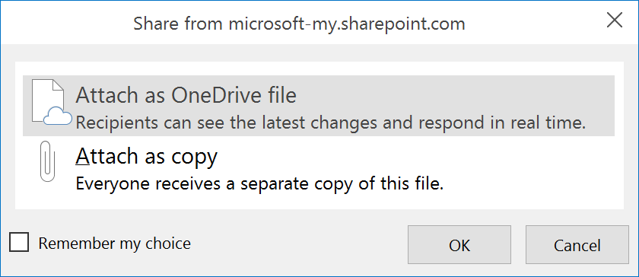

* **Change permissions**. If you want to select edit or view only permissions on a shared file

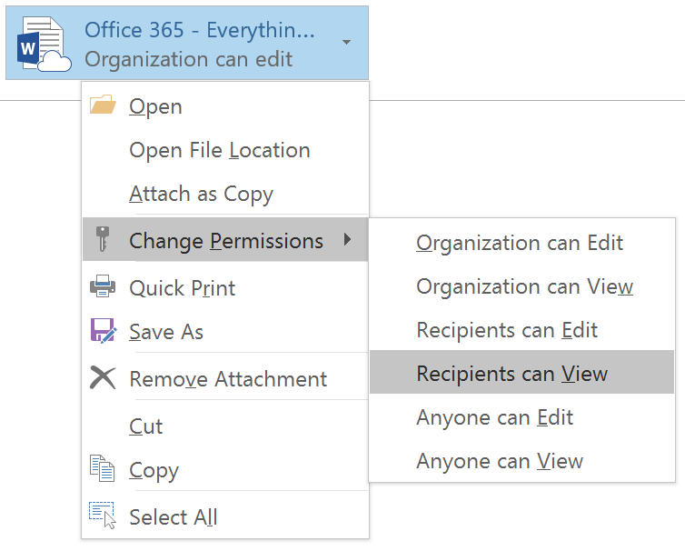

### Next Generation Sync Client for Windows and Mac

|  |
| --- |
| Office 365 ProPlus software available for download, **doesn’t include** the next generation sync client for PCs. |

**Setup Guidance**

Step-by-step guidance for IT administrators to deploy the OneDrive for Business Next Generation Sync Client to your organization is available for both [Windows](http://go.microsoft.com/fwlink/?LinkId=717731) and [Mac OS X](http://go.microsoft.com/fwlink/?LinkId=717733).

For users who want to set up Next Generation Sync Client on their own there are setup guides for [Windows](http://go.microsoft.com/fwlink/?LinkID=717725) and [Mac OS X](http://go.microsoft.com/fwlink/?LinkID=717727).

|  |
| --- |
| To block users in your tenant from syncing OneDrive for Business libraries using the old OneDrive for Business sync client (groove.exe), set the ***GrooveBlockOption*** parameter value to ***HardOptIn*** in [Set-SPOTenantSyncClientRestriction](https://technet.microsoft.com/en-us/library/dn917455.aspx) cmdlet. |

### New and Upcoming features

Information in this section is based on blog post: [Major OneDrive updates at Ignite 2016 include SharePoint Online sync preview](https://blogs.office.com/2016/09/26/sharepoint-online-sync-preview-headlines-ignite-announcements-for-onedrive/).

#### Powerful new sync options

*Public preview* of a single sync experience for all your files in Office 365, across OneDrive and SharePoint has been announced. Refer to [Get started syncing SharePoint sites with the new OneDrive sync client – Preview](https://support.office.com/en-us/article/Get-started-syncing-SharePoint-sites-with-the-new-OneDrive-sync-client-Preview-6de9ede8-5b6e-4503-80b2-6190f3354a88) article.

* SharePoint sync is being added to the OneDrive sync client, which we released last year, and offers superior levels of reliability, performance and control—including the flexibility to select the specific folders you want to take offline.

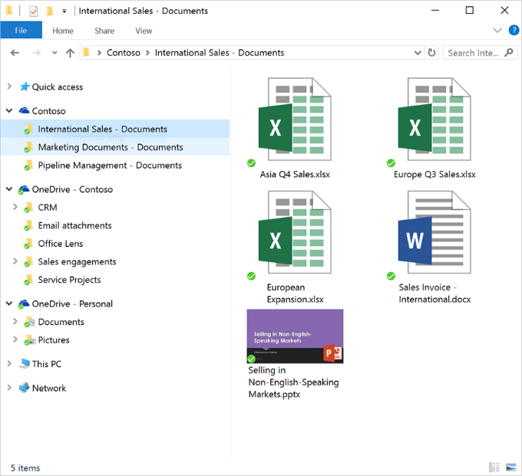

* **Shared folder sync** is another powerful capability shipping with this preview. If a colleague in your organization shares a folder with you from their OneDrive, then you can choose to take that folder offline.
* For better visibility of what is going on with your sync client, we’re rolling out the **activity center**. When a file is added, deleted or changed in a folder that you are syncing, the activity center shows you exactly what happened—so you can catch up on the most recent activity and see current sync status.

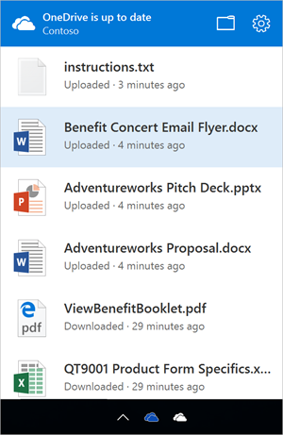

#### Better previews and thumbnails

OneDrive offers deep integration with Office Online, so you can view, edit and create Office files from any browser. There are times you want to view other types of files in the browser without downloading them. Rich previews for your most commonly used business file types are being enabled (rolling out before the end of 2016).

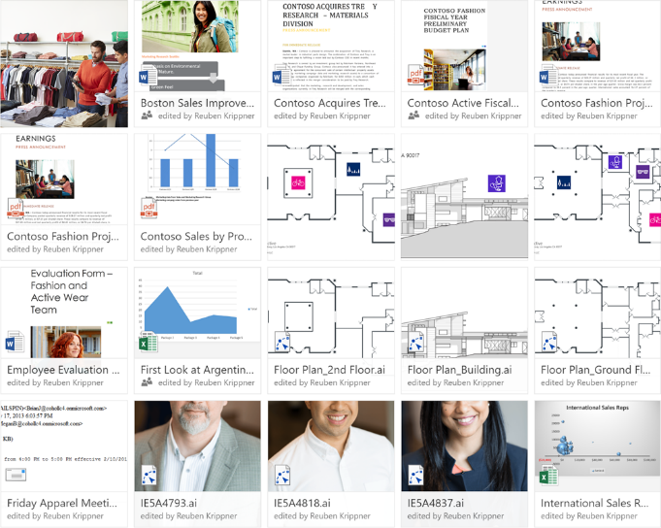

Without leaving OneDrive, you will be able to preview Adobe files, including Illustrator (.ai), Photoshop (.psd) and Encapsulated PostScript (.eps). Email files (.msg and .eml), almost all photo files (including many RAW formats) and streaming video are also supported. Additionally, most of these file types now have high resolution thumbnails in the folder’s tile view.

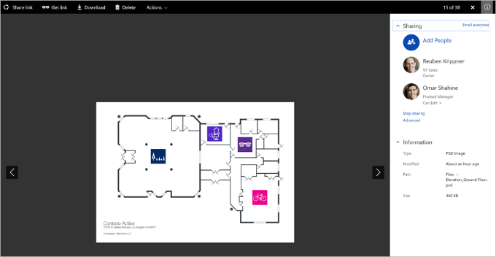

#### Access all your Office 365 files through the OneDrive browser experience

Our mission is to enable you to work with all your Office 365 files wherever you are. We’re releasing an update to the OneDrive browser experience that enables you to access, edit and share all files and folders in SharePoint Online that you own or follow. Combined with the single experience in mobile apps and sync, you have one consistent way to work with the Office 365 files you care about.

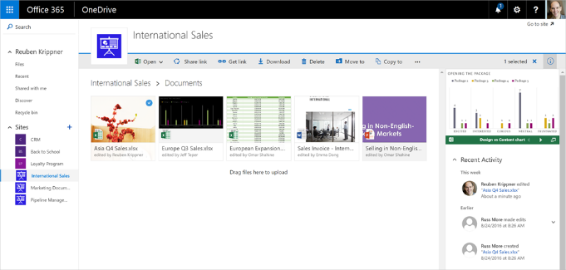

We’ll start rolling this out to First Release customers in the coming months, and rollout to all customers will be complete in the first quarter of 2017.

#### Download multiple files as a .zip file

In the OneDrive browser experience, you can select multiple files and folders and download them in a .zip file. This update is rolling out before end of 2016.

#### Keep informed with mobile notifications

For iOS or Android users, we’ve added notifications when a colleague shares a file with you. You can now open the file directly from the notification.

#### Extending the Scan function to handle multiple photos

Earlier this year we released the **Scan** function on Android, which enables you to take single photos that are then converted to PDF files and uploaded to OneDrive. We’ve now expanded this allow you to add multiple photos and combine them in the one PDF file. Now you can scan your multi-page expense receipt or extensive notes across multiple whiteboards into a single PDF that’s uploaded and stored in OneDrive.

This feature will be rolling out to iOS in the coming weeks.

#### Understand the reach and impact of your work

When you copy from OneDrive to SharePoint your file becomes accessible and discoverable by your team. On iOS, you can see over time how many people have discovered and viewed your files. This provides simple insight into the impact of your work.

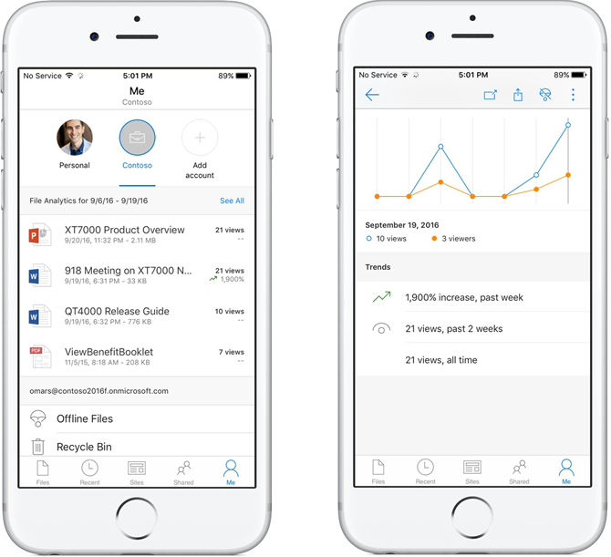

We’ll add this capability to Android and Windows in future updates.

#### New deeper Office 2016 integration

In the top right of the Office 2016 ribbon, you can see (available in First Release) the users who are currently editing the file and launch Skype for Business to converse in real-time. You can also share the file, see the history of all activity on the file as well.

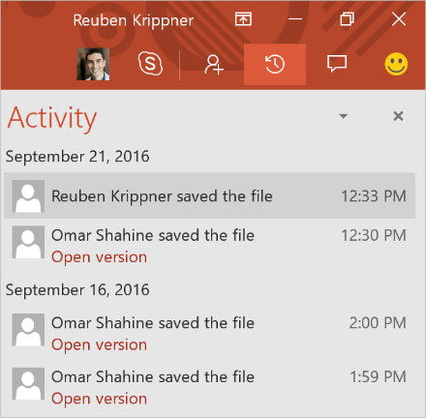

Being able to share with others and getting a snapshot of what is going on with your file without having to jump out of the Office app are big time-savers.

Additionally, when you click the File tab to open a file, you’ll notice now that in addition to having access to files you recently accessed in OneDrive and SharePoint Online, you can now also access files most recently shared with you. The result is simple: access to all the files you’re working with on any device.

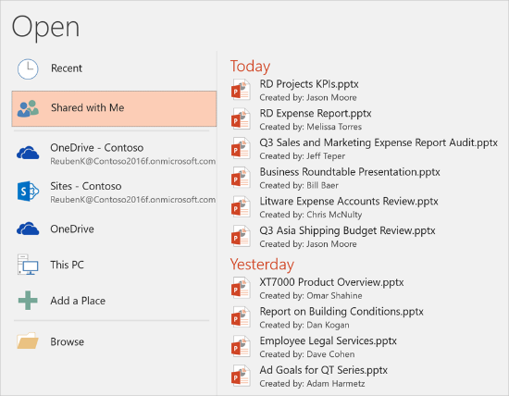

#### Per-user controls for OneDrive

We’ll add (rolling out before the end of 2016) **per-user controls for OneDrive** directly in the Office 365 User Management console. As an admin, you will be able to set the storage quota and external sharing permissions for a specific user, as well as help a user who misplaced a file or inadvertently shared the wrong file with others. In emergencies, such as a lost device, you can sign a user out of OneDrive on all devices. And, when an employee leaves the organization or is terminated, you can take over the user’s OneDrive to move or copy important files to other locations.

#### Dedicated admin console for OneDrive

This provides one place to discover and configure OneDrive-specific settings and perform administrative tasks—many of which used to require PowerShell. Once deployed to your tenant, all tenant and SharePoint admins will have permissions to access the OneDrive admin center preview at <https://admin.onedrive.com>

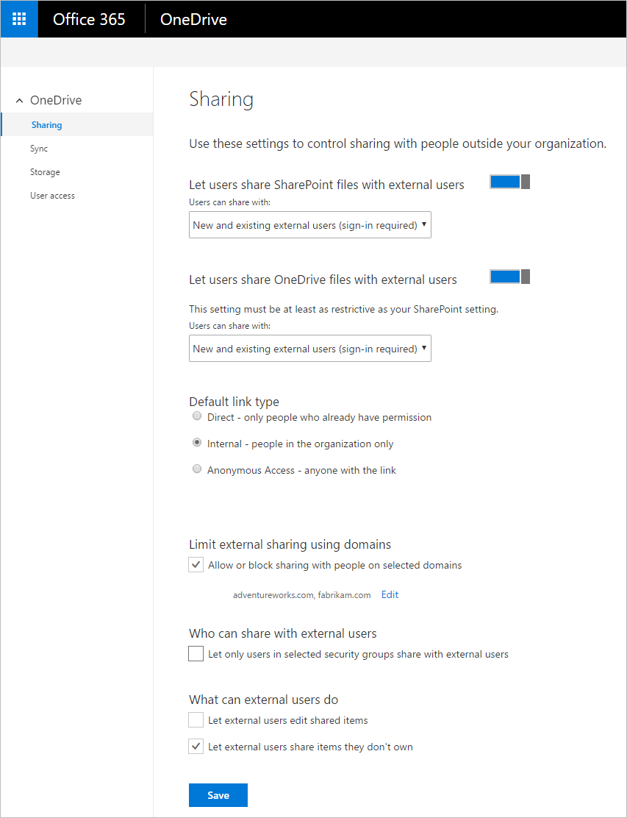

Key features by section include:

* **Home**: This is the dashboard for the admin center and will soon show recent Office 365 Message Center posts and usage reporting related to OneDrive for Business.
* **Sharing**: This section helps admins gain control over how and with whom your users are sharing information. This includes controlling the use of external sharing and anonymous links, as well as limiting which external domains users can share with.
* **Sync**: Admins can block syncing of specific file types and deny syncing to non-domain joined PCs.
* **Storage**: This section allows admins to easily set default storage limits and document retention durations.
* **Device Access**: This gives admins control over how and from where a user can access retheir files. This includes allow/deny access from personal devices or specific networks as well as rich Mobile Application Management Intune policies for iOS and Android.
* **Compliance**: Admins can find quick links to the Office 365 Security and Compliance Center for key scenarios like auditing, data loss prevention, retention, and eDiscovery.

### Options to secure OneDrive

**Control provisioning of OneDrive**

OneDrive for a user is created when they click on OneDrive tile or access the service first time. Their ability to create OneDrive site is governed by the create personal site permission in SharePoint Online. By default, the permission is assigned to all users.

If your Organization is looking for a phased rollout then you can create specific user groups and assign the create personal site permission to them.

**Enable Sync client restrictions**

SharePoint Online administrator can use PowerShell cmdlets to enable the OneDrive for Business sync client from **only** the domains present in the safe recipients list. For more information, read [Use Windows PowerShell cmdlets to enable OneDrive sync for domains that are on the safe recipients list](https://technet.microsoft.com/en-us/library/dn917452.aspx).

After that, if the version of sync client on a user’s PC is earlier than 15.0.4693.1000, sync client is considered outdated and user will not be able to sync documents.

**Configure restricted Domain sharing**

At a tenant level, administrators can configure external sharing by using either the **Allow List** or **Deny List** feature. Administrators can limit sharing invitations to a limited number of email domains by listing them in the Allow List or opt to use the Deny List, listing email domains to which users are prohibited to extend invitations.

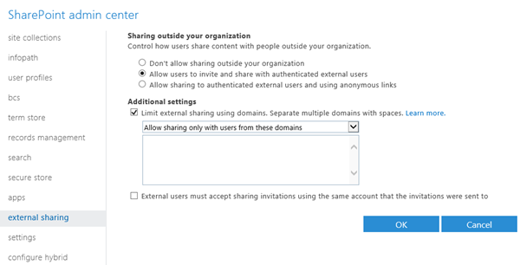

Additional parameters have been added to the PowerShell cmdlet, [Set-SPOTenant](https://technet.microsoft.com/en-us/library/fp161390.aspx), to allow configuration of restricted domains using PowerShell.

All external sharing invitation emails will blind copied to set mailboxes using *BccExternalSharingInvitations* and *BccExternalSharingInvitationsList* parameters.

**Discourage Org-wide sharing**

To discourage users from sharing files from their OneDrive with everyone in the Organization, hide “Everyone”, “All Users” and “Everyone except External Users” groups in the people picker.

The Parameters to configure in the PowerShell cmdlet - [Set-SPOTenant](https://technet.microsoft.com/en-us/library/fp161390.aspx) are *ShowAllUsersClaim*, *ShowEveryoneClaim* and *ShowEveryoneExceptExternalUsersClaim*.

**Restrict Sync based on file types**

When required, block syncing of certain file types using the new sync client. For e.g. sync of .pst and .mp4 can be blocked as all emails should in EXO mailbox and videos should be in O365 Videos service Or, just to conserve bandwidth consumption.

The Parameters to configure in the PowerShell cmdlet - [Set-SPOTenantSyncClientRestriction](https://technet.microsoft.com/en-us/library/dn917455.aspx) is *ExcludedFileExtensions*.

**Monitor User activities**

Office 365 Audit log search and Management Activity APIs enable monitoring of user activities on OneDrive and also integrate them with existing SIEM tool in your Organization. Refer to the Audit log search section later in this document.

**Configure usage or anomaly based alerts**

Office 365 Advanced Security Management enables you to set up **anomaly detection policies**, so you can be alerted to potential breaches of your network. For example, you can be alerted to impossible travel scenarios, such as if a user signs in to the service to check their mail from New York and then two minutes later is downloading a document from OneDrive in Tokyo.

Advanced Security Management also lets you set up that can track specific activities. With out-of-the-box templates like **Mass download by a single user**, IT can easily create policies that flag when someone is downloading an unusually large amount of data. Alerts can also be for multiple failed sign-in attempts or signs in from a risky IP address.

**Configure Mobile App Management (MAM) for mobiles**

Intune MAM, part of Enterprise Mobility + Security (EMS) suite, provides ability to manage OneDrive mobile app and disable user’s ability to copy-paste corporate content from their OneDrive to a non-managed/consumer app.

**Configure Conditional Access**

Azure AD Premium, part of Enterprise Mobility + Security (EMS) suite, provides **Risk-based conditional access** through an intelligent assessment of granting or blocking access to OneDrive. For e.g. access to OneDrive can be blocked is the user is using non-managed device.

**Additional Administrative settings for the sync client**

A variety of OneDrive and OneDrive for Business settings can be centrally administered through group policy. The group policy objects are available as part of the [OneDrive Deployment Package](http://go.microsoft.com/fwlink/p/?LinkId=717805).

The following User Configuration group policies are available:

* Coauthoring and in-app sharing for Office files
* Configure OneDrive.exe to receive updates after consumer production
* Prevent users from changing the location of their OneDrive folder
* Prevent users from configuring personal OneDrive accounts
* Set the default location for the OneDrive folder
* Users can choose how to handle Office files in conflict

The following Computer Configuration group policies are available:

* Prevent users from using the remote file fetch feature to access files on the computer
* Set the maximum percentage of upload bandwidth that OneDrive.exe uses

For more information, refer to [Administrative settings for the new OneDrive sync client](https://support.office.com/en-us/article/Administrative-settings-for-the-new-OneDrive-sync-client-0ecb2cf5-8882-42b3-a6e9-be6bda30899c) support article.

### OneDrive for Business usage reports

The new Office 365 Reports dashboard shows you the activity overview across the Office 365 products in your organization. The OneDrive card on the dashboard gives you a high-level view of the value you are getting from OneDrive in terms of the total number of files and storage used across all the OneDrive accounts in your organization. You can then drill into it to understand the trends of active OneDrive accounts, how many files are users interacting with as well as the storage used. It also gives you the per OneDrive account details.

You can get a view into OneDrive for Business usage by looking at the **Sites**, **Files**, and **Storage** views.

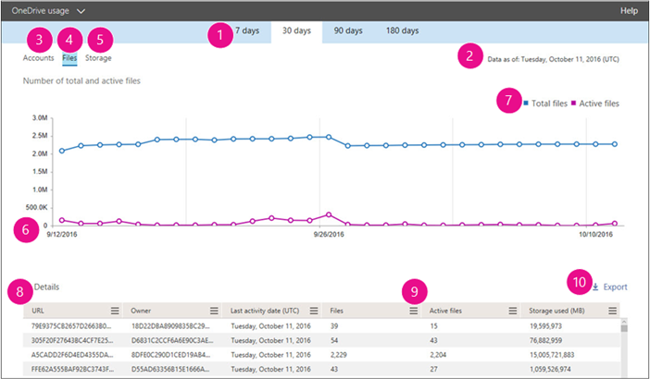

**Refer to**: [Activity Reports in the Office 365 admin center](https://support.office.com/en-us/article/Activity-Reports-in-the-Office-365-admin-center-0d6dfb17-8582-4172-a9a9-aed798150263?ui=en-US&rs=en-US&ad=US) and [Office 365 Reports in the new Admin Center - OneDrive for Business usage](https://support.office.com/en-us/article/Office-365-Reports-in-the-new-Admin-Center-OneDrive-for-Business-usage-0de3b312-c4e8-4e4b-a02d-32b2f726a680) articles for more details.

### Migrate files from on-premises OneDrive in SharePoint 2013

After you connect your SharePoint Server 2013 on-premises users to OneDrive for Business in Office 365, the first step is planning how your users will move their files to the cloud.

There are two ways in which you can plan to migrate your users’ files from their on-premises SharePoint Server 2013 OneDrive for Business document libraries to OneDrive for Business in Office 365:

* **Self-service migration**: The users select the documents they want to migrate and then move them to Office 365.
* **Tool-based migration**: The IT administrator creates or purchases a migration tool to move the content.

For more details, read the [Migrate OneDrive for Business document library files from on-premises SharePoint 2013 to Office 365](https://technet.microsoft.com/EN-US/library/dn771624.aspx) article.

### Scenarios

* Drive Personal productivity. Be Productive from anywhere and from any device.
* **Protect your critical business information**. Cloud saved files are not lost when local hard drives fail or are stolen, or if an employee leaves the company and takes the computer & files with them.

### Resources

**Watch Videos** …

* [OneDrive for Business: Sync client updates demo](https://www.youtube.com/watch?v=2Oq9PjlvLi4) - Duration: 2 minutes, 30 seconds.
* [OneDrive for Business: Demo of mobile device updates](https://www.youtube.com/watch?v=yYFi9ep81RQ) - Duration: 3 minutes, 23 seconds.
* [OneDrive for Business: Updates to web experiences](https://www.youtube.com/watch?v=GBJC0FDMygo) - Duration: 2 minutes, 58 seconds.
* [OneDrive for Business: Demo of IT control updates](https://www.youtube.com/watch?v=mIhZJrPPlWM) - Duration: 3 minutes, 19 seconds.
* [OneDrive for Business: Demo tour of updates to sync client, mobile and web](https://www.youtube.com/watch?v=NVQ9hae8pyI)
* Duration: 4 minutes, 44 seconds.[New IT management options in OneDrive for Business](https://www.youtube.com/watch?v=lJ51lx6UCL8)

**Read** …

* [File Security in Microsoft SharePoint and OneDrive for Business](https://www.microsoft.com/en-us/download/details.aspx?id=53884)
* [Manage My Site settings for SharePoint Online](https://support.office.com/en-in/article/Manage-My-Site-settings-for-SharePoint-Online-ec8c588e-28fd-4724-a8cb-85426869ce8a)
* [How user profiles are deleted in SharePoint Online and OneDrive for Business](https://support.microsoft.com/en-us/kb/3042522)
* [Attach a file to an email in Outlook 2016 for Windows](https://support.office.com/en-us/article/Attach-a-file-to-an-email-in-Outlook-2016-for-Windows-bdfafef5-792a-42b1-9a7b-84512d7de7fc)
* [Use Windows PowerShell cmdlets to enable OneDrive sync for domains that are on the safe recipients list](https://technet.microsoft.com/en-us/library/dn917452.aspx)
* [Restricted Domains Sharing in O365 SharePoint Online and OneDrive for Business](https://support.office.com/en-us/article/Restricted-Domains-Sharing-in-O365-SharePoint-Online-and-OneDrive-for-Business-5d7589cd-0997-4a00-a2ba-2320ec49c4e9?ui=en-US&rs=en-US&ad=US)
* [How to determine the version of OneDrive for Business Sync client](https://technet.microsoft.com/en-us/library/dn938436.aspx)
* [How to enumerate a domain GUID in an Active Directory forest](https://technet.microsoft.com/en-us/library/dn938435.aspx)
* [Transition from the existing OneDrive for Business sync client](https://support.office.com/en-us/article/Transition-from-the-existing-OneDrive-for-Business-sync-client-4100df3a-0c96-464f-b0a8-c20de34da6fa)
* [Deploying the OneDrive for Business Next Generation Sync Client in an enterprise environment](https://support.office.com/en-us/article/Deploying-the-OneDrive-for-Business-Next-Generation-Sync-Client-in-an-enterprise-environment-3f3a511c-30c6-404a-98bf-76f95c519668)
* [Deploying the OneDrive Next Generation Sync Client on OS X and configuring work or school accounts](https://support.office.com/en-us/article/Deploying-the-OneDrive-Next-Generation-Sync-Client-on-OS-X-and-configuring-work-or-school-accounts-eadddc4e-edc0-4982-9f50-2aef5038c307?ui=en-US&rs=en-US&ad=US)
* [Office 365 Reports in the new Admin Center - OneDrive for Business usage](https://support.office.com/en-us/article/Office-365-Reports-in-the-new-Admin-Center-OneDrive-for-Business-usage-0de3b312-c4e8-4e4b-a02d-32b2f726a680)

## Office 365 Videos

Office 365 Video is an intranet website portal where people in your organization can post and view videos. It's a streaming video service for your organization that's available with SharePoint Online in Office 365. It's a great place to share videos of executive communications or recordings of classes, meetings, presentations, or training sessions.

### Features

**Channels**

* Channel admins for Office 365 Video can create channels to organize videos.
* You can have channels for particular subjects, for example, or for specific groups such as departments or teams
* You see only the channels that you have permission to view

**Uploading videos**

* To upload a video, you upload it to a specific channel.
* You can upload multiple videos to a channel at the same time.
* Anyone in your organization who has edit permission for a particular channel can upload videos to it

**Editing information about a video**

* Providing information about a video will make it easier for other people to find it through search, and will provide additional context for it in Delve and the Office Graph
* You have to have owner or editor permission for the channel that the video is in

**Owner and people metadata**

* Office 365 Video also shows who uploaded the video and the various people who are in the video.
* This enhances the discoverability of the video and highlights the main speakers; it, too, enhances when and how your videos appear in other users’ Delve activity feeds pivoting off of the relevant context of who knows who

**Changing a thumbnail for a video**

* After a video you've uploaded to Office 365 Video has been processed and is ready to play, you can add a custom thumbnail for the video or you can choose from one of the auto-generated thumbnails provided.

**Add subtitles or captions**

* Subtitles or captions are lines of text that appear at the bottom of a video and provide a transcript of the audio portion of the video
* You can add subtitles or captions to any video by uploading one or more subtitle or caption files

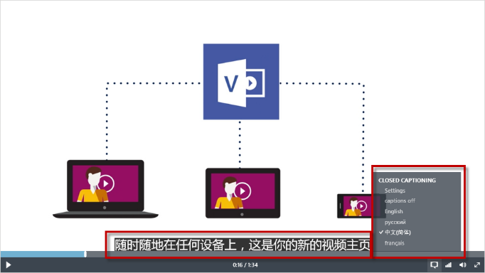

* Office 365 Video only supports the Web Video Text Track (.vtt) file format.

**Watching a video**

* You can watch videos from where they are featured on the Office 365 Video home page, and from specific channels.
* When you select a video thumbnail, the video plays right in your browser window

**Sharing videos with others**

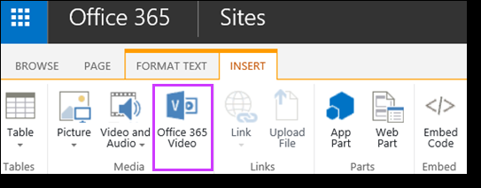

* Embed an Office 365 video on your site. You can display the video on a SharePoint Online site or other website by adding the embed code for that video to the page where you want the video to appear.
* Post to Yammer. You can post to Yammer about a video while you're watching it, and your post will automatically include a link to the video that you're watching.
* Send a link to a video in an email. To get a link for a video, select the video in Office 365 Video and then copy the URL from the browser address bar.

**Discover spotlighted channels and videos**

* Admin can spotlight up to three channels and four videos on the home page.
* Person with edit permission for a channel can spotlight up to five videos on the page for that channel.

**Find the most popular videos**

* See what videos are most popular for your entire organization, check the Trending section on the home page.
* See what videos are particularly popular in a certain channel, check the Trending section on that channel page.

**Find videos that you've uploaded**

* See what videos you've uploaded to a channel, select a channel, and then choose My Videos.

**Search for a video**

* Search for a particular video by typing what you are searching for in the Search videos box.
* Find videos that are in Office 365 Video by using SharePoint enterprise search.

**Restore a video in the Recycle Bin**

* Deleted videos sit in the Recycle Bin for 90 days, and it is now possible to recover and restore videos from the Recycle Bin.
* Admins can restore videos that have been deleted by a user

### Channel permissions

There are three types of channel permissions: owners, editors, and viewers. You must have owner permission to change permission settings.

* **Owners** - has full control over a channel. They can manage the channel from the channel settings page, upload videos, delete videos, and delete the channel.
* **Editors** - has edit permission for a channel. They can upload videos and delete videos. Then cannot manage the channel settings or delete the channel.
* **Viewers** - can view all of the videos that are in the channel. By default, everyone in your organization has viewer permission for a channel when the channel is created.

By default, only channel owners will see the download link on the player page for videos. To change who can download videos from the channel, select an option from the **Show download link for videos to** list.

### View statistics for a video

The video viewer statistics gives people insights into how their videos are being viewed—highlighting viewing spikes where shared via email and Yammer or discovered within Office Delve. It shows aggregate data on how many people have watched your video and how long they spend watching it, visualizing the drop-off rates over time.

On the Video page, next to the date when the video was uploaded, you'll see the cumulative number of video views. This information is updated every 15-20 minutes.

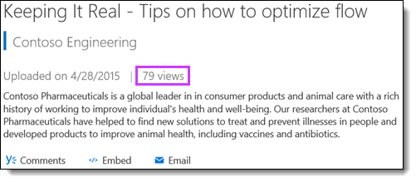

The **Statistics** link shows additional statistics for that video. The first graph shows:

* the total number of views by day for the last 14 days
* the total number of unique visitors by day for the last 14 days
* the total number of views per month for the last 36 months
* the sum of unique daily visitor counts per month for the last 36 months.

This information is updated once a day.

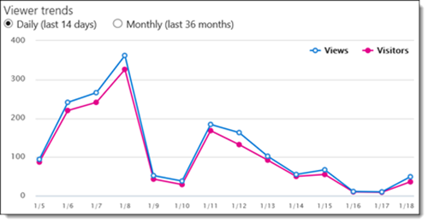

The second graph shows how viewers interacted with the video. For example, you can see which parts of your video users viewed the most or the least. The numbers on the left represent the number of times a specific section of the video was viewed. The numbers along the bottom of the graph represent 10 specific time ranges within the video and the percentage of the video that corresponds to each time range. This information is updated once a day.

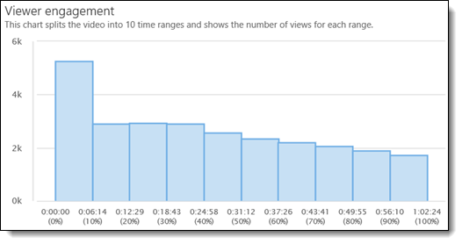

### Client Requirements

**Desktop**

| Browser | OS | Playback Supported |
| --- | --- | --- |
| Edge | Windows 10 | HTML5 |
| IE 11 | Windows 10 | HTML5 |
| IE 11 | Windows 8.1 | HTML5 |
| IE 11 | Windows 7 | Adobe Flash |
| IE 9 - 10 | Windows | Adobe Flash |
| Chrome (latest) | Windows 7+ / OSX (latest) | HTML5 |
| Firefox (latest) | Windows 7+ / OSX (latest) | HTML5 |
| Safari (latest) | OSX (latest) | Native HTML5 |

**Mobile**

| Browser | OS | Playback Supported |
| --- | --- | --- |
| IE 11 | Windows Phone 8.1 | HTML5 |
| Chrome | Android 4.4.4 | HTML5 |
| Safari | iOS 6 | Native HTML5 |

### Microsoft Stream and Office 365 Video

In July 2016, Microsoft announced the [preview of Microsoft Stream](https://stream.microsoft.com/en-us/blog/microsoft-stream-and-office-365-video/), a new business video service that makes it easier to access and discover video content inside your organization. Microsoft Stream builds upon the learnings and success of Office 365 Video, and over time the two experiences will converge, making Stream the de facto video experience in Office 365.

**There is no change for customers using Office 365 Video during the Microsoft Stream preview.** Microsoft Stream is currently in Preview but Office 365 Video is a Generally Available (GA) product.

For the immediate term, nothing changes with O365 Video. Microsoft Stream and Office 365 Video are two distinct services at this time

* If you have O365 E/A/G license use O365 Video.
* If you don't have O365 E/A/G license, now you can use Microsoft Stream Preview.

Over time, Microsoft Stream and Office 365 Video will converge into a single solution.

### Scenarios

* On-demand Trainings
* Corporate Messages
* Community knowledge sharing
* Help & How to

### Resources

**Watch Videos** …

* [Introducing Office 365 Video](https://www.youtube.com/watch?v=uXsJ_9lQubc)
* [What’s New: Office 365 Video](https://www.youtube.com/watch?v=NOaLzoCoVAY)
* [Overview of Office 365 Video and how to use it](https://www.youtube.com/watch?v=WFpRM5akYFQ)
* [What happens to a video file when you upload it into Office 365 Video?](https://www.youtube.com/watch?v=HXSZ0jYBKlM)
* [Office 365 Video - Embed Video Throughout Your Intranet](https://www.youtube.com/watch?v=43N7auV3EBk)

**Read** …

* [Meet Office 365 Video](https://support.office.com/en-in/article/Meet-Office-365-Video-ca1cc1a9-a615-46e1-b6a3-40dbd99939a6)
* [What’s new—Office 365 Video](https://blogs.office.com/2016/03/22/whats-new-office-365-video/)
* [Embed video throughout your intranet](https://blogs.office.com/2016/01/19/embed-video-throughout-your-intranet/)
* [Create and manage a channel in Office 365 Video](https://support.office.com/en-in/article/Create-and-manage-a-channel-in-Office-365-Video-1fede4cc-13c0-435a-b585-e7fbf1c83bb2)
* [Manage your Office 365 Video portal](https://support.office.com/en-in/article/Manage-your-Office-365-Video-portal-c059465b-eba9-44e1-b8c7-8ff7793ff5da)
* [Video formats that work in Office 365 Video](https://support.office.com/en-in/article/Video-formats-that-work-in-Office-365-Video-dd1af01c-fd8e-4640-b17b-93ee02b9b817)
* [Embed a video from Office 365 Video](https://support.office.com/en-us/article/Embed-a-video-from-Office-365-Video-59e19984-c34e-4be8-889b-f6fa93910581?ui=en-US&rs=en-IN&ad=IN)
* [Add subtitles or captions to a video in Office 365 Video](https://support.office.com/en-us/article/Add-subtitles-or-captions-to-a-video-in-Office-365-Video-06eb120d-0f3f-4865-99c8-3d1bea577984?ui=en-US&rs=en-IN&ad=IN)
* [View statistics for a video in Office 365 Video](https://support.office.com/en-us/article/View-statistics-for-a-video-in-Office-365-Video-46819666-2b24-4220-882d-aeceaf10a745?ui=en-US&rs=en-IN&ad=IN)
* [Video REST API reference](https://msdn.microsoft.com/office/office365/APi/video-rest-operations)
* [Office 365 Video networking Frequently Asked Questions (FAQ)](https://support.office.com/en-in/article/Office-365-Video-networking-Frequently-Asked-Questions-FAQ-2bed67a1-4052-49ff-a4ce-b7e6530eb98e?ui=en-US&rs=en-IN&ad=IN)

## Yammer

Companies looking to become more agile and customer-focused need to move beyond traditional centralized models to a more interconnected, flexible way of working.

**Yammer offers a smarter, faster way to connect and collaborate across a company.** Yammer’s open, flexible workspaces are ideal for cross-company collaboration. With Yammer, individuals and teams at a company can:

* Share and collaborate with the right people inside and outside the organization
* Tap into knowledge across an organization
* Connect and engage everyone
* Work seamlessly with Office

By creating a dynamic network of people and knowledge across a company, Yammer enables employees to respond faster, accomplish more, and keep the business moving forward together.

### Features

* **Groups**: From departmental communications to your next campaign launch or company event, set up a Group in seconds for any team, project or interest.
* **Related Groups**: You can add and prioritize groups related to the ones you’ve already joined so coworkers can discover even more relevant people, content, and conversations.
* **Announcements**: Share an announcement with a group to instantly notify members of important updates. Administrators can pin Announcements to a group for easy discovery
* **User Profiles**: Upload a picture, fill in contact details and list your expertise. Profiles aggregate all your information, including conversations and files.
* **Expertise**: Reach across the company to find the experts you need. Because Expertise is instantly searchable, useful information can be found on demand.
* **Praise**: Give and receive recognition for a job well done. Accomplishments and badges appear on profiles in the Praise tab.
* **Publisher**: Use the publisher to share an update, add a document, post a poll, or praise someone.
* **@Mention**: Notify other coworkers and loop them into a conversation by @mentioning their name.
* **Private Messages**: Start a private dialogue with one or more coworkers. You can add more participants at any time.
* **Share Conversations**: Share conversations to another group’s feed or via a private message to relay information and important messages.
* **Office Online support**: With Office Online support in Yammer, documents uploaded to Yammer can be viewed/edited with Office Online.
* **Polls**: Easily create a poll to survey coworkers and gather feedback from others to inform your decision-making
* **Files**: Share Microsoft Office documents, PDFs, images and videos across teams and get feedback right away.
* **Notes**: Draft content, collect notes and create wikis with your team members right inside Yammer and see character-by-character changes in real time.
* **Email a File**: Easily and securely email documents directly from your team workspace. Provide access to a file or Note with a secure, one-time URL and revoke viewing rights at any time.
* **Official Content**: Mark files and Notes as official and read-only. Official Content appears higher in search results and content directories for easy access
* **Inbox**: Inbox automatically aggregates your @mentions, group announcements, conversations and private messages so you can easily prioritize responses.
* **Feeds**: Stay on top of relevant conversations, files and projects happening across the company. Feeds let you quickly engage in conversations, @mention coworkers to loop them into a discussion and preview documents.
* **Recent Activity**: Discover what your coworkers are working on as it happens. Ticker shows you activity stories happening in real time, including page edits, file uploads and updates made in other business applications.
* **Topics**: Tag content with topics to help others quickly find related messages, files, Notes and more by adding a hashtag (#) before the word or by searching for existing topics.
* **Universal Search**: Full-text search lets you quickly find files, Notes, conversations, people and data across your Yammer network and integrated business apps.
* **External Networks**: Create a dedicated online workspace to collaborate with business contacts outside of your company’s Yammer network.
* **Fast Network Switching**: Seamlessly switch between internal and external networks. Easily monitor conversations within external networks and immediately share insights with your company’s internal network
* **Embeddable Feeds**: simple code snippet lets you easily embed any Yammer feed into your business application.
* **Like and Follow Buttons**: Add Like and Follow buttons to your business applications so employees can engage with objects outside of Yammer.
* **Data Export**: Manage and export network data according to company policies with a single click. You can also schedule daily or weekly data exports to meet legal and regulatory compliance requirements.
* **Keyword Monitoring**: Monitor keywords to track sensitive content. When a user posts a message that includes a monitored keyword or phrase, all Verified Admins are notified.
* **Analytics**: Gain insights from network analytics to find out how employees are using Yammer. From usage metrics to member statistics, identify ways to drive growth and increase the value of your network.
* **Usage Policy**: Set a custom usage policy for your company's network and require users to accept it.

For a more comprehensive information, refer to the [Yammer Service Description](https://technet.microsoft.com/en-us/library/yammer-service-description.aspx) online.

### New and upcoming updates

#### Standards Compliance

As part of the Office 365 Trust Center, Yammer complies with international and regional standards such as the Office 365 Data Processing Agreement with European Union Model Clauses (DPA with EUMC), Health Insurance Portability and Accountability Office 365 Business Associate Agreement (HIPAA BAA), ISO 27001, ISO 27018, Section 508 for web accessibility, and SSAE 16 SOC 1 and SOC 2 reports.

#### Yammer External Groups

The new **external groups** feature in Yammer enables you to include people outside your company in a Yammer group—making it easier for extended teams to work together. The external groups capability builds on the existing ways to work with people outside your company, such as [external networks](https://blogs.office.com/2011/06/21/communities-overview/) and [external messaging](https://support.office.com/en-us/article/External-messaging-FAQ-Yammer-35b59d6c-bb1c-4541-bf19-9f67d2f2b199), which enables you to add people outside your organization directly to a thread in your organization’s Yammer network.

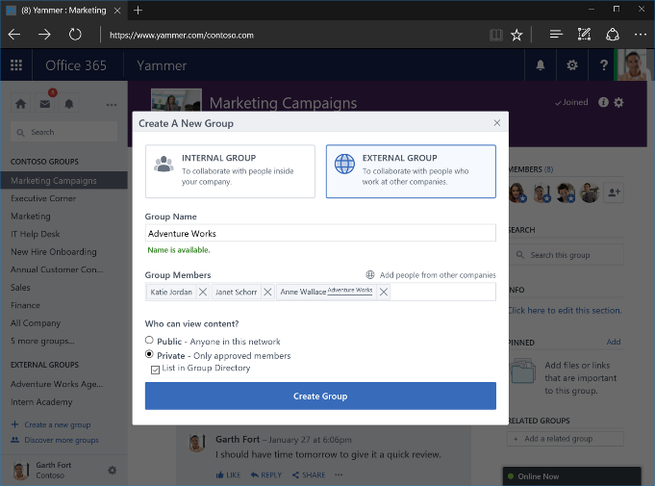

External groups allow team members with appropriate permissions from outside your organization to fully participate in projects and initiatives by providing access to all the conversations and content in the group.

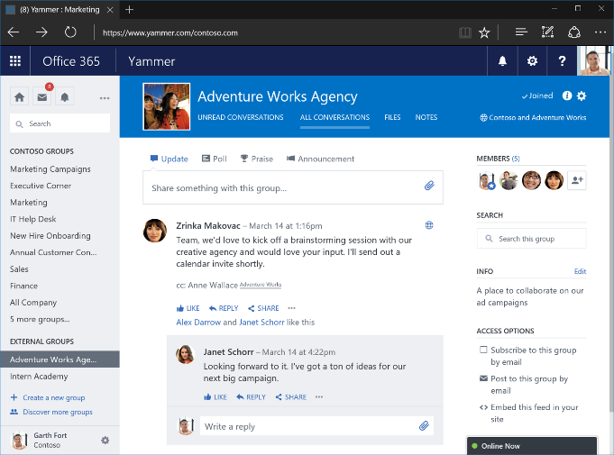

At the same time, we maintain the security of your network data by listing all external groups in a distinct section under the Groups menu and using clear indicators in the UI alerting users to the presence of external team members.

Refer to [Introducing Yammer external groups](https://blogs.office.com/2016/04/26/introducing-yammer-external-groups/) post for more details and learn more about how to [create and manage external groups in Yammer](https://support.office.com/en-us/article/Create-and-manage-external-groups-in-Yammer-9ccd15ce-0efc-4dc1-81bc-4a424ab6f92a?ui=en-US&rs=en-US&ad=US).

#### Intune MAM Support

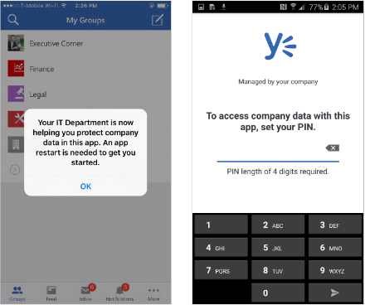

Yammer apps for iOS and Android were updated to allow IT administrators to protect their corporate data using mobile application management (MAM) controls in [Microsoft Intune](https://www.microsoft.com/en-us/cloud-platform/microsoft-intune). Refer to blog post - [Yammer App with Intune MAM – now available!](https://blogs.technet.microsoft.com/enterprisemobility/2016/08/11/yammer-app-with-intune-mam-now-available/) for more details.

#### Integration with Office 365 Audit Log

Over the coming weeks, you will be able to view Yammer events on users, groups, files, admins and network settings through the Office 365 Management Activity API and in the Office 365 Security & Compliance center. This will give you the ability to access and monitor various security and compliance-relevant Yammer events for your organization. The operations that you can search include the following categories:

* **Users**—including activating, suspending, and deleting a user.
* **Groups**—including creating, adding a member and deleting a group.
* **Files**—including creating, viewing, and deleting a file.
* **Admins**—including exporting data, triggering private content mode and forcing all users to log out.
* **Network settings**—including changing network usage policy and changing data retention policy.

Refer to [Yammer bolsters security and compliance with new auditing and reporting capabilities](https://blogs.office.com/2016/10/13/yammer-bolsters-security-and-compliance-with-new-auditing-and-reporting-capabilities/) and [Yammer Events are included in the Office 365 Audit log and Management Activity API](https://support.office.com/en-us/article/Yammer-Events-are-included-in-the-Office-365-Audit-log-and-Management-Activity-API-ce0a68ef-9731-4891-8c6b-6882988e727d) for more details.

#### Integration with Office 365 Groups

Yammer is integrating with Office 365 Groups, bringing together the power of open collaboration with the productivity tools millions rely on every day. With this integration, Yammer users can easily turn ideas into action with access to SharePoint sites and document repositories, a shared OneNote notebook, and lightweight task management with Planner. These new experiences and more will be **rolling out in phases over the coming months**.

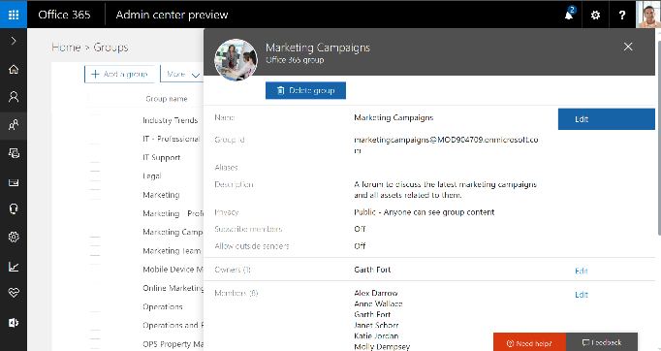

Yammer is now connected to the Office 365 Groups service, so all group properties, including name, description, profile picture, membership and public/private setting, are available in both Yammer and Azure AD, where Office 365 groups are stored. Admins can also centrally manage groups in the Office 365 admin center and apply PowerShell scripts to them to **simplify bulk updates**.

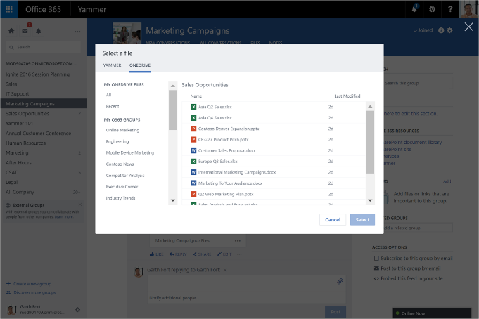

Uses can quickly share files in Yammer by uploading documents from a personal OneDrive, OneDrive for Business or SharePoint site using **the new Yammer file picker**.

Additionally, teams working within Yammer can now take advantage of a SharePoint document library, making it easy to manage files, apply workflow, review version history and comply with document retention policies. Each team also gets a SharePoint site, which gives members the ability to create structured content like wikis and blogs.

|  |
| --- |
| To avoid fragmenting team conversations, Office 365 Groups will provide either conversations in Yammer or conversations in Outlook. Office 365 Groups created in Yammer will have conversations in Yammer. Office 365 Groups created elsewhere in the suite will have conversations in Outlook. |

Refer to blog posts – [Now you can create and share Office documents while collaborating in Yammer](https://blogs.office.com/2016/10/07/now-you-can-create-and-share-office-documents-while-collaborating-in-yammer/) and [Yammer strengthens team collaboration through integration with Office 365 Groups](https://blogs.office.com/2016/09/26/yammer-strengthens-team-collaboration-through-integration-with-office-365-groups/) for more details.

### Scenarios

#### How organizations use Yammer

Here are some of the ways that organizations benefit from Yammer.

* **Centralize teams and projects.** Simplify collaboration by providing teams and projects flexible workspaces that allow them to communicate, share files, and find resources in one place.
* **Promote knowledge sharing**. Improve decision-making and reduce duplicate work by using Yammer to tap into knowledge across the organization and build on the work of others.
* **Foster innovation**. Foster innovation by connecting employees, ideas, and information without regard for time zones, geographies, or hierarchies
* **Support remote/mobile workers.** Identify and resolve problems with the customer experience by giving employees on the front line an efficient way to communicate with headquarters and supporting teams.
* **Improve internal communications.** Improve the effectiveness of the corporate communications strategy by connecting employees to executives, groups, and feedback.
* **Expand external collaboration.** Extend collaboration to customers, partners, and vendors by sending them a Yammer message, inviting them into a Yammer group, or setting up an external network.
* **Empower sales.** Yammer can maximize your sales team’s effectiveness with better account insight, instant access to experts, and enhanced information when on the road.
* **Enhance HR practices**. Reduce cost and initial training cycles for new employees by creating a designated group with the onboarding resources they need, while giving them access to subject matter experts across the organization.
* **Extend the reach of IT.** Speed end-user adoption by sharing tips and tricks for new products. Enable self-help, access to peer expertise, and a searchable knowledge base to reduce total time to problem resolution.

#### Transform Your HR Organization

An engaged workforce means good things for your company’s HR and Corporate Communications Organizations. With Yammer, employees feel empowered to make a difference by contributing to recruiting efforts, recognizing peer performance, and learning from experts throughout the company or industry. Yammer increases employee engagement by giving every team member a voice and the tools and information to do more.

* **Onboard new hires quickly**. Enable new hires to ramp up faster and continue to develop their skills over time as they learn from their peers.
* **Recognize top talent**. Identify high performers and publicly recognize employees who do great work - increasing engagement, satisfaction, and retention.
* **Gain insight into performance**. Keep up to date with what your team is working on and the progress made.
* **Start a company dialogue**. Connect with your coworkers and encourage two-way dialogues in order to improve communication among teams, employees, managers, and executives.
* **Give employees a voice**. Spark creativity and innovation by allowing all employees to share ideas, offer feedback and help drive business results.

#### Transform Your Marketing Organization

Collaboration across teams and with customers is critical to your organization’s marketing success. With Yammer, you can engage with agencies to build high-impact campaigns across geographies, share customer insights, and drive refined go-to market strategies. You can also improve execution through real-time collaboration of collateral. Empower your employees to become brand ambassadors and strengthen your competitive position with Yammer.

* **Centralize information.** Create one workspace where designated teams can sync up and get projects done.
* **Accelerate collateral development.** Develop quality collateral much faster and in real-time with colleagues, ensuring that the salesforce is always equipped with the latest materials.
* **Collaborate securely with agencies.** Share information and gather feedback easily with internal and external agencies through external private networks.
* **Plan and execute events.** Drive awareness of activities and promote interaction among attendees pre-, during-, and post-event.
* **Create brand ambassadors.** Easily ensure employees and partners are aligned with company messaging and positioning.

#### Empower Your Sales Organization

Finding the right information at the right time is critical to the success of your sales team. With Yammer, sales representatives can tap into the collective knowledge of your organization to close deals quickly and increase customer retention. Empower your teams to instantly access expertise and information, gain a competitive advantage, and secure deals faster.

* **Access and share key information**. Quickly distribute the latest key messaging out to the entire field.
* **Connect mobile workers**. Give your mobile and remote sellers access to key information in a timely manner with the Yammer mobile app.
* **Beat the competition**. Share in real-time what is and isn’t working in the field, giving your team a competitive advantage.

### Resources

**Watch Video**

* [6 steps to a successful Yammer network](https://www.youtube.com/watch?v=RViYgdfpMIE) - Check out this video to learn about Yammer rollout strategies and driving Yammer usage in your organization.

**Microsoft Virtual Academy Courses** …

* [Microsoft Yammer Essentials](https://mva.microsoft.com/en-us/training-courses/microsoft-yammer-essentials-10223)
* [Yammer Administration and Power User Best Practices](https://mva.microsoft.com/en-us/training-courses/yammer-administration-and-power-user-best-practices-10544)

**Read** …

* [Yammer Service Description](http://go.microsoft.com/fwlink/?LinkId=402612)
* Learning Path: [Work like a network with Yammer](https://support.office.com/en-US/article/Work-like-a-network-with-Yammer-ae29de94-bb13-45a5-a169-f27e646f1641). [Training Material](https://docs.com/yammer-team)
* [Yammer on the go](http://go.microsoft.com/fwlink/?LinkId=402151)

**For Yammer administrators** …

* [Yammer admin guide](https://support.office.com/en-in/article/Yammer-admin-guide-a9c206d4-fb18-4250-bec6-e783b926e4f6)
* [Yammer security FAQ (Yammer admin guide)](https://support.office.com/en-us/article/Yammer-security-FAQ-Yammer-admin-guide-a2c84111-1da6-4c70-8646-bfe585b93c90?ui=en-US&rs=en-US&ad=US)
* [Manage Yammer users across their life cycle from Office 365](https://support.office.com/en-in/article/Manage-Yammer-users-across-their-life-cycle-from-Office-365-6c4c8fff-6444-404a-bffc-f9da0bcc3039)
* [Enforce Office 365 identity for Yammer users](https://support.office.com/en-in/article/Enforce-Office-365-identity-for-Yammer-users-008f940b-6bec-47fc-bcc6-9c6133467562)
* [Manage Yammer user licenses in Office 365](https://support.office.com/en-in/article/Manage-Yammer-user-licenses-in-Office-365-34a67e3a-3fd8-4e54-bffb-dd5ad0e48590?ui=en-US&rs=en-IN&ad=IN)
* [Plan for Yammer SSO and DSync deprecation](https://support.office.com/en-in/article/Plan-for-Yammer-SSO-and-DSync-deprecation-847366a4-30c8-49d1-94cc-9d2452f6d43a)
* [Monitor private content in Yammer (verified admins)](http://go.microsoft.com/fwlink/?LinkId=627479)
* [Network migration: Consolidate multiple Yammer networks](https://support.office.com/en-us/article/Network-migration-Consolidate-multiple-Yammer-networks-a22c1b20-9231-4ce2-a916-392b1056d002?ui=en-US&rs=en-US&ad=US)

## Office 365 Groups

Office 365 Groups is a service that enables teams to come together and get work done by establishing a single team identity (managed in Azure Active Directory) and a single set of permissions across Office 365 apps including Outlook, OneDrive for Business, OneNote, Skype for Business, Power BI and Dynamics CRM etc. When a user joins a group, they immediately gain access to all of the assets of the team, such as conversations, meetings and documents.

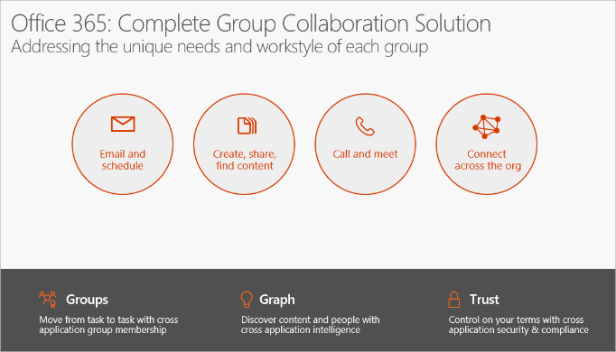

|  |
| --- |
| The Ignite session, [Discover Office 365 Groups—overview, administration and roadmap](https://www.youtube.com/watch?v=JR9KJq_5BP8&feature=youtu.be), presents a comprehensive overview and update on Office 365 Groups. We first discussed how group collaboration in the enterprise has evolved to be multi-faceted and how Office 365 addresses the unique needs and workstyle of different groups. |

A key benefit of Office 365 Groups is that any user in your organization can create a Group and start collaborating with others within minutes.

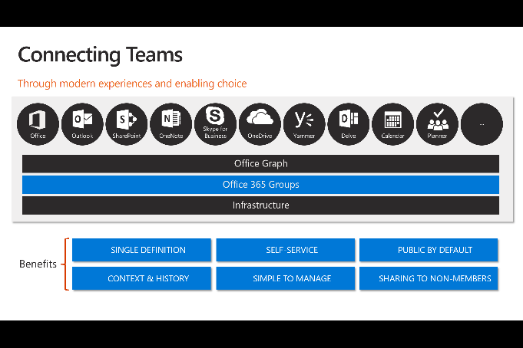

Groups create an integrated experience for teams to focus on group activity.

Groups can be public to enable information sharing within your company, or private for teams that deal with sensitive subjects.

### Features

**Conversations**

* In the Group inbox, all messages sent to the Group are displayed in a list view.
* Conversation details are displayed in the reading pane using a new conversation model
* Start a new conversation with Group members or reply inline to a conversation
* Send an email to a Group from your inbox, just like using a distribution list

**Files**

* File storage for Groups is accessed through a dedicated document library connected to the Group.
* Familiar OneDrive document management actions are available in the Group document library, such as document creation and upload.
* Provides some powerful scenarios involving co-authoring and attachment management

**Calendar Events**

* Helps you to track all your group events in one place, visible to everyone in the group.
* Visualize how group events will work into your schedule in Outlook Web App by overlaying your calendar with the group calendar.
* Any member of the group can create and update events, making it easy to keep the schedule up to date.
* For meetings scheduled on your personal calendar, you can add the group to the attendee list

**Navigation**

* The left navigation pane in Outlook Web App and Outlook makes it easy to navigate to any Group you have joined.
* Groups which you have marked as “favorites” are displayed first, ensuring that your key Groups are always just one click away
* The Group header makes it easy to switch between Group components, and provides easy access to Group management features such as favorites and subscription

**Group management**

* Groups support an open permission model, allowing you to add yourself as a member to any public Group, reducing management overhead and making it easy to access information.
* For sensitive topics, private Groups provide data privacy while offering a built-in mechanism for prospective members to request access to the Group.
* Group creation is available through Outlook Web App, just click the "+" button in the Groups area of the left navigation pane, to start creating your new Group

**Compliance and protection**

* **eDiscovery and Litigation Hold**—You can now perform an eDiscovery and Litigation Hold on a group’s mailbox using Exchange Admin Center and on group files using the Office 365 Security & Compliance Center. Refer to: [Security and compliance for Exchange Online](https://technet.microsoft.com/en-us/library/jj200706(v=exchg.150).aspx).
* **Auditing**—The Azure Management Portal now exposes group management events (creation, updates, membership changes, etc.) in the group audit report. Refer to: [Azure Active Directory Audit Report Events](https://azure.microsoft.com/en-us/documentation/articles/active-directory-reporting-audit-events/). Same events will appear in the Office 365 Security & Compliance Center alongside other Office 365 events you’re used to tracking. This gives you a complete picture of the Groups changes in your tenant over time.

**Directory management**

* **Naming policies for Office 365 Group names *and* aliases** - [Group naming policies](https://technet.microsoft.com/en-us/library/jj218693(v=exchg.150).aspx) allow users to self-organize, but enables control over the way that these groups appear in the corporate directory. The naming policy also applies to the email alias created for groups.
* **Dynamic membership** - Administrators can now create groups with rule-based memberships using the Azure Management Portal. Refer to: [Using attributes to create advanced rules](https://azure.microsoft.com/en-us/documentation/articles/active-directory-accessmanagement-groups-with-advanced-rules/). Group membership is updated within a minute as users’ properties change. This allows easy management of larger groups or the creation of groups that always reflect the organization’s structure. Note, *enabling dynamic membership for groups requires Azure AD Premium licenses*.

### Guest Access in Office 365 Groups

Guest access in Office 365 Groups enables you and your team to collaborate with people from outside your organization by granting them access to group conversations, files, calendar invitations, and the group notebook. Access can be granted to a guest—including partners, vendors, suppliers, or consultants—by any group owner.

#### How it works

Office 365 users can use Outlook on the web to add and manage guests in their Office 365 groups. Guests can have any email address, and the email account can be a work, personal, or school account.

* **Step 1**    A group owner [adds a guest to the group](https://support.office.com/en-us/article/adds-a-guest-to-the-group-3b650f4a-5c9b-4f94-a1bb-0cca4b1091de) or a guest is nominated by group members. The group owner approves the nominees.
* **Step 2**    The group owner is informed of what the guest can access within the group. A combination of text and icons give all group members clear indication of guest participation.
* **Step 3**    The [guest receives a welcome email](https://support.office.com/en-us/article/Guest-access-in-Office-365-Groups-bfc7a840-868f-4fd6-a390-f347bf51aff6?ui=en-US&rs=en-US&ad=US#BKMK_GuestExperience) and can [participate in group conversations](https://support.office.com/en-us/article/participate-in-group-conversations-a0482e24-a769-4e39-a5ba-a7c56e828b22), receive and respond to calendar invitations, and [access the group files](https://support.office.com/en-us/article/access-the-group-files-749bc73b-90c9-4760-9b6f-9aa1cf01b403).
* **Step 4**    Guests can [leave the group](https://support.office.com/en-us/article/leave-the-group-1470a263-3e01-4633-a7b9-851b786db0d2) at any time via a link in the footer of all group emails and calendar invites.

Guest access is a tenant-level setting and is enabled by default. A tenant admin can manage the guests and their access to Office 365 group resources using PowerShell. See [Allow external people guest access to Office 365 groups](https://support.office.com/en-us/article/Allow-external-people-guest-access-to-Office-365-groups-7c713d74-a144-4eab-92e7-d50df526ff96) for instructions.

#### The guest experience

When a guest is invited to join a group, they receive a welcome email that includes a little information about the group and what they can expect now that they're a member.

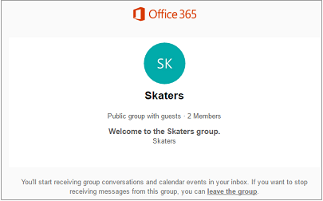

All of the guest member's interactions occur through their email inbox. They can't access the group site but can receive calendar invitations, participate in email conversations, and, if the tenant admin has enabled it, open shared files using a link or attachment.

All group emails and calendar invitations the guest receives will include a reminder to use "reply all" in responses to the group, along with links to **view group files** and **leave or unsubscribe** **from the group**.

### New and Upcoming Features

The following new capabilities are available:

* **Ability to update privacy type**. When you create an Office 365 group, users have two privacy options: public (anyone within your organization can access the group’s content) and private (only approved members can access the group’s content). This update enables group owners to change the privacy setting from public to private or vice versa by editing the group properties in Outlook on the web.
* **Multi-domain support**. Larger organizations use separate email domains to reflect different parts of their businesses. Office 365 groups that are created by users in one domain will share that domain (as opposed to using a common domain across the tenant). Administrators now also have control to create groups in specific domains of their choosing.
* **Guidance to configure Office 365 Groups with on-premises Exchange mailbox users**. If you’ve configured a hybrid deployment between your on-premises Exchange organization and Office 365, you can make groups created in Office 365 available to your on-premises users.
* **Allow users to send as the Office 365 group**. If you want to enable your group’s shared mailbox to “Send As,” you can now use the PowerShell cmdlets to configure this. Users can go to the group, create a new email and change the “Send As” field to the group’s email address.
* **Creation policy in Azure Active Directory**. We’ve implemented policy in Azure Active Directory that allows administrators to restrict group creation to certain users. This ensures that the creation of Office 365 groups through all endpoints, such as Planner and Power BI, can be given to selected users. The existing Exchange Mailbox policy only applies to creation in Exchange.
* **Usage guidelines**. You’ll be able to define usage guidelines for Office 365 Groups—to educate your users about best practices that help keep their groups effective and educate them on internal content policies.
* **Data classification and extensible policy**. You’ll be able to create a customizable data classification system for Office 365 Groups that allows separation of groups by policy type (e.g., “unclassified,” “corporate confidential” or “top secret”). In this manner, your groups can exhibit the policies of other content in your organization. Extensible policy allows your organization to configure an endpoint that is called whenever a group is created or changed—and you can then implement your own policies for group creation or change.
* **Mobile application management**. To protect users’ data on the go, we’re working on exposing the Outlook Groups mobile apps in Microsoft Intune as policy-managed apps.

Some of the key items on roadmap are:

* **Exchange Admin Center (EAC) UI for migrating Distribution Lists (DLs) to groups**. Building on the scripts we released (mentioned above) for DL migration, you will soon be able to migrate a DL to a group directly from the Exchange Admin Center with one click!
* **Naming policy in Azure Active Directory**. Administrators will be able to configure a policy for appending text to the beginning or end of a group’s name and email address no matter where the group is created (e.g., Outlook, Planner, Power BI, etc.). Administrators can also configure a list of specific blocked words that can’t be used in group names and also rely on the native list of thousands of blocked words to keep their directories clean.
* **Ability to search for private Groups files**. By integrating Groups files (stored in a SharePoint document library and surfaced in OneDrive for Business) and Office Delve, users will be able to search content from both public and private groups as long as they’re a member

### Evolving Distribution Lists with Groups

Distribution Lists (DL) are the leading way users share information with a set of people today. Office 365 Groups provide a way to improve that experience.

**Groups increase productivity** – Enabling a richer and immersive experience, yet familiar in integrating with email & existing business workflows

* Appear alongside your Inbox & require no context switching. Make them favorites and access them offline.
* Addressable in emails just like DL’s but provide a better down-level experience.
* Allows you to focus & immerse on a topic or project. Modern Reading experience helps you communicate @speed of social.

**Groups allow you to self-organize**, create dynamic teams & work as a network. Benefit from the collective wisdom of your team.

* Get access to complete history and context.
* Find & discover new groups & joining them easily.
* Form and create groups instantly and to work with your teams.

**Groups enable frictionless collaboration** & sharing by integrating with O365. Empowers teams to accomplish goals and milestones!

* Enable frictionless collaboration by accessing and sharing files from any conversation. View all group files at a glance.
* Meet milestone and goals by scheduling meetings on team calendar.
* Make better & faster decisions with your team via Skype meetings.
* Access them from anywhere, across all devices and Outlook experiences

#### Migrating Distribution Lists to Office 365 Groups

The article - [Migrate distribution lists to Office 365 Groups - Admin help](https://support.office.com/en-us/article/Migrate-distribution-lists-to-Office-365-Groups-Admin-help-787d7a75-e201-46f3-a242-f698162ff09f) explains how to use scripts to migrate multiple distribution lists (sometimes referred to as distribution groups) to Office 365 groups. If you want your organization's distribution lists to get all the features and functionality of Office 365 groups, you can now migrate your distribution lists using PowerShell.

### Office 365 Connectors for Groups

Office 365 Connectors are a great way to get useful information and content into your Office 365 Group. Any user can connect their group to services like Trello, Bing News, Twitter, etc., and get notified of the group's activity in that service. From tracking a team's progress in Trello, to following important hashtags in Twitter, Office 365 Connectors make it easier for an Office 365 group to stay in sync and get more done.

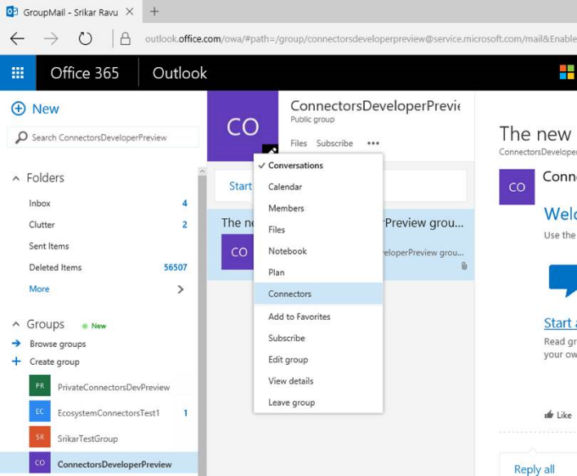

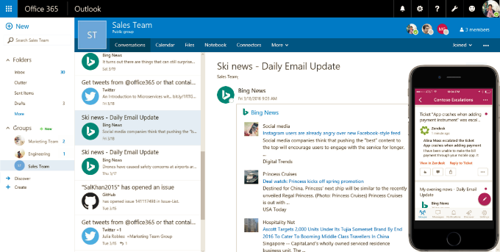

#### How connectors work

When you connect a tool or service to a group, everyone in the group can see the messages delivered by that service. For example, let's say your group wants to follow news reports about your company's new product that's hitting the market. You could add the Bing News connector to your group, configure it to send you links to topics of interest, and specify the frequency of delivery. When news headlines are sent to your group, everyone in the group will be able to read and respond to them.

The messages are delivered as rich connector cards, which can be viewed in multiple clients including Outlook on the web, Outlook for Windows, and in the Groups app for iOS and Android. Here's an example of what the UserVoice connector card would look like:

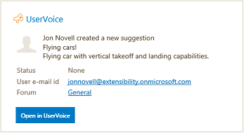

**Available Connectors**

50+ Office 365 Connectors are available today, spanning popular applications across productivity, news sources, HR systems, sales, project management, marketing automation, entertainment, eLearning, developer tools and many more.

### Scenarios

* In a manufacturing company, a product planning team is chartered to come up with a new idea for night lights. They want to quickly exchange thoughts and co-author a few documents to deliver a proposal, a presentation, a budget, and a collection of discussion notes.
* A company wants to coordinate logistics and expertise from its employees for a customer marketing and promotion event.
* A close-knit executive team needs to plan and schedule a big product announcement, but securely, so as not to risk an untimely disclosure.
* A large company wants to organize a Football league, set up a game schedule on a group calendar, and share common content such as team rosters, equipment inventories, and even a statistical spreadsheet.

### Resources

**Watch Videos** …

* [Introducing Office 365 Groups](https://www.youtube.com/watch?v=Cg-y3p4E8sA)
* [Office 365 Groups: Quick tour of new user and admin experiences](https://www.youtube.com/watch?v=-SgQ1_ATw9s)
* [Introducing Office 365 Connectors​​​](https://www.youtube.com/watch?v=9qcwzVFppMg)

**Read** …

* Office Training Center - [Unite your team with Groups](https://support.office.com/en-us/article/Unite-your-team-with-Groups-aef27003-2ce6-4c62-ad6c-d5fc472507cf?ui=en-US&rs=en-US&ad=US)
* [Find help about groups in Office 365](https://support.office.com/en-in/Article/Find-help-about-Groups-in-Office-365-7a9b321f-b76a-4d53-b98b-a2b0b7946de1)
* [Compare Outlook Groups on all platforms](https://support.office.com/en-US/Article/Compare-Outlook-Groups-on-all-platforms-3b4c6542-56cb-49d9-9445-31aa7d82aace)
* [Connect apps to your groups](https://support.office.com/en-us/article/Connect-apps-to-your-groups-ed0ce547-038f-4902-b9b3-9e518ae6fbab?)
* [Office 365 Connectors for Groups (Developer Preview)](https://dev.outlook.com/connectors/)
* [Get started with Office 365 Connector Cards](https://dev.outlook.com/Connectors/GetStarted)

**For Admins** …

* [View, create, and delete Groups in the Office 365 admin center](https://support.office.com/en-in/Article/View-create-and-delete-Groups-in-the-Office-365-admin-center-a6360120-2fc4-46af-b105-6a04dc5461c7)
* [Manage Group membership in the Office 365 admin center](https://support.office.com/en-in/Article/Manage-Group-membership-in-the-Office-365-admin-center-e186d224-a324-4afa-8300-0e4fc0c3000a)
* [Guest access in Office 365 Groups](https://support.office.com/en-us/article/Guest-access-in-Office-365-Groups-bfc7a840-868f-4fd6-a390-f347bf51aff6?ui=en-US&rs=en-US&ad=US)
* [Migrate distribution lists to Office 365 Groups - Admin help](https://support.office.com/en-us/article/Migrate-distribution-lists-to-Office-365-Groups-Admin-help-787d7a75-e201-46f3-a242-f698162ff09f)
* [Office 365 Groups now supports eDiscovery, litigation hold, dynamic membership and more!](https://blogs.office.com/2015/12/09/office-365-groups-now-supports-ediscovery-litigation-hold-dynamic-membership-and-more/)
* [Multi-domain support for Office 365 Groups](https://support.office.com/en-us/article/Multi-domain-support-for-Office-365-Groups-Admin-help-7cf5655d-e523-4bc3-a93b-3ccebf44a01a?ui=en-US&rs=en-US&ad=US)
* [Configure Office 365 Groups with on-premises Exchange hybrid](https://technet.microsoft.com/en-us/library/mt668829%28v=exchg.150%29.aspx)
* [Use PowerShell to manage Office 365 Groups](https://support.office.com/en-us/article/Use-PowerShell-to-manage-Office-365-Groups-Admin-help-aeb669aa-1770-4537-9de2-a82ac11b0540?ui=en-US&rs=en-US&ad=US)

**Key Ignite session**s …

* [Help your users collaborate better with Office 365 Groups](https://youtu.be/s1UYLRQnE9o)
* [Learn about Office 365 Groups and how to use them](https://youtu.be/or2arI1zNLQ)
* [Use Office 365 Groups at schools and universities](https://youtu.be/XM37GEStlcw)
* [Learn what to use when: Office 365 Groups, SharePoint Team Sites, Yammer and OneDrive for Business](https://www.youtube.com/watch?v=HtEQr77npwI)
* [Communicate on your terms with Outlook, Yammer and Skype](https://www.youtube.com/watch?v=6zFZMS5qQso)
* [Explore the ultimate field guide to Microsoft Office 365 Groups](https://www.youtube.com/watch?v=qdEps9gF-6w)
* [Collaborate outside the firewall with Office 365 Groups](https://www.youtube.com/watch?v=IbAh097pvYo)
* [Migrate DL to Microsoft Office 365 Groups](https://www.youtube.com/watch?v=D2gjUuNTq8k&)
* [Ask us anything about Microsoft Office 365 Groups](https://www.youtube.com/watch?v=D9ciQDWc508)
* [Work smarter with Yammer and Office 365 Groups](https://www.youtube.com/watch?v=Lg_4h0we1Jw)
* [Meet Planner—the new Microsoft Office 365 work management application](https://www.youtube.com/watch?v=rkTea5BJc8M)
* [Discover what’s new and what’s coming to the SharePoint Mobile and Intelligent Intranet](https://www.youtube.com/watch?v=xjwz9WLrw9Q)
* [Connect your business-critical applications to Outlook and Groups](https://www.youtube.com/watch?v=zT8iMQHYgG8)

## Microsoft Teams *(Preview)*

**Microsoft Teams** is a chat-centered workspace in Office 365 that's a hub for teamwork. It's extensible and customizable, so you can tailor it for the information your team needs. Microsoft Teams supports flexible communication, including chats, calls, meetings, and private and group conversations.

**Core Values**

Microsoft Teams is designed for highly engaged teams that work closely together to get things done:

* Share updates and give feedback in the open
* Make quick decisions and stay in the loop with team activities
* Coordinate on projects and tasks, including co-create content and deliverables

|  |
| --- |
| **Note**: Microsoft Teams is available in preview to eligible Office 365 commercial customers. **We expect the service to become generally available in Q1 CY2017**. |

### Key Differentiators

Being part of Office 365 means Microsoft Teams comes with **built-in integrations to Azure Active Directory, SharePoint, OneNote, Office 365 Groups and more**. This allows you to maximize your Office 365 investments, while providing a simple and secure user experience across tools.

#### Chat for today’s teams

First and foremost, Microsoft Teams provides a modern conversation experience for today’s teams. Microsoft Teams supports not only persistent but also threaded chats to keep everyone engaged. Team conversations are, by default, visible to the entire team, but there is of course the ability for private discussions. Skype is deeply integrated, so teams can participate in voice and video conferences. And everyone can add personality to their digital workspace with emojis, stickers, GIFs and custom memes to make it their own.

#### Hub for teamwork

Second, Microsoft Teams brings together the full breadth and depth of Office 365 to provide a true hub for teamwork. Word, Excel, PowerPoint, SharePoint, OneNote, Planner, Power BI and Delve are all built into Microsoft Teams so people have all the information and tools they need at their fingertips. Backed by the Microsoft Graph, intelligent services are surfaced throughout the workspace to help with information relevancy, discovery and sharing. Microsoft Teams is also built on Office 365 Groups—our cross-application membership service that makes it easy for people to move naturally from one collaboration tool to another, preserve their sense of context and share with others.

#### Customizable for each team

Third, since all teams are unique, we’ve invested deeply in ways for people to customize their workspace, with rich extensibility and open APIs available at general availability. For example, Tabs provides quick access to frequently used documents and cloud services. Microsoft Teams also shares the same Connector model as Exchange, providing notifications and updates from third-party services like Twitter or GitHub. Further, we are including full support for the **Microsoft Bot Framework** to bring intelligent first- and third-party services into your team environment.

#### Security teams trust

Finally, Microsoft Teams provides the advanced security and compliance capabilities that our Office 365 customers expect. Data is encrypted in transit and at rest. Like all our commercial services, we have a transparent operational model with no standing access to customer data. Microsoft Teams will support key compliance standards including EU Model Clauses, ISO 27001, SOC 2, HIPAA and more. And, as customers would expect, Microsoft Teams is served out of our hyper-scale global network of data centers, automatically provisioned within Office 365 and managed centrally, just as any other Office 365 service.

### Definitions

#### Organization

All teams created by employees in your organization are associated with your Office 365 tenant. You can designate all employees or a subset of employees with the ability to create teams, using Office 365 Groups.

#### Team

A team is designed to bring together a group of people that work closely to get things done. Teams can be dynamic for project-based work (e.g. launching a product, creating a digital war room), as well as ongoing, to reflect the internal structure of your organization (e.g. departments and office locations). Conversations, files and notes across team channels are only visible to members of the team.

#### Channel

A channel helps organize the team’s conversations, content and tools around a specific topic. Channels can be organized, for example, by topic (events), discipline (design), project (launch) or just for fun (fun stuff). Team owners can create channels, and enable team members with the ability to create channels, as needed. Tabs along the top of a channel enable teams to keep files, notes, and customized content such as Power BI metrics, business goals on a Word doc or organizational chart on a PowerPoint slide. This content is then easily accessible to everyone on the team. Additional connectors to 3rd party applications can be customized at the channel level to bring in data from everyday tools such as Trello, Asana, GitHub and more.

#### Team Membership

When Microsoft Teams is activated for your entire organization, designated team owners are able to invite any employee they work with to join their team. Microsoft Teams makes it easy for team owners to add people in the organization based on their name.

Team owners can also create a team based on an existing Office 365 Group. Any changes made to the group will be synched with Microsoft Teams automatically. Creating a team based on an existing Office 365 Group not only simplifies the process of inviting and managing members, but also syncs group files inside of Microsoft Teams.

#### Team Roles

There are two main roles in Microsoft Teams: a **team owner**, the person who creates the team, and **team members**, the people who they invite to join their team. Team owners can make any member of their team a co-owner when they invite them to the team or at any point after they’ve joined the team. Having multiple team owners enables you to share the responsibilities of managing settings and membership, including invitations.

#### Team Settings

Team owners can manage team-wide settings directly in Microsoft Teams. Settings include the ability to add a team picture, set permissions across team members for creating channels, adding tabs and connectors, @mentioning the entire team or channel, and the usage of GIFs, stickers and memes.

As a Microsoft Teams admin, you have access to system-wide settings in the admin center. These settings can impact the options and defaults team owners see under team settings. For example, you can enable a default channel, “General”, for team-wide announcements, discussions and resources, which will appear across all teams

### Features

#### Teams and Channels

* Teams are collections of people, content, and tools surrounding different projects and jobs within an organization. Team members can share conversations, files, notes, and more!
* Keep team conversations organized in specific channels. You can dedicate channels to specific topics, projects, disciplines—whatever you like!

**Creating Teams**

* Click on Create a Team below the Team list to create a team
* Some organizations might decide to only let certain people create teams
* A team owner can add people to the team by clicking on Add members option
* Let people know that you created team. In the General channel, you can @mention the team by typing @team or @[team name] in the compose box.

**Channels**

* Create a new Channel by clicking on Add a Channel option in the team list
* Let people know you created a channel. In the compose box of your brand new channel, you can mention people's names (@somebody) to get their attention
* See all the Channels in the team by selecting the Channels tab

**Managing Teams**

* Team owner can change team settings by clicking View Team option and going to Setting tab
* Team owner can change the team picture in team settings
* Leave a team at any time by clicking … next to the team name and selecting Leave the team option

**Uploading Files**

* To upload a file to a channel, click the Files tab at the top, then click Upload a file. When you upload a file, everyone on the team can see and edit it from the Files tab.
* You can also upload a file by sending a message with a file attachment to a channel. This will add the file to the channel's Files tab and share it with everyone on the channel.

**Ownership**

* Team owners can change the name of team channels anytime they like using the Edit this channel option
* Team owners can delete a Team using Delete the team option. Your team will be permanently

Other Admin Settings for Team owners….

* Set team members' permissions for channels, tabs, and connectors.
* Control @[team name] mentions that will notify everyone on the team.
* Allow @channel or @[channel name] mentions, which will notify members who’ve favorited the channel.
* Allow usage of Giphy, stickers, and memes

#### Meetings and Calling

**Team Meetings**

* Team meetings are a quick and easy way for people in a channel to go from a conversation to an impromptu meeting.
* Anyone from the team can join, so people work in the open.
* Team meetings include audio, video, and sharing
* Start a new meeting, by clicking the meeting icon in a new conversation
* Keep the context of the conversation and bring in the people you're already talking to by clicking the meeting icon in an existing conversation
* Desktop sharing lets you see what someone is presenting and is an easy way to work together on a shared document

**Scheduling Team Meeting**

* Clicking on the Schedule icon on the left side of the app will show you list of all your currently schedule meetings
* Click "Schedule Meeting" to schedule a new meeting

**Joining a Team Meeting**

There are three ways to join meetings in Microsoft Teams:

* You can join from a message within a conversation
* If you're working in another channel and your messages aren't currently in view, you can join a meeting from a notification that will appear in the top right corner of your screen.
* You'll receive a notification that you've been invited to a meeting, and you can join from there

**Multitasking in a Meeting**

* Multitasking during a meeting is easy - you can check on what's going on in other channels or catch up on your messages.
* Whenever you click away from a meeting, a call monitor will appear. From there, you can click back in an instant

#### Managing My Space

**Availability**

* Change your status by clicking on your picture or avatar, and update

**Personalizing**

* Reorder your teams by clicking and dragging the team name anywhere in your team list.
* Channels follow the alphabet, and there’s no reordering the alphabet
* To change your profile image, just click on your avatar on the left-hand side of your screen, then click **Change picture**.
* All the channels you've already favorited will be listed underneath the team they belong to in your Teams view.
* To favorite a new channel, click on the overflow menu that appears under your current favorites for each team. Scroll down to the channel you want to favorite. Click on favorite icon next to the channel name.

#### Keeping up with information updates

There are lots of things you can do to stay up-to-date. You can:

* **Arrange** your teams in an order that makes sense to you, putting the busiest teams at the top of your list.
* **Favorite** the channels you use the most. This way, they'll stay visible in your team list, and you'll see when new messages have been posted.
* **@mention** people so they @mention you. You'll see you've been @mentioned in your notifications. Also, a red circle with a number in it will appear next to the channel name.
* And watch the **Activity** button. That lets you know whenever you've got notifications.

#### Connectors

* You can set up a connector, which lets you get real-time updates from your external apps and services sent directly to a channel. Some examples are Twitter, Bing News, Trello, and GitHub.
* We have connectors that let you integrate apps and services right into the conversation.
* To add connectors, click on the channel name, click … , and then click Connectors
* We support incoming webhooks, which can be set up by creating a connector. They allow you to build custom integrations with other apps and services.
* You can see connector messages in the mobile app, but you can only add them in the desktop or web app
* Team owner can disable the setting that allows non-owners to add connectors.

#### Files

* To share files with a team, go to the Files tab at the top of a conversation, and click Upload. You can also attach a file directly to a message and it will still appear in your Files tab
* The easiest way to send a file in a direct message or channel is to click paperclip icon in the compose box
* In a one-on-one or group conversation, you can upload a file to your OneDrive for Business and share it or choose an existing OneDrive file. Everyone in the conversation will automatically be given permission to view, edit, and share the file.
* In a channel, you can choose to upload a file from your Microsoft Teams, Recent files, OneDrive for Business, or desktop. The entire team will be able to access the file instantly.

### Manage Microsoft Teams

Office 365 admins can enable and manage Microsoft Teams directly from the Office 365 admin center.

In the **Services & add-ins** page, admins will find a new **Microsoft Teams** section where they can enable the service for their organization, as it is disabled by default during the preview period. After enabling, admins can configure Microsoft Teams for their organization, including notifications, feedback, bots and screen sharing in meetings.

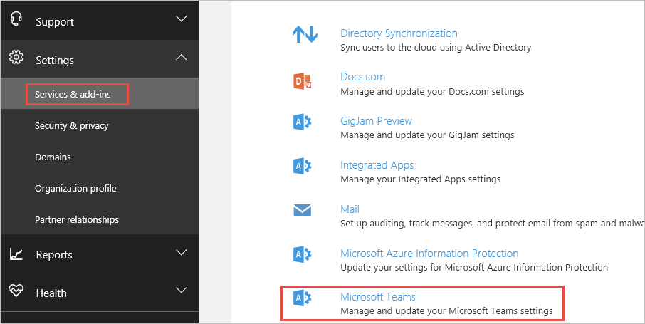

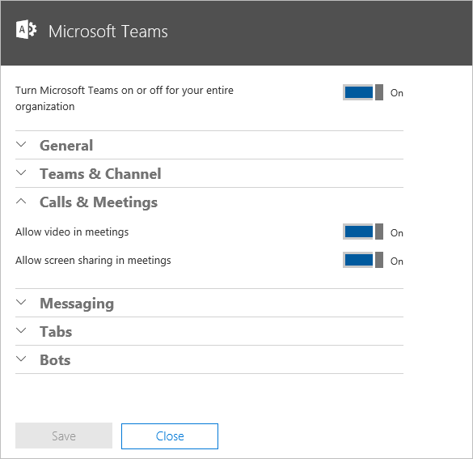

### Scenarios

Microsoft Teams is particularly well suited for teams where team members are highly engaged, iterating on shared deliverables. There are such scenarios across Sales, Marketing, Project Management, Engineering and Customer Service.

**Sales**

* Close deals faster: get answers to customer questions, advice on objections and approvals
* Spend more time selling: digitize status meetings, sales training and expert Q&A sessions
* Stay ahead of customers: know the latest company, product and competitor news
* Build a winning culture: share customer feedback and wins with valuable context
* Update the account team with customer feedback and implications for account management

**Marketing**

* Execute marketing campaigns and events flawlessly: coordinate tasks and deliverables, share updates across multiple stakeholders
* Manage the creative process from concept to launch: share designs, gather feedback and approvals
* Work closer with field marketers: keep the field in the loop, get their input and feedback
* Build a creative team culture: share ideas, inspiration and best practices

**Project Management**

* Collaborate engineering and development across a distributed team
* Streamline product launches and releases: coordinate tasks and deliverables, share status and updates
* Speed up issue resolution: spin up digital war rooms for escalations and track progress

**Engineering**

* Develop faster across distributed teams: enable continuous communication and smooth handoffs between teams
* Build a collaborative culture: discuss ideas and requirements, gather inputs and feedback in the open

**Customer Support**

* Enable continuous knowledge-sharing: share known issues and fixes between shifts
* Build a collective knowledge base: document customer FAQs and subject matter Q&A
* Speed up issue resolution: troubleshoot critical issues together in various subject matter experts
* Stay ahead of customers: know the latest product updates and customer offers

### Resources

**Watch**

* [Introducing Microsoft Teams](https://www.youtube.com/watch?v=nKU-FMzZFF0)
* [Onboard your teams](https://support.office.com/en-us/article/Onboard-your-teams-702a2977-e662-4038-bef5-bdf8ee47b17b)

**For Users**

* Blog post: [Introducing Microsoft Teams—the chat-based workspace in Office 365](https://blogs.office.com/2016/11/02/introducing-microsoft-teams-the-chat-based-workspace-in-office-365/)
* [Microsoft Teams Help](https://support.office.com/en-us/article/Microsoft-Teams-help-23156c0c-2c6e-49dd-8b7b-7c564b76508c). [FAQ](https://support.office.com/en-us/article/FAQ-f4644010-d5fa-4055-b42a-6a5317316e18)
* [Teams and Channels](https://support.office.com/en-us/article/Teams-and-Channels-df38ae23-8f85-46d3-b071-cb11b9de5499)
* [Meetings and Calling](https://support.office.com/en-us/article/Meetings-and-Calling-d92432d5-dd0f-4d17-8f69-06096b6b48a8)
* [Managing My Space](https://support.office.com/en-us/article/Managing-My-Space-d2089e76-ef91-4bbd-89e9-7b49a8635dc7)
* [Managing Notifications and Staying Focused](https://support.office.com/en-us/article/Managing-Notifications-and-Staying-Focused-6fa7c08a-6fd4-47a0-b275-90a5f60f1df9)

**For Admins**

* [Microsoft Teams Customer Success Kit](https://www.microsoft.com/en-us/download/details.aspx?id=54244)
* MVA Course: [Introducing Microsoft Teams (in Preview)](https://mva.microsoft.com/en-US/training-courses/introducing-microsoft-teams-in-preview-16877?l=OUuGW55AD_6301937548)
* [Frequently asked questions about Microsoft Teams – Admin Help](https://support.office.com/en-us/article/Frequently-asked-questions-about-Microsoft-Teams-–-Admin-Help-05cbe533-2181-4e95-a4b0-52cd7695fafc)
* [Microsoft Teams: Step-by-step intro for using, enabling and managing the experience](https://www.youtube.com/watch?v=tAqAtI6K7NY&feature=youtu.be)
* [Administrator settings for Microsoft Teams](https://support.office.com/en-us/article/Administrator-settings-for-Microsoft-Teams-3966a3f5-7e0f-4ea9-a402-41888f455ba2)

## Delve

Delve helps you discover the information that's likely to be most interesting to you right now - across Office 365. Find information about people - and through people - and help others find you.

You don't have to remember the title of a document or where it's stored. Delve shows you documents no matter where they're stored in OneDrive for Business or SharePoint in Office 365.

Delve never changes any permissions, so you'll only see documents that you already have access to. Other people will not see your private documents. [Learn more about privacy](https://support.office.com/en-us/article/Learn-more-about-privacy-f5f409a2-37ed-4452-8f61-681e5e1836f3).

* Click someone’s name or picture anywhere in Delve to see documents they’re working on or to learn more about them.
* When you find a document you’re interested in, add it as a favorite or to a board to easily get back to it later.
* Search for people, documents, or boards.

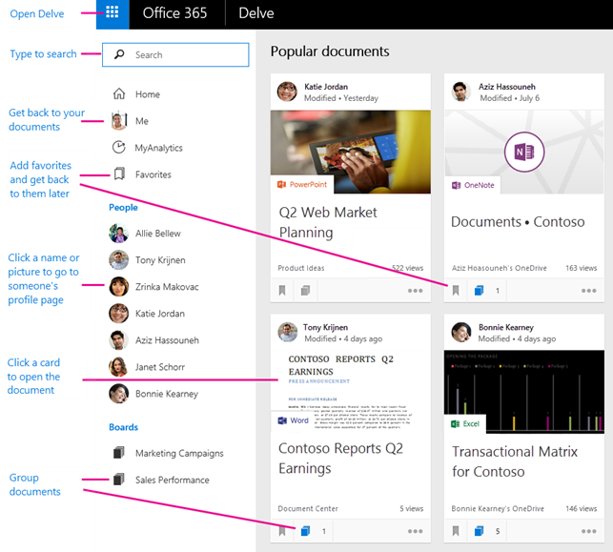

### Features

#### View and edit your profile

The profile page in Delve makes it easy for you to update your profile information, and for others to find and connect with you. With the new profile page in Delve, you can also quickly get back to documents you've worked on recently, or go to other people's profile pages to see what they're up to.

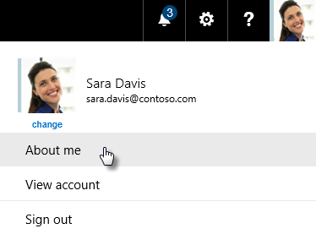

You can go to your profile page by selecting **Me** from the left-hand menu. To change your information, choose **Edit profile.**

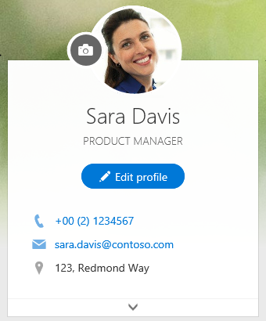

#### Connect and collaborate

You and everyone else in your organization have your own profile page in Delve. Use the profile pages to find information **about** people - and **through** people - and to help others find you. You can also connect with others directly from their profile page.

On your own page, you can quickly **get back to documents** you've worked on recently, **go to other people's pages** to see what they're up to, and update your personal information.

To go to your profile page, click **Me** in the left pane, or click your name or picture anywhere in Delve.

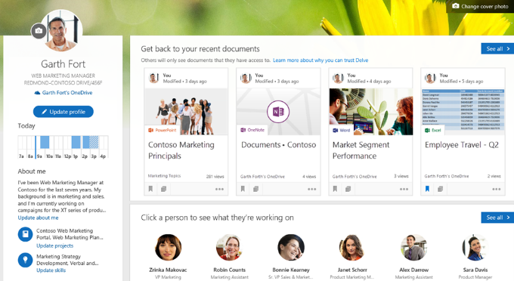

**Get back to your recent documents**

This section shows documents you've recently authored or modified, and that are stored in OneDrive for Business or SharePoint. Click a document to open it, or click **See all** to see more documents.

**Click a person to see what they're working on**

In this section, you see some of the people you work with, or people you're connected to in the organization. Click a person to go to their profile page, or click **See all** to see more people.

**Discover documents from people around you**

This section shows a selection of popular documents from people around you. The selection of documents changes over time, and is based on what the people you work with have worked on or read. Click a document to open it, or click **See all** to see more documents.

If you find something you want to keep for later, add the document to your **favorites** or to a **board**.

#### Group and share documents

In Delve, you can use **boards** to group and share related documents. You can, for example, create a board to collect all project documents for your team. Boards make it easy to collect and discover content, and they are easy to share with others, too.

You can also keep track of documents in Delve by adding them to your **Favorites**. If you find a document you want to save for later, click the icon in the lower left corner to add it to your favorites.

Boards are open to everyone in your organization, and you can see, add documents to, or remove documents from any board in Delve. If a board has documents that you don't have access to, those documents will not show up for you.

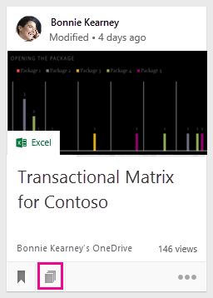

**Share a board with others**

To send a link to a board through email, click **Send a link** at the top of the board. Type in the email address, change the message if you want, and send.

**Remove a document from a board**

Click the board icon in the bottom left corner on a content card. In the dialog box that opens, click the **X** for the board you want to remove the card from.

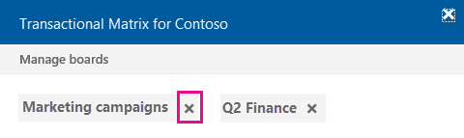

**Keep track of your favorite documents**

To add a document to your **Favorites**, click the icon in the lower left corner of the card.



**Share a document with others through email**

To send a link to a document through email, click the three dots in the lower right corner on the content card and then **Send a link**. Type in the email address, change the message if you want, and send.

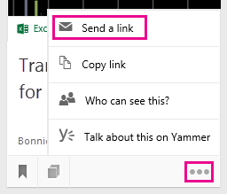

**Give other people access to your document**

To share a document with others from within Delve, click the three dots in the lower right corner on the content card, then **Who can see this?**, and then click **Invite people**.

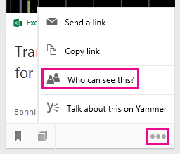

**Work with others on documents in Delve**

When you open documents in **Office Online**, your colleagues can open them at the same time. That means you don’t have to wait for someone to finish adding information to a document before you can enter yours.

As you see each other’s updates you can discuss and share ideas, resulting in a document that’s truly a team effort

**Work together on documents by using Yammer**

You can post documents to Yammer from Delve. You can also talk about the document on Yammer, or view existing conversations.

#### Find people and information

Discover new information on your **Home** page, get back to your own documents on your profile page (**Me**), and find information about other **people** on their profile pages. You can also find back to documents in **Favorites** or find documents through **boards**.

The **Get back to your recent documents** section shows the documents you've recently authored or modified, and that are stored in OneDrive for Business or in Sites.

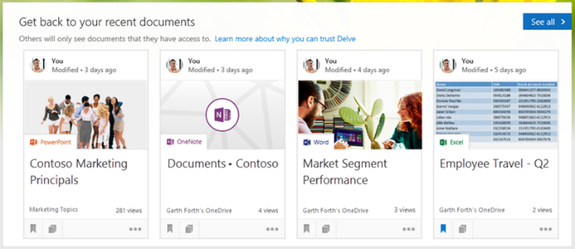

**Find information about other people**

You can find information about other people by going to their profile page in Delve. The **People** list on the left shows some of the people you’ve recently viewed in Delve. To find other people:

* Click a person's name or picture anywhere in Delve.
* Or, type their name in the search box, and then click their name.

**Keep track of your favorite documents and boards**

Whenever you see a document in Delve that you want to save for later, click the star to add it to your favorites.

**Find people and information by using search**

Start typing in the search box to find people, documents, or boards.

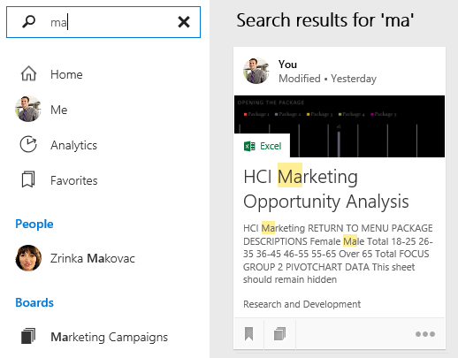

### Office Graph

The Office Graph lives in Office 365. It stores data *about* Office 365 entities and the relationships between them as nodes and edges in a graph index. Examples of entities are **person** and **document**; examples of relationships are **shared** and **modified**.

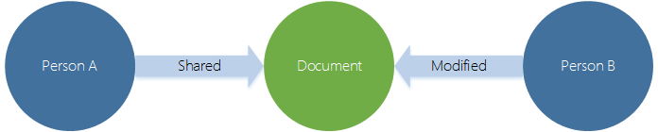

The Office Graph uses advanced analytics and machine learning techniques to connect and complete the data coming from all of the Office 365 services. To present the most relevant content in different contexts, the Office Graph uses a two-step analysis.

* calculates which users in the graph are most relevant to the current context.
* retrieves the most relevant content associated with these users.

The Office Graph continuously collects and analyses signals that you and your colleagues send when you work in Office 365. For example, when you and a colleague modify or view the same document, it’s a signal that you’re likely to be working together.

Other signals are who you communicate with through e-mail, and who you’ve shared documents with, who your manager is, and who has the same manager as you.

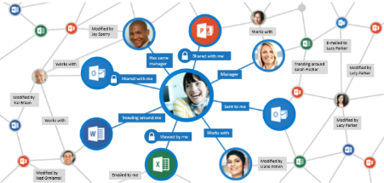

Delve uses the result of the Office Graph analysis to show you documents that are most likely to be relevant to you right now. For example, the Office Graph will notice if several of the people you regularly work with, view a specific document. That document is most likely also interesting to you, so Delve shows it on your **Home** page.

The [Microsoft Graph API](http://graph.microsoft.io/) allows developers to discover and modify entities in the Office Graph. Like other Office 365 APIs, the Office Graph API will follow REST and OData 4.0 standards for data transport, and use the OAuth 2.0 standard for authentication and authorization.

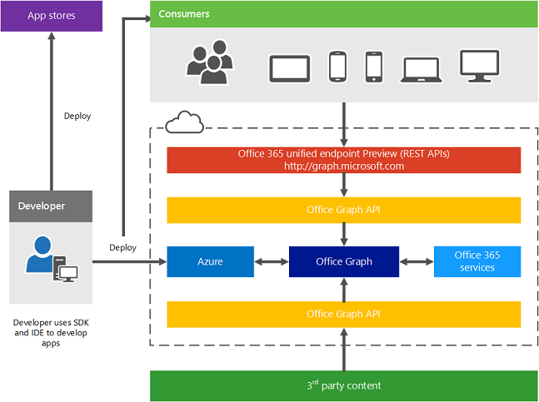

Refer to the Office 365 Application Development section later in this document.

### Introduce Delve in your Organization

* SharePoint Online and OneDrive for Business are the primary sources of content in Delve. How you and users manage permissions on documents and sites affects what users see in Delve.
* You can download this [email template](https://view.officeapps.live.com/op/view.aspx?src=https%3A%2F%2Fsuccesscenter.blob.core.windows.net%3A443%2Fmedia%2FDefault%2FResources%2FService_Updates%2FGet%2520started%2520with%2520Delve.docx) to announce Delve in your organization.
* Let users know they can get Delve on their mobile phones, see [Office Delve for Android](https://support.office.com/en-in/article/Office-Delve-for-Android-4080a65d-c160-4369-bed0-215fb00b5547) or [Office Delve for iPhone](https://support.office.com/en-in/article/Office-Delve-for-iPhone-41fef4f6-407b-4e5e-89d8-e1479f8a344b).
* You can point users to the Delve help articles. [What is Office Delve?](https://support.office.com/en-in/article/What-is-Office-Delve-1315665a-c6af-4409-a28d-49f8916878ca) is a great starting point, and users may be particularly interested in the information in the articles - [Are my documents safe in Office Delve?](https://support.office.com/en-in/article/Are-my-documents-safe-in-Office-Delve-f5f409a2-37ed-4452-8f61-681e5e1836f3), [What kind of information will I find in Office Delve?](https://support.office.com/en-in/article/What-kind-of-information-will-I-find-in-Office-Delve-46f92806-b52c-4187-b60e-b3bf8d25f73e) and [Store your documents where Office Delve can get to them](https://support.office.com/en-in/article/Store-your-documents-where-Office-Delve-can-get-to-them-49a0db49-5e6c-4dda-816e-e11dd77de49d).

### Resources

**Watch Videos** …

* [Introducing Office Delve Mobile Apps for Android and iPhone](https://www.youtube.com/watch?v=05VrH4uX-Mc)
* [The Office 365 Authoring Canvas inside Office Delve](https://www.youtube.com/watch?v=2owYQp2Y76g)

**Read** …

* [What is Office Delve?](https://support.office.com/en-in/article/What-is-Office-Delve-1315665a-c6af-4409-a28d-49f8916878ca)
* [What kind of information will I find in Office Delve?](https://support.office.com/en-in/article/What-kind-of-information-will-I-find-in-Office-Delve-46f92806-b52c-4187-b60e-b3bf8d25f73e?ui=en-US&rs=en-IN&ad=IN)
* [How does Office Delve know what's relevant to me?](https://support.office.com/en-in/article/How-does-Office-Delve-know-what-s-relevant-to-me-048d502e-80a7-4f77-ac5c-f9d81733c385?ui=en-US&rs=en-IN&ad=IN)
* [How to use the content cards in Delve](https://support.office.com/en-in/article/How-to-use-the-content-cards-in-Delve-e6157225-0e40-441c-906f-0c82bfee55f3)
* [View and edit your profile](https://support.office.com/en-in/article/View-and-edit-your-profile-4e84343b-eedf-45a1-aeb9-8627ccca14ba)
* [Connect and collaborate in Office Delve](https://support.office.com/en-us/article/Connect-and-collaborate-in-Office-Delve-46f92806-b52c-4187-b60e-b3bf8d25f73e?ui=en-US&rs=en-US&ad=US)
* [Group and share documents in Office Delve](https://support.office.com/en-us/article/Group-and-share-documents-in-Office-Delve-da0c5804-01ef-4edd-8b87-e576b19bef3e?ui=en-US&rs=en-US&ad=US)
* [How can I find people and information in Office Delve?](https://support.office.com/en-us/article/How-can-I-find-people-and-information-in-Office-Delve-5b8bffdd-a50a-430a-8570-09b39481887c?ui=en-US&rs=en-US&ad=US)
* [Are my documents safe in Office Delve?](https://support.office.com/en-in/article/Are-my-documents-safe-in-Office-Delve-f5f409a2-37ed-4452-8f61-681e5e1836f3?ui=en-US&rs=en-IN&ad=IN)
* [What decides the title on the card?](https://support.office.com/en-in/article/How-to-use-the-content-cards-in-Office-Delve-e6157225-0e40-441c-906f-0c82bfee55f3?ui=en-US&rs=en-IN&ad=IN#BKMK_TitleOnCard)

For Admins

* [Office Delve for Office 365 admins](https://support.office.com/en-in/article/Office-Delve-for-Office-365-admins-54f87a42-15a4-44b4-9df0-d36287d9531b)
* [What is the effect of allowing or not allowing access to the Office Graph?](https://support.office.com/en-in/article/Office-Delve-for-Office-365-admins-54f87a42-15a4-44b4-9df0-d36287d9531b#BKMK_EffectOfficegraphOnOff)

## Power BI Pro

Power BI enables anyone and everyone to easily connect to any of their data, create live dashboards and reports, and explore data through interactive visualizations at any time. With Power BI, you can make all of your data viewable in a single location, regardless of where the data resides, enabling a consolidated view of business operations.

Power BI includes two companion applications:

* **Power BI Desktop**, a visual data exploration and reporting tool.
* **Mobile applications** for Windows, iOS, and Android devices, providing secure access to live Power BI dashboards and reports from any device.

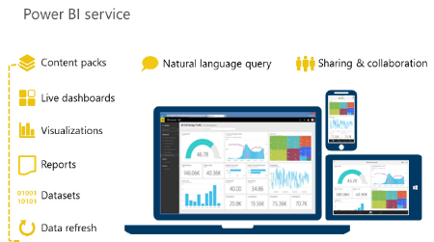

In addition, Power BI can be extended with a set of REST APIs which enable developers to integrate client and web solutions with Power BI or to build custom visualizations.

Power BI ecosystem provides a unique set of features that empower everyone to benefit from direct access to the BI they need.

### Power BI vs Power BI Pro

Power BI is a freemium offer that includes a free offer “Power BI” and a paid offer “Power BI Pro”

* **Power BI**: will enable anyone to get started quickly allowing them to create, view, and share personal dashboards and reports.
* **Power BI Pro**: will continue to offer the full range of Power BI capabilities ideal for corporate-wide use including extended data source support, enhanced data refresh options, and richer collaboration and sharing.

| Feature | Power BI | Power BI Pro |
| --- | --- | --- |
| Data capacity limit | 1 GB/ user | 10 GB/ user |
| Create, view and share your personal dashboards and reports | **●** | **●** |
| Author content with the Power BI Desktop | **●** | **●** |
| Explore data with Natural Language | **●** | **●** |
| Access your dashboards on mobile devices using native apps | **●** | **●** |
| Consume curated content packs for services like Dynamics, Salesforce, and Google Analytics | **●** | **●** |
| Import data and reports from Excel, CSV and Power BI Desktop files | **●** | **●** |
| **Data Refresh** |  |  |
| Consume content that is scheduled to refresh | Daily | Hourly |
| Consume streaming data in your dashboards and reports | 10K rows/ hour | 1M rows/ hour |
| Consume live data sources with full interactivity |  | **●** |
| Access on-premises data using the Data Connectivity Gateways |  | **●** |
| **Collaboration** |  |  |
| Collaborate with your team using Office 365 Groups in Power BI |  | **●** |
| Create, publish and view organizational content packs |  | **●** |
| Manage access control and sharing through Active Directory groups |  | **●** |
| Shared data queries through the Data Catalog |  | **●** |

**Personal dashboards & reports** are created, updated, deleted & shared by a single individual. Recipients of shared content receive a read-only copy.

**Team dashboards & reports** allow one or more individuals to create, update, delete & share the content. Whether shared content is read-only or editable by recipients can be controlled by the sharer or by IT policy.

### Features

**Live dashboards**

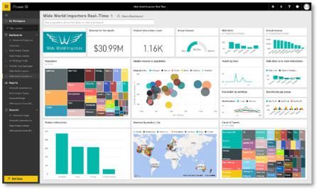

* Set of data visualizations, or charts, from one or more underlying reports.
* When a visualization in a dashboard is connected to a real-time data source, the visualization updates continuously, enabling faster insights.
* May contain visualizations from multiple reports.
* Highly customizable - you may add, or “pin”, any chart from any report to any dashboard.

**Interactive reports**

* Enables anyone to create rich, interactive reports. Reports are the foundation for dashboards.
* Report is a set of charts, also known as visualizations, based on the same underlying dataset
* To create reports that use data from multiple sources, use Power BI Desktop or Power Pivot for Excel with multiple sources, then upload the Power BI Desktop or Excel file to Power BI.
* Construct a report from scratch, select a pre-authored report (such as a report generated in Power BI Desktop), or apply a default report for a given dataset.
* Can be customized - for example, by modifying visualizations in an existing report, or adding new visualizations.
* Once a report contains the desired visualizations, pin the report, or a subset of its contents, to a dashboard for ease of viewing.
* Reports can also be shared with other individuals in an organization, and consumed on both desktop computers and mobile devices.

**Data visualizations**

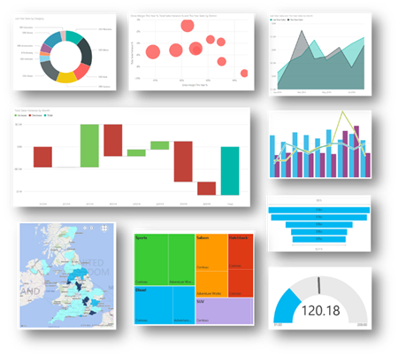

* Dashboards and reports are built using visualizations, or charts.
* Variety of visualization options are available, enabling you to present data in a compelling and visually appealing manner.
* Visualizations include: comparison charts (bar, line, basic area and waterfall charts), composition charts (treemaps, donut and pie charts), mixed comparison and composition charts (stacked charts), relationship charts (bubble charts), geographical charts, and gauges based on a percentage value.
* Use slicers to filter visualizations on the same report page so they display exactly what’s needed.

**Mobile applications**

* Supports live, secure dashboard access on any device through native, interactive apps for Windows, iOS, and Android.
* Dashboard user interface is optimized for smaller displays.
* Setting favorites makes it easier to access specific visualization tiles.
* Zoom in and out of visualizations to look at data more closely.
* Set up alerts, and receive a notification when data exceeds or drops below certain thresholds.
* Take a snapshot of a report or visualization, and make annotations using highlight features.
* Collaborate with others by sharing your annotated snapshot via SMS or email

**Natural Language Query**

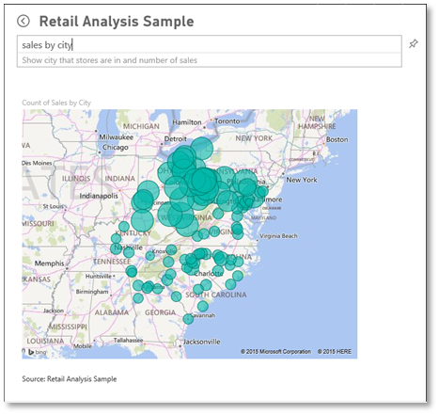

* Let’s you ask questions of your data phrased in plain English, and produces answers in the form of new visualizations, or charts.
* Intelligently filters, sorts, aggregates, groups, and displays data based on key words in the question asked.
* Generates a chart to answer the question, using the data from the underlying reports.
* Pin the chart to the dashboard if desired, and modify it by asking more questions.
* Because a dashboard can contain charts from multiple datasets, your questions can involve data from any one of the datasets.

**Sharing with others**

* By default, all of the data and reports you create and upload are privately visible only to you.
* Dashboards can be easily shared with other users in your organization if needed
* Any subsequent changes to a shared dashboard automatically sync across all users - no manual updates required.
* To control access, you can specify whether another user can share that same dashboard with others.
* Dashboard and the underlying reports are shared in reading view.
* User who accesses the shared dashboard cannot create new reports or save changes to existing reports.
* Users of a shared dashboard cannot see or download a dataset that are used in the dashboard.
* Power BI groups offer a powerful collaborative experience built on Office 365 groups. Team of people can collaborate on dashboards and reports. The datasets for the dashboards and reports reside in the group’s workspace. You can manage your group workspaces directly from within Power BI.

### Power BI data sources

Power BI integrates with a wide range of data sources, including both cloud and on-premises solutions. With a wide variety of data sources, you can quickly and easily connect to SaaS solutions, on-premises data living in SQL Server Analysis Services, Azure services, and Excel and Power BI Desktop files. Using REST APIs, you can even connect to custom data sources, such as proprietary corporate data or external data services.

**SaaS solutions**

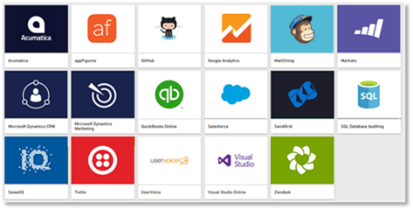

* Users can connect directly to popular SaaS solutions.
* Power BI delivers a seamless user experience through solution-specific “content packs” and automatic data refresh.
* Content packs include pre-configured dashboards, reports, datasets, embedded queries, and metadata.
* Data is refreshed automatically, eliminating the need for time-consuming data provisioning.

**Organizational content packs**

* You can package up and share your own dashboard, reports, and datasets with your coworkers. For example, your finance team can use an organizational content pack to distribute finance data consistently and efficiently to executives across your organization.
* You can create the reports in Power BI and publish them as an organizational content pack to your team.
* Content packs are easy to find - they are all in one location, the content gallery.
* Organizational content packs can be used like the pre-defined content packs available for SaaS solutions, and offer a pre-packaged experience.

**On-premises data sources**

* The Analysis Services Connector functionality built into Power BI allows live queries to SSAS tabular models. There is no need to move data to the cloud or to schedule data refreshes - you can view live data in Power BI dashboards and reports. Communication between the connector and Power BI occurs through Azure Service Bus.
* With Power BI Desktop or Excel, business analysts can import data from a wide range of on-premises data sources and publish it to Power BI.

**Integration with Azure services**

* Power BI integrates with other Microsoft cloud services, including Azure SQL Database, Azure SQL Database Auditing, and Azure Stream Analytics.
* By extending existing Azure services capabilities into Power BI, you can build seamless, end-to-end BI solutions. For example, you can use Azure Stream Analytics to process streaming data, then push the data into Power BI, enabling real-time dashboard updates.

**Excel and Power BI Desktop files**

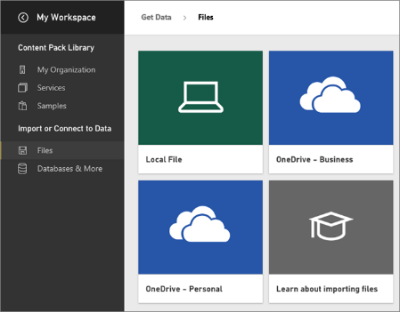

* Excel and Power BI Desktop files may be published directly to Power BI with a single click, where you can create dashboards and reports based on the data.
* When a file is uploaded, Power BI may automatically enhance the data by detecting key characteristics. For example, if a table in an uploaded Excel file includes a date field, Power BI may automatically create month and year columns to facilitate reporting based on those elements.
* Loading files from Power BI Desktop enables you to surface data from a variety of sources that do not directly connect to Power BI. For example, if you want to use Power BI to explore data from Facebook, a SharePoint list, or from your SAP system.

### Gateway for the on-premises data

With Power BI gateways, you can keep your data fresh by connecting to on-premises data sources. Query large data sets while leveraging your existing investments. The gateways provide the flexibility you need to meet individual needs, and the needs of your organization.

* **Power BI Gateway – Personal**: Refresh your on-premises data quickly without waiting for an IT Admin. Designed for use with personal data sets, there is no central monitoring capabilities for this gateway.
* **Power BI Gateway - Enterprise (preview)**: This gateway is used by organizations to serve a large number of users. It also enables administrators to set up access control for individual data sources and monitor usage.

### Important Terms

* A ***dataset*** is data uploaded into the Power BI service from an online or on-premises data source.
* A ***data source*** is where the data actually comes from. It can be just about anything; a database, Excel worksheet, Web service, etc.
* The ***gateway*** is different from a data source. The gateway is more of the proxy between on-premises and the cloud.
* ***DirectQuery*** always gets the latest data using the credentials that were setup for the Data Source by the Gateway Admin.

### Resources

* [Power BI - Overview and Learning](https://support.office.com/en-us/article/Power-BI-Overview-and-Learning-02730e00-5c8c-4fe4-9d77-46b955b71467)
* [Power BI - basic concepts](https://support.powerbi.com/knowledgebase/articles/487029-power-bi-preview-basic-concepts)
* [Get started with Power BI](https://support.powerbi.com/knowledgebase/articles/430814-get-started-with-power-bi)
* [Propelling digital transformation in manufacturing operations with Power BI](https://www.microsoft.com/en-us/download/details.aspx?id=54523)
* [Get data for Power BI](https://support.powerbi.com/knowledgebase/articles/434354-get-data-for-power-bi)
* [Power BI Blog](http://blogs.msdn.com/b/powerbi/)
* [Power BI Personal Gateway](http://www.microsoft.com/en-us/download/details.aspx?id=47753)
* [Power BI Gateway - Enterprise (Preview)](https://powerbi.microsoft.com/en-us/documentation/powerbi-gateway-enterprise/)
* [Microsoft Power BI Desktop](http://www.microsoft.com/en-us/download/details.aspx?id=45331)
* [Microsoft Power BI Analysis Services Connector](http://www.microsoft.com/en-us/download/details.aspx?id=45333)
* Download a Power BI app:
* The [iPad app](https://powerbi.microsoft.com/en-us/documentation/powerbi-mobile-ipad-app-get-started/) (Power BI for iOS)
* The [iPhone app](https://powerbi.microsoft.com/en-us/documentation/powerbi-mobile-iphone-app-get-started/) (Power BI for iOS)
* The [Power BI app for Windows](https://powerbi.microsoft.com/en-us/documentation/powerbi-service-windows-app-get-started/) devices (not Windows phones)
* The [Power BI app for Android](https://powerbi.microsoft.com/en-us/documentation/powerbi-mobile-android-app-get-started/) phones

## MyAnalytics

The decisions that each individual employee in an organization makes each day add up to a tremendous impact on the success or failure of an organization. We know that our most scarce resource is time, and when we make decisions on how to use our time we are literally choosing where to spend the capital of our organization. Now with the power of big data, we have a massive opportunity to understand how organizations work, and to optimize processes, activities, and interactions for the highest impact.

By understanding the building blocks on how work gets done – communication and collaboration – MyAnalytics creates a source of innovation and competitive advantage for individuals and organizations. The power of this capability is when it is harnessed in the context of a business or strategic initiative and leadership is seeking to solve a particular business problem.

### Features

**Personal work analytics dashboards**

* Monitor personal dashboards the vital stats of your work
* Understand where you are spending time
* Establish feedback loops and set targets and monitor benchmarks
* Receive recommendations for ways to get your time back and spend it more effectively

**Team analytics dashboards**

Aggregated and anonymous data about teams of a certain size can help managers understand important aspects about the team is executing.

* Aggregated and anonymous data from your team
* Understand where time is going across your team
* Ensure your team is focused on the right activities for success

**Analytics Platform & APIs**

Pursue industry or initiative specific analysis with the analytics platform and API component of the offer.

* Customize dashboards with additional data sources
* Support business initiatives with data driven analysis
* Target specific queries with customized analysis

### MyAnalytics Dashboard and Outlook add-in

MyAnalytics helps you understand how you collaborate with colleagues and spend your time at work. The dashboard gives you the tools you need to help you prioritize work and spend time more effectively. You can set weekly goals and measure your progress over time. The Outlook add-in gives you insight on how your colleagues respond to you in email.

Only you have access to your MyAnalytics dashboard and Outlook add-in. **MyAnalytics does not include any settings that provide your manager or anyone else in your organization access to your dashboard or add-in**.

**What data do the personal dashboard and the Outlook add-in use?**

MyAnalytics uses information from your Office 365 mailbox and calendar, such as how many emails you send and receive from different recipients, and meeting duration. However, we don't collect content from the email body or calendar descriptions.

**Can I opt out of MyAnalytics and the Outlook add-in?**

You can opt out of your data being used to calculate aggregate statistics for your organization. For example, if you opt out, your data will not be used to calculate statistics on the average time people in your organization spend in meetings, or the percentage of recipients who have read an email.

* If you opt out, you will no longer be able to access your personal dashboard or the Outlook add-in.
* You can opt back in any time. You'll get access to your personal dashboard and the Outlook add-in.

#### How are statistics calculated?

**Meeting Hours**

|  |  |
| --- | --- |
| What you see | Shows how much time you spent in meetings. |
| Where the data comes from | Your data is collected from your Office 365 calendar. Company averages are based on aggregated data from other users in your organization. |
| How it's calculated | The statistics are based on meetings in your calendar that you've accepted, and where your status is set to **Busy**. The following meetings are *not included*:   * Meetings with no other participants than yourself, for example when you block time in your calendar or set reminders. * All-day meetings. * Meetings marked as **Private**. * Meetings with more than 500 attendees. |

**Email Hours**

|  |  |
| --- | --- |
| What you see | An estimate of how much time you spent sending and reading emails. See how these compare to the company average and to your personal goals. |
| Where the data comes from | Your data is collected from your Office 365 mailbox. Company averages are based on aggregated data from other users in your organization. |
| How it's calculated | The main rules are:   * For each email you write (send), we assign 5 minutes. * For each email you read (open), we assign 2.5 minutes.   However, there are exceptions:   * If you send one email and then open or send another one within 5 minutes, we assign the time between the two actions to the first email. * If you open an email and then open or send another one within 2.5 minutes, we assign the time difference between the two actions to the first email. |

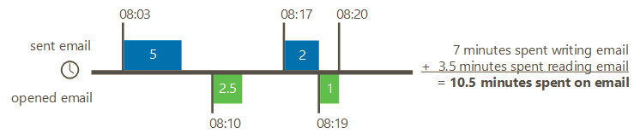

* We register email across all devices, such as laptop or mobile phone.
* We only include emails where your name, or a group you’re a member of, is on the To or Cc lines.
* We don’t count emails you delete without opening.
* Email that you read or write outside the defined work hours are included in After hours.

**Focus Hours**

|  |  |
| --- | --- |
| What you see | Focus hours are defined as at least two consecutive hours of time without meetings. |
| Where the data comes from | Your data is collected from your Office 365 calendar. |
| How we calculate the numbers | * Sums up the total number of hours in your calendar where you have at least two consecutive hours without meetings. * Only includes focus hours within your defined work hours. * Sending or receiving emails during focus hours doesn’t interfere with the focus hour calculation. |

**After Hours**

|  |  |
| --- | --- |
| What you see | Shows time spent on email and in meetings outside defined work hours, for example emails read or sent on weekends. |
| Where the data comes from | Your data is collected from your Office 365 calendar and mailbox. Company averages are based on aggregated data from other users in your organization. |
| How we calculate the numbers | See Meetings hours and Email hours tables above. |

#### MyAnalytics Outlook add-in

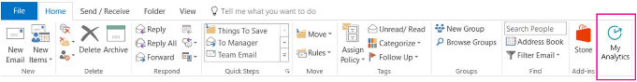

The MyAnalytics Outlook add-in helps you understand the reach of your emails and your relationships with colleagues.

* For emails you **send**, the add-in shows the number of people who have read, forwarded, and replied, as well as a lifespan chart showing the email’s read activity. You’ll only see these statistics for emails you’ve sent to at least five people, and you can’t identify who read or forwarded the email.
* For emails you **receive**, the add-in gives you information about your relationships with colleagues, including the number of emails you’ve exchanged, your average response times, and the percentage of their email you read. Only you have access to your personal relationship statistics.

#### No statistics available - why?

**For privacy reasons**, you will not be able to identify individual people from the MyAnalytics Outlook add-in. This means that MyAnalytics does not display statistics for emails sent to fewer than five people or show that 100% of recipients read an email.

|  |  |
| --- | --- |
| Too few recipients | We only show statistics for emails that are sent to at least five people. |
| Too few qualified recipients | We only show statistics for emails that are sent to at least five people who are also *qualified* for statistics. Qualified people are people within your organization who use Office 365 and Outlook/OWA, and who are **not**:   * Opted out of **MyAnalytics**. * Excluded from MyAnalytics (for example legal departments). |
| Too old | We don't show read statistics for emails that are older than seven days. |
| Too new | It takes some time to generate statistics for recent emails. |
| Low read activity | Fewer than two people have read the email. Check back later once more people have read the email. |
| 100% read your email | For privacy reasons, MyAnalytics does not provide an exact read rate when 100% (or close to 100%) of recipients read your email. The message will say: **Essentially everyone read your email.** |
| You opted out of MyAnalytics | If Delve isn’t permitted to use your email and meeting information, you will not see any statistics. You can opt in through **Feature settings** in Delve. |

### How can these statistics help my work?

With insights about how effective your communication is, you can evaluate and make changes if necessary.

Check your read rate frequently to improve email effectiveness over time. For example, if a weekly digest email has low read rate, try these recommendations:

* Send it on a different day of the week to see if more people read it.
* Consider increasing the number of recipients or changing the recipient list.
* Try using different subject lines to engage your recipients or shorten the content to make it easier to read.
* Test new ways of broadcasting your message - maybe email isn't the best medium.

### MyAnalytics tips

These tips that can help you spend your time better and focus on what's important in your work. All tips aren't for everyone. What you can and should do always depends on your role and the organization you work in.

#### Meetings

Fewer meetings, shorter meetings, or more focused meetings. These are some options if you want to save time spent in meetings.

* Send recaps instead of invitations
* Shorten your meetings
* Rethink recurring meetings
* Rethink the attendee list
* Discourage “business tourism”

#### Email

Pick up the phone, don't "reply all", or unsubscribe from email lists that aren't useful, are some alternatives for what you can do if you see that you spend too much time on emails.

* Remove unnecessary email recipients
* Send fewer emails - use Skype or pick up the phone
* Unsubscribe from groups that you don’t read
* Spare others' inboxes

#### After hours

Be a thoughtful coworker!

* Condense emails and status updates with daily or weekly digests for “inform” type emails. This reduces the overall noise and randomization caused by email overload.
* Save drafts or delay delivery for email until the recipients’ normal business hours. Limit late night/early morning email to urgent email to cut through the noise.
* Turn off notifications on your phone and desktop when you are trying to focus.

As a team:

* For example: No meetings Wednesdays
* Agreed upon “team hours”
* Be respectful of people’s  time
* Be intentional of meeting overruns and who you invite

#### Focus time

We define focus time as at least two consecutive hours of time without meetings. Focus time is meant to represent enough time so you can focus on deliverables or complete other important tasks.

* Block focus time on your calendar
* Fewer meetings
* More time for fostering relationships can translate to higher levels of productivity
* Make time for what's important

### Resources

* [Learn more about the way you work with MyAnalytics](https://support.office.com/en-US/article/Learn-more-about-the-way-you-work-with-Delve-Analytics-23462129-e512-40ee-acad-d968916c31b8)
* [MyAnalytics Outlook add-in](https://support.office.com/en-us/article/Delve-Analytics-Outlook-add-in-e305ae2d-6f16-4688-b2b0-487c4c2d067b?ui=en-US&rs=en-US&ad=US)
* [MyAnalytics Dashboard and Outlook add-in](https://support.office.com/en-us/article/Delve-Analytics-Dashboard-and-Outlook-add-in-c52d090c-a4fc-478c-b027-757ed86d5993?ui=en-US&rs=en-IN&ad=IN)
* [MyAnalytics Tips](https://support.office.com/en-us/article/Delve-Analytics-Tips-bbe5903a-1ef1-495d-938f-a9afa2ec1e97?ui=en-US&rs=en-US&ad=US)
* [MyAnalytics for Office 365 admins](https://support.office.com/en-US/article/Delve-Analytics-for-Office-365-admins-77590915-6eb0-47a6-a72f-8116cfcfc2c7)

## Office 365 ProPlus (Office)

Office 365 ProPlus is the new Office, Office as a service. Office 365 ProPlus has the full set of application experiences you are used to, fully-customizable and available without a connection to the Internet but, it is licensed, deployed and updated as a service.

Full suite of rich productivity apps with the added value of a service.

**Cloud** – The ubiquity of the cloud shifts us from a world of individual creation to real-time, anytime, anywhere, collaboration and collective creation.

* Office 365 ProPlus roams documents and settings across your devices - so your dictionary and theme settings, your recent documents, as well as the last page or slide you were working on go with you. So users can switch from device to device and maintain cohesive, productive experience.
* Connected people are productive people. Office 365 keeps people connected to one another, and to content and data. Office 365 ProPlus is the front-end to a productivity platform to share, collaborate and create wherever, whenever.
* Office 365 ProPlus is updated like a service, with frequent, non-disruptive updates, for faster value delivery to users

**Mobility** – The cloud powers our devices. We believe in a truly mobile world that revolves around us so that any device can become your device.

* As a user-based service, Office 365 ProPlus allows each person to install on multiple devices. Up to 5 PCs of Macs, 5 tablets and 5 smartphones.
* Per-user licensing provides business agility as your business grows and doesn’t penalize you for living a device-rich lifestyle.

**Deployment** – Full control of your Office

* Streaming from the cloud, Office 365 ProPlus can be up and running in 2-3 minutes. But moving to Office 365 ProPlus does not mean that you have to give up control over software updates. You can still use your existing software management tools and processes.
* As a service, Office 365 ProPlus uses smaller, easily managed updates instead of large, complex upgrades.
* Office 365 ProPlus can help free up IT time and resources to focus on other value added products.

### Change Management for Office 365 Clients

Both Windows 10 and Office 365 have adopted the servicing model for client updates. This means that new features, non-security updates, and security updates are released regularly, so your users can have the latest functionality and improvements. The servicing model also includes time for enterprise organizations to test and validate releases before adopting them.

For the Office 2016 version of Office 365 ProPlus, Microsoft provides you three options, called update channels, to control how often Office 365 ProPlus is updated with new features. Here's an overview of the three options.

| Update channel | Primary purpose |
| --- | --- |
| Current Channel | Provide users with the newest features of Office as soon as they're available. |
| Deferred Channel | Provide users with new features of Office only a few times a year. |
| First Release for Deferred Channel | Provide pilot users and application compatibility testers the opportunity to test the next Deferred Channel. |

| Update channel | Feature updates | Security updates | Non-security updates |
| --- | --- | --- | --- |
| Current Channel | Monthly | Monthly | Monthly |
| Deferred Channel | Every four months | Monthly | Every four months |
| First Release for Deferred Channel | Every four months | Monthly | Monthly |

**What’s in it for Enterprise Organizations?**

You want up-to-date features, but you also want the control and support you need to run your business. With the variety of release programs and branches for Windows 10 and Office 365, you can evaluate new features, pilot them with specific groups in your organization, and then deploy them widely to your organization. You can also keep specialty systems on a long-term build for control. Use the update option that’s right for your devices and your business needs.

**Focus on your business, not managing the software**

The following table explains ways you can focus on your business, not managing the software, with the Office 365 client applications

|  |  |
| --- | --- |
| **Stay up to date** | Regular updates mean your users’ phones, tablets, and desktops stay up to date with the latest fixes. |
| **Mix and match programs** | Follow your business needs – not all systems need to follow the same deployment model. You can even use different models for Windows and Office on the same devices. |
| **Save on management** | Allow automatic updates to the fully tested Current Branch for Business (Windows) and Deferred Channel (Office 365) instead of managing the software packages yourself. |
| **Stay in the loop** | See what’s coming in the next releases and find out what security updates have been included by reviewing communications from Microsoft. |
| **Manage risk** | Use Current Branch for Business (Windows) and Deferred Channel or First Release for Deferred Channel (Office 365) to test critical line-of-business applications that must remain up and running. |
| **Save on development** | First, check the marketplace – others may have a solution that works. If you need custom development, use best practices to ensure add-ins work after updates. |

**Security, always**: You’ll always get the latest security updates, no waiting, whichever program you choose.

**Default Branches for Client Applications**

Office 365 includes different sets of client applications. Office 365 Business includes the core Office applications (Word, Excel, PowerPoint, Outlook, OneNote, and Publisher), and Office 365 ProPlus includes the core applications plus Skype for Business and Access. Project Online Desktop Client and Visio Pro for Office 365 also follow this release model.

By default, the client applications for Office 365 are set to these channel releases:

* **Office 365 Business, Project Online Desktop Client, and Visio Pro for Office 365** are set to use Current Channel.
* **Office 365 ProPlus** is set to use Deferred Channel

|  |
| --- |
| **Note**: Learn more about what’s new for Office 365 subscribers this month at: [Office 2016](https://support.office.com/article/95c8d81d-08ba-42c1-914f-bca4603e1426) | [Office for Mac](https://support.office.com/article/44d5a464-3051-41b0-b44e-c6cee569f545) | [Office Mobile for Windows](https://support.office.com/article/88d3ef79-4f5d-4042-a447-f632d1d497ea) | [Office for iPhone and iPad](https://support.office.com/article/2918baf9-2605-410c-855b-f33074090765) | [Office on Android](https://support.office.com/article/137414f2-6505-4240-ae20-c5e4a9ba7189). |

### Resources

**Microsoft Virtual Academy courses**

* [Office 365 ProPlus: What’s New in 2016 and Beyond](https://mva.microsoft.com/en-us/training-courses/office-365-proplus-whats-new-in-2016-and-beyond-14065?l=6k9rJAomB_9800115881)
* [Office 365 ProPlus Deployment Deep Dive](https://mva.microsoft.com/en-US/training-courses/office-365-proplus-deployment-deep-dive-14066?l=iwlCsZLsB_6805368485)

**Watch Videos** …

* [Office 2016 and the new servicing options for Office 365 admins demo](https://www.youtube.com/watch?v=vg23LyfSAV8) - Duration: 4 minutes, 54 seconds.
* [Office 2016 setup and deployment updates demo](https://www.youtube.com/watch?v=TNHyHnedY4E) - Duration: 4 minutes, 9 seconds.
* [Office 2016 security updates demo - DLP, MFA & sharing from Outlook](https://www.youtube.com/watch?v=Tc85-ZS7bIc) - Duration: 3 minutes, 35 seconds.
* [Office 2016 real-time co-authoring and how it works demo](https://www.youtube.com/watch?v=slGxMLOPy7E)

**Read** …

* [What's new and improved in Office 2016 for Office 365](https://support.office.com/en-in/article/What-s-New-and-Improved-in-Office-2016-95c8d81d-08ba-42c1-914f-bca4603e1426?ui=en-US&rs=en-IN&ad=IN)
* [Overview of Office 365 ProPlus](https://technet.microsoft.com/en-us/library/gg702619.aspx)
* [Office 365 for business training](https://support.office.com/en-in/article/Office-365-for-business-training-e990f8ff-56d7-450e-ad9f-74ae8718ef09?CorrelationId=c4ea07fa-aa2e-43f1-b53e-249b5595edce&ui=en-US&rs=en-IN&ad=IN)
* [Office 2016 Quick Start Guides and downloadable guides](https://support.office.com/en-us/article/Office-2016-Quick-Starts-25f909da-3e76-443d-94f4-6cdf7dedc51e#ID0EAADAAA=Business_and_Education)
* [Collaborate on Word documents with real-time co-authoring](https://support.office.com/en-us/article/Collaborate-on-Word-documents-with-real-time-co-authoring-7dd3040c-3f30-4fdd-bab0-8586492a1f1d?ui=en-US&rs=en-US&ad=US)
* [Collaborate on PowerPoint presentations with co-authoring](https://support.office.com/en-us/article/Collaborate-on-PowerPoint-presentations-with-co-authoring-0c30ee3f-8674-4f0e-97be-89cf2892a34d?ui=en-US&rs=en-US&ad=US)
* [Getting started with Word 2016](https://www.microsoft.com/en-us/download/details.aspx?id=54126)
* [Getting started with Excel 2016](https://www.microsoft.com/en-us/download/details.aspx?id=49130)
* [Managing your email and calendar on the go with Outlook 2016](https://www.microsoft.com/en-us/download/details.aspx?id=54127)

**For Admins …**

* [New Office 365 ProPlus deployment guide for IT pros](https://blogs.office.com/2016/12/19/new-office-365-proplus-deployment-guide-for-it-pros-now-available/)
* [Determine the deployment method to use for Office 365 ProPlus](https://technet.microsoft.com/EN-US/library/gg998766.aspx)
* [Overview of update channels for Office 365 ProPlus](https://technet.microsoft.com/EN-US/library/mt455210.aspx)
* [Prepare to update Office 365 ProPlus to the Office 2016 version](https://technet.microsoft.com/EN-US/library/mt422981.aspx)
* [Change management for Office 365 clients](https://technet.microsoft.com/library/mt584223). [Model](http://www.microsoft.com/en-us/download/details.aspx?id=49141)
* [Updated Office 365 modern authentication public preview](https://blogs.office.com/2015/11/19/updated-office-365-modern-authentication-public-preview/)

## Office 2016 for Mac

Microsoft Office 2016 for Mac enables you to do your best work – anywhere, anytime and with anyone. New, modern versions of Word, Excel, PowerPoint, Outlook, and OneNote have the familiar look and feel of Office, and are thoughtfully designed for Mac.

**Unmistakably Office, designed for Mac**

Get started quickly with new, modern versions of Word, Excel, PowerPoint, Outlook and OneNote – combining the familiarity of Office and the unique Mac features you love.

* The redesigned **Ribbon menu** organizes features in a similar way as Office for Windows and iPad, so you can quickly find what you need.
* The new **task pane** interface makes complex tasks easy, like formatting images in Word, designing animations in PowerPoint, and inserting formulas in Excel.
* Office offers unequaled **file compatibility and layout fidelity**. Documents will look how you intended in Office on Mac, PC, tablet and phone.
* Your document’s text and graphics are beautifully rendered and sharper than ever on your Mac’s **Retina display**, and presentations look absolutely stunning.
* Navigate your documents, spreadsheets and presentations intuitively with familiar **Multi-Touch gestures**.

**Do your best work, anywhere, anytime**

The new Office for Mac is cloud-connected, so you can create great-looking documents, gain new insights, and present with confidence - anywhere, anytime.

* Access your files whenever you need to, thanks to **integration with OneDrive, OneDrive for Business and SharePoint**.
* With **roaming recent files**, you can quickly pick up from where you left off on any device.
* The new **Insights pane** in Word, powered by Bing, shows relevant contextual information from the Web within the reading and authoring experience.
* Excel takes the guesswork out of visualizing your data: it **recommends charts** best suited for your numbers, and lets you preview different options.
* **Presenter View** in PowerPoint gives you the tools to present with confidence – displaying the current slide, next slide, speaker notes and a timer on your Mac, while projecting only the presentation to your audience on the big screen.
* Outlook automatically organizes your inbox in **conversations**, without inadvertently including messages with the same subject that belong to a different conversation.

**Made for teamwork**

Get more done by working together using built-in tools to share, review and co-edit documents, presentations and notes.

* Easily **share your documents** and invite others to review or edit them.
* **Co-authoring** in Word and PowerPoint enables several people to work simultaneously in the same document from different devices in different locations.
* **Threaded comments** in Word and PowerPoint enable you to have useful conversations right next to relevant text. You can quickly see who replied to whom and when.
* The new **Conflict Resolution view** in PowerPoint lets you visually compare conflicting changes, so you can easily decide what version to keep.
* **Share a OneNote notebook** with friends, family or colleagues so everyone can add their notes and work together on travel plans, household tasks or work projects.

### Touch Bar support

Through the Touch Bar, Office intelligently puts the most common commands at your fingertips—all based on what you’re doing in the document.

**Word**

From the Touch Bar you can enter **Word Focus Mode**, a brand-new experience that hides all of the on-screen ribbons and commands so you can simply focus on your work. One tap and you can quickly apply a new style to a heading or paragraph.

**PowerPoint**

Touch Bar commands in PowerPoint allow you to easily manipulate graphic elements. The Reorder Objects button produces a graphical map of all the layers on a slide, making it easy to find the right object and move it where you want it. And by sliding your finger across the Touch Bar you can easily rotate an object to get just the right angle.

**Excel**

Typing an equals sign into a cell in Excel immediately pulls up the most recently used functions in the Touch Bar. For example, with a tap (for the formula) and another tap (for a named range) in the Touch Bar, you can quickly sum a range in your spreadsheet. The Touch Bar also provides quick access to borders, cell colors and recommended charts—making it easier than ever to organize and visualize your data.

**Outlook**

The Touch Bar in Outlook provides quick access to the most commonly used commands as you work on email and manage your calendar. When composing a new mail, the Touch Bar displays a list of recent documents. One tap and you can add a file—either as an attachment or a link. And from the Today view on the Touch Bar you can not only see your calendar events for the day, but even join a Skype for Business meeting.

Read more at: [Office for Mac adds Touch Bar support](https://blogs.office.com/2016/10/27/office-for-mac-adds-touch-bar-support/).

### Resources

* Watch: [Office 2016 for Mac: Top 10 reasons to get the new version​](https://www.youtube.com/watch?v=iMTKbWix3k4)
* [Download and install Office 2016 for Mac using Office 365 for business](https://support.office.com/en-us/article/Download-and-install-Office-2016-for-Mac-using-Office-365-for-business-2eb5e0ad-eb5f-418c-a476-81be30e6fe4e?ui=en-US&rs=en-US&ad=US)
* [Outlook 2016 for Mac training](https://support.office.com/en-in/article/Outlook-2016-for-Mac-training-bdb79e7d-7a7f-4265-b7a5-75bf416e382e)
* [Word 2016 for Mac training](https://support.office.com/en-in/article/Word-2016-for-Mac-training-5913b68c-640a-4db1-8665-82ad0e6895fa)
* [Excel 2016 for Mac training](https://support.office.com/en-in/article/Excel-2016-for-Mac-training-7d77385f-9b97-41c6-b43e-6b11a4d4520f)
* [PowerPoint 2016 for Mac training](https://support.office.com/en-in/article/PowerPoint-2016-for-Mac-training-9fe951b1-df67-4fb5-bf87-f1814a73bb99)
* [OneNote 2016 for Mac training](https://support.office.com/en-in/article/OneNote-2016-for-Mac-training-a8dd68eb-3267-48ae-bbb0-4ad037306398)

## Office on iOS, Android, Windows

Office for mobile device provides the same look and feel as Office on your desktop. Office also provides the same ability to store and share data on the cloud through Microsoft OneDrive for Business, allowing you to create, share, and edit data quickly and easily, even when you are on the go.

### Setup Mobile Device

Office 365 Windows Phone setup

* [Set up email on Windows Phone](https://support.office.com/en-us/article/Set-up-email-on-a-Windows-Phone-181a112a-be92-49ca-ade5-399264b3d417)
* [Set up Office on Windows Phone with Office 365](https://support.office.com/en-us/article/Set-up-Office-on-a-Windows-Phone-96e8a54c-2a5b-46af-955c-111166d77489)

Office 365 iPhone or iPad setup

* [Set up email on iPhone, iPad, or iPod Touch](https://support.office.com/en-us/article/Set-up-email-on-an-iPhone-or-iPad-b2de2161-cc1d-49ef-9ef9-81acd1c8e234)
* [Install and set up Office on an iPhone or iPad with Office 365](https://support.office.com/en-us/article/Set-up-Office-on-an-iPhone-or-iPad-9df6d10c-7281-4671-8666-6ca8e339b628)

Office 365 Android phone or tablet setup

* [Set up email on an Android phone or tablet](https://support.office.com/en-us/article/Set-up-email-on-an-Android-phone-or-tablet-886db551-8dfa-4fd5-b835-f8e532091872)
* [Install and set up Office on an Android with Office 365](https://support.office.com/en-us/article/Set-up-Office-on-an-Android-cafe9d6f-8b0c-4b03-b20a-12438a82a22d)

After you have installed the Office apps, you can sign in with the Microsoft account that is connected to your Office 365 subscription to use the premium features of each app.

### Resources

* [How Office mobile apps work on Android or iOS devices with an Office 365 plan](https://support.office.com/en-in/article/How-Office-mobile-apps-work-on-Android-or-iOS-devices-with-an-Office-365-plan-9ef8b63a-05fd-4f9c-bac5-29da046833ea?ui=en-US&rs=en-IN&ad=IN)
* [Office for iPad videos](https://support.office.com/en-US/Article/Office-for-iPad-videos-de134bdb-b024-4a29-a1c7-706133b55bd7)
* [Office for iPhone videos](https://support.office.com/en-US/article/Office-for-iPhone-videos-0c4b6fdd-68e9-475e-a93e-c8b7e1e6fd37)
* [Getting started with Word for Android tablet](https://support.office.com/en-us/article/Video-Getting-started-with-Word-for-Android-1aaaa121-99a7-426d-af6a-ee1611002dca)
* [Getting started with Excel for Android tablet](https://support.office.com/en-us/article/Video-Getting-started-with-Excel-for-Android-c5d5c135-0bc1-4aea-9b54-95a518dd0c11)
* [Getting started with PowerPoint for Android tablet](https://support.office.com/en-us/article/Video-Getting-started-with-PowerPoint-for-Android-1ca4c589-217b-4762-ae20-d1877555b8c1)

## Sway

Sway is an intelligent digital storytelling app for business that helps you and your colleagues express ideas using an interactive, web-based canvas. Sway’s built-in design engine helps you produce professional, visually-appealing reports, presentations, and more without the need for extensive formatting or additional training.

You can also modify the results to get the unique look and feel you want. Sway makes your creation look great in any browser on any screen, and it can be shared with colleagues and customers by simply sending a link. Sway helps you find and pull together all sorts of content without leaving the app, so you can drag and drop your images, text, videos, and charts right on to your canvas.

### Resources

Microsoft Sway Tutorials

* [The Sway Way](https://www.youtube.com/watch?v=2CwjBK2ENdk)
* [How to Build a Presentation in Sway](https://www.youtube.com/watch?v=U8WOSQ-z6VA)
* [How to Build a Presentation in Sway - Part 2](https://www.youtube.com/watch?v=Np5Gc_7pb5I)
* [How to Collaborate on a Sway​](https://www.youtube.com/watch?v=zfBTecFGokI)
* [How to Create a Newsletter in Sway](https://www.youtube.com/watch?v=Qq7FaWkMAiY)
* [How to Make a Tutorial in Sway](https://www.youtube.com/watch?v=mf2YzUEbUlM)
* [How to Share a Sway​](https://www.youtube.com/watch?v=C5Z3kDACq2M)

## Exchange Online Protection (EOP)

Microsoft Exchange Online Protection (EOP) is a cloud-based email filtering service that helps protect your organization against spam and malware, and includes features to safeguard your organization from messaging-policy violations. EOP can simplify the management of your messaging environment and alleviate many of the burdens that come with maintaining on-premises hardware and software.

The following are the primary ways you can use EOP for messaging protection:

* **In a standalone scenario.**   EOP provides cloud-based email protection for your on-premises Exchange Server 2013 environment, legacy Exchange Server versions, or for any other on-premises SMTP email solution.
* **As a part of Microsoft Exchange Online.**   By default, EOP protects Exchange Online cloud-hosted mailboxes.
* **In a hybrid deployment.**   EOP can be configured to protect your messaging environment and control mail routing when you have a mix of on-premises and cloud mailboxes.

### Features

**Anti-malware protection**

* Using multiple anti-malware engines, EOP offers multilayered protection that’s designed to catch all known malware
* Messages transported through the service are scanned for malware (viruses and spyware)
* If malware is detected, the message is deleted. Notifications may also be sent to senders or administrators when an infected message is deleted and not delivered.
* Customize anti-malware policies in the EAC. You can configure the default policy for company-wide settings.
* Create custom content filter policies and apply them to specified users, groups, or domains in your organization

**Anti-spam protection**

* Uses proprietary anti-spam technology to help achieve high accuracy rates.
* Provides strong connection filtering and content filtering on all inbound messages.
* Outbound spam filtering is also always enabled if you use the service for sending outbound email.
* Spam filtering cannot be completely disabled, but certain company-wide settings can be modified by editing your default anti-spam policies
* Create custom content filter policies and apply them to specified users, groups, or domains in your organization.

**Quarantine**

* Messages identified as spam and messages that match a transport rule can be sent to the administrator quarantine.
* Administrators can search for and view details about quarantined email messages in the EAC.
* After locating the email message, you can release it to specific users and optionally report it as a false positive (not junk) message to the Microsoft Spam Analysis Team if it was misidentified as spam.
* Spam quarantine for end users lets them manage their own spam-quarantined messages.

**Junk Email Reporting**

* From Office Outlook or Outlook Web Access, lets EOP users easily report junk (spam) email to Microsoft for analysis to help reduce the number and impact of future junk email messages filtered by the service.

### Resources

**Microsoft Virtual Academy Courses** …

* [Office 365 Security & Compliance: Exchange Online Protection](https://mva.microsoft.com/en-us/training-courses/office-365-security-compliance-exchange-online-protection-8415)

**Read** …

* [Exchange Online Protection](https://products.office.com/en-us/exchange/microsoft-exchange-online-protection-email-filter-and-anti-spam-protection-email-security-email-spam)
* [Exchange Online Protection Service Description](https://technet.microsoft.com/en-us/library/exchange-online-protection-service-description.aspx)
* [Exchange Online Protection Limits](https://technet.microsoft.com/EN-US/library/exchange-online-protection-limits.aspx)
* [Anti-Malware Protection](http://go.microsoft.com/fwlink/p/?LinkId=282244) and [Anti-Malware Protection FAQ](http://go.microsoft.com/fwlink/p/?LinkId=320401)
* [Anti-Spam Protection](http://go.microsoft.com/fwlink/p/?LinkId=271754) and [Anti-Spam Protection FAQ](http://go.microsoft.com/fwlink/p/?LinkId=320403)
* [Prevent false positive email marked as spam with a safelist or other techniques](https://support.office.com/en-in/article/Prevent-false-positive-email-marked-as-spam-with-a-safelist-or-other-techniques-74aaade0-efc0-46ac-b949-f2d1d59256fa)
* [What's the Difference Between Junk Email and Bulk Email?](http://technet.microsoft.com/en-us/library/dn720441(v=exchg.150).aspx)
* [Customize an SPF record to validate outbound email sent from your domain](http://technet.microsoft.com/en-us/library/dn789058(v=exchg.150).aspx)
* [Backscatter Messages and EOP](http://technet.microsoft.com/en-us/library/dn499795(v=exchg.150).aspx)

## Advanced Threat Protection (ATP)

Advanced threat protection (ATP) in Exchange Online Protection (EOP) helps you **prevent zero-day malware attacks** in your email environment.

ATP provides a way for you to create policies in the Exchange Admin Center (EAC) that help ensure your users access only links in emails or attachments to emails that are identified as not malicious.

If you already use EOP to help combat malware in your email messaging environment, adding ATP will provide more-effective protection than ever before against attacks propagated by unsafe links and unsafe attachments.

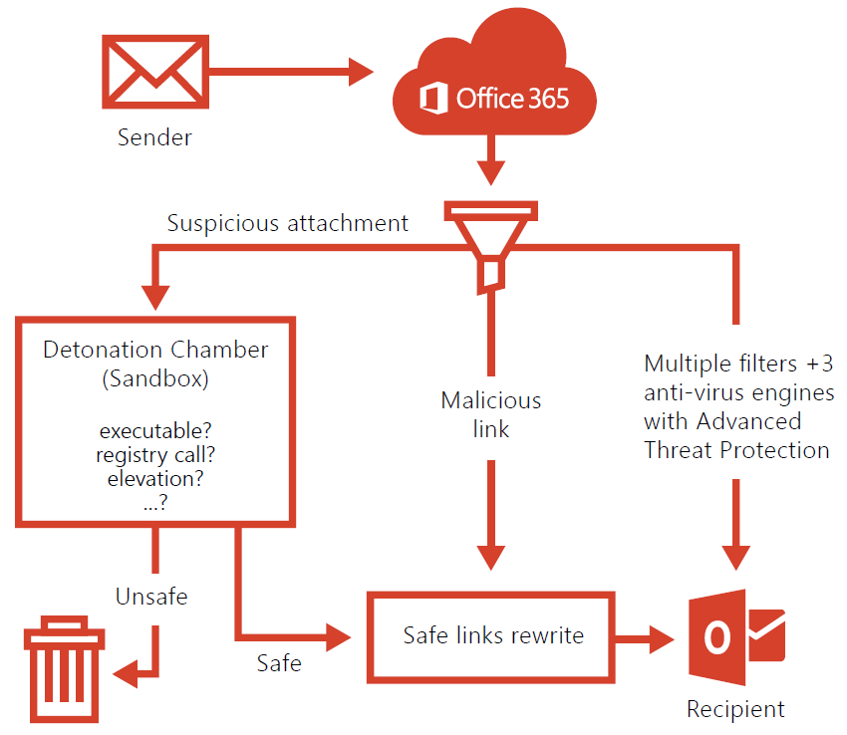

ATP complements existing EOP anti-malware scanning. Only those attachments that successfully pass anti-malware scanning are affected by your safe attachments or safe links policies.

### Features & Benefits

ATP for Exchange Online delivers the following benefits:

* **Protection against unknown malware and viruses**—Today EOP employs a robust and layered anti-virus protection powered with three different engines against known malware and viruses. ATP extends this protection through a feature called Safe Attachments, which protects against unknown malware and viruses, and provides better zero-day protection to safeguard your messaging system. All messages and attachments that don’t have a known virus/malware signature are routed to a special hypervisor environment, where a behavior analysis is performed using a variety of machine learning and analysis techniques to detect malicious intent. If no suspicious activity is detected, the message is released for delivery to the mailbox.
* **Real time, time-of-click protection against malicious URLs**—EOP scans each message in transit in Office 365 and provides time of delivery protection, blocking any malicious hyperlinks in a message. But attackers sometimes try to hide malicious URLs with seemingly safe links that are redirected to unsafe sites by a forwarding service after the message has been received. ATP’s Safe Links feature proactively protects your users if they click such a link. That protection remains every time they click the link, as malicious links are dynamically blocked while good links can be accessed.
* **Rich reporting and URL trace capabilities**—ATP also offers rich reporting and tracking capabilities, so you can gain critical insights into who is getting targeted in your organization and the category of attacks you are facing. Reporting and message tracing allows you to investigate messages that have been blocked due to an unknown virus or malware, while the URL trace capability allows you to track individual malicious links in the messages that have been clicked.

### Upcoming Improvements

* **New reports**—Get better insights to malware activity. Security admins will have a new reporting dashboard to see details of malware that Office 365 Advanced Threat Protection is analyzing. The new reports will be in *preview later this year*.
* **Dynamic delivery**—Better performance and lower latency for emails with attachments. Users will see a placeholder while attachments are scanned in a sandbox environment. If deemed safe, attachments are re-inserted into the email. Dynamic Delivery is rolling out to customers now.
* **URL detonation**—Deeper protection against malicious URLs. Not only do we check a list of malicious URLs when a user clicks on a link, but Office 365 will also perform real-time behavioral malware analysis in a sandbox environment to identify malicious links. URL reputation checks are part of Advanced Threat Protection today; URL detonation will be in *preview later this year*.
* **Intelligence sharing** **with** [Windows Defender Advanced Threat Protection](https://www.microsoft.com/en-us/WindowsForBusiness/windows-atp)—Security admins will be able to see malware activity and relationships across Windows 10 and Office 365. Integration with Windows will be in *preview in early 2017*.
* **Broader protection**—Advanced Threat Protection will extend to include protection for SharePoint Online, Word, Excel, PowerPoint and OneDrive for Business. These extended capabilities will be in *preview in early 2017*.

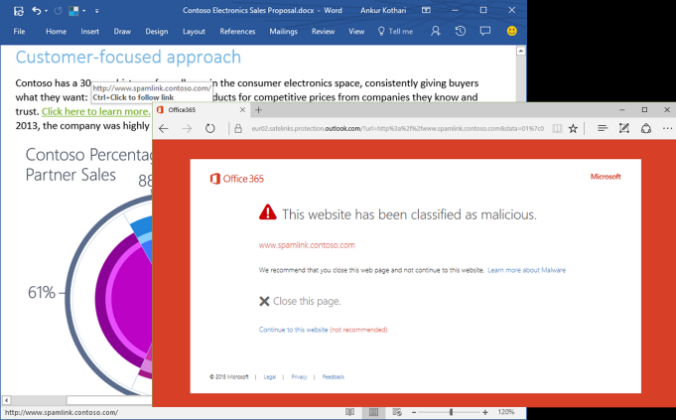

### Scenarios

Advanced protection against unknown & sophisticated threats in end-user email, attachments & URLs.

* protect against unknown malware and viruses
* real time, time-of-click protection against malicious URLs
* rich reporting and URL trace capabilities

### Resources

* [Microsoft Mechanics: Overview of Advanced Threat Protection in Exchange: new tools to stop unknown attacks](https://www.youtube.com/watch?v=GEE5y9sE_t4)
* [Advanced threat protection for safe attachments and safe links](https://technet.microsoft.com/en-us/library/mt148491(v=exchg.150).aspx)
* [Set up a safe attachments policy in EOP](https://technet.microsoft.com/en-us/library/mt148489(v=exchg.150).aspx)
* [Set up a safe links policy in EOP](https://technet.microsoft.com/en-us/library/mt148490(v=exchg.150).aspx)

## RMS for Office 365 (RMS)

Rights Management Services enables you to restrict access to documents and email to specific people and to prevent anyone else from viewing or editing them, even if they are sent outside the organization.

* **Exchange Online IRM Integration**. Enables users of Exchange Online to IRM protect and consume e-mail messages (and attachments).
* **SharePoint Online IRM Integration**. Enables SharePoint Online administrators to create IRM-protected document libraries so that when a user checks-out a document from the IRM-protected document library, protection is applied to the document no matter where it goes and the user has the usage rights to that document as they were specified for the document library.
* **Office IRM Integration**. Enables Microsoft Office users to be able to IRM protect content using predefined policies provided by the service within an organization. Office applications that include these capabilities are Word, Excel, PowerPoint and, Outlook. In addition to this, Visio support is also available.

### Features

* **Help protect emails against unauthorized access** by applying different IRM options to your email messages.
* **Enhance security of your SharePoint libraries** by using IRM to set up appropriate permissions.
* **Help keep your information safe, online or offline,** because your files are protected whether they’re viewed using Office Online or downloaded to a local machine.
* **Seamless integration with all Office documents** helps guard your organization’s intellectual property.
* **Apply custom templates** based on your business needs in addition to using default Rights Management Services templates.

Examples of policies you can apply to email and documents with Rights Management for Office 365 are:

* **Do not forward (email)/ Restricted Access (Office apps)**: Only the recipients of the email or document will be able to view and reply. They cannot forward or share with other people or print.
* **CompanyName Confidential**: Only people inside your organization (that is, people with an Office 365 account @companyname.com) can access the content, make edits, and share with others inside your company
* **CompanyName Confidential View Only**: People inside your organization can view this content but cannot edit or change it in any way. They can print and share with other people inside your company.

### Levels of Protection

**Native**

* For text, image, Microsoft Office (Word, Excel, PowerPoint) files, Visio files, .pdf files, and other application file types that support RMS, native protection provides a strong level of protection that includes both encryption and enforcement of rights (permissions).

**Generic**

* For all other applications and file types, generic protection provides a level of protection that includes both file encapsulation using the .pfile file type and authentication to verify if a user is authorized to open the file.

### Azure Rights Management Connector

The Microsoft Rights Management (RMS) connector lets you quickly enable existing on-premises servers to use their Information Rights Management (IRM) functionality with the cloud-based Microsoft Rights Management service (Azure RMS).

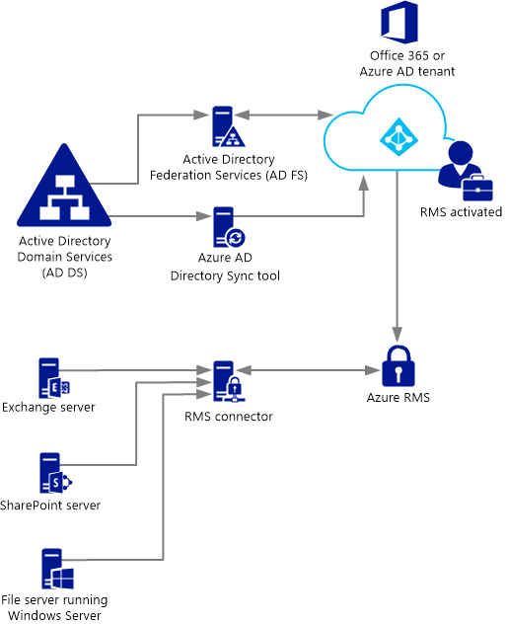

With this functionality,

* All users can easily protect documents and pictures both inside your organization and outside, without having to install additional infrastructure or establish trust relationships with other organizations.
* You can use this connector even if some of your users are connecting to online services, in a hybrid scenario. For example, some users' mailboxes use Exchange Online and some users' mailboxes use Exchange Server.

The RMS connector supports the following on-premises servers: Exchange 2010/2013 Server, SharePoint 2010/2013 Server, and file servers that run Windows Server and use File Classification Infrastructure (FCI) to classify and apply policies to Office documents in a folder.

### Microsoft Rights Management sharing application

The Microsoft Rights Management sharing application is an optional downloadable application for Microsoft Windows and other platforms that provides the following:

* Protection of a single file or bulk protection of multiple files as well as all files within a selected folder.
* Full support for protection of any type of file and a built-in viewer for commonly used text and image file types.
* Generic protection for files that do not support RMS protection.
* Full interoperability with files protected using Office Information Rights Management (IRM).
* Full interoperability with PDF files protected using SharePoint, FCI, and supported PDF authoring tools.

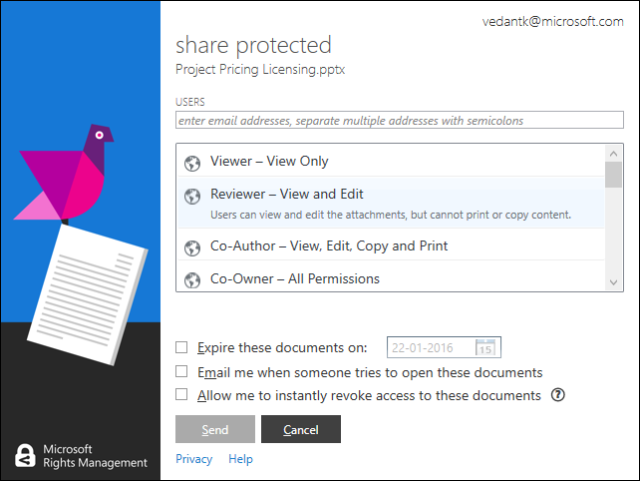

### Scenarios

* Prevent loss of intellectual property and proprietary information.
* Limit e-mail and file access to only a specific list of individual users or groups identified by their e-mail addresses.
* Limit the use of e-mail and/or files to only a limited set of rights such as the right to view the document while blocking other actions such as copying or printing.

### Resources

* [Microsoft Azure Rights Management](https://products.office.com/en-us/business/microsoft-azure-rights-management)
* [How Applications Support Azure Rights Management](https://technet.microsoft.com/en-us/library/jj585004.aspx)
* [Activate Rights Management (RMS) in the Office 365 admin center](https://support.office.com/en-in/article/Activate-Rights-Management-RMS-in-the-Office-365-admin-center-5b6d3ac7-b1ac-428e-b03e-50e882f85a6e)
* [Configure IRM (in Exchange Online) to use Azure Rights Management](https://technet.microsoft.com/en-us/library/dn151475(v=exchg.150).aspx)
* [Set up Information Rights Management (IRM) in SharePoint admin center](https://support.office.com/en-in/article/Set-up-Information-Rights-Management-IRM-in-SharePoint-admin-center-239CE6EB-4E81-42DB-BF86-A01362FED65C)
* [Configuring Super Users for Azure Rights Management and Discovery Services or Data Recovery](https://technet.microsoft.com/en-US/library/mt147272.aspx)
* [Deploying the Azure Rights Management Connector](https://technet.microsoft.com/en-us/library/dn375964.aspx)
* [Rights Management sharing application user guide](https://technet.microsoft.com/en-us/library/dn339006.aspx)
* [Migrating from AD RMS to Azure Rights Management](https://technet.microsoft.com/en-us/library/dn858447.aspx)

## O365 Message Encryption (OME)

Office 365 Message Encryption is an easy-to-use service that lets email users send encrypted messages to people inside or outside their organization.

Designated recipients can easily view their encrypted messages and return encrypted replies. Regardless of the destination email service—whether it’s Outlook.com, Yahoo, Gmail, or another service—email users can send confidential business communications with an added level of protection against unauthorized access.

Office 365 Message Encryption is an online service that’s built on Microsoft Azure Rights Management (Azure RMS).

Exchange Online and Exchange Online Protection (EOP) administrators set up Office 365 Message Encryption by defining encryption rules.

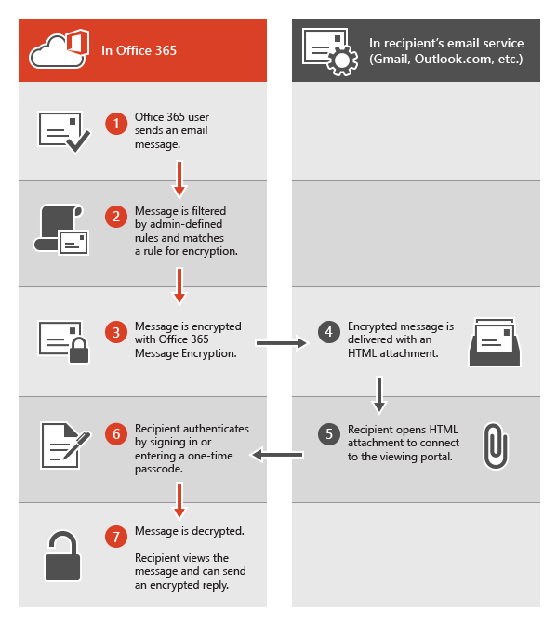

### Features

Office 365 Message Encryption provides advanced security and reliability to help protect your information.

* **Send encrypted email messages to anyone**, regardless of the recipient's email address.
* **Provide strong, automated encryption** with a cost-effective infrastructure.
* **Eliminate the need for certificates** and use a recipient's email address as the public key.
* **Communication through a TLS-enabled network** further enhances message security.
* **Enhance the security of subsequent email responses** by encrypting each message in the thread

Office 365 Message Encryption helps keep your data safe, while allowing you to maintain control over your environment.

* **Easily set up encryption** using the single action Exchange transport rules.
* **Protect sensitive information** and data from leaving your gateway, consistently and automatically.
* **Policy-based encryption** encrypts messages at the gateway based on policy rules.
* **Help manage compliance** by leveraging the strong integration with data loss prevention.
* **Integrate with existing email infrastructure** for minimal up-front capital investment.
* **Grow your organization’s brand** by using custom branding text or disclaimers and a custom logo

### Language support

Office 365 Message encryption supports Office 365 languages, as follows:

* Incoming email messages and attached HTML files are localized based on the sender’s language settings.
* The viewing portal is localized based on the recipient's browser settings.
* The body (content) of the encrypted message isn't localized.

### Scenarios

There are many scenarios in which email message encryption might be required, including the following:

* A bank employee sending credit card statements to customers
* An insurance company representative providing policy details to customers
* A mortgage broker requesting financial information from a customer for a loan application
* A health care provider sending health care information to patients
* An attorney sending confidential information to a customer or another attorney
* A consultant sending a contract to a customer

### Resources

* [Office 365 Message Encryption](https://products.office.com/en-us/exchange/office-365-message-encryption)
* [Encryption in Office 365](https://technet.microsoft.com/en-us/library/dn569286.aspx)
* [Service information for Office 365 Message Encryption](https://technet.microsoft.com/en-us/library/dn569290.aspx)
* [Send, view, and reply to encrypted messages](https://technet.microsoft.com/EN-US/library/dn569287.aspx)
* [Sign in to view your Office 365 encrypted message](https://support.office.com/en-in/article/Sign-in-to-view-your-Office-365-encrypted-message-0A57775D-0A2C-4AAF-A370-CEB079F19454)
* [Use a one-time passcode to view an encrypted message](https://technet.microsoft.com/EN-US/library/use-a-one-time-passcode-to-view-an-encrypted-message.aspx)
* [Office 365 Message Encryption FAQ](https://technet.microsoft.com/EN-US/library/dn569285.aspx)

## Office 365 Security & Compliance Center

The **Office 365 Security & Compliance Center** is your one-stop portal for protecting your data in Office 365.

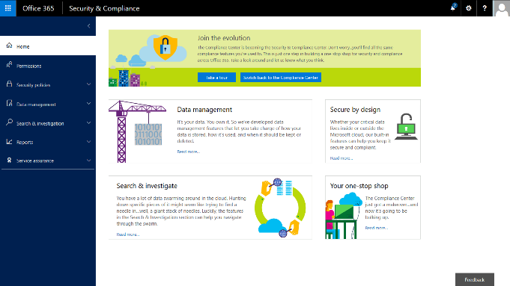

### Navigation Pane

The new navigation pane on the left that gives you easy access to all the pages in the Security & Compliance Center.

|  |  |
| --- | --- |
| Menu Option | What it’s for |
| Permissions | Grant permissions to people who perform compliance tasks like device management, data loss prevention, eDiscovery, and retention. |
| Security Policies | Manage devices and set up data loss prevention for your organization. |
| Data Management | Import email from other systems. Enable archive mailboxes or set policies for retaining email and other content within your organization. |
| Search & Investigation | Search for content and review user activity. Use eDiscovery to manage cases and Supervisory review to define policies that help you capture communication for review. |
| Reports | View user activity reports such as sign-ins for SharePoint Online, Exchange Online, and Azure Active Directory. |
| Service Assurance | View details about how Microsoft keeps Office 365 customer data safe, and how Office 365 helps customers meet industry compliance requirements. |

### Security Policies

Use security policies to help control and manage mobile device access to your organization's data, help protect your organization from data loss, and help protect inbound and outbound messages from malicious software and spam. You also use these policies to protect your domain's reputation and to determine whether or not senders are maliciously spoofing accounts from your domain.

| Tool | Description |
| --- | --- |
| Device management | Opens the Mobile Device Management (MDM) for Office 365 page where you can set up MDM for Office 365 to help you secure and manage your users' iPhones, iPads, Androids, and Windows phones. |
| Device security policies | Helps you protect your organization’s information in Office 365 from unauthorized access. |
| Data loss prevention | Lets you create policies that help you identify, monitor, and automatically protect sensitive information across Office 365 |
| Anti-spam | Fine-tune and monitor settings that help prevent spam in Office 365. Create allow and block lists, determine who is spoofing your domain and why, and configure and view spam filter policies |
| Anti-malware | Protects against viruses and spyware traveling to or from your organization in Office 365. |
| Outbound spam | Checks to ensure that your users aren't sending spam. This can happen, for example, if a user's computer gets infected by malware that is programmed to send email messages |
| DKIM | DomainKeys Identified Mail (DKIM) helps ensure that other email systems trust messages that you send from Office 365. DKIM does this by adding a unique digital signature to email messages that you send from your organization. |
| Safe attachments | Safe attachments is part of Advanced Threat Protection (ATP). When enabled, email attachments are opened in a special, isolated environment that is separate from Office 365 before they are sent to recipient inboxes. Safe attachments is designed to help detect malicious attachments even before anti-virus signatures are available. |
| Safe links | Safe links is part of Advanced Threat Protection (ATP). Safe links helps prevent users from following links in email that link to web sites recognized as malicious. |

### Data management

Use the data management features to archive and preserve content in Exchange Online mailboxes, SharePoint Online sites, and OneDrive for Business locations, and import data into your Office 365 organization.

#### Import

Use the **Import** feature to import PST files to Exchange mailboxes or import data files to SharePoint sites in your organization. For both types of files, you can upload the files over the network or copy them to a hard drive and then ship the drive to a Microsoft datacenter, where your data will be imported to Office 365.

#### Archive

Use the **Archiving** feature to enable or disable a user's archive mailbox, which provide users with an alternate storage location for historical messaging data. When archive mailboxes are enabled, an archive policy will automatically move messages from a user’s primary mailbox to their archive mailbox after a specified period (default setting: two years after the date a message is delivered). And users can still access these messages in their archive mailbox.

#### Retention

Use the **Retention** feature to manage the lifecycle of email and documents by keeping the content you need and removing content after it’s no longer required. While your organization may be required to retain content for a period of time because of compliance, legal, or other business requirements, keeping content longer than required might create unnecessary legal risk. These retention features let you manage how long your organization retains content.

* **Retention tags and policies**: Use to manage the email lifecycle by archiving or deleting messages that are older than a specified period
* **Document deletion policies**: Use to delete documents located in SharePoint site collections after a specific period of time. You can enforce a single mandatory policy on all site collections created from the same site collection template or you can allow site owners to choose from several policies that you centrally create and manage. You can also allow site owners to opt out altogether if they decide a policy doesn’t apply to their content.
* **Preservation policies**: Use to preserve content in mailboxes, public folders, and sites in your organization. You can set up preservation policies to preserve the content indefinitely, until you remove the policy, or for a specific period of time. You can also specify a date range and keywords to narrow the content that’s preserved. Preserved content remains in-place, where it's currently located, so people can continue to work with it. If content is modified or deleted, a copy is saved to a secure location

### Search & investigation

Use the search and investigation features to quickly find content in mailboxes and documents or search audit logs for various types of user and admin activity. You can find all content and user activity—whether it’s in Exchange Online, SharePoint Online, or OneDrive for Business—providing you with unified protection for your Office 365 organization.

#### Content search

Use the **content search** feature to search all mailboxes and public folders in Exchange Online, all SharePoint Online sites, and all OneDrive for Business locations in a single search. There are no limits on the number of mailboxes and sites that you can search. There are also no limits on the number of searches that can run at the same time.

After you run a search, the number of content sources and an estimated number of search results are displayed in the details pane on the search page, where you can preview the results, or export them to a local computer. You can also analyze the results of a content search using the powerful analytics features of **Advanced eDiscovery**.

#### Audit log search

You can use the **audit log search** feature to view user and admin activity in your Office 365 organization. You can search for audit log entries for the following types of actions:

* User activity in SharePoint Online and OneDrive for Business
* User activity in Exchange Online (Exchange mailbox audit logging)
* Admin activity in SharePoint Online
* Admin activity in Azure Active Directory (the directory service for Office 365)
* Admin activity in Exchange Online (Exchange admin audit logging)
* User and admin activity in Sway
* User and admin activity in Power BI for Office 365
* User and admin activity in Yammer

**Important points**

* Mailbox audit logging must be turned on for each user mailbox before user activity in Exchange Online will be logged.
* You (or another admin) must first turn on audit logging before you can start searching the Office 365 audit log. To turn it on, just click **Start recording user and admin activity** on the **Audit log search** page in the Security & Compliance Center.
* You have to be assigned the View-Only Audit Logs or Audit Logs role in Exchange Online to search the Office 365 audit log. By default, these roles are assigned to the Compliance Management and Organization Management role groups on the **Permissions** page in the Exchange admin center.
* You can search the Office 365 audit log for activities that were performed within the last 90 days.
* It takes up to 15 minutes after an event occurs in SharePoint Online or OneDrive for Business for the corresponding audit log entry to be displayed. It takes up to 12 hours for events in Exchange Online and Azure Active Directory.

**Run an Audit log search**

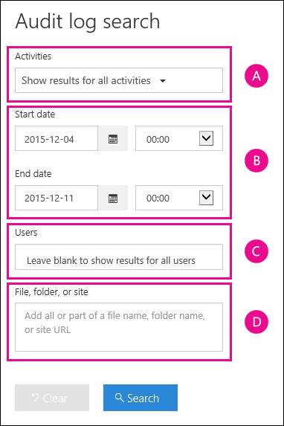

Configure the following search criteria:

1. **Activities**. Click the drop-down list to display the activities that you can search for. User and admin activities are organized in to groups of related activities.
2. **Start date and End date**. The last seven days are selected by default. Select a date and time range to display the events that occurred within that period.
3. **Users**. Click in this box and then select one or more users to display search results for.
4. **File, folder, or site**. Type some of all of a file or folder name to search for activity on the file of folder that contains the specified keyword.

Click **Search** to run the search using your search criteria.

Refer to [Search the audit log in the Office 365 Security & Compliance Center](https://support.office.com/en-us/article/Search-the-audit-log-in-the-Office-365-Security-Compliance-Center-0d4d0f35-390b-4518-800e-0c7ec95e946c) article for more information.

#### eDiscovery

You can use the **eDiscovery** feature to access and manage eDiscovery cases in the eDiscovery Center of your SharePoint Online organization. It provides a quick and easy way to go to the eDiscovery Center, manage existing eDiscovery cases, create new eDiscovery cases, and close eDiscovery cases that are no longer needed.

You can also use this page to access **Advanced eDiscovery**, which provides advanced eDiscovery capabilities that help you analyze large, unstructured data sets and reduce the amount of data that's most relevant to a legal case.

#### Advanced eDiscovery

Office 365 **Advanced eDiscovery** builds on the existing set of eDiscovery capabilities in Office 365. For example, you can use the **Content Search** feature to perform an initial search of all the content sources in your organization to identify and collect the data that may be relevant to a specific legal case. Then you can perform analysis on that data by applying the text analytics, machine learning, and the Relevance/predictive coding capabilities of Advanced eDiscovery.

This can help your organization quickly process thousands of email messages, documents, and other kinds of data to find those items that are most likely relevant to a specific case. The reduced data set can then be exported out of Office 365 for further review.

#### Supervisory Review

Define a supervisory review policy to indicate who in your organization will have their email communications reviewed and who will perform those reviews.

Follow the steps to implement Supervisory review:

* [Set up groups for Supervisory review](https://support.office.com/en-us/article/Configure-supervisory-review-policies-for-your-organization-d14ae7c3-fcb0-4a03-967b-cbed861bb086?ui=en-US&rs=en-US&ad=US#exampledist). Before you start using Supervisory review, determine who will have their communication reviewed, and who will perform those reviews. If you want to get started with just a few individuals to see how Supervisory review works, you can skip setting up groups for now.
* [Make Supervisory review available in your organization](https://support.office.com/en-us/article/Configure-supervisory-review-policies-for-your-organization-d14ae7c3-fcb0-4a03-967b-cbed861bb086?ui=en-US&rs=en-US&ad=US#SRavailable). Add the supervisory review role for yourself so you can set up policies. Anyone who has this role assigned can find Supervisory review in the Office 365 Security & Compliance Center menu.
* [Set up a supervisory review policy](https://support.office.com/en-us/article/Configure-supervisory-review-policies-for-your-organization-d14ae7c3-fcb0-4a03-967b-cbed861bb086?ui=en-US&rs=en-US&ad=US#setupsuper) in the Security & Compliance Center. These policies define which communications are subject to review in your organization, and specifies who should perform reviews.
* [Install the supervisory review Outlook app for reviewers](https://support.office.com/en-us/article/Configure-supervisory-review-policies-for-your-organization-d14ae7c3-fcb0-4a03-967b-cbed861bb086?ui=en-US&rs=en-US&ad=US#OutlookApp). This gives reviewers access the Supervisory Review folder in Outlook so they can assess and categorize each item.

**Supervisory review report** - [Run the Supervisory review report](https://support.office.com/en-us/article/Run-the-Supervisory-review-report-2a762db5-e1c9-4c09-aa8e-bef49ce97209) to check the review process is working well for your organization.

#### Quarantine

Set up a quarantine for incoming email messages in Office 365 where messages that have been filtered as spam, bulk, or phishing mail can be kept for later review.

Both users and admins can work with quarantined messages. Users can work with just their own filtered messages in quarantine. Admins can search for and manage quarantined messages for all users.

Learn more about working with quarantined messages:

* [Find and release quarantined messages as an administrator](https://support.office.com/en-us/article/Find-and-release-quarantined-messages-as-an-administrator-065cc2cf-2f3a-47fd-a434-2a20b8f51d0c)
* [Use user spam notifications to release and report spam-quarantined messages](https://support.office.com/en-us/article/Use-user-spam-notifications-to-release-and-report-spamquarantined-messages-56de4ed5-b0aa-4195-9f46-033d7cc086bc)
* [Quarantine FAQ](https://support.office.com/en-us/article/Quarantine-FAQ-714a6a74-a1a1-4769-9df2-19739c06b57c)

### Service Assurance

Use Service assurance to access documents that describe a variety of topics, such as Microsoft’s security practices for customer data that is stored in Office 365 and independent third-party audit reports on Office 365. You can also find out how Office 365 can help customers be compliant with standards, laws, and regulations across industries.

#### Service Compliance Reports

These reports are created by independent 3rd-party auditors who assess how Office 365 complies with the regulatory and security standards that apply to specific industries and regions. Review the reports to stay up to date on how Office 365 is committed to helping you stay compliant with the standards that matter to your organization.

#### Trust documents

Review white papers, FAQs, end-of-year reports, and other trust-related documents provided by Microsoft.

### Resources

* [Overview of the Office 365 Security & Compliance Center](https://support.office.com/en-us/article/Overview-of-the-Office-365-Security-Compliance-Center-a5f2fd18-b029-4257-b5a8-ae83e7768c85?ui=en-US&rs=en-US&ad=US)
* [Permissions in the Office 365 Security & Compliance Center](http://go.microsoft.com/fwlink/?LinkId=715704)
* [Security policies in the Office 365 Security & Compliance Center](https://support.office.com/en-us/article/Security-policies-in-the-Office-365-Security-Compliance-Center-0a73d5fa-b2c8-43e7-9ed4-61f0552b1c98?ui=en-US&rs=en-US&ad=US)
* [Data management in the Office 365 Security & Compliance Center](https://support.office.com/en-us/article/Data-management-in-the-Office-365-Security--Compliance-Center-5fe09846-41b6-4168-9c48-2eb491b69dc2)
* [Search and investigation in the Office 365 Security & Compliance Center](https://support.office.com/en-us/article/Search-and-investigation-in-the-Office-365-Security--Compliance-Center-c4915c5f-82a7-4871-ba20-ef47c7588043)
* [Reports in the Office 365 Security & Compliance Center](http://go.microsoft.com/fwlink/?LinkId=715710)
* [Service assurance in the Office 365 Security & Compliance Center](https://support.office.com/en-us/article/Service-assurance-in-the-Office-365-Security--Compliance-Center-47e8b964-4b09-44f7-a2d7-b8a06e8e389c)
* [Audited activities in Office 365](https://support.office.com/en-us/article/Search-the-audit-log-in-the-Office-365-Security-Compliance-Center-0d4d0f35-390b-4518-800e-0c7ec95e946c?ui=en-US&rs=en-US&ad=US#auditlogevents)
* [Office 365 Management Activity API reference](https://msdn.microsoft.com/en-us/library/office/mt227394.aspx)
* [Office 365 Management Activity API schema](https://msdn.microsoft.com/library/office/mt607130.aspx)
* MSIT Showcase: [Changing our approach to information security at Microsoft](https://www.microsoft.com/en-us/download/details.aspx?id=54436)

## Data Loss Prevention (DLP)

To **comply with business standards and industry regulations**, organizations need to protect sensitive information and prevent its inadvertent disclosure. Examples of sensitive information that you might want to prevent from leaking outside your organization include financial data or personally identifiable information (PII) such as credit card numbers, social security numbers, or health records.

With a data loss prevention (DLP) policy in the O365 Security & Compliance Center, you can identify, monitor, and automatically protect sensitive information across Office 365.

### For Exchange Online

You can configure DLP policies which allows you to:

* Start with a pre-configured policy template that can help you detect specific types of sensitive. DLP includes 80 sensitive information types that are ready for you to use in your DLP policies
* Use the full power of existing transport rule criteria and actions and add new transport rules.
* Test the effectiveness of your DLP policies before fully enforcing them.
* Incorporate your own custom DLP policy templates and sensitive information types.
* Detect sensitive information in message attachments, body text, or subject lines and adjust the confidence level at which the service takes action.
* Detect sensitive form data by using Document Fingerprinting which helps you easily create custom sensitive information types based on text-based forms.
* Add Policy Tips, which can help reduce data loss by displaying a notice to your Outlook 2013, Outlook Web App, and OWA for Devices users and can also improve the effectiveness of your policies by allowing false-positive reporting.
* Review incident data in DLP reports or add your own specific reports by using a generate incident report action

### For SharePoint Online and OneDrive for Business

By extending DLP to OneDrive for Business and SharePoint Online, we expanded on the same protection you already have in Exchange, Outlook and Outlook on the web, offering broader protection of your data wherever it lives.

With a DLP policy, you can:

* Identify sensitive information across many locations, such as SharePoint Online and OneDrive for Business. For example, you can identify any document containing a credit card number that’s stored in any OneDrive for Business site, or you can monitor just the OneDrive sites of specific people.
* Prevent the accidental sharing of sensitive information. Across all sites, you can identify any document containing a health record that’s shared with people outside your organization, and then automatically block access to that document for everyone except the site owner, document owner, and the person who last modified the content.
* Monitor and protect sensitive information in Office 2016. Excel 2016, PowerPoint 2016, and Word 2016 include capabilities to identify sensitive information and apply DLP policies. DLP provides continuous monitoring when people share content in these Office 2016 programs.
* Help users learn how to stay compliant without interrupting their workflow. Send them an email notification and show them a policy tip in the context of the document library. Allow them to override the policy if they have a business justification. The same policy tips also appear in Excel 2016, PowerPoint 2016, and Word 2016.
* View DLP reports showing content that matches your organization’s DLP policies.

### Resources

**Watch Videos** …

* [Updates to Data Loss Prevention in Office 365](https://www.youtube.com/watch?v=O542rUaAMTI)

**Read** …

* [Data loss prevention in Exchange Online](http://go.microsoft.com/fwlink/?LinkID=627429&clcid=0x409)
* [How DLP rules are applied to evaluate messages](https://technet.microsoft.com/en-us/library/dn329050(v=exchg.150).aspx)
* [Document Fingerprinting](https://technet.microsoft.com/en-us/library/dn635176(v=exchg.150).aspx)
* [Overview of data loss prevention policies](https://technet.microsoft.com/en-us/library/ms.o365.cc.dlplandingpage.aspx)
* [Create a DLP policy from a template](https://technet.microsoft.com/en-us/library/mt589537.aspx)
* [Sensitive information types inventory](https://technet.microsoft.com/EN-US/library/ms.o365.cc.unifieddlprulecontainssensitiveinformation.aspx)

|  |
| --- |
| **Microsoft IT** recently released a case study on how it leverages the data loss prevention solution in Office 365 to help reduce the risk of sharing sensitive data while still promoting collaboration.  Read: [How Microsoft monitors and protects sensitive data in Office 365](https://www.microsoft.com/itshowcase/Article/Content/721/Monitoring-and-protecting-sensitive-data-in-Office-365) |

## eDiscovery and Content Search

Electronic discovery, or eDiscovery, is the process of identifying and delivering electronic information that can be used as evidence in legal cases. You can use eDiscovery in Office 365 to search that spans Exchange email, SharePoint and OneDrive for Business documents, and Skype conversations.

If you only need to search mailboxes, you can use In-Place eDiscovery in the Exchange admin center (EAC). If you need to search mailboxes and SharePoint sites in the same eDiscovery search, you can use the eDiscovery Center in SharePoint Online. In both cases, you can identify, hold, and export content found in Exchange mailboxes and SharePoint sites

The **Office 365 Security & Compliance Center** is quick and easy way to …

* go to the eDiscovery Center,
* manage existing eDiscovery cases,
* create new eDiscovery cases, and
* close eDiscovery cases that are no longer needed.

### Content Search

You can use **Content Search** in the **Office 365 Security & Compliance Center** to search **all** the mailboxes, SharePoint Online sites, and OneDrive for Business locations in your Office 365 organization.

* Compliance Search is a new eDiscovery search tool with new and improved scaling and performance capabilities.
* Run very large eDiscovery searches.
* Search all mailboxes, all SharePoint Online sites, and OneDrive for Business locations in a single compliance search.
* No limits on the number of mailboxes and sites that you can search.
* No limits on the number of searches that can run at the same time.
* Number of content sources and an estimated number of search results are displayed in the details pane on the Compliance search page, where you can preview the results

### Place sources on hold

When a content source is part of a case, you can place it on hold so that a copy is preserved. This includes SharePoint sites, documents, or pages, and Exchange mailboxes.

These types of content can be placed on hold as part of a case:

* SharePoint Objects, such as, Documents, Lists (including blogs and wiki content), Pages (including pages that host blogs and wikis)
* Exchange objects, such as tasks, calendar entries, contacts, email messages and attachments. If Microsoft Skype conversations are archived in Microsoft Exchange, they will be included.

When you place a hold on the content sources in an eDiscovery set, the hold status for each source is displayed in the **In-Place Hold Status** column in the list of content sources.

### Scenarios

* **Reduce risk** of non-compliance due to time delays
* **Control increasing cost** of compliance processes: time, expenses, resources.
* **Effective management** of compliance processes.

### Resources

* [eDiscovery in the Office 365 Security & Compliance Center](https://technet.microsoft.com/en-US/library/ms.o365.cc.eDiscoveryHelp.aspx)
* [Permissions in the Office 365 Security & Compliance Center](https://technet.microsoft.com/en-US/library/ms.o365.cc.adminrolegroups.aspx)
* [Compliance Search in the Office 365 Security & Compliance Center](https://technet.microsoft.com/en-us/library/ms.o365.cc.compliancesearch.aspx)
* [Add content to an eDiscovery case and place sources on hold](https://support.office.com/en-in/article/Add-content-to-an-eDiscovery-case-and-place-sources-on-hold-54d70de9-1ec2-4325-84f3-aeb588554479?ui=en-US&rs=en-IN&ad=IN)
* [In-Place Hold and Litigation Hold (Exchange Online)](https://technet.microsoft.com/en-us/library/ff637980(v=exchg.150).aspx)
* MSIT Showcase: [Office 365 meets evolving eDiscovery challenges in a cloud-first world](https://www.microsoft.com/en-us/download/details.aspx?id=54517)

## Advanced eDiscovery

With Advanced eDiscovery, you can better understand your Office 365 data and reduce your eDiscovery costs. Advanced eDiscovery helps you analyze unstructured data within Office 365, perform more efficient document review, and make decisions to reduce data for eDiscovery. You can work with data stored in Exchange Online, SharePoint Online, OneDrive for Business, and Skype for Business. You can select groups, individual mailboxes and sites, and then analyze it with Advanced eDiscovery.

Advanced eDiscovery streamlines and speeds up the document review process by identifying redundant information with features like Near-duplicates detection and Email Thread analysis. The Relevance feature applies predictive coding technology to identify relevant documents. Advanced eDiscovery learns from your tagging decisions on sample documents and applies statistical and self-learning techniques to calculate the relevance of each document in the data set. This enables you to focus on key documents, make quick yet informed decisions on case strategy, cull data, and prioritize review.

### Features

**More efficient document review**

* identifies redundant information with features like **Near-Duplicate Detection**, which provides information about how similar documents are to each other; and **Thread Analysis**, which identifies emails that contain other emails in a thread, allowing you to review just the unique emails rather than every single one.
* reduces document review costs significantly.
* when you export data, the near-duplicate and email thread metadata are available to be loaded into other eDiscovery tools.

**Reduce data for eDiscovery**

* offers a **Relevance** feature, which applies predictive coding technology to teach the system to identify relevant documents
* **learns** from your tagging decisions on sample documents, and the system **applies statistical and self-learning techniques** to calculate the relevance of each document in the data set.
* enables you to focus on key documents and make quick yet informed decisions on case strategy.
* by ranking documents by relevance, you can also precisely cull the data and prioritize review.

**Understand unstructured data**

* **Themes** and **Search** are powerful features for early case assessment and internal investigations that help you quickly map the collection and find key data points.
* Themes groups related documents, allowing you to identify topics of interest, drill down to discover more material, find similar documents, and intuitively explore your data set by following up on related themes.
* Search gives search capabilities such as wildcards, Boolean logic, conceptual search and term expansion.

### Setup and Use

Please refer to following articles to learn how to setup and use various modules and features:

* [Quick setup for Advanced eDiscovery](https://technet.microsoft.com/en-us/library/mt297730.aspx): Helps you to get started with Advanced eDiscovery.
* [Running the Advanced eDiscovery Process module](https://technet.microsoft.com/en-us/library/mt346185.aspx): Enables the preparation of files from specified data sources.
* [Analyzing case data with Advanced eDiscovery](https://technet.microsoft.com/en-us/library/mt297877.aspx): Allows identification and grouping of Near-duplicate files and hierarchically structured groups of Email Threads.
* [Managing Advanced eDiscovery Relevance setup](https://technet.microsoft.com/en-us/library/mt303705.aspx): Allows the definition of parameters for Relevance processing.
* [Using the Advanced eDiscovery Relevance module](https://technet.microsoft.com/en-us/library/mt303697.aspx): Identifies and ranks files by Relevance scores, which assists with early case assessment, document culling, and review.
* [Exporting case data with Advanced eDiscovery](https://technet.microsoft.com/en-us/library/mt346189.aspx): Enables the export of Advanced eDiscovery data and results for review.
* [Running reports in Advanced eDiscovery](https://technet.microsoft.com/en-us/library/mt612812.aspx): Enables the generation of .csv file output for the selected reports.
* [Defining case and tenant settings in Advanced eDiscovery](https://technet.microsoft.com/en-us/library/mt427264.aspx): Allows the definition of parameters at the case and tenant level.
* [Using Advanced eDiscovery utilities](https://technet.microsoft.com/en-us/library/mt427265.aspx): Enables the execution of defined Advanced eDiscovery utilities on case data.
* [User roles and access in Advanced eDiscovery](https://technet.microsoft.com/en-us/library/mt628620.aspx): Describes the access to features for each user role.

### Scenarios

Simplifies the eDiscovery process across your email and document repositories

This **new machine learning & analytics** functionality improves existing eDiscovery by:

* Significantly **reducing** document review **costs**.
* **Speeding** up the document review **process**.
* Using core technology (Equivio) that has already achieved **broad acceptance** in the legal community.

### Resources

**Watch Videos** …

* [Office 365 Advanced eDiscovery](https://www.youtube.com/watch?v=yPEGF3Auw_M)

**Read** …

* [Office 365 Advanced eDiscovery](https://support.office.com/en-us/article/Office-365-Advanced-eDiscovery-fd53438a-a760-45f6-9df4-861b50161ae4?ui=en-US&rs=en-US&ad=US)
* [Analyze Office 365 data with Equivio Zoom](https://blogs.office.com/2015/05/21/analyze-office-365-data-with-equivio-zoom/)
* MSIT Showcase: [Office 365 meets evolving eDiscovery challenges in a cloud-first world](https://www.microsoft.com/en-us/download/details.aspx?id=54517)

## MFA for Office 365 (MFA)

MFA helps secure user sign-ins for cloud services beyond just a single password. The security of multi-factor authentication lies in its layered approach.

* Compromising multiple authentication factors presents a significant challenge for attackers.
* Even if an attacker manages to learn the user's password, it is useless without also having possession of the trusted device.
* Should the user lose the device, the person who finds it won't be able to use it unless he or she also knows the user's password.

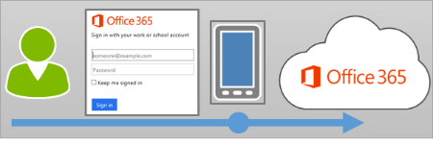

Office 365 uses multi-factor authentication to help provide the extra security and is managed from the **Office 365 admin center**.

### Features

Office 365 offers the following subset of Azure multi-factor authentication capabilities as a part of the subscription:

* The ability to **enable and enforce multi-factor authentication** for end users
* The use of a **mobile app** (online and one-time password) as a second authentication factor
* The use of a **phone call** as a second authentication factor
* The use of a **Short Message Service (SMS)** message as a second authentication factor
* **Application passwords** for non-browser clients
* **Default Microsoft greetings** during authentication phone calls

### Feature comparison of versions

A form of multi-factor authentication is included with Office 365, but you can also purchase Azure Multi-Factor authentication that includes extended functionality.

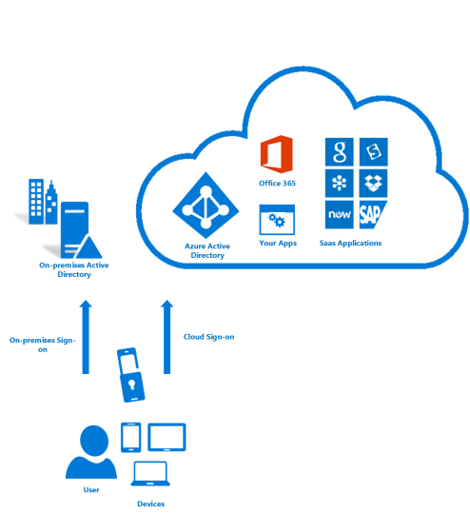

The following table below provides a list of the features that are available in the various versions of Azure Multi-Factor Authentication.

| Feature | O365 MFA | Azure MFA |
| --- | --- | --- |
| Administrators can protect accounts with MFA | **●** | **●** |
| Mobile app as a second factor | **●** | **●** |
| Phone call as a second factor | **●** | **●** |
| SMS as a second factor | **●** | **●** |
| App passwords for clients that don't support MFA | **●** | **●** |
| Admin control over authentication methods |  | **●** |
| PIN mode |  | **●** |
| Fraud alert |  | **●** |
| MFA Reports |  | **●** |
| One-Time Bypass |  | **●** |
| Custom greetings for phone calls |  | **●** |
| Customization of caller ID for phone calls |  | **●** |
| Event Confirmation |  | **●** |
| Trusted IPs |  | **●** |
| Suspend MFA for remembered devices (Public Preview) |  | **●** |
| MFA SDK |  | **●** |
| MFA for on-premises apps using MFA server |  | **●** |

### Resources

* [What is Azure Multi-Factor Authentication?](https://azure.microsoft.com/en-in/documentation/articles/multi-factor-authentication/)
* [How Azure Multi-Factor Authentication works](https://azure.microsoft.com/en-in/documentation/articles/multi-factor-authentication-how-it-works/#feature-comparison-of-versions)
* [Plan for multi-factor authentication for Office 365 Deployments](https://support.office.com/en-in/article/Plan-for-multifactor-authentication-for-Office-365-Deployments-043807b2-21db-4d5c-b430-c8a6dee0e6ba)
* [Set up multi-factor authentication for Office 365](https://support.office.com/en-in/article/Set-up-multi-factor-authentication-for-Office-365-8f0454b2-f51a-4d9c-bcde-2c48e41621c6)
* [Sign in to Office 365 with a second verification method](https://support.office.com/en-in/article/Sign-in-to-Office-365-with-a-second-verification-method-2b856342-170a-438e-9a4f-3c092394d3cb)

## MDM for Office 365 (MDM)

Mobile Device Management for Office 365 can help you secure and manage mobile devices like iPhones, iPads, Androids, and Windows Phones used by licensed Office 365 users in your organization.

You can create mobile device management policies with settings that can help control access to your organization’s Office 365 email and documents for supported mobile devices and apps. If a device is lost or stolen, you can remotely wipe the device to remove sensitive organizational information.

The following diagram shows what happens when a user with a new device signs in to an app that supports access control with MDM for Office 365. The user is blocked from accessing Office 365 resources in the app until they enroll their device.

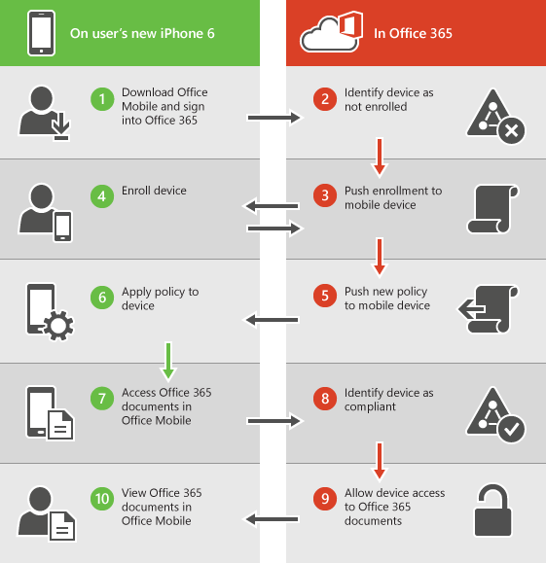

### Policy settings for mobile devices

If you create a policy to block access with certain settings turned on, users will be blocked from accessing Office 365 resources when using a supported app. The settings that can block users from accessing Office 365 resources are in these sections:

* Security
* Encryption
* Jail broken
* Managed email profile

For example, the following diagram shows what happens when a user with an enrolled device isn’t compliant with a security setting in a mobile device management policy that applies to their device.

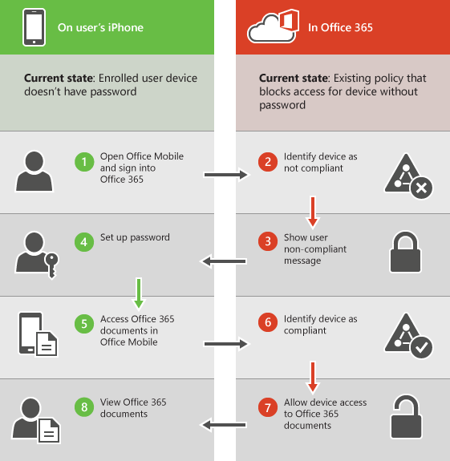

The user signs in to an app that supports access control with MDM for Office 365. They are blocked from accessing Office 365 resources in the app until their device complies with the security setting.

### Supported Devices

You can use MDM for Office 365 to secure and manage the following types of devices.

* Windows Phone 8.1+
* iOS 7.1 or later versions
* Android 4 or later versions
* Windows 8.1*
* Windows 8.1 RT*
* Windows 10**
* Windows 10 Mobile**

* Access control for Windows 8.1 and Windows 8.1 RT devices is limited to Exchange ActiveSync.

** Requires the device to be joined to Azure Active Directory and be enrolled in the mobile device management service of your organization.

If people in your organization use mobile devices that aren't supported by Mobile Device Management for Office 365, you might want to block Exchange ActiveSync app access to Office 365 email for those devices, to help make your organization's data more secure. Steps for blocking Exchange ActiveSync: See [Manage device access settings](https://support.office.com/en-us/article/Manage-device-access-settings-170d44dd-0c61-472f-b9bb-3242eb8bd5c3)..

### Choose between Exchange Active Sync and MDM for Office 365

|  |  |  |
| --- | --- | --- |
| Feature | EAS | MDM for O365 |
| **Device Configuration** |  |  |
| Inventory mobile devices that access corporate apps | **●** | **●** |
| Full device wipe | **●** | **●** |
| Mobile device configuration settings | **●** | **●** |
| Self-service password reset (Cloud only users) | **●** | **●** |
| **Office 365** |  |  |
| Provides reporting on devices that do not meet IT policy |  | **●** |
| Group-based policies and reporting |  | **●** |
| Root and jailbreak detection |  | **●** |
| Selective wipe |  | **●** |
| Prevent access to corporate email and docs based upon device enrollment and policies |  | **●** |

### Choose between Intune and MDM for Office 365

Both MDM for Office 365 and Intune provide cloud-based solutions for managing devices in your organization.

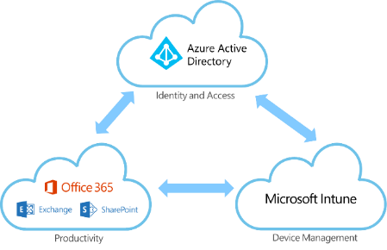

| MDM for Office 365 | Microsoft Intune |
| --- | --- |
| **Cost** | |
| Included with many Office 365 commercial subscriptions. | Requires a paid subscription for Microsoft Intune or can be purchased with Enterprise Mobility Suite. |
| **How you manage devices** | |
| Manage devices using the [Security and Compliance Center in](https://support.office.com/en-us/article/Security-and-Compliance-Center-in-7e696a40-b86b-4a20-afcc-559218b7b1b8) Office 365. | If you use Intune by itself, you manage devices using the Intune admin console.  If you integrate Intune with SCCM 2012, you use the Configuration Manager console to manage devices on-premises and in cloud. |
| **Devices you can manage** | |
| iOS, Android, and Windows Phone. | iOS, Mac OS X, Android, Windows Phone, and Windows PCs. |
| **Key capabilities** | |
| Help ensure that Office 365 corporate email and documents can be accessed only on phones and tablets that are managed by your company and that are compliant with your IT policies.  Set and manage security policies, like device level pin lock and jailbreak detection, to help prevent unauthorized users from accessing corporate email and data on a device when it is lost or stolen.  Remove Office 365 company data from an employee’s device while leaving their personal data in place. | MDM for Office 365 capabilities, plus:  Help users securely access corporate resource with certificates, Wi-Fi, VPN, and email profiles.  Enroll and manage collections of corporate-owned devices, simplifying policy and app deployment.  Deploy your internal line-of-business apps and apps in stores to users.  Ensuring security of data by helping to restrict actions like copy, cut, paste, and save as, to only those apps managed by Intune.  Enable more secure web browsing using the Intune Managed Browser app.  Manage PCs from the cloud with no infrastructure required using Intune, or connect Intune to Configuration Manager to manage all of your devices including PCs, Macs, Linux and UNIX servers, and mobile devices from a single management console.  An Intune subscription also allows you to set up MAM (mobile app management) policies by using the Azure portal, even if people's devices aren't enrolled in Intune. |

### Resources

* [Overview of built-in Mobile Device Management for Office 365](https://technet.microsoft.com/en-us/library/ms.o365.cc.devicepolicy.aspx)
* [Capabilities of built-in Mobile Device Management for Office 365](https://technet.microsoft.com/en-us/library/ms.o365.cc.devicepolicysupporteddevice.aspx)
* [Choose between MDM for Office 365 and Microsoft Intune](https://support.office.com/en-us/article/Choose-between-MDM-for-Office-365-and-Microsoft-Intune-c93d9ab9-efb2-4349-9b93-30c30562ee22?ui=en-US&rs=en-US&ad=US)
* [Ways to do enterprise mobility](https://technet.microsoft.com/library/dn957912.aspx)
* [Manage mobile devices in Office 365](https://support.office.com/en-in/article/Manage-mobile-devices-in-Office-365-dd892318-bc44-4eb1-af00-9db5430be3cd)
* [Create and deploy device security policies](https://technet.microsoft.com/library/d310f556-8bfb-497b-9bd7-fe3c36ea2fd6(v=technet.10).aspx)
* [Wipe a mobile device in Office 365](https://support.office.com/en-in/article/Wipe-a-mobile-device-in-Office-365-9d727c7d-8b47-4499-bf24-d046b449214c)
* [Frequently asked questions about Mobile Device Management for Office 365](https://support.office.com/en-in/article/Frequently-asked-questions-about-Mobile-Device-Management-for-Office-365-3871f99c-c9db-4a23-86f9-902c1b02f58d?ui=en-US&rs=en-IN&ad=IN)

## Customer Lockbox

Customer Lockbox ensures that no one at Microsoft can access customer content without the customer’s explicit approval.

Customer Lockbox brings the customer into the approval workflow for access to customer content.

For the purpose of maximizing data security and privacy for Office 365 customers, we have engineered the service to require nearly zero interaction with customer content by Microsoft employees.

Nearly all service operations performed by Microsoft are either fully automated so there is no human interaction, or the human involvement is abstracted away from Office 365 customer content.

In the very rare instances someone may need access to customer content to resolve a customer issue. Today within Microsoft, **Lockbox** enforces access control through multiple levels of approval, providing just-in-time access with limited and time-bound authorization. In addition, all access control activities in the service are logged and audited.

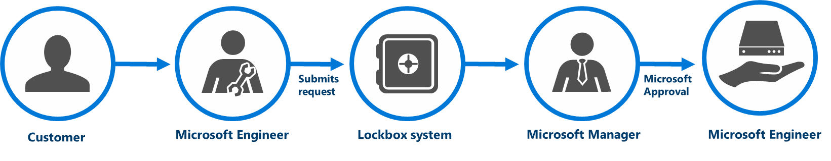

**Customer Lockbox for Office 365**, provides unprecedented customer control over content residing in Office 365, so customers can be assured that their content will not be accessed by Microsoft employees without their explicit approval. It brings customers into the access approval loop, requiring the customer to provide explicit approval of access to their content by a Microsoft employee for service operations.

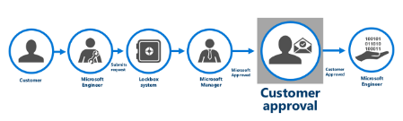

### How it Works

* Administrators in the customer’s Office 365 environment are notified via email that there is a request for access.
* Office 365 Admin Center portal will also display requests that have been submitted to the customer for approval.
* Administrators in the customer’s Office 365 environment can approve or reject Customer Lockbox requests.
* Microsoft can only proceed following approval of a Customer Lockbox request.
* If a customer rejects a Customer Lockbox request, no access to customer content will occur.
* If a user was experiencing a service issue that required Microsoft to access customer content in order to resolve (though such circumstances are expected to be extremely rare), then the service issue might simply persist. Microsoft would inform the customer of this outcome.
* Customer Lockbox requests have a default lifetime of 12 hours; after which they expire. Expired requests do not result in access to customer content.

### Resources

**Watch Videos** …

* [An Overview of Customer Lockbox in Office 365](https://www.youtube.com/watch?v=rpznIuTGrSA) - Duration: 2 minutes, 49 seconds.

**Read** …

* [Announcing Customer Lockbox for Office 365](https://blogs.office.com/2015/04/21/announcing-customer-lockbox-for-office-365/)
* [Microsoft Mechanics: An Overview of Customer Lockbox in Office 365](https://www.youtube.com/watch?v=rpznIuTGrSA)

## Office 365 Advanced Security Management

The cloud offers many security benefits to organizations, but also raises new security considerations. It can also add to existing ones such as shadow IT, the use of software that is not formally sanctioned by the organization. **Office 365 Advanced Security Management**, a new set of capabilities powered by [Microsoft Cloud App Security](https://www.microsoft.com/en-us/server-cloud/products/cloud-app-security/) gives you greater visibility and control over your Office 365 environment.

Advanced Security Management includes:

* **Threat detection** - Helps you identify high-risk and abnormal usage, and security incidents.
* **Enhanced control** - Shapes your Office 365 environment leveraging granular controls and security policies.
* **Discovery and insights** - Get enhanced visibility into your Office 365 usage and shadow IT without installing an end point agent.

### Threat detection

Advanced Security Management enables you to set up **anomaly detection policies**, so you can be alerted to potential breaches of your network. Anomaly detection works by **scanning user activities and evaluating their risk against over 70 different indicators**, including sign-in failures, administrator activity and inactive accounts. For example, you can be alerted to impossible travel scenarios, such as if a user signs in to the service to check their mail from New York and then two minutes later is downloading a document from SharePoint Online in Tokyo.

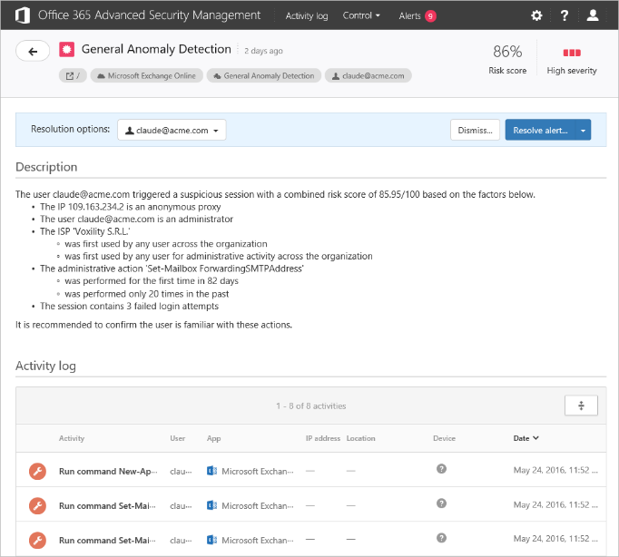

Advanced Security Management also leverages **behavioral analytics** as part of its anomaly detection to assess potentially risky user behavior. It does this by understanding how users typically interact with Office 365, spotting anomalies and giving the anomalous activity a risk score to help IT decide whether to take further action.

### Enhanced control

Advanced Security Management lets you set up **activity policies** that can track specific activities. With out-of-the-box templates, IT can easily create policies that flag when someone is downloading an unusually large amount of data, has multiple failed sign-in attempts or signs in from a risky IP address. Policies can also be customized to your environment. Using activity filters, IT can look for the location of a user, device type, IP address or if someone is granted admin rights. Alerts can be created to notify an IT lead immediately via email or text message.

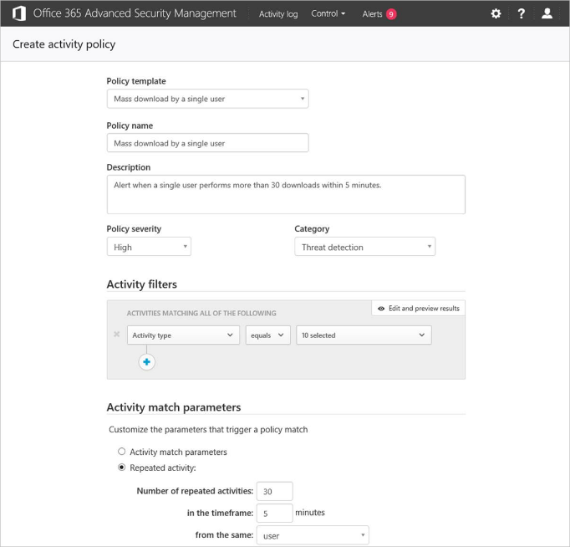

**Default activity policy templates that are included**

The policy templates that are included are the following:

* **Administrative activity from a non-administrative IP address** Alert when an admin user performs an administrative activity from an IP address that is not included in a specific IP range category.
* **User logon from a non-categorized IP address** Alert when a user logs on from an IP address that is not included in a specific IP range category.
* **Mass download by a single user** Alert when a single user performs more than 30 downloads within 5 minutes.
* **Multiple failed user log on attempts to an app** Alert when a single user attempts to log on to a single app, and fails more than 10 times within 5 minutes.
* **Logon from a risky IP address** Alert when a user logs on from a risky IP address to your sanctioned services. The **Risky** IP category contains, by default, anonymous proxies and TOR exits point.

After reviewing an alert and investigating a user’s activities, IT may deem that the behavior is risky and want to stop the user from doing anything else. This can be done directly from the alert. Some activities may be deemed so risky that IT may want to immediately suspend the account. To help with this, IT can configure the activity policy so that an account is **automatically suspended** if that risky activity takes place.

Advanced Security Management also **shows which apps are connected to Office 365** in their environment, who is using them and the permissions they have. For example, if a user grants a scheduling application access to their Office 365 calendar data, IT will be able to see the details of the connection and revoke that application’s permissions with one click if they deem it a security risk.

### Discovery and insights

Advanced Security Management also provides an **app discovery dashboard** that allows IT Pros to visualize your organization’s usage of Office 365 and other productivity cloud services, so you can maximize investments in IT-approved solutions. With the ability to discover about 1,000 applications in categories like collaboration, cloud storage, webmail and others, IT can better determine the extent to which shadow IT is occurring in your organization. Advanced Security Management will also give you details about the top apps in each category. For example, you can see how much data is being sent to OneDrive for Business, Box, Dropbox and other cloud storage providers.

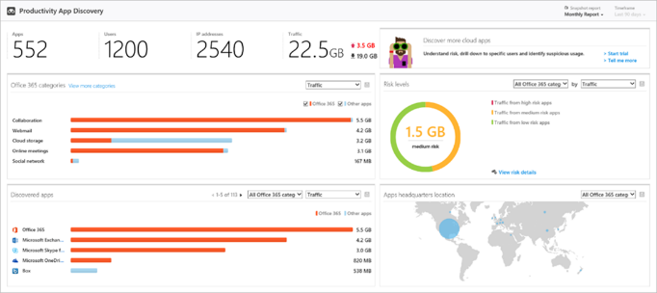

You can do all this without installing anything on device end points. To load the data into the dashboard, all you have to do is take the logs from your network devices and upload them via an easy-to-use interface.

Many organizations allow users to connect apps to Office 365 without IT intervention to help them be more productive. The challenge is that it reduces the visibility and control that IT has over what apps are doing with the data. **App Permissions** as part of Office 365 Advanced Security Management can help mitigate that risk.

App Permissions provides information to IT about which applications in their network have access to Office 365 data, what permissions they have and which users granted these apps access to their Office 365 accounts.

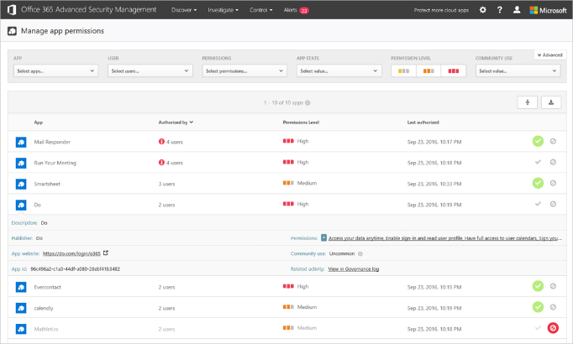

Based on this information, IT admins can choose to approve the app or revoke its access to Office 365. If they choose to revoke permissions to the app, it will no longer be able to access the information for any of the users in the Office 365 tenant. App Permissions also makes it easy for IT admins to notify users who have installed the application that is going to be banned.

### Resources

* Blog post: [Gain enhanced visibility and control with Office 365 Advanced Security Management](https://blogs.office.com/2016/06/01/gain-enhanced-visibility-and-control-with-office-365-advanced-security-management/)
* Video: [Introducing Advanced Security Management for Office 365](https://www.youtube.com/watch?v=gWTSTqNHgSg)
* [Overview of Advanced Security Management in Office 365](https://support.office.com/en-us/article/Overview-of-Advanced-Security-Management-in-Office-365-81f0ee9a-9645-45ab-ba56-de9cbccab475)
* [Get started with Advanced Security Management](https://support.office.com/en-us/article/Get-started-with-Advanced-Security-Management-d9ee4d67-f2b3-42b4-9c9e-c4529904990a?ui=en-US&rs=en-US&ad=US)
* [Create app discovery reports in Advanced Security Management](https://support.office.com/en-us/article/Create-app-discovery-reports-in-Advanced-Security-Management-3e68e691-1fc4-4d3e-a2c0-d3134eb64055?ui=en-US&rs=en-US&ad=US)
* Blog post: [Enhanced control over third-party apps now available in Office 365](https://blogs.office.com/2016/10/31/enhanced-control-over-third-party-apps-now-available-in-office-365/)

## Office 365 Secure Score

The [Office 365 Secure Score](https://securescore.office.com) is a security analytics tool that will help you understand what you have done to reduce the risk to your data in Office 365, and show you what you can do to further reduce that risk.

The core idea is that it is useful to rationalize and contextualize all of your cloud security configuration and behavioral options into **one simple, analytical framework**, and to make it very easy for you to take **incremental action** to improve your score over time. Rather than constructing a model with findings slotted into critical, moderate, or low severity, we wanted to give you a non-reactive way to evaluate your risk and make **incremental changes** over time that add up to a very **effective risk mitigation plan**.

The Secure Score does not express an absolute measure of how likely you are to get breached. It expresses the extent to which you have adopted controls which can offset the risk of being breached.

No service can guarantee that you will not be breached, and the Secure Score should not be interpreted as a guarantee in any way.

### Your Secure Score Summary

The **Score Summary** panel gives you your current Secure Score, and the total number of points that are available to you, given your subscription level, the date that your score was measured, as well as a simple pie chart of your score.

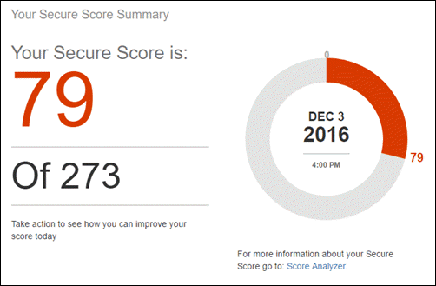

The score is calculated once per day. If you make a change to a measured action, the score will automatically update the next day. It takes up to 48 hours for a change to be reflected in your score.

### Risk Assessment

While the Secure Score is framed as a ‘gamification’ of your security, it is important to recognize that every action you take will mitigate a real-world threat. This panel shows you the top threats for your tenancy, given your particular configuration and behaviors. Make sure you read about and understand the risks you are mitigating every time you take an action.

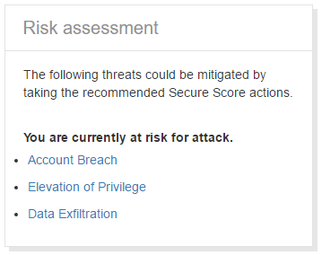

### Compare Your Score

The **Office 365 Average Secure Score** is calculated from every Office 365 customer’s Secure Score. You can use this panel to get a better sense of how your score stacks up against the average. The specific controls that are passed by any given customer are not exposed in the average, and your Secure Score is private.

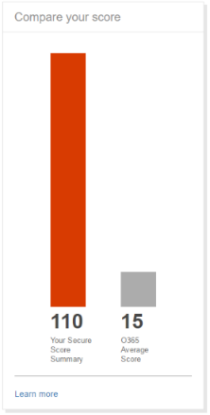

### Take Action

Helping you figure out which actions to take to improve your score is the purpose of the Secure Score. There are three basic parts to the experience:

First, there is the **modeler**. Use the slider to figure out how many actions you want to review.

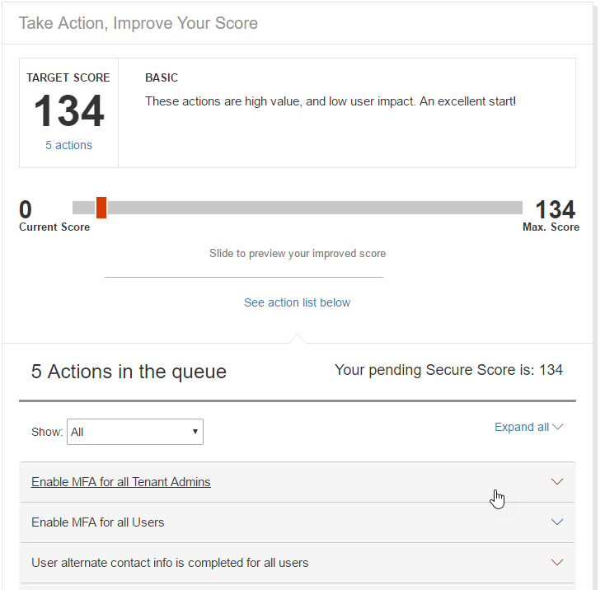

Second is the **action pane**. When you open this, you will see a description of the control, explaining why we think it is an effective mitigation, and what we observed about your configuration.

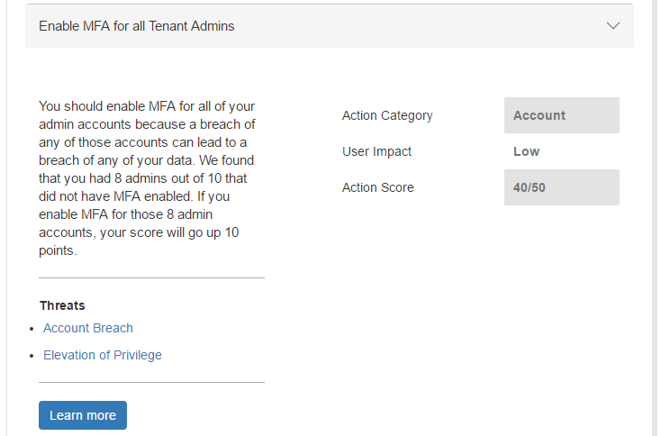

Thirdly, you will see a **remediation pane fly-out** that explains exactly what you are about to change, and how it will affect your users. Eventually, the Launch Now link (which takes you to a separate security center now) will allow you to make the desired change right from the Secure Score experience.

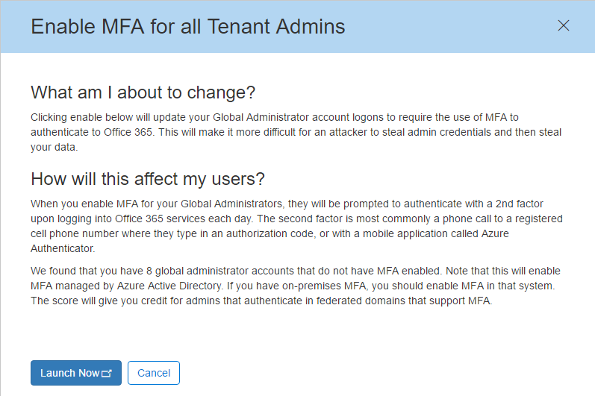

### Score Analyzer

We wanted to make it easy for admins to analyze and report to their executives and stakeholders their progress on risk mitigation over time. The Score Analyzer experience allows you to review a line graph of your score over time, to export the audit of your control measurements for the selected day to either a PDF or a CSV, and to review what controls you have earned points for, and which ones you could take action on.

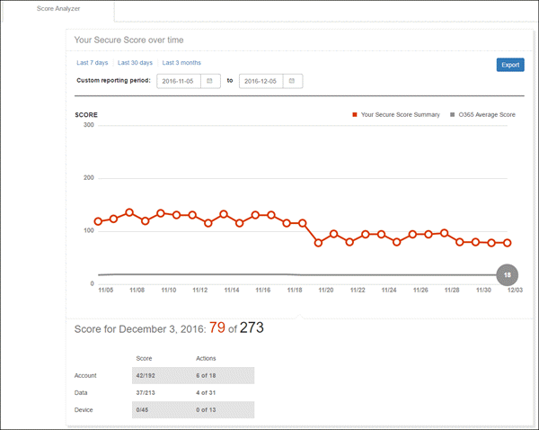

### Resources

* [Introducing the Office 365 Secure Score](https://support.office.com/en-us/article/Introducing-the-Office-365-Secure-Score-c9e7160f-2c34-4bd0-a548-5ddcc862eaef?ui=en-US&rs=en-US&ad=US)
* Video: [An introduction to Office 365 Secure score](https://www.youtube.com/watch?v=h__nxWlm5Nc)

## Threat Intelligence (*Preview)*

Availability: **first quarter of 2017.** Included as part of the **Office 365 Enterprise E5** plan and the new **Secure Productive Enterprise E5** offering.

Organizations are being targeted with increasingly sophisticated attacks. **Threat Intelligence** will help you proactively uncover and protect against advanced threats by analyzing billions of data signals across Office consumer and commercial services. Threat Intelligence also provides deep insights from cyber threat hunters to create a comprehensive view of malware trends around the world. In addition, we’re integrating signals from Windows and Azure to help customers realize the full benefit of the Microsoft Cloud.

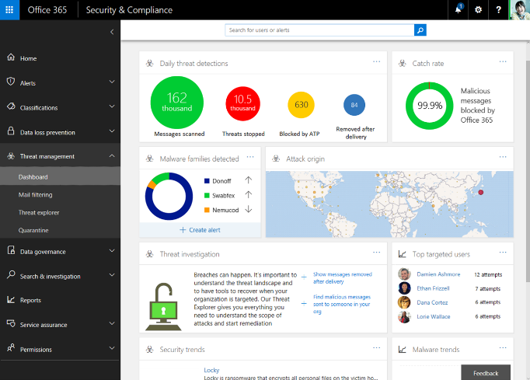

Security admins will see a dashboard with rich insights to do deep investigation of malware and will be able to integrate data with existing security management tools.

Threat Intelligence takes it a step further by alerting security admins and proactively creating and suggesting security policies to help protect you against malware. For example, if analytics show that attacks are happening in the financial industry, the service will alert customers in finance and related areas to the trend. Threat Intelligence will also dynamically create and suggest additional security policies to help protect you before they get to your network.

## Advanced Data Governance (*Preview)*

Availability: **first quarter of 2017**. Included as part of the **Office 365 Enterprise E5** plan and the new **Secure Productive Enterprise E5** offering.

**Advanced Data Governance** in Office 365 will help you manage the exploding volume and increasing complexity of corporate data. We’re applying intelligence to help you achieve organizational compliance and automate data retention.

You’ll be able to classify, set policy and take action on the data that is most relevant for your organization and industry, with recommendations driven by behavioral analysis and machine learning.

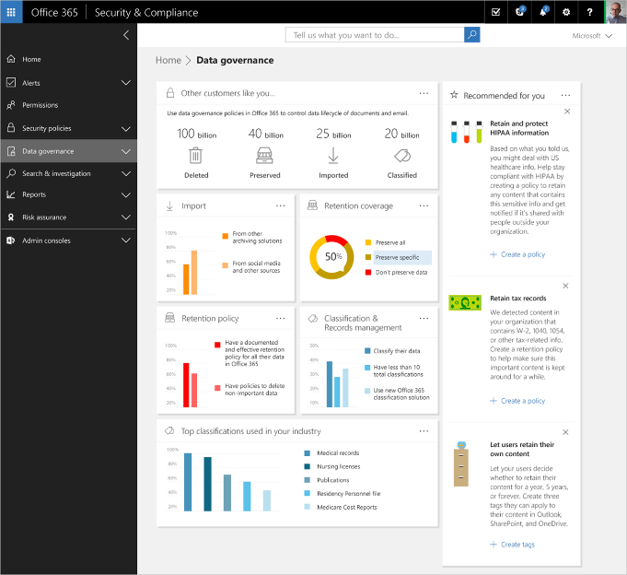

Advanced Data Governance will include the following capabilities:

* **Import**—Intelligently import only the data you need from on-premises and third-party archives using classifications such as age, data type, user or groups, sensitivity or importance.
* **Policies**—Policy recommendations are provided, based on machine assisted insights of your data, classifications, tenant, organization, industry, geography and more. Recommendations may include delete, move, encrypt or share.
* **Retention**—Intelligently preserve only what’s important to you by using classifications such as keywords, age, data type, user or group, sensitivity, importance. Integration with line-of-business systems allows you to trigger retention based upon events, such as creation of a human resources record.

Advanced Data Governance will help organizations apply the right actions to preserve high value data and purge redundant or obsolete data.

# Plan Office 365 security & information protection

**Office 365** includes many security and information protection capabilities. Microsoft **Enterprise Mobility + Security (EMS)** includes additional capabilities for protecting data, identities, and devices with Office 365. EMS includes Microsoft Intune and Azure Active Directory Premium. It can be challenging for large organizations to determine which capabilities to implement and in what order. The [Plan for Office 365 security and information protection capabilities](https://support.office.com/en-us/article/Plan-for-Office-365-security-and-information-protection-capabilities-3d4ac4a1-3920-4ff9-918f-011f3ce60408) article provides help.

### Deciding which capabilities to use

Our cybersecurity consulting team recommends taking a methodical approach to planning and implementing security and information protection features. If you don’t already have an established approach, here is a recommended starting point.

**Step 1: Set information protection standards**

First, agree on a set of standards that can be applied across your organization. Here is an example of what this can look like.

|  |  |  |
| --- | --- | --- |
| **A** | Establish information protection priorities | The first step of protecting information is identifying what to protect. Develop clear, simple, and well-communicated guidelines to identify, protect, and monitor the most important data assets anywhere they reside. |
| **B** | Set organization minimum standards | Establish minimum standards for devices and accounts accessing any data assets belonging to the organization. This can include device configuration compliance, device wipe, enterprise data protection capabilities, user authentication strength, and user identity. |
| **C** | Find and protect sensitive data | Identify and classify sensitive assets. Define the technologies and processes to automatically apply security controls. |
| **D** | Protect high value assets (HVAs) | Establish the strongest protection for assets that have a disproportionate impact on the organizations mission or profitability. Perform stringent analysis of HVA lifecycle and security dependencies, establish appropriate security controls and conditions. |

**Step 2: Classify data by sensitivity level**

Three levels is a good starting point if your organization doesn’t already have defined standards.

**Step 3: Map service capabilities to data sensitivity levels**

Some information protection capabilities apply broadly and can be used to set a higher minimum standard for protecting all data. Other capabilities can be targeted to specific data sets for protecting sensitive data and HVAs.

This table includes an example of how capabilities can be mapped to data sensitivity levels. There are two examples for level 1 because the default service will meet this need for some organizations while others require greater protection.

| Level | Standard | Description |
| --- | --- | --- |
| **1** | Data is encrypted and available only to authenticated users | This level of protection is provided by default for data stored in Office 365 services. Data is encrypted while it resides in the service and in transit between the service and client devices. For some organizations, this level of protection meets the minimum standard. |
|  | Additional data and identity protection applied broadly | Capabilities such as multi-factor authentication (MFA), mobile device management, and Exchange Online Advanced Threat Protection increase protection and substantially raise the minimum standard for protecting devices, accounts, and data. Many organizations will require one or more of these features to meet a minimum standard. |
| **2** | Sophisticated protection applied to specific data sets | Capabilities such as Azure Rights Management (RMS) and Data Loss Protection (DLP) across Office 365 can be used to enforce permissions and other policies that protect sensitive data. |
| **3** | Strongest protection and separation | You can achieve the highest levels of protection with capabilities such as Customer Lockbox for Office 365, eDiscovery features in Office 365, and SQL Server Always Encrypted for partner solutions that interact with Office 365. Use auditing features to ensure compliance to policies and prescribed configurations. Not all organizations require the highest level of protection. |

### Protecting data on devices

Many organizations start by implementing controls to protect data on devices. Office 365 includes some built-in capabilities. Intune and Azure Active Directory Premium include additional configurable capabilities for implementing conditional access and other access controls. For more information, see [Controlling Access to Office 365 and Protecting Content on Devices](https://www.microsoft.com/en-us/download/details.aspx?id=53317).

This table summarizes the capabilities.

|  | Office 365 | Intune |
| --- | --- | --- |
| BYOD (not enrolled) | Basic multi-factor authentication capabilities for Office 365. | Enforce PIN and encryption requirements, as well as other policy settings, for applications accessing Office 365.  Restrict actions like copy, cut, paste, and save as, to only apps managed by Intune. Enable secure web browsing using the Intune Managed Browser App. |
| Enrolled devices | Access control for Office 365 email and documents.  Only mobile devices that are enrolled in MDM for Office 365 can access Exchange Online and SharePoint Online. | Configurable conditional access policies for Office 365 apply to SharePoint Online, OneDrive for Business, and Skype for Business.  Configure secure access with certificates, Wi-Fi, VPN and email profiles.  Keep managed computers secure by ensuring the latest patches and software updates are quickly installed. |

**Additional Azure Active Directory Premium capabilities**

Create access policies that evaluate the context of a user's login to make real-time decisions about which applications they should be allowed to access.

For example, you can require multi-factor authentication per application or only when users are not at work. Or you can block access to specific applications when users are not at work.

|  |
| --- |
| **Microsoft Enterprise Mobility + Security (EMS)** is the only comprehensive solution designed to help manage and protect users, devices, apps, and data in a mobile-first, cloud-first world.  Refer to the Enterprise Mobility + Security (EMS) section later in this document. |

# Migrate your Org’s data to Office 365 Enterprise

When you migrate an enterprise organization to Office 365, it's important to plan exactly what steps you want to take, when to perform them, and who will perform them.

## Migrate email to Office 365

Your organization can migrate email to Office 365 from other systems.

### Migrate mailboxes from Exchange Server

For migrations from an existing on-premises Exchange Server environment, an administrator can migrate all email, calendar, and contacts from user mailboxes to Office 365.

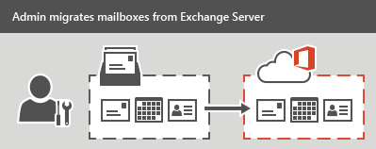

### Use Office 365 Import Service to migrate PST-files

If your organization has many large PST files, you can use the [Office 365 Import Service](http://go.microsoft.com/fwlink/p/?LinkId=544944) to migrate email data to Office 365.

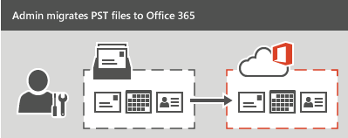

### Migrate email from another IMAP-enabled email system

You can use the Internet Message Access Protocol (IMAP) to migrate user email from Gmail, Exchange, and other email systems that support [IMAP migration](https://support.office.com/en-us/article/Migrate-your-IMAP-mailboxes-to-Office-365-3fe19996-29bc-4879-aab9-5a622b2f1481). When you migrate the user's email by using IMAP migration, only the items in the users' inbox or other mail folders are migrated. Contacts, calendar items, and tasks can't be migrated with IMAP, but they can be by a user.

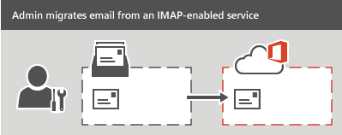

### Have users import their own email

Users can import their own email, contacts, and other mailbox information to Office 365. See [Migrate email and contacts to Office 365 for Business](https://support.office.com/en-us/article/Migrate-email-and-contacts-to-Office-365-for-Business-a3e3bddb-582e-4133-8670-e61b9f58627e) to learn how.

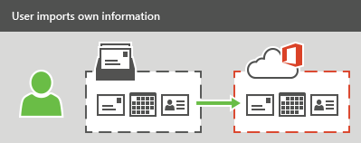

## Migrate files and folders

Before deciding on a migration strategy, it is vital that you perform an analysis of your current environment. This analysis should focus on those SharePoint workloads and content that you plan to move to SharePoint Online.

Office 365 provides the following methods for migrating multiple files to SharePoint Online.

* Use [Microsoft's Fast Track](http://go.microsoft.com/fwlink/?prd=12564&pver=1.0&sbp=FastTrack&plcid=0x409&clcid=0x409&ar=SharePoint%20Online&sar=Migration%20FastTrack) service for tools and guidance to get your data migrated to the cloud.
* You can use the [SPO migration API](http://go.microsoft.com/fwlink/p/?LinkId=617475) can be used to create migration import job to Office 365 and queue it up for later processing by a separate timer job.
* Use [Windows PowerShell cmdlets for SPO Migration Public Preview](http://go.microsoft.com/fwlink/p/?LinkId=617474) to migrate content from an on-premises fileshare or an on-premises SharePoint Server site to Office 365.

Microsoft partners are also available to assist with migrating your SharePoint content to SharePoint Online using third-party tools. Before choosing the migration tool to migrate your SharePoint content, be sure to verify that the tool meets your migration requirements and that it supports all of the SharePoint artifacts you want to migrate.

### Move your OneDrive files from SharePoint 2013 to Office 365

Moving to OneDrive for Business on Office 365 involves a few one-time tasks. To move your files, do the following tasks in sequence:

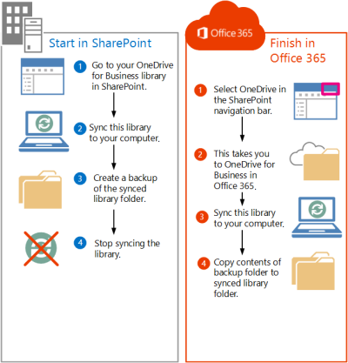

1. Go to your SharePoint OneDrive for Business library
2. Sync your SharePoint Server 2013 OneDrive for Business library to your computer
3. Create a backup copy of the synced library folder on your computer
4. Stop syncing your SharePoint Server 2013 OneDrive for Business library
5. Sync your Office 365 OneDrive for Business library to your computer
6. Upload files to your synced Office 365 OneDrive for Business library

**Note**: Files you move from SharePoint Server 2013 to Office 365 don’t retain their original metadata and, they are essentially recognized as new files. As a result, these files don’t retain metadata details such as Modified and Modified By.

Also, refer to: [Migrate OneDrive for Business document library files from on-premises SharePoint 2013 to Office 365](https://technet.microsoft.com/library/dn771624.aspx) article.

### Resources

* [Import PST files or SharePoint data to Office 365](https://technet.microsoft.com/en-us/library/ms.o365.cc.ingestionhelp.aspx)
* [Encrypt and import PST files to Office 365](https://technet.microsoft.com/en-us/library/mt684587.aspx) (network upload)
* [Import unencrypted PST files to Office 365](https://technet.microsoft.com/en-us/library/mt644809.aspx) (network upload)
* [Use drive shipping to import PST files to Office 365](https://technet.microsoft.com/en-us/library/mt651664.aspx) (drive shipping)
* [Import SharePoint data to Office 365](https://technet.microsoft.com/en-us/library/mt210445.aspx) (network upload and drive shipping)

## Migrate Skype for Business users

Learn how to migrate user settings and move users to Skype for Business Online in the [Move users to Skype for Business Online](https://technet.microsoft.com/library/jj204969.aspx) article.

* Before actually moving the user to Office 365, you should first confirm that the user accounts are synchronized to the cloud, and assign them a license.
* Before you start migrating users to Skype for Business Online, you should backup the user data associated with the accounts to be moved.
* Before you begin to move users to Skype for Business Online, you may want to move a few pilot users to confirm that your environment is correctly configured. You can then verify that the features and services function as expected before attempting to move additional users.
* You can verify that the user was moved successfully by checking online user settings and features.

## Archiving third-party data

Office 365 has released a new feature that lets you import and archive third-party data from social media platforms, instant messaging platforms, and document collaboration platforms, to mailboxes in your Office 365 organization. Examples of third-party data sources that you can import to Office 365 include the following:

* **Social**: Twitter, Facebook, Yammer, and LinkedIn
* **Instant messaging**: Yahoo Messenger, GoogleTalk, and Cisco Jabber
* **Document collaboration**: Box and DropBox
* **Vertical industries**: Customer Relationship Management (such as Salesforce Chatter) and Financials (such as Thomson Reuters and Bloomberg)
* **SMS/text messaging**: BlackBerry

After third-party data is imported, you can apply Office 365 compliance features to this data.

The following illustration and description explain how the third-party data import process works.

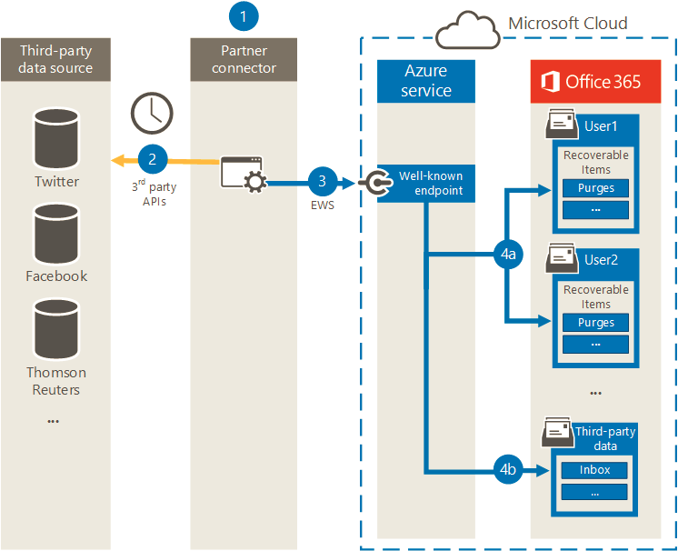

1. Customer works with their partner of choice to configure a connector that will extract items from the third-party data source and then import those items to Office 365.
2. The partner connector connects to third-party data sources via a third-party API (on a scheduled or as-configured basis) and extracts items from the data source. The partner connector converts the content of an item to an email message format.
3. Partner connector connects to the Azure service in Office 365 by using Exchange Web Service (EWS) via a well-known end point.
4. Items are imported into the mailbox of a specific user or into a "catch-all" third-party data mailbox. Whether an item is imported into a specific user mailbox or to the third-party data mailbox is based on the following criteria:
5. **Items that have a user ID that corresponds to an Office 365 user account**. If the partner connector can map the user ID of the item in the third-party data source to a specific user ID in Office 365, the item is copied to the Purges folder in the user's Recoverable Items folder. Users can't access items in the Purges folder. However, you can use Office 365 eDiscovery tools to search for items in the Purges folder.
6. **Items that don’t have a user ID that corresponds to an Office 365 user account**. If the partner connector can't map the user ID of an item to a specific user ID in Office 365, the item is copied to the Inbox folder of the third-party data mailbox. Importing items to the inbox allows you or someone in your organization to sign in to the third-party mailbox to view and manage these items, and see if any adjustments need to be made in the partner connector configuration.

### Resources

* [Archiving third-party data in Office 365](https://technet.microsoft.com/library/mt621583.aspx)
* [Enable or disable archive mailboxes in Exchange Online](http://go.microsoft.com/fwlink/p/?LinkId=404425)
* [Place a mailbox on Litigation Hold](http://go.microsoft.com/fwlink/?LinkId=404420)
* [Create or remove an In-Place Hold](http://go.microsoft.com/fwlink/?LinkId=404418)

# Office 365 Application Development

## Office 365 APIs

Whether you want to incorporate the richness of Office 365 data into your app, or create a custom experience within Office 365 itself, or use custom reports to keep your Office 365 Enterprise environment running smoothly, you can use the developer features below to achieve your goals.

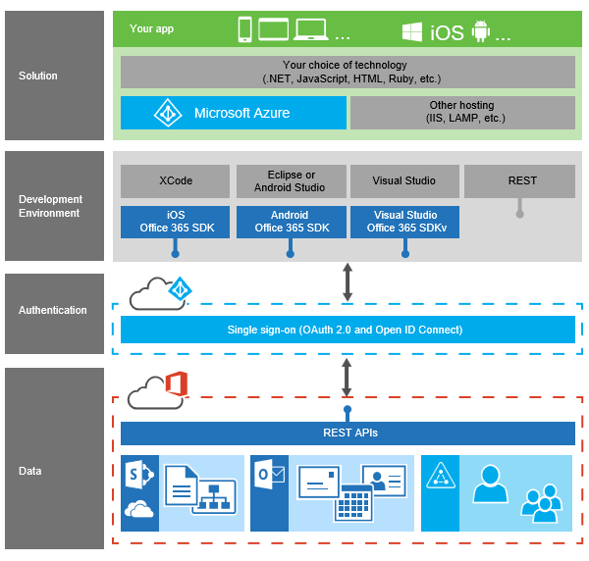

**Integrate Office 365 data into your own apps**

You can create custom solutions that access and interact with all the richness of a user’s Office 365 data—and you can build those solutions across all mobile, web, and desktop platforms.

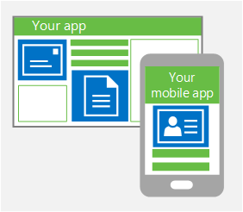

* Office 365 APIs enable you to provide access to Office 365 data, including their mail, calendars, contacts, files, and folders. All right from within your app itself.
* Whether you're building web applications using .NET, PHP, Java, Python, or Ruby on Rails, or creating apps for Windows 8, Universal Apps, iOS, Android, or on another device platform. It's your choice.

See [Office 365 API overview](https://msdn.microsoft.com/office/office365/HowTo/rest-api-overview).

**Create custom experiences within Office 365**

Now, you can extend Office 365 itself. Customize how your data and experiences are displayed within and interact with Office 365 to provide a seamless user experience.

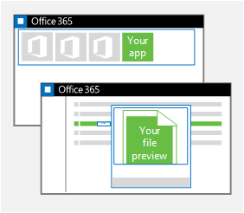

* [Create a FileHandler add-in](https://msdn.microsoft.com/office/office365/HowTo/using-cross-suite-apps) to control how SharePoint Online displays and interacts with your custom file types, including custom file type icons, file preview within the Office 365 UI, and opening the file type in a custom editor. And since FileHandler add-ins host their data and logic remotely, you can develop your add-in using the language, tools, and web development stack of your choice.
* [Add your app to the app launcher](https://msdn.microsoft.com/office/office365/HowTo/connect-your-app-to-o365-app-launcher) to give it visibility and make it accessible right from the Office 365 home page. Take advantage of Azure AD single sign-on to provide seamless access to your app for authorized users.

**Analyze and manage the health of your Office 365 Enterprise environment**

Office 365 Enterprise provides administrators a variety of developer features to keep their domains and subscriptions effective and well-tuned.

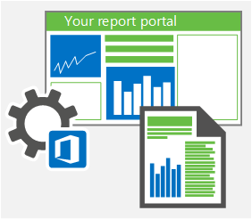

* [Access the Reporting web service](https://msdn.microsoft.com/en-us/library/office/jj984325.aspx) to build reporting dashboards, charts, and graphs to help their organization manage their subscription usage.
* [Use the Office 365 Service Communications API (preview)](https://msdn.microsoft.com/library/office/dn707386.aspx) to retrieve real-time service health information and Message Center communications for the domains that they own or manage. This enables them to monitor service health, manage communications, and develop plans to respond to upcoming service maintenance.
* [Use the Office 365 Management Activity API](https://msdn.microsoft.com/library/office/mt227394.aspx) to retrieve information about various user, admin, system, and policy actions and events from Office 365 and Azure AD activity logs. Use this information to build solutions that provide monitoring, analysis, and data visualizations.

### How do the Office 365 APIs work?

The Office 365 APIs are REST services that provide access to high-value data from Office 365 services:

* Mail, calendars, and contacts from Exchange Online
* Files and folders from SharePoint Online and OneDrive for Business
* Users and groups from Azure AD

And with the simplicity of REST, you don't need any specialized Exchange, SharePoint, or Azure AD knowledge to access these services.

Select the language, development platform, and hosting environment you want. Build using any web language, including JavaScript, HTML5, Python, Ruby, PHP, and ASP.NET. Use Visual Studio, Eclipse, Android Studio, Xcode, or the IDE of your choice. Host your apps in Microsoft Azure or any cloud platform you choose.

Then use single sign-on with Azure AD to authenticate your users and let them access email, files, calendar, and user information, and the petabytes of data that are stored in Office 365.

First, [set up your developer environment](https://msdn.microsoft.com/office/office365/HowTo/setup-development-environment). Then start building your first [iOS](https://msdn.microsoft.com/office/office365/HowTo/getting-started-Office-365-APIs), [Android](https://msdn.microsoft.com/office/office365/HowTo/getting-started-Office-365-APIs), [JavaScript](https://msdn.microsoft.com/office/office365/HowTo/getting-started-Office-365-APIs) or [ASP.NET](https://msdn.microsoft.com/office/office365/HowTo/getting-started-Office-365-APIs) app that uses the Office 365 APIs.

### Resources

**Microsoft Virtual Academy Courses** …

* [Office 365 Developer Overview](https://mva.microsoft.com/en-us/training-courses/office-365-developer-overview-13986)
* [Deep Dive into the Office 365 App Model](https://mva.microsoft.com/en-us/training-courses/deep-dive-into-the-office-365-app-model-8386)
* [Deep Dive: Integrate Office 365 APIs in Your Web Apps](https://mva.microsoft.com/en-us/training-courses/deep-dive-integrate-office-365-apis-in-your-web-apps-8400)
* [Advanced Web Development with the Office 365 APIs](https://mva.microsoft.com/en-us/training-courses/advanced-web-development-with-the-office-365-apis-14048)
* [Advanced Web Development Using Angular with Office 365 APIs](https://mva.microsoft.com/en-us/training-courses/advanced-web-development-using-angular-with-office-365-apis-14047)
* [Getting Started with Mobile App Development with the Office 365 APIs](https://mva.microsoft.com/en-us/training-courses/getting-started-with-mobile-app-development-with-the-office-365-apis-14050)

**Read** …

* [Overview of developing on the Office 365 platform](https://msdn.microsoft.com/office/office365/HowTo/platform-development-overview)
* [Set up your Office 365 development environment](https://msdn.microsoft.com/office/office365/HowTo/setup-development-environment)
* [Office 365 app authentication and resource authorization](https://msdn.microsoft.com/office/office365/HowTo/common-app-authentication-tasks)
* [Office 365 API sandbox](https://apisandbox.msdn.microsoft.com/)
* [Office 365 OAuth sandbox](https://oauthplay.azurewebsites.net/)
* [Office 365 API code samples and videos](https://msdn.microsoft.com/en-us/office/office365/howto/starter-projects-and-code-samples)
* [Resource reference for the Mail, Calendar, and Contacts REST APIs](https://msdn.microsoft.com/office/office365/APi/complex-types-for-mail-contacts-calendar)
* [Get started with Office 365 Management APIs](https://msdn.microsoft.com/en-us/library/office/dn707383.aspx)

## Microsoft Graph

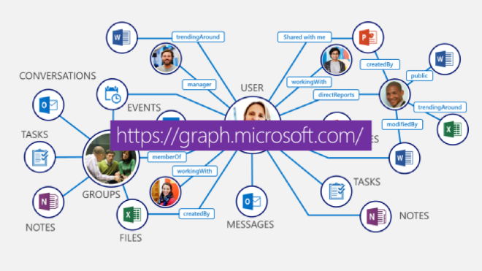

Microsoft Graph exposes multiple APIs from Office 365 and other Microsoft cloud services through a single endpoint: https://graph.microsoft.com. Microsoft Graph simplifies queries that would otherwise be more complex.

You can use Microsoft Graph to:

* Access data from multiple Microsoft cloud services, including Azure Active Directory, Exchange Online as part of Office 365, SharePoint, OneDrive, OneNote, and Planner.
* Navigate between entities and relationships.
* Access intelligence and insights from the Microsoft cloud (for commercial users).

**Microsoft Graph development stack**

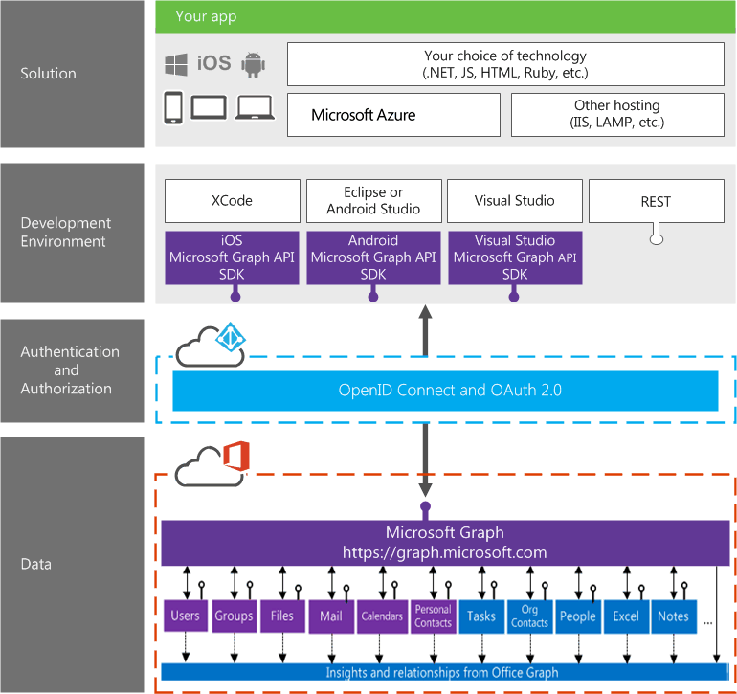

### Why use Microsoft Graph?

Keeping the end user experience at the center, the Microsoft Graph unlocks new productivity scenarios by:

* Enabling corporate IT to rapidly build solutions for employees.
* Enabling developers to build inline social experiences.
* Empowering partners to customize their Office experience and extend their apps with Office 365 data.

The Microsoft Graph, located at graph.microsoft.com, allows applications to access digital work and digital life data across the intelligent Microsoft cloud.

* **Consistent and unified.** Microsoft Graph provides a consistent and interlinked API for working with a wide variety of types of data across Microsoft services. Developers can traverse their organizational hierarchy, discover tasks and groups associated with those users, and use organizational insights to find active working relationships between teams.
* **Available on devices and services.** Microsoft Graph has a growing set of SDKs for devices and for services – so whether you’re working on Android apps, creating a .net Azure web site, or building a Ruby service, you can quickly incorporate Graph data into your application.
* **Growing support for Hybrid and On-Premises.** Increasingly, Microsoft Graph will offer support hybrid deployments, meaning that organizations can flexibly expose on-premises and cloud services behind one consistent endpoint.

The articles in [Getting started building Microsoft Graph apps](https://graph.microsoft.io/en-us/docs/get-started/get-started) section provide detailed guidance on how to build apps that connect to Microsoft Graph across a variety of languages and development platforms. Each article starts with a sample starter project for the appropriate platform, and walks you through adding functionality that authenticates the user and makes a sample request to have Microsoft Graph send an email from their account.

**SharePoint and Microsoft Graph API Beta now available**

|  |
| --- |
| This functionality is an early developer preview and is only available through the Microsoft Graph API beta endpoint. The API design is likely to change as we incorporate feedback from developers. |

The SharePoint API in Microsoft Graph supports the following core scenarios:

* Access to SharePoint **sites**, **lists**, and **drives** (via document libraries)
* Read-only support for **site** and **list** resources (no ability create new sites or lists)
* Read-write support for **listItems** and **driveItems**
* Address resources by SharePoint ID, URL, or relative path

The SharePoint API exposes three major resource types:

* [Site](http://graph.microsoft.io/en-us/docs/api-reference/beta/resources/site.htm) *(top-level object)*
* [List](http://graph.microsoft.io/en-us/docs/api-reference/beta/resources/list.htm)
* [ListItem](http://graph.microsoft.io/en-us/docs/api-reference/beta/resources/listitem.htm)

Read [Working with SharePoint sites in Microsoft Graph](http://graph.microsoft.io/en-us/docs/api-reference/beta/resources/sharepoint) article for more information.

### Resources

* [Microsoft Graph homepage](https://graph.microsoft.io/)
* [Overview of Microsoft Graph](https://graph.microsoft.io/docs/overview/overview)
* [Graph Explorer](https://graphexplorer2.azurewebsites.net/)
* [Samples & SDKs](https://graph.microsoft.io/code-samples-and-sdks)
* [Nine samples showing how to connect to Office 365 using the Microsoft Graph API (iOS, PHP, Android, Ruby, Nodejs, Python, Angular, UWP, AspNewMVC)](https://github.com/Officedev?utf8=%E2%9C%93&query=Graph-Connect)
* [Four samples demonstrating common Microsoft Graph API operations (Angular, iOS, Android, UWP)](https://github.com/Officedev?utf8=%E2%9C%93&query=Graph-Connect)

## SharePoint Online Development

### SharePoint Add-ins

SharePoint Add-ins are self-contained extensions of SharePoint websites that you create, and that run without custom code on the SharePoint server. There are two basic kinds of SharePoint Add-ins — **SharePoint-hosted** and **Provider-hosted**.

Build [SharePoint-hosted](https://msdn.microsoft.com/EN-US/library/office/fp142379.aspx) or [provider-hosted](https://msdn.microsoft.com/EN-US/library/office/fp142381.aspx) add-ins to use remote web applications, surface remote data, offload business logic, access SharePoint list data, integrate with Office applications and services, make SharePoint a portal for other applications, and more.

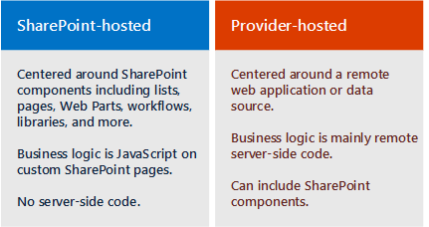

* All SharePoint Add-ins are to solve a well-defined business problem.
* Add-ins don't have custom code that runs on the SharePoint servers. Instead, all custom logic moves "up" to the cloud, or "down" to client computers, or "over" to an on-premises server that is outside the SharePoint Online subscription.
* Almost all major types of SharePoint components can be part of a SharePoint Add-in, including pages, lists, workflows, custom content types, list templates, Web Parts, and more.
* SharePoint Add-ins can fit into a SharePoint website in several ways: As an **immersive full-page** experience that can have the look and feel of a SharePoint page, as **part of a webpage**, using a special kind of control, called an add-in part, to surface an iframe element that contains the add-in OR, as **UI commands** that extend ribbons and menus by adding the add-in to list items, documents, and more.
* All SharePoint Add-ins that users install get a tile on the Site Contents page of the SharePoint website. Clicking the tile runs the add-in.
* A SharePoint Add-in is configured using an add-in manifest—an XML file that declares the add-in’s basic properties, where it runs, and what SharePoint should do when the add-in starts.

#### Using data in SharePoint Add-ins

In your add-in, you will frequently have to retrieve and manipulate SharePoint data, such as items in document libraries and lists, metadata, or user profiles. Similarly, you might have scenarios where you need to access external data in add-in. The model for SharePoint Add-ins provides multiple connectivity options and a rich set of APIs for accessing the data and services that reside on SharePoint and on external systems.

As you design add-in and plan for data access, you have to make two key decisions:

* Which connectivity option should I use?
* What APIs should I use for accessing the data I need?

The following figures summarize the different options that are provided by the model for SharePoint Add-ins.

**Options for using SharePoint data in your add-in**

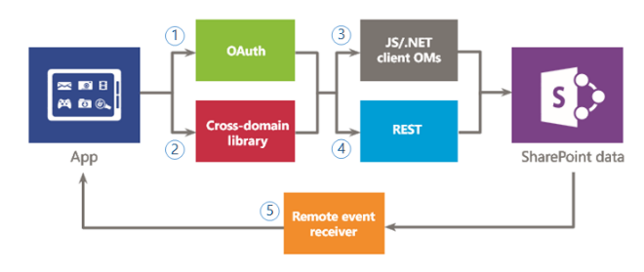

You have to decide whether you want to authenticate and communicate to SharePoint by using (1) OAuth, or (2) the cross-domain library. Then, for the data access API, you must decide between (3) the client object model (JavaScript/.NET client object models), or (4) Representational State Transfer (REST).

Keep in mind that you can also access certain data using (5) remote event receivers, however, the main scenario for remote event receivers is remote code execution.

**Options for using external data in your add-in**

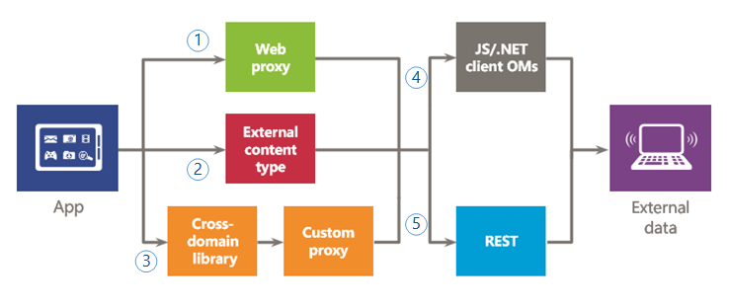

You have to decide whether you want to use (1) the web proxy, (2) external content types, or (3) the cross-domain library with a custom proxy page to authenticate and communicate with external services or systems. You can also use (4) the client object model (JavaScript/.NET client object models), or (5) Representational State Transfer (REST).

#### Data connectivity options

The following connectivity options are available when accessing SharePoint and External data from add-ins.

**SharePoint data connectivity options**:

* **OAuth**: An open protocol that enables secure authorization in a simple and standard way. OAuth enables users to approve an application to act on their behalf without sharing their user name and password. You can use OAuth with server-side code. It is a good option if you need to run a non-interactive process, or if you need to elevate privileges to other than those of the logged-on user.
* **Cross-domain library**: A client-side alternative in the form of a JavaScript file (SP.RequestExecutor.js) hosted in the SharePoint website that you can reference in your remote add-in. This library allows you to interact with more than one domain in your remote add-in page through a proxy. This is a good option if you prefer your add-in code to run in the client rather than in the server, or if there are connectivity barriers, such as firewalls, between SharePoint and your remote infrastructure.
* **Remote event receivers**: You can use remote event receivers to handle events that occur to an item in the add-in, such as a list, a list item, or a web. These events resemble those in a traditional SharePoint solution, except that they can work with the remote components of the SharePoint Add-in.

**External data connectivity options**:

* **Web proxy**: As a developer, you can use the web proxy exposed in client APIs such as the JSOM. When you use the web proxy, you issue the initial request to SharePoint. In turn, SharePoint requests the data to the specified endpoint and forwards the response back to your page. Use the web proxy when you want the communication to occur at the server level. The web proxy is designed to access unstructured data that doesn’t require authentication.
* **External content types**: You can create add-ins that access external data from SAP, Netflix, and proprietary and other types of data without involving the tenant administrator. Access to external applications is maintained through Business Connectivity Services (BCS), which provides a consistent and uniform interface that can be used by other SharePoint applications. App-scoped ECTs are a good option when you are using a BCS model and access to the data requires authentication.
* **Custom proxy page for the cross-domain library**: You can use the cross-domain library to access data in your remote add-in if you provide a custom proxy page that is hosted in the remote add-in infrastructure. As the developer, you are responsible for the custom proxy page implementation and must provide custom logic, such as the authentication mechanism to the remote add-in. Use the cross-domain library with a custom proxy page if you want the communication to occur at the client level.

#### Available data access APIs

The following API choices are available when you want to access SharePoint data from add-in:

* **Representational State Transfer (REST)**: For scenarios in which you need to access SharePoint entities from client technologies that do not use JavaScript and are not built on the .NET Framework platform, SharePoint provides an implementation of a REST web service that uses the Open Data (OData) protocol to perform CRUDQ (Create, Read, Update, Delete, and Query) operations on SharePoint data.
* **.NET Framework client object model (.NET client OM):** Almost every class in the core site and list server-side object model has a corresponding class in the .NET Framework client object model. In addition, the .NET Framework client object model also exposes a full set of APIs for extending other features, including some SharePoint-level features such as ECM, taxonomy, user profiles, advanced search, analytics, BCS, and others.
* **JavaScript client object model (JSOM)**: SharePoint provides a JavaScript object model for use in either inline script or separate .js files. It includes all the same functionality as the .NET Framework client object model. The JSOM is a useful way of including custom SharePoint code in an add-in, especially in a SharePoint-hosted add-in, where custom server-side code is not allowed.

For the latest CSOM, refer to: [New SharePoint CSOM version released for SharePoint Online - December 2016](https://dev.office.com/blogs/new-sharepoint-csom-version-released-for-Office-365-december-2016) blog post. We are also looking to update the [SharePoint Online Management Shell](https://www.microsoft.com/en-us/download/details.aspx?id=35588) on early January to align with this specific version. Keep track of the [Office Dev Blog](http://dev.office.com/blogs) for updates in this area.

#### Resources

**Microsoft Virtual Academy Courses** …

* [Getting Started with SharePoint Add-Ins](https://mva.microsoft.com/en-us/training-courses/getting-started-with-sharepoint-addins-14053?l=sMyOE1nmB_3700115881)
* [Advanced SharePoint Add-in Development](https://mva.microsoft.com/en-us/training-courses/advanced-sharepoint-addin-development-14046?l=TxuanknmB_7400115881)

**Read** …

* [SharePoint Add-ins](https://msdn.microsoft.com/EN-US/library/office/fp179930.aspx)
* [Get started creating SharePoint-hosted SharePoint Add-ins](https://msdn.microsoft.com/EN-US/library/office/fp142379.aspx)
* [Get started creating provider-hosted SharePoint Add-ins](https://msdn.microsoft.com/EN-US/library/office/fp142381.aspx)
* [Secure data access and client object models for SharePoint Add-ins](https://msdn.microsoft.com/EN-US/library/office/fp179897.aspx)
* [Choose patterns for developing and hosting your SharePoint Add-in](https://msdn.microsoft.com/EN-US/library/office/fp179887.aspx)
* [New SharePoint CSOM version released for SharePoint Online - December 2016](https://dev.office.com/blogs/new-sharepoint-csom-version-released-for-Office-365-december-2016)
* [How to install add-in/app to SharePoint sites using CSOM](https://channel9.msdn.com/blogs/OfficeDevPnP/How-to-install-add-inapp-to-SharePoint-sites-using-CSOM)
* [SharePoint Online Management Shell](https://www.microsoft.com/en-us/download/details.aspx?id=35588)

### Office 365 Public CDN Developer *Preview*

Office 365 Public Content Delivery Network (CDN) capability in the Office 365 will enable you to **automatically host static assets**, like images and JavaScript files in CDN for **providing better performance** with SharePoint pages. CDN will work effectively as a geo-distributed caching proxy, by caching the static assets closer to the browsers requesting them.

Office 365 Public CDN is now released as a ***Developer Preview*** for all tenants in Office 365. You can start using it by explicitly enabling the capability on the tenant level using PowerShell cmdlets.

Following picture clarifies the logical flow of using Office 365 Public CDN:

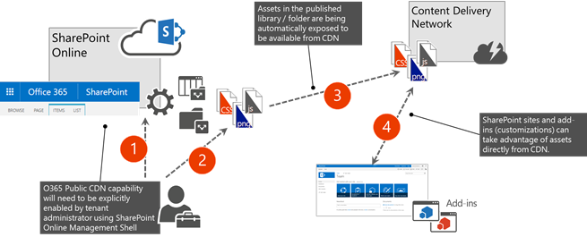

1. Administrator enables Office 365 Public CDN for the tenant using SharePoint Online Management Shell.
   * Cmdlets allow to designate certain SharePoint document libraries or folders to serve as a CDN origin. Note, that assets exposed via Public CDN are accessible by everyone anonymously. Therefore, resources that are considered sensitive by the company should never be placed in those libraries.
   * Cmdlets also provide capability to choose the file types exposed via CDN. By default, common design asset types are enabled.
2. Static assets to be shared via CDN are being uploaded to the SharePoint libraries or folders, which are enabled as the CDN origins.
3. Assets are being exposed from the configured libraries of folders and they can be accessed using the CDN URLs.
4. URLs pointing to CDN location are available to be used in the SharePoint sites and in the customizations hosted from SharePoint.

In case the asset is updated in the SharePoint library, the new version will become available via CDN within 15 minutes.

During developer preview of this capability, you’ll need to explicitly update the used asset links and replace them with CDN URLs. The CDN URL can be easily constructed for all the assets in the enabled library of folder, you will need to use the REST API for getting prefix for one of the assets in library/folder and use that as the constant for other assets.

Refer to the [Office 365 Public CDN Developer Preview Release](http://dev.office.com/blogs/office-365-public-cdn-developer-preview-release) blog post and the [Office 365 Public CDN - Developer Preview](https://www.youtube.com/watch?list=PLR9nK3mnD-OWSbg0o9a7mx_E7s2u7h_o2&v=bt_THzaAX50) video for more information.

### The Modern experiences

SharePoint Online has started the gradual introduction of "modern" experiences cross the SharePoint service, which has a direct impact on the end user experience but also on the customization options that can be used.

|  |
| --- |
| The SharePoint "modern" experiences are currently not available for SharePoint on-premises. They are planned to, step by step, become available for SharePoint 2016 as part of upcoming feature packs. |

The modern experiences in SharePoint Online are:

* **Modern team sites**
* **Modern list and library experiences**
* **Modern site pages**

"Modern" experiences are gradually released in SharePoint Online and you can control how they are taken into use from tenant or site level. If you have a lot of existing important customizations, you can defer taking new experiences into use until needed customizations scenarios can be enabled with them as well.

We recommend using the following process for adopting to the "modern" experiences, if you have existing customizations which are business critical for your deployment:

1. **Readiness**: Understand the "modern" experiences, know what features they offer but equally important understand what's features are not (yet) available
2. **Assess**: Assess to what extend your current customizations can work in the "modern" experience. Also assess which of your sites do have customizations or features that will not work in the "modern" experiences, these sites and their customizations should be updated or need to stay in "classic". However all other sites should work fine using the "modern" experiences.
3. **Solution planning**: Plan the needed work on both custom solutions as sites to prepare them to be used with the "modern" experiences
4. **Develop and test**: Apply the needed changes to your customizations and test them
5. **Deploy**: Roll out the updated changes to your SharePoint Online environment

Here are the key scenarios currently supported by the "modern" experiences.

| Customization | Introduction to options |
| --- | --- |
| Provisioning "modern" team sites | "Modern" team sites can be provisioned by an end user but you can also create these sites programmatically which is explained in detail in [Provisioning modern team sites](https://msdn.microsoft.com/en-us/pnp_articles/modern-experience-customizations-provisioning-sites) article. |
| Customizing "modern" team sites | "Modern" team sites are sites which bring a fresh new responsive user experience to SharePoint Online, showing relevant information on the home page. Typically these sites also have a corresponding Office 365 Group associated. Learn more about the customization options in [Customizing modern team sites](https://msdn.microsoft.com/en-us/pnp_articles/modern-experience-customizations-customize-sites) article. |
| Customizing "modern" lists and libraries | "Modern" lists and document libraries bring a better user experience which is faster, more intuitive and responsive. The [Customizing modern lists and libraries](https://msdn.microsoft.com/en-us/pnp_articles/modern-experience-customizations-customize-lists-and-libraries) article focuses on the extensibility options, such as user custom actions and branding, which are supported for the "modern" library and list experiences. |
| Customizing "modern" site pages | "Modern" team site pages are fast, easy to author and support rich multimedia content. And pages look great on any device, in a browser or from within the SharePoint mobile app. The [Customizing modern site pages](https://msdn.microsoft.com/en-us/pnp_articles/modern-experience-customizations-customize-pages) article focuses on the extensibility options there are in the "modern" page experience. |

Online resources to refer to are:

* [Customizing the "modern" experiences in SharePoint Online](https://msdn.microsoft.com/en-us/pnp_articles/modern-experience-customizations)
* [Provisioning "modern" team sites programmatically](https://msdn.microsoft.com/en-us/pnp_articles/modern-experience-customizations-provisioning-sites)
* [Customizing "modern" team sites](https://msdn.microsoft.com/en-us/pnp_articles/modern-experience-customizations-customize-sites)
* [Customizing "modern" lists and libraries](https://msdn.microsoft.com/en-us/pnp_articles/modern-experience-customizations-customize-lists-and-libraries)
* [Customizing "modern" site pages](https://msdn.microsoft.com/en-us/pnp_articles/modern-experience-customizations-customize-pages)

### SharePoint Webhooks

SharePoint [webhooks](http://en.wikipedia.org/wiki/Webhook) enable developers to build applications that subscribe to receive notifications on specific events that occur in SharePoint. When an event is triggered, SharePoint sends an HTTP POST payload to the subscriber. Webhooks are easier to develop and consume than Windows Communication Foundation (WCF) services used by SharePoint add-in remote event receivers. This is because webhooks are regular HTTP services (web API).

Currently webhooks are only enabled for SharePoint list items. SharePoint list item webhooks cover the events corresponding to list item changes for a given SharePoint list or a document library. SharePoint webhooks provide a simple notification pipeline so your application can be aware of changes to a SharePoint list without polling the service.

For more information see [SharePoint list webhooks](https://dev.office.com/sharepoint/docs/apis/webhooks/lists/overview-sharepoint-list-webhooks) and [SharePoint webhooks sample reference implementation](https://dev.office.com/sharepoint/docs/apis/webhooks/webhooks-reference-implementation).

### SharePoint Framework (*Preview*)

The SharePoint Framework is the next evolution in SharePoint development.

The SharePoint Framework is currently in preview and is subject to change. SharePoint Framework client-side web parts are not currently supported for use in production environments.

The **SharePoint Framework (SPFx)** is a page and web part model that provides full support for client-side SharePoint development, easy integration with SharePoint data, and support for open source tooling. With the SharePoint Framework, you can use modern web technologies and tools in your preferred development environment to build productive experiences and apps that are responsive and mobile-ready from day one. The SharePoint Framework works for SharePoint on-premises and SharePoint Online.

Key features of the SharePoint Framework include:

* Runs in the context of the current user and connection in the browser. There are no iFrames.
* The controls are rendered in the normal page DOM.
* The controls are responsive and accessible by nature.
* Enables the developer to access the lifecycle - including, in addition to **render** - **load**, **serialize** and **deserialize**, **configuration changes**, and more.
* It's framework agnostic. You can use any browser framework that you like: React, Handlebars, Knockout, Angular, and more.
* The toolchain is based on common open source client development tools like npm, TypeScript, Yeoman, webpack, and gulp.
* Performance is reliable.
* End users can use SPFx client-side solutions that are approved by the tenant administrators (or their delegates) on all sites, including self-service team, group, or personal sites.
* Solutions can be deployed in both classic web part and publishing pages and modern pages.

#### Resources

* [SharePoint Framework documentation](http://dev.office.com/sharepoint)
* [React - A JavaScript Library for Building User Interfaces](https://facebook.github.io/react/)
* [Sample SharePoint Framework web parts in GitHub](https://github.com/SharePoint/sp-dev-fx-webparts)
* [Open and Connected Framework - The SharePoint Framework](https://www.youtube.com/watch?v=T_bGyqKwT4g) - YouTube
* [PnP Webcast - Building multi-view React client-side web parts with SharePoint Framework](https://dev.office.com/blogs/building-multi-view-react-client-side-web-parts-with-spfx)
* [PnP Webcast - Building real time news feed web part with SharePoint Framework](https://dev.office.com/blogs/building-real-time-news-feed-web-part-with-sharepoint-framework)
* [PnP Webcast - Building multi-view Angular 1.x client-side web parts with SharePoint Framework](https://dev.office.com/blogs/building-multi-view-angular-1-x-client-side-web-parts-with-spfx)
* [PnP Webcast - Reuse your existing JavaScript libraries with SharePoint Framework](https://dev.office.com/blogs/reuse-your-existing-javascript-libraries-with-sharepoint-framework)
* [PnP Webcast - Building a sample search web part with SharePoint Framework using React](https://dev.office.com/blogs/building-a-sample-search-web-part-with-spfx-using-react)
* [PnP Webcast - Azure AD implicit flow with SPFx client-side web part (developer preview)](https://dev.office.com/blogs/azure-ad-implicit-flow-with-spfx-client-side-web-parts)
* [PnP Webcast - CRUD operations with SharePoint Framework client-side web parts](https://feeds.feedburner.com/office/dev.office.com/blogs/crud-operations-with-sharepoint-framework-client-side-web-parts)
* [PnP Webcast - Using Office Graph from SharePoint client-side web parts](http://dev.office.com/blogs/using-office-graph-from-client-side-web-parts)
* [PnP Webcast - Referencing external JavaScript libraries from client-side web part](http://dev.office.com/blogs/referencing-external-js-libraries-from-client-side-web-part)
* [PnP Webcast - Building Angular SharePoint Framework client-side web part](http://dev.office.com/blogs/building-angular-sharepoint-framework-client-web-part)
* [PnP Webcast - Building simple SharePoint Framework Client Web Part](http://dev.office.com/blogs/building-simple-sharepoint-framework-client-web-part)
* [PnP Webcast - Integrating Angular v1.x to SharePoint Framework client side web part](http://dev.office.com/blogs/integrating-angular-to-sharepoint-framework-client-side-web-part)
* [PnP Webcast - Getting started with web stack in SharePoint Development](http://dev.office.com/blogs/getting-started-with-web-stack-in-sharepoint-development)
* [PnP Webcast - Getting started with SharePoint Framework](http://dev.office.com/blogs/getting-started-with-sharepoint-framework)
* [PnP Webcast - Preparing for SharePoint Framework - What should I learn?](http://dev.office.com/blogs/preparing-for-sharepoint-framework-what-should-i-learn)
* [PnP Webcast - Converting existing JavaScript apps to SharePoint Framework](https://channel9.msdn.com/blogs/OfficeDevPnP/PnP-Web-Cast-Converting-existing-JS-apps-to-SharePoint-Framework)
* [PnP JavaScript Core component](https://github.com/OfficeDev/PnP-js-core)

## Office UI Fabric

Office UI Fabric is a responsive, mobile-first, front-end framework that you can use to apply the Office Design Language to your web experiences. Whether you’re creating a new app or add-in or updating an existing one, Fabric makes it easy to get up and running.

* Built by Microsoft designers and design developers for Microsoft (and you).
* Just like other popular frameworks, but built from the ground up for Office 365 without excessive overriding.
* All about styling instead of JavaScript, so you can focus on your look and feel.
* Integrates with other frameworks, like Bootstrap. Built with **LESS** for powerful customization.
* Language support (including right-to-left behavior) to simplify localization.

The Office UI Fabric project is developed and maintained by the OneDrive and SharePoint Design Studio in order to...

* Help the development community build Office Add-ins and Office 365 web apps that integrate seamlessly with Office.
* Provide a point of reference for the evolving Office 365 design language that anyone can reference.
* Enable the community to contribute to better experiences for everyone who builds for Office.

### Resources

* [What is Office UI Fabric?](http://dev.office.com/fabric/what-is-fabric)
* [GitHub: Office UI Fabric](https://github.com/OfficeDev/Office-UI-Fabric)
* [Office UI Fabric: Resources](http://dev.office.com/fabric/resources)
* [Fabric tutorial](https://github.com/OfficeDev/Office-UI-Fabric/blob/master/ghdocs/TUTORIAL.md)

## OneDrive API

OneDrive API is available for OneDrive, OneDrive for Business and SharePoint Online. OneDrive API is also integrated into Microsoft Graph API, which enables even more scenarios around personal and business files.

**Note:** Although OneDrive stores OneNote notebooks, you shouldn't use the OneDrive API to work with OneNote notebooks. Instead, use the [OneNote API](http://dev.onenote.com/).

### Resources

* [Develop with the OneDrive API](https://dev.onedrive.com/README.htm)
* [OneDrive for Business authentication and sign in](https://dev.onedrive.com/auth/aad_oauth.htm)
* [Access to shared items and items “added to OneDrive”](https://dev.onedrive.com/misc/working-with-links.htm)
* [Working with OneDrive API and CORS](https://dev.onedrive.com/misc/working-with-cors.htm)
* [OneDrive unified JavaScript Picker and Saver SDK (preview)](https://dev.onedrive.com/sdk/unified-javascript-picker-saver.htm)
* SDKs for [iOS](https://github.com/onedrive/onedrive-sdk-ios), [Android](https://github.com/onedrive/onedrive-sdk-android), [Windows / .NET / Xamarin](https://github.com/onedrive/onedrive-sdk-csharp) and [Python](https://github.com/onedrive/onedrive-sdk-python) are now generally available

## Office 365 Connectors

Office 365 Connectors are a great way to get useful information and content into your Office 365 Group. Any user can connect their group to services like Trello, Bing News, Twitter, etc., and get notified of the group's activity in that service.

Office 365 Connectors also provides a compelling extensibility solution for developers. Developers can build connectors through **incoming webhooks** to generate rich connector cards. Additionally, with the new "**Connect to Office 365**" button, developers can embed the button on their site and enable users to connect to Office 365 groups.

### Office 365 Connector Cards

Connectors use webhooks to create Connector Card messages within an Office 365 group. Developers can create these cards by sending an HTTP request with a simple JSON payload to an Office 365 group webhook address. A user can generate a group webhook from the "Incoming Webhooks" page in the Connectors menu.

Connector cards can be short text-based messages, or a developer can use "sections" to display rich or specially-formatted information. When more content is added to the payload, the card scales gracefully.



A section is a canvas to show richer content than what can be represented in the just the title and text of the card. A section can contain text and images, or the activity and facts fields can be used to highlight key events and details.

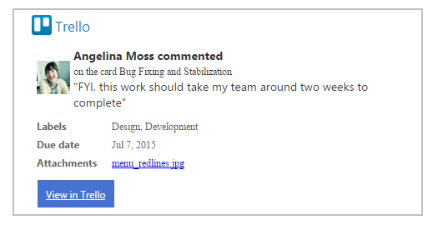

### 'Connect to Office 365' button

'Connect to Office 365' is an easy way for developers to integrate their product with Office 365 Groups. The Connect button lets you empower and engage your customers by sending connector cards to their Office 365 Groups.

Once you add a Connect button to your application, your users are able to use it to authorize their Office 365 Groups to receive your connector cards. The Connect button helps your app obtain a webhook to the Group authorized by your users. You can send rich connector cards to the Group using the webhook URL to share important updates, send reminders for pending actions, send weekly reports and so on.

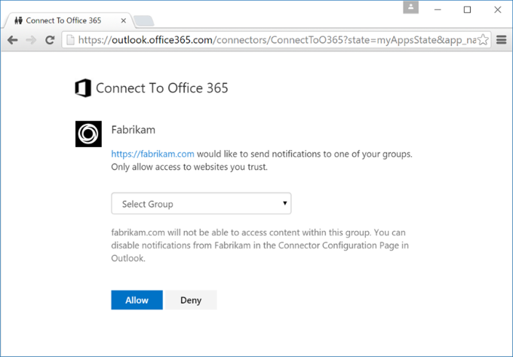

### Resources

* [Get started with Office 365 Connector Cards](https://dev.outlook.com/Connectors/GetStarted)
* [Introducing 'Connect to Office 365' Beta](https://dev.outlook.com/Connectors/ConnectButton)

## Business Application Platform

Compose analytics, user experiences, and automation using an integrated set of services from Microsoft. Build and extend modern business applications fast.

* **Power users** who understand their business challenges the best can now quickly build and deliver solutions without writing code.
* **Professional developers** can now easily extend capabilities for power users and take advantage of rich platform services with the full power of Azure.
* **The Microsoft Common Data Model** offers a rich framework that comes with hundreds of established entities and can be used across apps.
* **Connectors and Gateways** make it possible to get more value out of the services you’re already using.

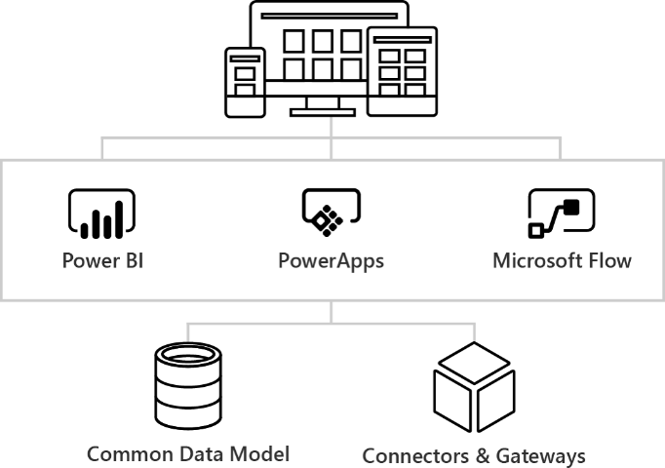

### Power up your power users

Now business analysts and power users can create apps quickly without writing code. The people who understand their challenges best can compose data analytics, interfaces, and automation into flexible solutions.

**Add insights to your apps**

Monitor your business and get answers quickly with apps that have stunning visualizations and analytics built in.

Get started with Power BI

**Build experiences you can act on**

Create rich user experiences across the web, phones and tablets. Assemble forms, add business logic, and take advantage of device capabilities with full creative freedom.

[Get started with PowerApps](#_Microsoft_PowerApps_(Preview))

**Automate your workflows**

Work smarter by building solutions that automate processes across apps and services. Streamline notifications, sync data between systems, automate approval workflows and more.

[Get started with Microsoft Flow](#_Microsoft_Flow_(Preview))

### Seamlessly grow up with Azure

Power BI, PowerApps and Microsoft Flow are all backed by best-in-class cloud services for enterprise developers and IT professionals. Quickly extend capabilities for power users and scale to enterprise-wide manageability easily at any time.

**Unlock insight**

Deliver valuable insight that moves your business forward with comprehensive business intelligence, analytics and machine learning services that can be embedded into any app.

* [SQL Server Business Intelligence](https://www.microsoft.com/sql-bi)
* [Data analytics](https://azure.microsoft.com/documentation/scenarios/data-analytics/)
* [Internet of Things (IoT)](https://azure.microsoft.com/documentation/scenarios/internet-of-things/)

**Build intelligent interfaces**

Leverage powerful cloud platform services to quickly create components for power users. Take advantage of the same services to deliver standalone web and mobile apps rapidly.

* [App Services](https://azure.microsoft.com/services/app-service/)
* [Service Fabric](https://azure.microsoft.com/services/service-fabric/)
* [Azure Functions](https://azure.microsoft.com/services/functions/)

**Evolve your integration**

Bring together disparate applications to deliver solutions such as payment processing, supply chain management, and more that integrate seamlessly with the rest of your apps.

* [Logic Apps](https://azure.microsoft.com/services/app-service/logic/)
* [API Management](https://azure.microsoft.com/services/api-management/)
* [BizTalk](https://azure.microsoft.com/services/biztalk-services/)

### Keep it all connected

Build business apps using a robust data framework with hundreds of established entities built in. Connect the services you’re already using – even custom APIs and on-premises systems.

**Build on the Common Data Model**

The Microsoft Common Data Model comes with hundreds of entities established over years of working with enterprise customers. Use the same data with any of the platform tools, add custom entities, and rest easy with built-in scalability and analytics.

**Get more from the systems you’re already using**

Bring together all the data your business already relies on without migrating a thing. Build apps using a rich set of connectors to popular applications, including on-premises sources. Integrate your own APIs easily.

## Microsoft PowerApps

**Microsoft PowerApps** is a business application platform that enables power users in line of business roles to easily build and deploy business apps. At the same time, **PowerApps** empowers IT organizations to catalyze business innovation by allowing business units to create apps, while maintaining control over data access and security.

The **Common Data Service**, included in **PowerApps**, is an out-of-the-box secure business database to improve operational efficiency offering a unified view of business data. **Common Data Service** provides App creators the flexibility to use standard business entities or custom entities to power their business apps.

To generate an app automatically, you just need to specify a data source. For step-by-step instructions, see [Create an app to manage data in SharePoint](https://powerapps.microsoft.com/en-us/tutorials/app-from-sharepoint/). Even though the topic is designed for SharePoint, the same principles apply to other types of data sources.

### Customize an App

If the generated app doesn't meet your needs by default, you can [customize it](https://powerapps.microsoft.com/en-us/tutorials/customize-card/). You might, for example, want to show data in a different kind of UI element (known as a control).

For ideas about how to improve your app further, you can [open a sample app](https://powerapps.microsoft.com/en-us/tutorials/open-and-run-a-sample-app/) to get a sense of what you can invent with some creativity and a bit of experience.

You can also [build an app from a template](https://powerapps.microsoft.com/en-us/tutorials/get-started-test-drive/). Each template is based on fictitious data in a cloud account, such as Dropbox, OneDrive, or Google Drive. Explore specific screens and controls to understand how they're configured, and experiment with customization to discover techniques that you can apply to your own apps.

### Create an app from scratch

You can [create an app from scratch](https://powerapps.microsoft.com/en-us/tutorials/get-started-create-from-blank/). By working from the ground up, you gain flexibility in app design, flow, and controls, and you can incorporate a larger variety of [data sources](https://powerapps.microsoft.com/en-us/tutorials/connections-list/).

For detailed explanations of some concepts you'll need, see these topics:

* [formulas](https://powerapps.microsoft.com/en-us/tutorials/formula-reference/)
* [galleries and forms](https://powerapps.microsoft.com/en-us/tutorials/working-with-forms/)
* [tables and records](https://powerapps.microsoft.com/en-us/tutorials/working-with-tables/)
* [controls and their properties](https://powerapps.microsoft.com/en-us/tutorials/reference-properties/)

### Features and Pricing

PowerApps is licensed on a per-user basis. Each user who accesses the service to create and run apps needs a license. Office 365 and Dynamics 365 customers can immediately benefit from the PowerApps and Microsoft Flow capabilities that these offerings include. Customers who want to build apps and flows that access data sources outside Office 365 and Dynamics 365, or need additional functionality, can purchase standalone subscriptions to PowerApps and Microsoft Flow. There are important differences in functionality between these groups of licenses.

| For Office 365 and Dynamics 365 | For business users | For app makers and admins |
| --- | --- | --- |
|  |  |  |
| PowerApps for Office 365 and Dynamics 365 | PowerApps  Plan 1 | PowerApps  Plan 2 |
| * Create and run custom business apps * Extend the capabilities of Office 365 and Dynamics 365 * Automate your workflows with Microsoft Flow | * Everything included with PowerApps for Office 365 and Dynamics 365 * Use apps that connect to an even wider range of data sources, with premium connectors * Use apps built on the Common Data Service | * Everything included with Plan 1 * Model your data using the Common Data Service * Create and manage instances of the Common Data Service * Enterprise-grade administration of environments and user policies |

#### PowerApps for Office 365 and Dynamics 365

PowerApps capabilities for Office 365 and Dynamics 365 enable users to create and run apps within the context of these services. **PowerApps licenses always include Microsoft Flow capabilities**. In addition to being included in PowerApps licenses, Microsoft Flow is also available as a standalone service.

PowerApps will be added to existing and new Office 365 subscriptions starting later in November 2016.

These Office 365 plans include PowerApps for Office 365:

* Office 365 Business Essentials
* Office 365 Business Premium
* Office 365 Enterprise E1
* Office 365 Enterprise E3
* Office 365 Enterprise E5

### Resources

* [Introduction to PowerApps](https://powerapps.microsoft.com/en-us/tutorials/getting-started/)
* [PowerApps Blog](https://powerapps.microsoft.com/en-us/blog/)
* [Choose the right plans for your team](https://powerapps.microsoft.com/en-us/pricing/)
* [Licensing Overview](https://powerapps.microsoft.com/en-us/tutorials/pricing-billing-skus/)
* [Manage your connections](https://powerapps.microsoft.com/en-us/tutorials/add-manage-connections/)
* [Add a data connection in an app](https://powerapps.microsoft.com/en-us/tutorials/add-data-connection/)
* [Microsoft Common Data Model preview available for PowerApps](https://powerapps.microsoft.com/en-us/blog/cdm-preview-available-for-powerapps/)

**Useful Ignite sessions** …

* [Review business application platform roadmap, strategy and packaging](https://myignite.microsoft.com/videos/22170)
* [Dive into PowerApps, building apps that mean business without writing code](https://myignite.microsoft.com/videos/4986)

## Microsoft Flow

Microsoft Flow is a *preview*, cloud-based, business-automation service with which you can build simple processes that make your business move more quickly and efficiently with less effort. You can connect to a broad range of services through easy-to-use templates and create your own processes that are tailored to your goals.

**Templates** are pre-built flows for popular and common scenarios. Using a template only requires you to have access to the services in the template and to fill out any required settings.

**Data sources**: [Built-in data connectors](https://flow.microsoft.com/en-us/services/) to more than 50 services, including Office 365, Twitter, OneDrive, Dropbox, Google Drive, Slack, MailChimp, Facebook, Dynamics CRM, SharePoint, Salesforce, and SQL.

### Manage Connections

Connections in Microsoft Flow allow you to easily access your data while building flows. Flow includes commonly used connections, including SharePoint, SQL, Office 365, OneDrive for Business, Salesforce, Excel, Dropbox, Twitter, and more. Connections are shared with **Microsoft PowerApps**, so when you create a connection in PowerApps, it shows up in Microsoft Flow, and vice versa.

For example, you can use connections to:

* Update a list on a SharePoint site.
* Get Excel data from your OneDrive for Business or Dropbox account.
* Connect to Office 365 and send email.
* Create a Twitter connection to send a tweet.

You can create connections in Microsoft Flow in multiple scenarios, such as:

* Creating a [flow from a template](https://flow.microsoft.com/en-us/documentation/get-started-logic-template/)
* Creating a [flow from blank](https://flow.microsoft.com/en-us/documentation/get-started-logic-flow/) or updating an existing flow
* Creating a connection in the [Microsoft Flow portal](https://flow.microsoft.com/)

### Flow and Logic Apps

Microsoft Flow is a stand-alone SaaS Service that is designed for broad usage, including business users that want to automate day-to-day tasks.

Logic Apps is an Azure service available through the Azure Portal. It is targeted at IT Professionals that need to tackle more complex integration problems, it includes the great features available in Microsoft Flow, plus additional capability like integration with Azure Resource Manager and the Azure Portal, PowerShell and the Azure Command-Line Interface (Azure CLI), Visual Studio, more advanced connectors. [Learn more about Logic apps](https://azure.microsoft.com/services/app-service/logic/).

### Flow creation now available from mobile phones

You can now easily create a flow from your phone (available both on our [iOS](https://itunes.apple.com/us/app/microsoft-flow/id1094928825?ls=1&mt=8) and [Android](https://play.google.com/store/apps/details?id=com.microsoft.flow) apps) by just a few simple clicks. Browse our rich template gallery, navigate through our services list, or select a various template category to drill into.

Also, if you’re looking for a specific service or template, you can simply search the gallery by keyword, and get in no time a list of results focused to your needs.

Finally, after creating your flow, you can come back and edit or rename it directly from within the app, from the flow properties page.

View our [app video](http://go.microsoft.com/fwlink/?LinkId=808727&clcid=0x409), and check out our [documentation](http://go.microsoft.com/fwlink/?LinkID=808728&clcid=0x409) that covers app concepts, from getting started to more advanced capabilities.

### Features and Pricing

Premium plans give you more runs, more checks, and access to services like MailChimp, Salesforce and many more.

|  |  |
| --- | --- |
| Flow Free | Flow for Office 365 and Flow for Dynamics 365 |
| * 750 runs per month * Unlimited flow creation * 15-minute checks | * 2,000 runs per month * Unlimited flow creation * 5-minute checks * 99.9% SLA |
|  |  |
| Flow Plan 1 | Flow Plan 2 |
| * 4,500 runs per month * Unlimited flow creation * 3-minute checks * Premium Services * 99.9% SLA | * 15,000 runs per month * Unlimited flow creation * 1-minute checks * Premium Services * Org policy settings * 99.9% SLA |

For more detailed information, refer to the [Pricing](https://flow.microsoft.com/en-us/pricing/) page.

### Resources

* [Microsoft Flow Blog](https://flow.microsoft.com/en-us/blog/)
* [Flow in your organization Q&A](https://flow.microsoft.com/en-us/documentation/organization-q-and-a/)
* [Create a flow from a template in Microsoft Flow](https://flow.microsoft.com/en-us/documentation/get-started-logic-template/)
* [Create a flow in Microsoft Flow](https://flow.microsoft.com/en-us/documentation/get-started-logic-flow/)
* [Manage connections in Microsoft Flow](https://flow.microsoft.com/en-us/documentation/add-manage-connections/)
* [Manage an on-premises data gateway](https://flow.microsoft.com/en-us/documentation/gateway-manage/)
* [YouTube Playlist: Microsoft Flow](https://www.youtube.com/playlist?list=PL8nfc9haGeb55I9wL9QnWyHp3ctU2_ThF)

**Useful Ignite sessions** …

* [Dive into the Microsoft Common Data Model](https://myignite.microsoft.com/videos/22169)
* [Review business application platform roadmap, strategy and packaging](https://myignite.microsoft.com/videos/22170)
* [Dive into Microsoft Flow, create automated workflows between your favorite apps and services](https://myignite.microsoft.com/videos/4976)

## Office Add-ins

Build an add-in that lives inside [Outlook](https://msdn.microsoft.com/en-us/library/office/fp161135(v=office.15).aspx), [Excel, Word, PowerPoint](https://msdn.microsoft.com/en-us/library/office/jj220082(v=office.15).aspx), or [Project](https://msdn.microsoft.com/en-us/library/office/fp161143(v=office.15).aspx) to extend what you can do from right in the documents, across devices and platforms — like pulling content from the web, calling mapping services, locating news, translating text, and more.

### Office Add-ins platform overview

Office Add-in is a web application hosted in a web browser control or iframe running in the context of an Office host application that can interact with a user's documents or mail items. You can use Office Add-ins to extend and interact with:

* Documents or data - Word documents, Excel spreadsheets, PowerPoint presentations, Access browser-based databases, and Project schedules and views.
* Outlook mailbox items - Email messages, meeting requests, or appointments.

Add-ins can run in multiple environments, including Office desktop applications, Office Online in both desktop and mobile browsers, and a growing number of Office tablet and phone add-ins.

### Resources

**Microsoft Virtual Academy Courses** …

* [Getting Started with Office Add-Ins](https://mva.microsoft.com/en-us/training-courses/getting-started-with-office-addins-14051)
* [Advanced Office Add-in Development with Excel, Word, and PowerPoint](https://mva.microsoft.com/en-us/training-courses/advanced-office-addin-development-with-excel-word-and-powerpoint-14044)

**Read** …

* [Office Add-ins platform overview](https://msdn.microsoft.com/EN-US/library/office/jj220082.aspx)
* [Plan to develop Office Add-ins](https://msdn.microsoft.com/EN-US/library/office/jj220077.aspx)
* [Create Office Add-ins with Napa with an Office 365 Developer Site](https://msdn.microsoft.com/EN-US/library/office/jj220038.aspx)
* [Create and debug Office Add-ins in Visual Studio](https://msdn.microsoft.com/EN-US/library/office/dn833106.aspx)
* [Understanding the JavaScript API for Office](https://msdn.microsoft.com/EN-US/library/office/fp160953.aspx)

## Skype Developer Platform

The Skype Developer Platform enables **native integration of real-time presence, secure messaging, calling, and conference capabilities** within your web and mobile applications. Harness the power of our platform to embed interactive, multi-channel communications that enable greater productivity and collaboration.

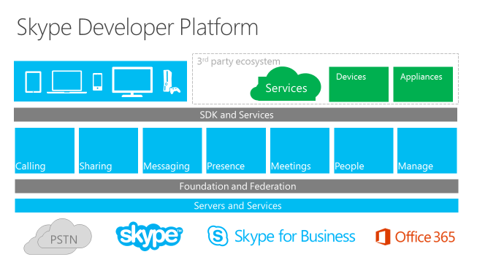

**Embedded Engagement**

Embed live conversations in your website and apps by using our [Web SDK](https://msdn.microsoft.com/en-us/skype/websdk/skypewebsdk) and [App SDK](https://msdn.microsoft.com/en-us/skype/appsdk/skypeappsdk).

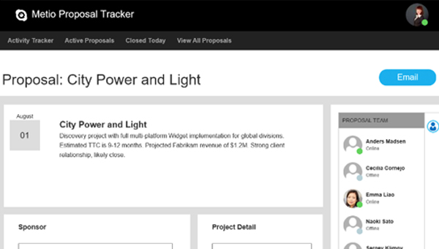

Harness the power of our platform to embed interactive, multi-channel communications that enable greater productivity and collaboration.

**Industry Solutions**

You can build more engaging industry solutions using the Skype [User API](https://msdn.microsoft.com/en-us/library/office/dn324971(v=office.16).aspx), [Web SDK](https://msdn.microsoft.com/en-us/skype/websdk/skypewebsdk) and [App SDK](https://msdn.microsoft.com/en-us/skype/appsdk/skypeappsdk).

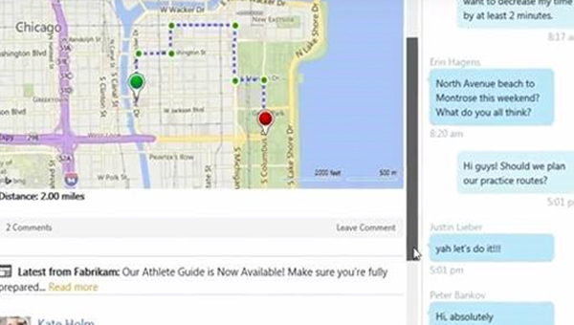

Check out our [industry solutions](https://www.youtube.com/watch?v=C2oWD1AiOrQ&index=5&list=PLH5ElbTc1hWSmmA6O4eoc0Z_d2jC0xu1f) in [healthcare](https://www.youtube.com/watch?v=MiwIRPrXbfo&list=PLH5ElbTc1hWSmmA6O4eoc0Z_d2jC0xu1f&index=3), [financial services](https://www.youtube.com/watch?v=mDPNRy4ijkg&list=PLH5ElbTc1hWSmmA6O4eoc0Z_d2jC0xu1f&index=2), [retail](https://www.youtube.com/watch?v=2xLpAtu50wA&index=4&list=PLH5ElbTc1hWSmmA6O4eoc0Z_d2jC0xu1f), and [customer service](https://www.youtube.com/watch?v=i40ZT8igKd8&list=PLH5ElbTc1hWSmmA6O4eoc0Z_d2jC0xu1f&index=1) and get inspired.

**Social Connection**

Get people sharing and talking about your business with the friendly [Skype Share](https://www.skype.com/en/developer/create-share-buttons/) and [Contact Me buttons](http://www.skype.com/en/create-contactme-buttons) for instant calls and chats.

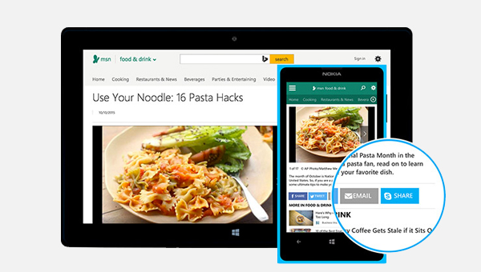

### Skype Web SDK

The Skype Developer Platform for Web ("Skype Web SDK") is a set of JavaScript Web APIs and HTML controls that enable you to build web experiences that seamlessly integrate a wide variety of real-time collaboration models leveraging Skype for Business services and the larger Skype network. It provides support for multiple core collaboration services like presence, chat, audio, and video, enabling web experiences across a broad spectrum of users, platforms, and devices.

### Unified Communications Web API 2.0

Microsoft Unified Communications Web API 2.0 is a REST API that exposes Skype for Business Online instant messaging (IM) and presence capabilities. UCWA 2.0 enables developers to make their enterprise applications and intranets more lively and connected to business contacts.

Key use cases enabled by this API include:

* Lighting up presence in business apps and intranets.
* Embedding IM experience in enterprise-specific Line of Business apps across platforms/browsers/devices (contextual communications), especially Windows 8, Apple iPad, and others.
* Enabling Web Chat - pro-active chat feature for e-commerce site, helpdesk, support, and other scenarios.

Although UCWA 2.0 is language-independent, developers can use any programming language from C/C++ to Java, and the API is fine-tuned for web developers who are familiar with ordinary web technologies such as HTTP, OAuth, JSON, and JavaScript.

### Resources

* [Skype Developer Platform](http://dev.office.com/Skype)
* [Skype Developer Platform – MSDN homepage](https://msdn.microsoft.com/en-us/skype/skypedeveloperplatform)
* [Skype Web SDK](https://msdn.microsoft.com/en-us/skype/websdk/skypewebsdk)
* [Unified Communications Web API 2.0](https://msdn.microsoft.com/en-us/skype/ucwa/unifiedcommunicationswebapi2_0)

## Azure WebJobs

**Azure WebJobs** provide an easy way to run scripts or programs as background processes on App Service Web Apps. You can upload and run an executable file such as as cmd, bat, exe (.NET), ps1, sh, php, py, js and jar. These programs run as WebJobs on a schedule (cron) or continuously.

The **WebJobs SDK** makes it easier to use Azure Storage. The WebJobs SDK has a binding and trigger system which works with Microsoft Azure Storage Blobs, Queues and Tables as well as Service Bus Queues.

Creating, deploying, and managing WebJobs is seamless with integrated tooling in Visual Studio.The WebJobs dashboard in the Azure portal provides powerful management capabilities that give you full control over the execution of WebJobs.

### Using Azure WebJobs for Office 365

#### Performing repetitive, scheduled, background processes

In SharePoint Online, you cannot deploy farm solutions, which is how timer jobs were deployed on SharePoint on-premises. To implement similar timer job functionality in SharePoint Online, you need to run a console application as an Azure WebJob. The console application accesses SharePoint Online using the client-side object model (CSOM). Some examples:

* Site metadata collection – for example reports on current administrators, storage usage, etc.
* Replicate taxonomy structure changes from on-premises master metadata management system to Office 365

#### Performing asynchronous operations

Azure WebJob can be triggered immediately whenever there is a new message added to queue, not as a scheduled task. You can hook in your WebJob to either [Azure queue storage](http://azure.microsoft.com/en-us/documentation/articles/websites-dotnet-webjobs-sdk-storage-queues-how-to/) or [Azure service bus queues](http://azure.microsoft.com/en-us/documentation/articles/websites-dotnet-webjobs-sdk-service-bus/).

Here’s the key elements for providing us the asynchronous processing pattern.

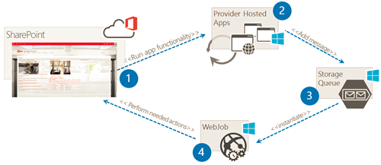

1. User operates in the SharePoint and starts provider hosted app UI one way or another (full page, pop up, app part etc.)
2. Actual operations are performed in the provider hosted app side which is collecting needed parameters and other settings for the processing
3. Operation request is stored to Azure storage queue or Service bus for processing
4. Task is picked up automatically by continuously running WebJob with needed details and requested operation is applied

Some examples:

* Self service operations for the end users, like site collection provisioning for cloud or for on-premises with service bus usage
* Route entries or information from Office 365 to on-premises systems

### Resources

**Watch Videos**

* [PnP Web Cast - Asynchronous operations with Office 365 using Azure WebJobs](https://channel9.msdn.com/blogs/OfficeDevPnP/PnP-Web-Cast-Asynchronous-operations-with-Office-365-using-Azure-WebJobs)
* [PnP Add-In Transformation Training module 5: Using Remote Event Receivers and Remote Timer Jobs](https://channel9.msdn.com/blogs/OfficeDevPnP/PnP-Add-In-Transformation-Training-module-5-Remote-timer-events)

**Read**

* [Introduction to Azure WebJobs](http://www.hanselman.com/blog/IntroducingWindowsAzureWebJobs.aspx)
* [Azure WebJobs documentation resources](https://azure.microsoft.com/en-us/documentation/articles/websites-webjobs-resources/)
* [Use Microsoft Azure WebJobs with Office 365](https://msdn.microsoft.com/en-us/library/office/dn986826.aspx)
* [Using Azure storage queues and WebJobs for async actions in Office 365](https://blogs.msdn.microsoft.com/vesku/2015/03/02/using-azure-storage-queues-and-webjobs-for-async-actions-in-office-365/)
* [Asynchronous operations with Azure storage queues and WebJobs](https://github.com/OfficeDev/PnP/tree/dev/Samples/Core.QueueWebJobUsage)
* [How to Synchronize Terms across multiple term stores](https://github.com/OfficeDev/PnP/tree/dev/Samples/Core.MMSSync)
* [Create remote timer jobs in SharePoint](https://msdn.microsoft.com/en-us/library/office/mt204004.aspx)

## Office 365 Developer Patterns and Practices

The Office 365 Developer Patterns and Practices program provides samples and documentation to help you transition your development solutions from full-trust code to the app model. Start by reading [Transforming your SharePoint customizations to add-in model - Resources](http://dev.office.com/blogs/transforming-your-sharePoint-customizations).

You can use the code samples and guidance in the [Office 365 Developer Patterns and Practices](https://github.com/OfficeDev/PnP) project to help you develop business solutions for your organization or your customers. The project includes code samples that show you how to use provider-hosted add-ins to address key scenarios, as well as other resources that illustrate best practices for add-in model development.

**Must Read**: The [Office 365 development patterns and practices solution guidance](https://msdn.microsoft.com/en-us/library/dn904529(v=office.15).aspx) on MSDN provides samples and documentation to help you to implement typical customizations for Office 365 or for SharePoint Online based on your functional requirements.

The GitHub repo - [Office 365 Development Training Content](https://github.com/OfficeDev/TrainingContent) houses all of the training content for Office 365 Development training courses. Videos related to the guidance are available on the [Office 365 Developer Patterns and Practices channel](https://channel9.msdn.com/blogs/OfficeDevPnP) on Channel 9.

|  |
| --- |
| **PnP weekly web casts** are quick videos recorded around key topics for the Office 365 and SharePoint add-in model development. These are around 30-45 min long recordings on different resources, guidance and other patterns and practices. All web casts will be published to [PnP YouTube channel](http://aka.ms/sppnp-videos).  **Office 365 Dev PnP releases** are done typically first Friday of each month. Details on monthly releases are covered in the monthly community calls. [Download calendar invite (ics)](http://aka.ms/OfficeDevPnPCall) to save the call details to your calendar. |

### Resources

* [Transforming your SharePoint customizations to add-in model - Resources](http://dev.office.com/blogs/transforming-your-sharePoint-customizations)
* [PnP under dev.office.com](http://aka.ms/OfficeDevPnP). One location for all the latest resources and announcements
* [PnP GitHub](http://aka.ms/OfficeDevPnPGitHub). Main repository
* [PnP MSDN pages](http://aka.ms/OfficeDevPnPMSDN)
* [PnP Yammer group](http://aka.ms/OfficeDevPnPYammer)
* [PnP Videos at Channel 9](http://aka.ms/OfficeDevPnPVideos)
* [PnP training package](http://aka.ms/OfficeDevPnPTraining)
* [PnP Guidance Repository](http://aka.ms/OfficeDevPnPGuidance)

# Enterprise Mobility + Security (EMS)

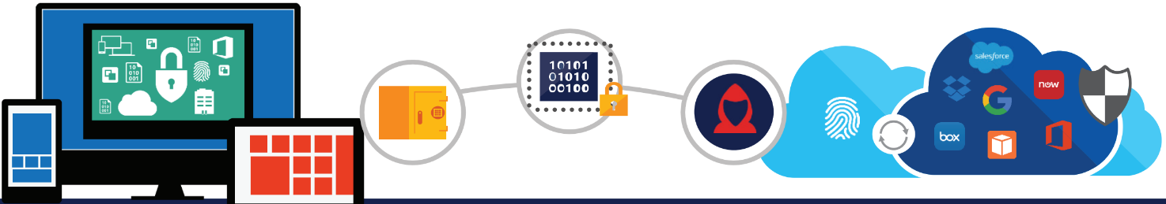

**Microsoft Enterprise Mobility + Security (EMS)** is the only comprehensive solution designed to help manage and protect users, devices, apps, and data in a mobile-first, cloud-first world. EMS enables Digital transformation with freedom and peace of mind.

## Solutions

### Identity and access management

|  |  |
| --- | --- |
|  | **Control identity + access in the cloud**  Centrally manage single sign-on across devices, your datacenter, and the cloud |

Azure AD is more than a “domain controller running on a cloud-hosted server,” and more than a directory in the cloud. It is an **Identity and Access Management Solution as a Service**.

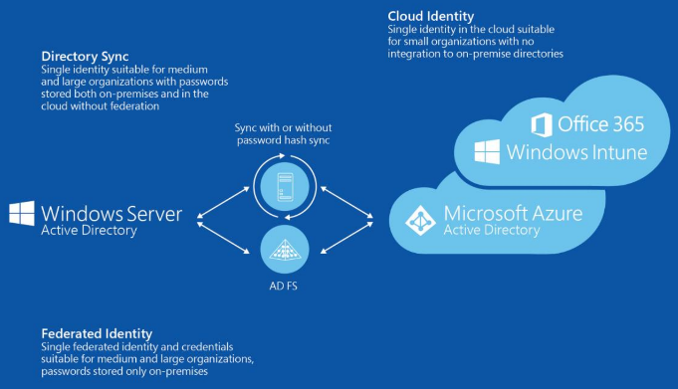

Azure AD offers several capabilities that can allow customers to expand their identity footprint from on-premises into the cloud:

* Synchronizing with AD DS
* Federating with AD DS
* Cloud-Only Authentication
* Pre-integrated SaaS apps for SSO and allowing corporate credentials to “just work”
* Custom line-of-business (LOB) app support and developer features
* User self-service capabilities like password reset and group management

By using Azure AD, your organization will be well positioned to adopt cloud-first or Hybrid Identity scenarios.

Refer to: [Identity and access management](https://www.microsoft.com/en-us/cloud-platform/identity-management)

#### Benefits

* Create and manage a single identity for each user across your hybrid enterprise, keeping users, groups and devices in sync
* Provide single sign-on access to your applications including thousands of pre-integrated SaaS apps
* Enable application access security by enforcing rules-based Multi-Factor Authentication for both on-premises and cloud applications
* Improve user productivity with self-service password reset and application access requests for directories in the datacenter and the cloud
* Provide secure remote access to on-premises web applications through Azure AD Application Proxy
* Take advantage of the high-availability and reliability of a worldwide, enterprise-grade, cloud-based identity and access management solution

### Identity-driven security

|  |  |
| --- | --- |
|  | **Get identity-driven security**  Comprehensive, intelligent protection against today's advanced attacks |

Microsoft Identity-Driven Security addresses the security challenges of today and tomorrow across users, devices, apps, data, and platforms. Each of your employees receive a single protected common identity for secure, risk-based conditional access to thousands of apps—on-premises and in the cloud. Innovative technologies safeguard your network at the front door.

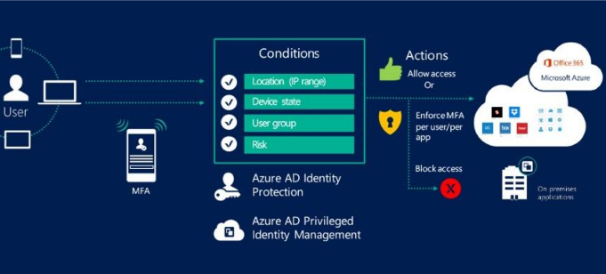

Deep visibility into apps, devices, and data activity uncovers suspicious activities, user mistakes, and potential threats before they become real ones. And with behavioral analytics, machine learning, and unique Microsoft security intelligence, you can secure your corporate files and data while freeing your employees to get their work done on the go.

Refer to: [Identity-driven security](https://www.microsoft.com/en-us/cloud-platform/identity-driven-security)

#### Benefits

* Protect your organization at the front door with secure single sign-on, multi-factor authentication, and risk-based conditional access.
* Provide one common identity for accessing thousands of apps, and manage privileged identities and identity protection.
* Gain deeper visibility for your cloud apps and start controlling data with granular policies.
* Enable secure internal and external file sharing that lets you classify and label files at creation, track their usage, and protect them wherever they go.
* Help prevent data loss in iOS and Android devices with an unparalleled ability to manage Microsoft Office mobile apps.
* Identify advanced persistent threats by using behavioral analytics to detect suspicious user or entity behavior, both on-premises and in the cloud.
* Draw from vast Microsoft threat intelligence and security research data to detect anomalies and prevent threats right away

### Mobile device and application management

|  |  |
| --- | --- |
|  | **Manage mobile devices + apps**  Securely manage apps and data on iOS, Android, and Windows from one place. |

Leveraging Microsoft Intune, you can deliver application and device management completely from the cloud, or on-premises through integration with System Center Configuration Manager, all via a single management console.

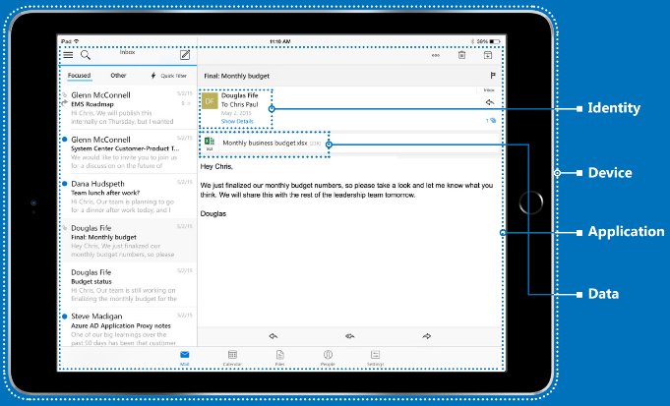

Microsoft has also incorporated manageability and data protection directly into the Intune-managed Office mobile apps to help maximize productivity while providing the flexibility to extend these same management capabilities to your existing line-of-business apps through the Intune App Wrapping Tool. You can choose to manage the Office mobile apps with or without enrolling the device for management to protect corporate information without the risk of intruding on a user’s personal life.

Refer to: [Mobile device and application management](https://www.microsoft.com/en-us/cloud-platform/mobile-device-management)

#### Benefits

* Deliver and manage apps across a broad range of devices, including iOS, Android, Windows and Windows Phone all from a single management console
* Simplify administration by deploying required apps automatically during enrollment and allowing users to easily install corporate apps from the self-service Company Portal
* Help maximize productivity with the Office mobile apps your employees know and love while preventing the leakage of company data by restricting actions such as copy/cut/paste/save in your managed app ecosystem, and extend these capabilities to existing line-of-business apps
* Deploy certificates, WiFi, VPN, and email profiles automatically once a device is enrolled, enabling users to seamlessly access corporate resources with the appropriate security configurations
* Provide comprehensive settings management for mobile devices, including remote actions such as passcode reset, device lock, and data encryption
* Remove corporate data and applications when a device is unenrolled, noncompliant, lost, stolen, or retired from use
* Extend your System Center Configuration Manager infrastructure through integration with Microsoft Intune to provide a consistent management experience across devices located on-premises and in the cloud

### Information security and data protection

|  |  |
| --- | --- |
|  | **Protect your information**  Intelligently safeguard your corporate data and enable secured collaboration. |

Microsoft Azure Information Protection helps you classify and label your data at the time of creation. Protection (encryption + authentication + use rights) can then be applied to sensitive data.

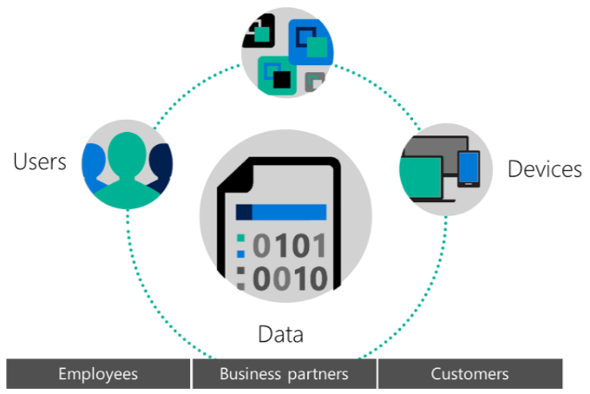

Classification labels and protection are persistent, traveling with the data so that it’s identifiable and protected at all times – regardless of where it’s stored or with whom it’s shared. The interface is simple and intuitive and does not interrupt your normal working experience. You also have deep visibility and control over shared data.

Refer to: [Information security and data protection](https://www.microsoft.com/en-us/cloud-platform/information-protection).

#### Benefits

* Policies classify and label data at time of creation or modification based on source, context, and content. Classification with Azure Information Protection is fully automatic, driven by users, or based on recommendation.
* Embed classification and protection information for persistent protection that follows your data—ensuring it remains protected regardless of where it’s stored or who it’s shared with.
* Track activities on shared data and revoke access if necessary. Your IT team can use powerful logging and reporting to monitor, analyze, and reason over data.
* Share data safely with coworkers as well as your customers and partners. Define who can access data and what they can do with it—such as allowing to view and edit files but not print or forward.
* Data classification and protection controls are integrated into Microsoft Office and common applications to secure the data you’re working on with one click. In-product notifications such as recommended classification help users make right decisions.
* Help protect your data whether it’s stored in the cloud or in on-premises infrastructures. You have the flexibility to choose how your encryption keys are managed, including Bring Your Own Key (BYOK) options.

### Desktop virtualization

|  |  |
| --- | --- |
|  | **Virtualize your desktops**  Efficiently deliver and manage Windows desktops and apps on all devices. |

Workspace virtualization, whether through apps or full desktops, has been a trusted method to achieve these objectives. The key to your success is investing in a secure platform that will provide the necessary capabilities to serve varied use cases while allowing for ﬂexibility and choice of deployment. Microsoft Remote Desktop Services (RDS) has been your trusted platform for delivering virtualized workspaces. Refer to: [Desktop virtualization](https://www.microsoft.com/en-us/cloud-platform/desktop-virtualization).

#### Benefits

* Choose different deployment models to meet your needs: on-premises or in Azure
* Deliver Windows apps on any device: Windows, Mac, iOS, Android
* Scale up or down to meet dynamic business needs by delivering apps from the Azure cloud
* Provide a rich remote user experience similar to applications running on a local PC
* Maintain data compliance by keeping sensitive corporate resources off user devices

## Business Benefits

### Identity-driven security

**Safeguard your resources at the front door**. EMS calculates risk severity for every user and sign-in attempt, so risk-based conditional access rules can be applied to protect against suspicious logins.

**Protect your data against users mistakes**. Gain deeper visibility into user, device, and data activity on-premises and in the cloud to create more effective, granular level policies. Classify and label files at creation, track their usage, and change permissions when necessary.

**Detect attacks before they cause damage**. Identify attackers in your organization using innovative behavioral analytics and anomaly detection technologies – all driven by vast amounts of Microsoft threat intelligence and security research data.

### Managed mobile productivity

**Mobile apps without compromising your Office experience**. EMS is the only solution built with and for Microsoft Office. This means that email and other Office files can be secured without compromising the Office experience - the gold standard of productivity.

**Enable easy access to resources**. Sign in once for secure access to all corporate resources, on-premises and in the cloud, from any device. This includes pre-integrated support for Office365, Salesforce.com, Box, ServiceNow and thousands more popular SaaS apps.

**Enable users to protect and control data**. Employees can encrypt virtually any type of file, set granular permissions, and track usage. The encryption stays with the file where it goes, enabling more secure file sharing, internally and externally.

### Flexible + Comprehensive

**Work with what you have.** Get an integrated set of solutions that are designed to work together with your on-premises investments, avoiding the need for costly and complicated integration efforts across point capabilities.

**Future-proof your investment**. As a cloud solution that integrates with your on-premises infrastructure, EMS takes the worry out of scale, maintenance, and updates.

**Simplify your set-up**. To make deployment even easier, EMS comes with FastTrack - a Microsoft service that includes best practices, tools, resources, and experts committed to make your experience with EMS a success.

**Get more for less**. Our complete solution can cost less than combining standalone products from other vendors.

## Products

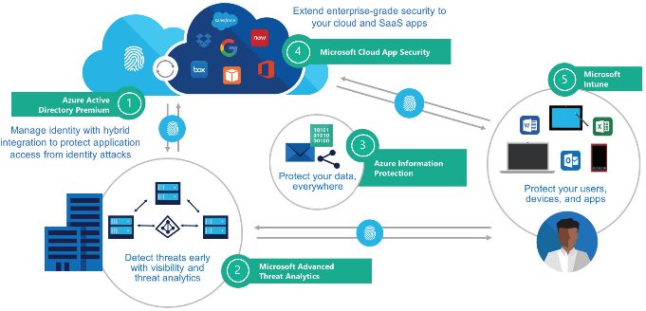

1. **Azure Active Directory Premium** delivers multi-factor authentication; access control based on device health, user location; and, holistic security reports, audits, and alerts. Refer to: [Azure Active Directory](https://www.microsoft.com/en-us/cloud-platform/azure-active-directory)
2. **Microsoft Advanced Threat Analytics** helps extend the visibility, auditing, and control you have on-premises to your cloud applications. Refer to: [Microsoft Advanced Threat Analytics](https://www.microsoft.com/en-us/cloud-platform/advanced-threat-analytics)
3. **Azure Information Protection** provides persistent data protection of files shared internally and externally, including the option to track, classify and label data. Refer to: [Azure Information Protection](https://www.microsoft.com/en-us/cloud-platform/azure-information-protection).
4. **Microsoft Cloud App Security** provides deep visibility and control of data inside cloud applications. Refer to: [Cloud App Security](https://www.microsoft.com/en-us/cloud-platform/cloud-app-security)
5. **Microsoft Intune** makes it easier to secure and manage iOS, Android, and Windows PCs all from one console. Deep integration with Office 365 helps keep company data secure in the Office mobile apps. Refer to: [Microsoft Intune](https://www.microsoft.com/en-us/cloud-platform/microsoft-intune)

# Microsoft's Enterprise Cloud Roadmap

Microsoft is using Microsoft Azure, Office 365 and Microsoft Dynamics to deliver the industry's most complete cloud — for every business, every industry, and every geography.

## Cloud Services and Platform Options

### Microsoft SaaS Services

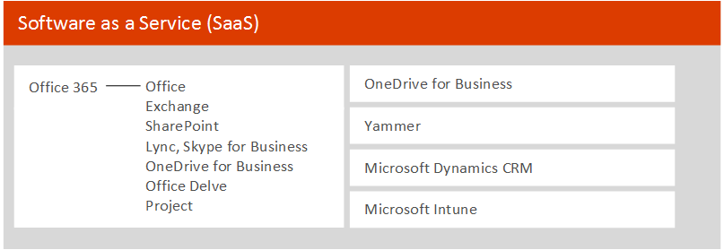

Taking advantage of productivity workloads provided in the cloud is a first step for many enterprise organizations.

* Get started quickly.
* Rich feature set is always up to date.
* Frees organizations to focus IT resources on strategic applications.
* Includes a Microsoft Azure Active Directory tenant for use with other Microsoft cloud services.

|  |
| --- |
| Office 365 |
| Enterprise cloud productivity and collaboration services |
| OneDrive for Business |
| File storage and synchronization for enterprises |
| Yammer |
| Enterprise cloud social networking |
| Microsoft Dynamics CRM |
| Enterprise cloud customer relationship management |
| Azure Active Directory |
| Provides an identity and access management solution: directory services, identity governance, security, and application access management. |
| Microsoft Intune |
| Enterprise cloud PC and mobile device management |
| Azure Multi-Factor Authentication |
| Used with Azure Active Directory, it allows you to safeguard access to data and applications while employing a simple  sign-in process. |

**Best for**

All productivity workloads:

* Organization-wide email
* Instant messaging, video conferencing
* Sharing organization data, team sites, project sites
* Secure cloud-storage for business documents
* Desktop and cloud-based applications that are always up to date

Enterprise-wide, private social networking:

* Share information across teams & projects
* Connect to the right people

Manage mobile devices, PCs, and applications from the cloud

Manage customer relationships, including sales, service, and marketing.

### Microsoft Azure PaaS

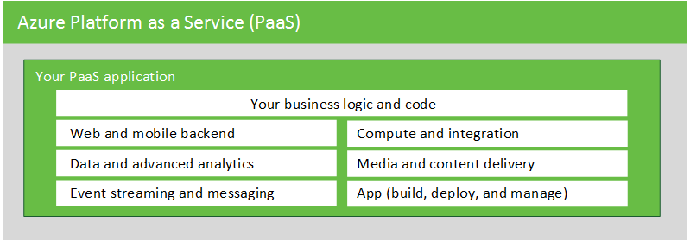

Use the Azure PaaS open and flexible platform to quickly build, deploy, and manage cloud-enabled applications across the global network of datacenters managed by Microsoft.

* Build modern applications and focus on functionality instead of infrastructure.
* Build applications that are not possible on-premises.
* Support for many programming languages including .Net, Java, PHP, Ruby, Node.js, Python, and more.
* Choice of frameworks including .Net, ExpressJS, Rails, Zend, and more.

Microsoft Azure PaaS is a growing collection of integrated services—compute, storage, data, app, and networking—that helps you move faster, do more, and save money.

|  |
| --- |
| Azure Web Apps |
| Build websites with .Net, PHP, Python, Java, or Node.js and deploy in seconds. |
| Azure Storage |
| Massively scale storage in different types. Manage SQL databases as a service. Secure and dedicated Redis cache. |
| Azure Compute |
| Quickly deploy and manage multi-tier apps. Achieve continuous availability. |
| Azure Media Services |
| Encode, store, and stream video and audio at scale. Deliver content globally. |
| Azure Mobile Services |
| Create highly functional mobile apps that can access backend capabilities. |
| Azure Stream Analytics |
| Perform real-time stream processing in the cloud for Internet of Things solutions. Create dashboards and alerts. |
| Azure Logic Apps |
| Develop powerful integration solutions with SaaS and enterprise applications. |
| Azure API Apps |
| Expose and your application its APIs to your SaaS and enterprise applications. |

**Best for**

* Mobile applications
* Hybrid cloud storage with StorSimple
* Media streaming, Video archiving
* Big data solutions using HD Insights
* Machine learning and other advanced analytics scenarios
* B2B e-commerce, E-commerce website
* Scalable web portals and sites
* Multichannel marketing
* Gaming apps
* Internet of Things (IoT) solutions

### Microsoft Azure IaaS

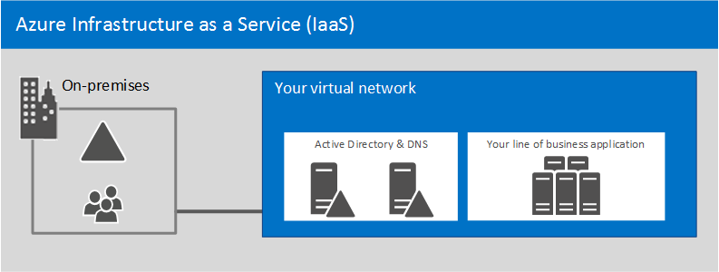

Extend your IT infrastructure to the cloud by using Azure compute, storage, and networking features and resources.

* Combine Azure IaaS with Azure PaaS features as you move existing workloads to the cloud.
* Create, resize, and decommission virtual machines in minutes for dev and test scenarios.
* Reduce your on-premises servers and your overall datacenter costs.
* Plan, size, and scale your infrastructure to support your long-term cloud adoption plans.

Microsoft Azure IaaS includes network services and virtual machines. These services can be combined with any PaaS services. Manage your environment using the Azure portal, Azure PowerShell, or the Azure Command Line Interface (CLI).

|  |
| --- |
| Virtual Network |
| Provision and manage virtual networks in Azure and securely link to your on-premises IT infrastructure. |
| ExpressRoute |
| Connects on-premises infrastructure directly to the Microsoft network that contains Azure datacenters, without using the Internet. |
| Virtual Machines |
| Create new virtual machines or create and upload your own to create pre-configured virtual machines. |
| Traffic Manager |
| Load balance incoming global traffic across multiple services running in the same or different datacenters. |

**Best for**

* Development and test environments
* Disaster recovery of on-premises solutions
* Big data solutions using HDInsight
* SAP solutions
* SQL Server test, backup, and disaster recovery
* Datacenter expansion or replacement

### Private cloud

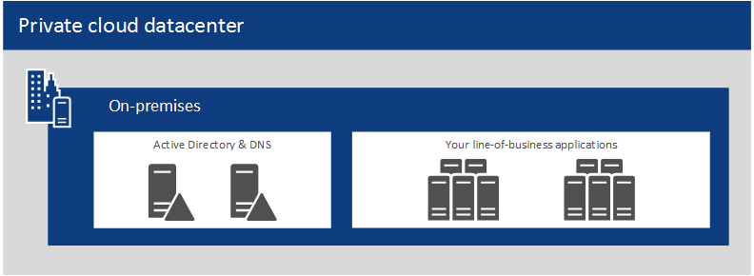

Private cloud datacenters excel at hosting services that remain on-premises to support hybrid cloud solutions. Organizations that excel with private cloud IaaS capabilities can benefit from taking this approach with a broader portfolio.

* Combines Windows Server, System Center, and other Microsoft technologies to provide a private IaaS environment.
* Provides the benefits of IaaS but on your terms with dedicated resources, complete control, greater potential for customization, and greater datacenter efficiency.

**Windows Server** delivers an enterprise-class, multi-tenant datacenter and cloud infrastructure.

|  |
| --- |
| Generation 2 Virtual Machines |
| Advanced virtual machine features. |
| Hyper-V Replica |
| Provides asynchronous replication of Hyper-V virtual machines between two hosting servers. |
| Live Migration |
| Move a running virtual machine from one physical server to another without interruption of service. |

**System Center** delivers Unified management across on-premises, service provider, and Microsoft Azure environments.

|  |
| --- |
| Virtual Machine Manager (VMM) |
| Configure and manage virtualization hosts, networking, and storage resources for private clouds. |
| App Controller & Service Manager |
| Provide application self-service — Delegate authority to users to create applications and cloud environments. |
| Configuration Manager |
| Manage PCs & servers, setting configuration and ensuring compliance with security policies. |

**Best for**

* Running core network services to support hybrid cloud environments:
* Compliance with data sovereignty, privacy, and regulatory requirements
* Legacy applications
* Implementing a chargeback process based on consumption for business units in your organization
* Providing delegated authority and tools to implement a self-service model
* Constructing and spanning cloud environments across multiple datacenters, infrastructure, and service providers

### Balance of Responsibilities



The balance of control and responsibility for managing solutions depends on the category of the service. The above chart summarizes the balance of responsibility for both Microsoft and the customer.

### Resources

* [Microsoft Cloud Services and Platform Options](http://aka.ms/cloudarchoptions)

## Microsoft IT moves its workloads to the cloud

Modernization and efficiency demands are driving Microsoft IT to a “cloud first” strategy.

* Two datacenters are closing in the near future, leases on others will expire.
* Thousands of servers are reaching end of life (EOL), with replacement requiring $200 million over the next five years.

### Three-Phase Approach

1. **Productivity workloads move to SaaS**. Microsoft IT moved quickly to take advantage of Microsoft SaaS offerings with employees using Office 365, Yammer, and OneDrive. Microsoft also uses Dynamics CRM Online.
2. **New development and modern applications move to PaaS**. New applications are optimized for cloud computing. Focus is on functionality rather than infrastructure.
3. **Existing applications move to IaaS**. Existing applications are moved to IaaS virtual machines using one of two approaches:

* Lift and shift. Existing virtual machines are shifted to the cloud.
* Build in the cloud. Applications are prebuilt in Azure and traditional methods are used to back up and restore data.

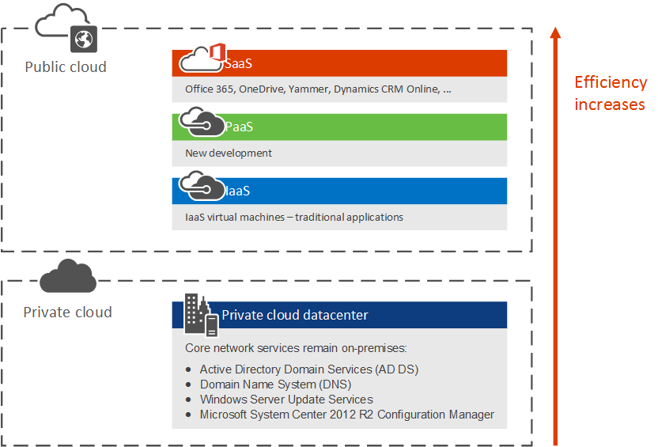

## Microsoft cloud storage options

The [Microsoft Cloud Storage for Enterprise Architects](https://technet.microsoft.com/library/dn919927.aspx#storage) document covers what IT architects need to know about storage options in Microsoft cloud services and platforms along with the reasons for using cloud storage and the key scenarios.

* **Move-in ready** cloud storage options that are bundled with existing services, which you can use immediately and with minimal configuration.
* **Some assembly required** storage options that you can use as a starting point for your storage solution with additional configuration or coding for a custom fit.
* **Build it from the ground up** with storage building blocks to create your own storage solution or storage for your apps from scratch.